QUALITY CONTROL REPORT
BIOVISION SPECIALITY DIAGNOSTIC CENTRE ,MAVELIKARA,
JULY 2025
The quality control mechanism of the Biovision speciality diagnostic centre is detailed as below
Internal Quality control
The internal quality material for biochemistry is purchased from Randox and two levels is used for routine biochemistry control analysis. The L1 with lot no. 89731 and L2 with lot no.89732 is run on alternate days and values are evaluated as per the reference of the manufacturers data sheet. The lab is strictly following the instruction to adhere to the mean value provided though a slight variation from mean to +/- 1SD is allowed due to the various influencing parameters and factors of the test process. The charts attached here with some systemic /random errors have noticed and rectified.
The triglyceride L2 values from 16-7-25 to26-7-25 showed a shift to higher values and returned to mean on 28-7-25may be due to a reagent change, The QC results of HDL L2 is running between -1SD and -2SD range which is showing a constant value range which denotes that a lab mean of the parameter will enable the graph to be corrected as a perfect representation. The values of LDL L2 is also be represented between mean and -1SD values and in a constant range.An interlab comparison of these two parameters are done with Lalpath and the results are found identical. Bil D values are between -1SD and -2SD range needs for setting a lab mean for this parameter also.. The calcium L 1 value changed from +1Sd to a range between 2SD and 3SD and returned to +1SD and it was a 1:2S change may be due to a reagent change and rectified.
Hormones, tumour markers and metabolic studies are carried out in Abbott i1000 SR machine and the QC materials for performing these tests are provided by Abbott in three levels, L1.L2 and L3. Frequent testing parameters like for TFT QC is run daily each levels alternatively. The uncommon parameters like Vit D, Beta HCG QC s are done once in a week
. The QC performance of all the above said tests are at par with the QC kit insert literature
The Electrolyte analyser used is Sensacore and the daily QC is run with RL solution with estimated electrolyte values where as in the occasion of changing of reagent kit manufacturer provided QC samples are used for validation. The material used forrunning internal QC is RL solution in 500 ml capacity,which in turn contaminates on standing and small quantity of solution may purchased for tackling this type of defects which may leadto QC discordanceas happened this month
Hematology machine is of ERBA and QC is done on alternate days with the manufacturer provided QC samples. The values are seen with in the acceptable range as per the radar chart attached

EXTERNAL QUALITY CONTROL
The eternal quality control mechanism of this lab is as follows . the biochemistry external QC agreement is with RIQUAS and CMC vellore and samples are tested and uploaded to the respective sites on time. The results when obtained is analysed and corrective measures are undertaken if there is any disparity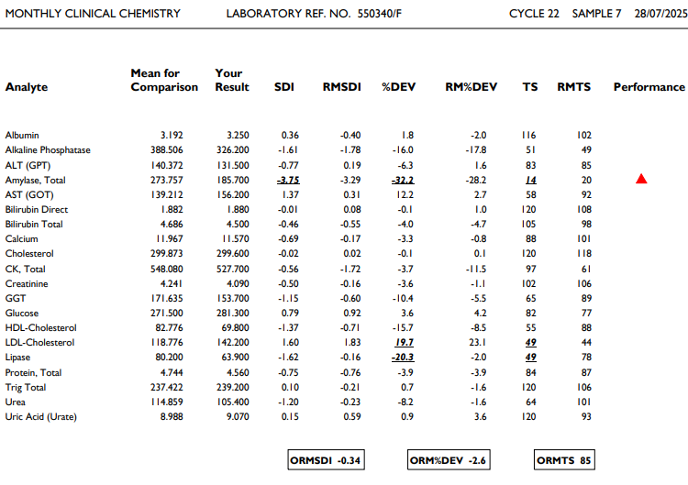
Standard Deviation Index (SDI)

The Standard Deviation Index (SDI) is an indication of how far reported result is from the consensus mean relative to the Standard Deviation for Performance Assessment
Running Mean Standard Deviation Index (RMSDI)
The RMSDI is the average of the last 10 SDIs for a given parameter, as a measure of performance over the full range of concentrations
percentage deviation
percentage error or bias, the % Deviation is calculated as follows:
%Deviation = participant’s result - mean for comparison x 100
mean for comparison
The closer % deviation is to zero, the better your performance.
Calculation of Running Mean Percentage Deviation (RM%Dev)
The RM% Dev is the average of the last 10 %Deviations, as a measure of performance over the full range of concentrations.

The Standard Deviation Index (SDI)
is a measurement of how far your reported result is from the consensus mean relative to the Standard Deviation for Performance Assessment, SDI is presented in the text section of the report, and is plotted on the Levey-Jennings chart. This participant’s SDI is acceptable as it is less than 2
- Acceptable performance
Criteria for acceptable performance is considered to be:

- Target Score greater than 50
- SDI less than 2
- % Deviation within the “acceptable limits” set
As per last months performance, the parameters with Target score less than 50 are Amylase, Lipase and HDL.. In the case of Amylase the reagents now using is manufactured in 1-1-23 and having an expiry date only up to 31-8-25.In the case of sensitive enzymatic reagents smaller pack size may be preferred so that the assay errors due to shelf life can be minimised. So also in the case of Lipase. All the other assay parameters fall within acceptable range.
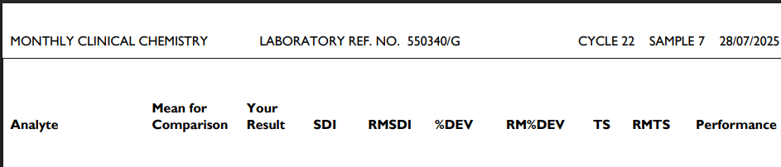
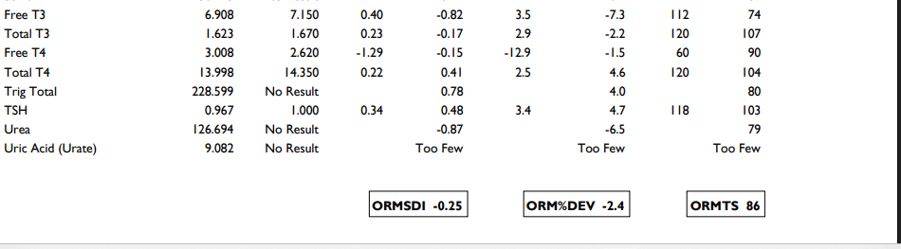
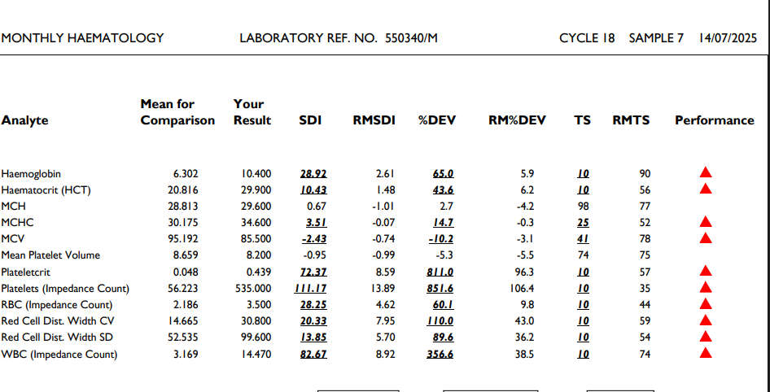

EQAS done with collaboration of CMC Vellore results are as follows
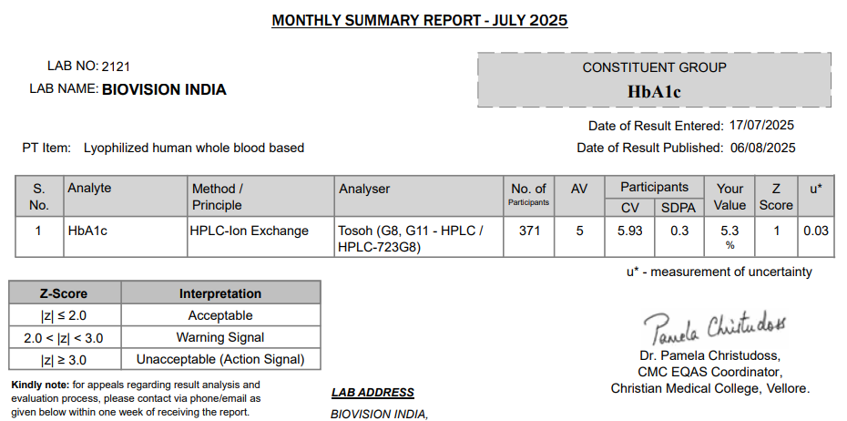
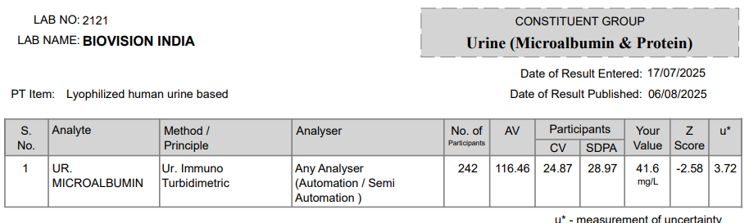
z-score, also known as a standard score, is a statistical measurement that indicates how many standard deviations a data point is away from the mean of a distribution. It's a way to standardize data, allowing for comparisons between different datasets or distributions. A positive z-score means the data point is above the mean, while a negative z-score means it's below the mean. A z-score of 0 indicates the data point is equal to the mean. And the acceptable range is between =/- 2.00 Z score.All the parameters of analytes are with in range except Amylase ,reason of which is discussed earlier. The urine microalbumin z score is -2.02 which is below the target value, which may be evaluated . Remedial action is taken for investigating the error causes.
€

