**DSA 01(OOPS C++)**

**NAME:K VISHNU VARDHAN**

**REG NO:192110362**

QUESTION 1

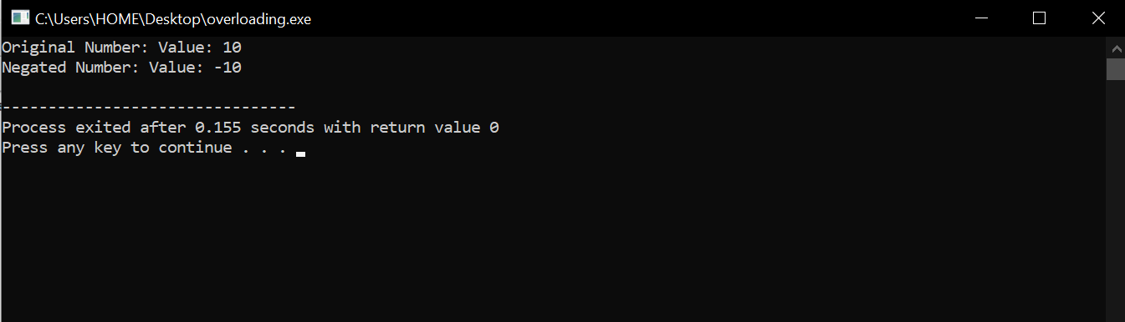

QUESTION 2

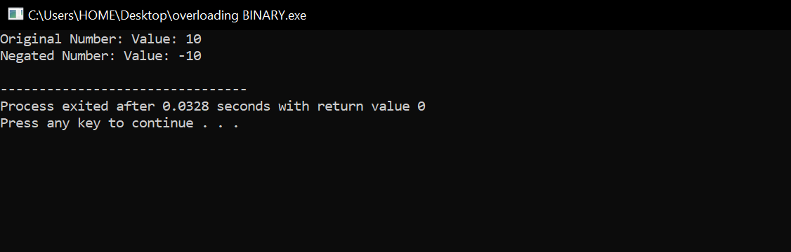

QUESTION 3

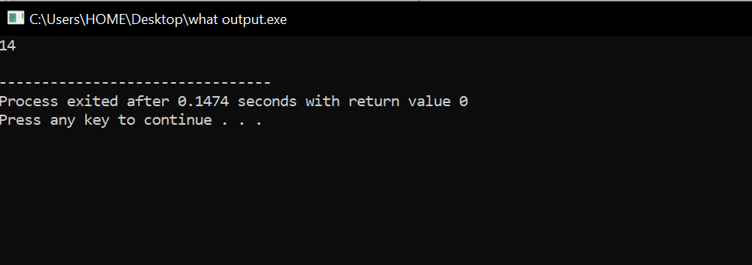

QUESTION 4

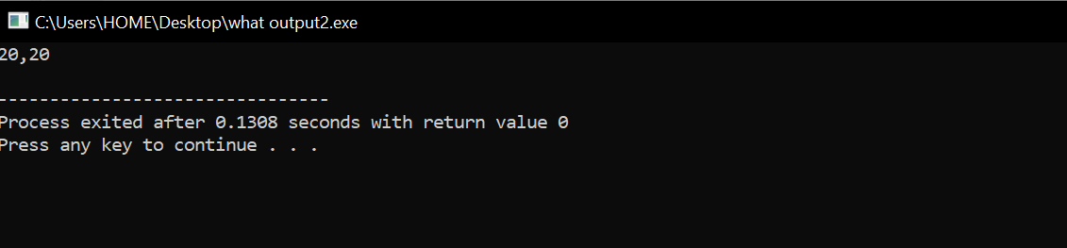

QUESTION 5

