Advanced Data Analysis and Visualization in Logistics
Hypothetical Logistics Dataset — Exploratory Data Analysis, Visualization, Insights & Recommendations
Python-based analysis | 1,200 simulated shipments | January–December 2025

1. Executive Summary
This report analyzes 1,200 simulated shipments across four regions, four warehouses, three transport modes, and two service priorities. The analysis focuses on delivery reliability, transportation cost, shipment volume, distance, and operational bottlenecks.
Overall on-time delivery was 36.2%. Average delivery time was 7.78 days (median 7.93), and total simulated transportation spend was $1,074,534. Average transportation cost was $895 per shipment and $61 per ton.
The results indicate that distance, shipment volume, transport mode, regional conditions, and congestion are meaningful operational drivers. Air is fastest but expensive, while the East region has the weakest on-time performance and merits targeted investigation.

2. Objectives and Analytical Questions
- Measure central tendency and spread of core logistics metrics.
- Understand delivery-time and transportation-cost distributions.
- Compare service performance across modes, regions, and warehouses.
- Identify relationships among volume, distance, delivery time, and cost.
- Identify operational bottlenecks and cost drivers.
- Convert findings into practical logistics recommendations.

3. Dataset Structure and Simulation Method
The dataset is hypothetical and was generated programmatically with random seed 42 for reproducibility. The simulation embeds plausible logistics relationships: longer distances and larger loads tend to increase time and cost; air is faster but more expensive; rail is comparatively economical; congestion increases delay and cost; and regional effects create performance differences.
Variable | Type | Description
Shipment_ID | ID | Unique shipment identifier
Date | Date | Shipment date
Region | Category | North, South, East, West
Warehouse | Category | WH-A to WH-D
Transport_Mode | Category | Road, Rail, Air
Priority | Category | Standard or Express
Shipment_Volume_tons | Numeric | Shipment size
Distance_km | Numeric | Transportation distance
Delivery_Time_days | Numeric | Actual delivery time
Transport_Cost_USD | Numeric | Transportation cost
Target_Days | Numeric | SLA target
On_Time | Boolean | SLA met or missed
Delay_Days | Numeric | Days beyond target
Cost_per_ton_USD | Numeric | Cost normalized by volume

4. Exploratory Data Analysis

4.1 Central Tendencies and Distributions
Metric | Mean | Median | Std. Dev. | Min | Max
Shipment Volume tons | 14.77 | 12.73 | 8.62 | 4.00 | 70.96
Distance km | 498.10 | 435.32 | 289.77 | 40.00 | 1500.00
Delivery Time days | 7.78 | 7.93 | 1.93 | 1.30 | 14.01
Transport Cost USD | 895.44 | 743.04 | 629.36 | 98.18 | 7722.26
Delay Days | 0.96 | 0.53 | 1.14 | 0.00 | 6.01
Cost per ton USD | 67.62 | 60.20 | 34.88 | 8.29 | 252.48
Mean-versus-median differences reveal skew. Cost and shipment volume are right-skewed because a smaller number of large or expensive shipments raise the mean. Delivery time is dispersed because the network combines multiple modes, distances, priorities, and regional conditions.

4.2 Correlation Analysis
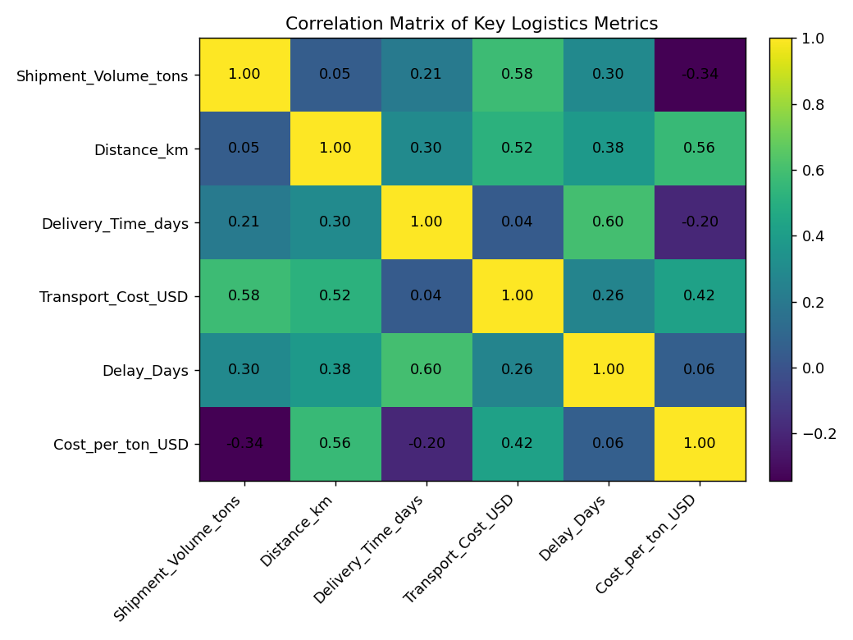
Figure 1. Correlation matrix of key numeric logistics variables.
Distance and transportation cost show a strong positive relationship, consistent with longer routes requiring more transport resources. Shipment volume also contributes to cost. Delivery time is positively associated with distance and volume, indicating that route length and load size are important contributors to service time.

5. Visual Analysis

5.1 Delivery-Time Distribution — Histogram
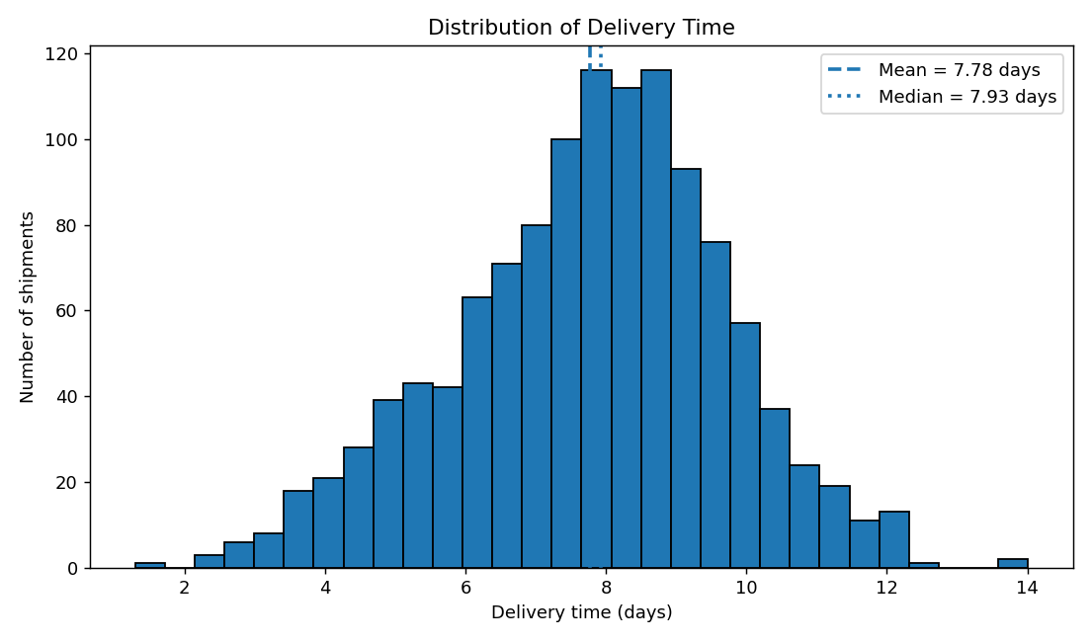
A histogram is appropriate for a continuous KPI because it reveals concentration, spread, and the upper tail of slow shipments. The mean delivery time is 7.78 days versus a median of 7.93 days. The higher mean suggests a slower upper tail that should be examined for congestion, long routes, mode constraints, or other exceptions.

5.2 On-Time Performance by Transport Mode — Bar Chart
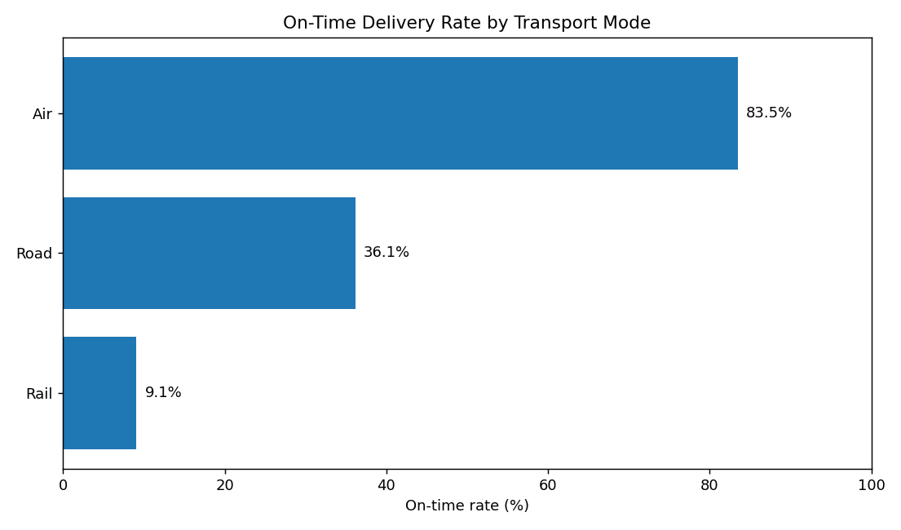
A horizontal bar chart supports direct ranking of categorical groups. On-time percentage is a service-level KPI, so the comparison is immediately actionable. Air provides the fastest service but at a higher cost structure. Road carries most shipments and therefore has the greatest operational leverage; rail can be attractive where transit-time requirements permit.

5.3 Transportation Cost vs. Distance — Scatter Plot
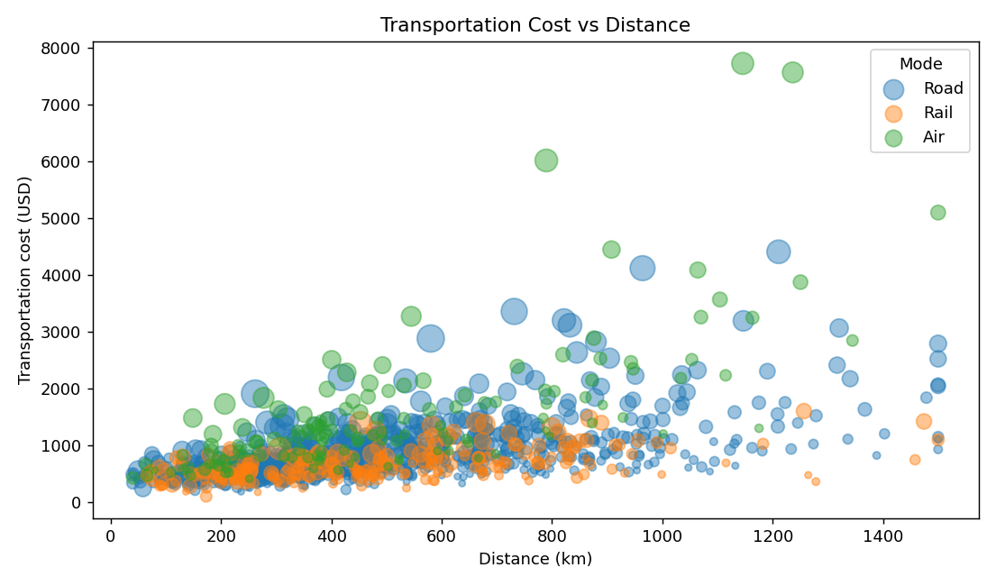
A scatter plot is suitable for relationships between continuous variables. Point size adds shipment volume while grouping by mode exposes mode-specific cost structures. Cost generally rises with distance and larger shipments occupy higher-cost points. Air shows the premium associated with speed. This supports selective rather than blanket use of premium transport.

5.4 Monthly On-Time Performance — Line Chart
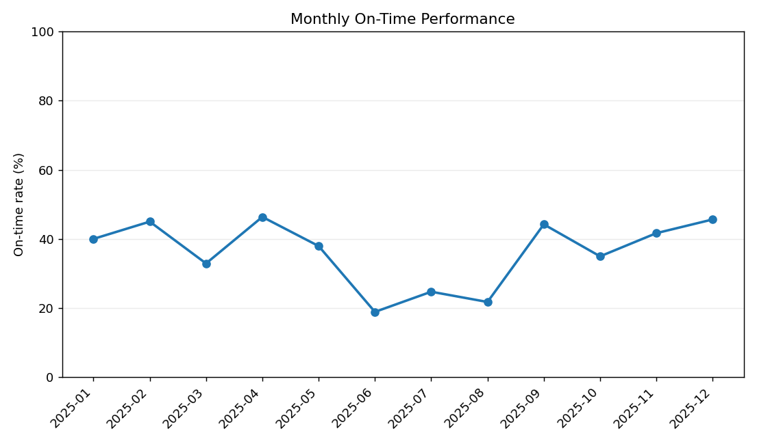
A line chart emphasizes movement and seasonal patterns in a KPI over time. The best simulated month was 2025-04 at 46.4%; the weakest was 2025-06 at 18.9%.

5.5 Regional Delivery Time and Cost — Combined Chart
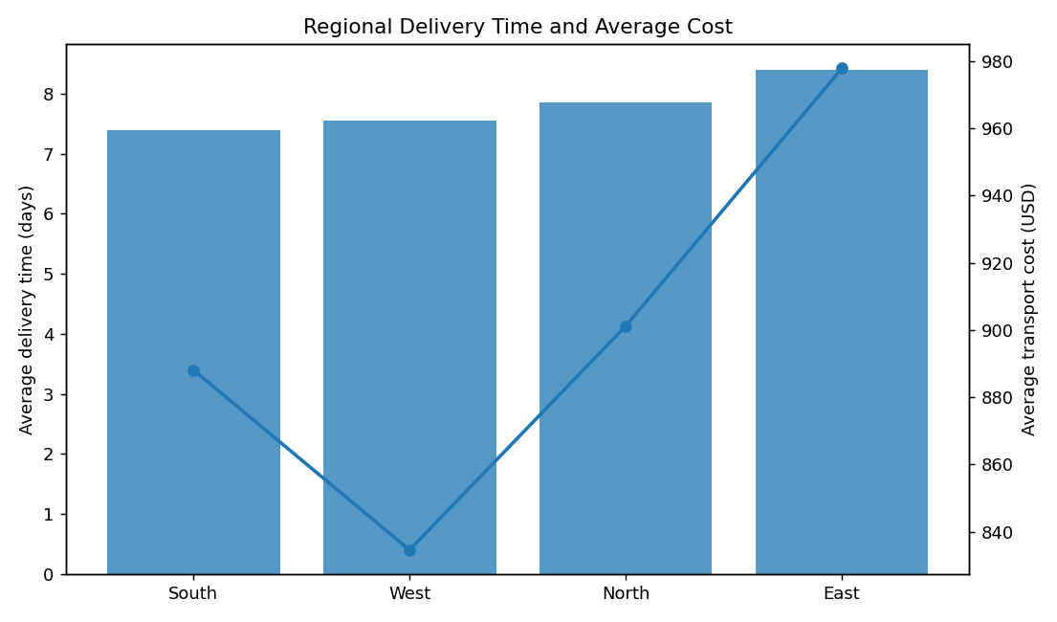
The combined chart compares delivery time and cost using region as the common category, making potentially slow-and-expensive segments visible. East has the lowest on-time rate. That pattern warrants route-, carrier-, and warehouse-level diagnosis rather than an undifferentiated network-wide change.

6. Performance Scorecard
Mode | Shipments | Avg Delivery | On-Time | Avg Cost | Cost/Ton
Air | 139 | 5.69 d | 83.5% | $1,554 | $111
Road | 819 | 7.78 d | 36.1% | $855 | $64
Rail | 242 | 8.97 d | 9.1% | $656 | $54

Regional scorecard
Region | Shipments | Avg Delivery | On-Time | Avg Cost | Avg Distance
East | 247 | 8.40 d | 22.7% | $978 | 493 km
North | 347 | 7.85 d | 31.7% | $901 | 497 km
West | 334 | 7.55 d | 41.9% | $835 | 505 km
South | 272 | 7.40 d | 47.1% | $888 | 496 km

7. Key Analytical Insights
- Overall service reliability: 36.2% of shipments meet the simulated SLA; 63.8% miss it.
- Speed-cost trade-off: air is fastest but substantially more expensive than road or rail.
- Distance is a major cost driver and is also associated with longer delivery time.
- Shipment scale matters: larger loads increase total cost and delivery time, making consolidation and load planning relevant.
- Regional bottleneck: East is the weakest region by on-time performance.
- Monthly monitoring is important because aggregate annual KPIs can conceal periods of deterioration.
- Cost per ton is a more informative efficiency measure than total shipment cost when shipment sizes differ materially.

8. Recommendations
Segment transport mode by service requirement: Use road/rail for cost-sensitive predictable freight and reserve air for genuinely time-critical shipments.
Investigate the weakest region: Analyze routes, carriers, handoffs, loading constraints, and congestion in the lowest-performing region.
Adopt cost per ton as a control KPI: Use normalized cost to compare shipments of different sizes and identify inefficient lanes or low-utilization loads.
Increase consolidation where feasible: Combine compatible shipments when SLA requirements allow to improve utilization and reduce unit cost.
Use exception-based monitoring: Flag shipments likely to miss SLA or exceed lane-specific cost thresholds instead of treating every shipment equally.
Track performance monthly: Maintain a dashboard for on-time rate, delivery time, cost per ton, volume, and exception counts.

9. Limitations
- The dataset is simulated and does not represent actual operations.
- Simulation relationships are plausible assumptions, not estimates from real observations.
- Correlation does not prove causation.
- Aggregate analysis should be supplemented with route, carrier, customer, and shipment-level investigation.
- No forecasting or causal inference model was required for this EDA-focused task.

10. Python Tools, Code, and Reproducibility
NumPy was used for controlled data simulation, pandas for transformation and aggregation, and Matplotlib for visualization. The fixed seed makes the dataset reproducible. The full script is supplied separately.
# EDA
print(df[numeric_cols].describe())
print(df[numeric_cols].corr())

# Mode-level KPI comparison
mode_perf = df.groupby("Transport_Mode").agg(
On_Time_Rate=("On_Time", "mean"),
Avg_Delivery_Days=("Delivery_Time_days", "mean"),
Avg_Cost_USD=("Transport_Cost_USD", "mean")
)

# Distribution
plt.hist(df["Delivery_Time_days"], bins=30, edgecolor="black")
plt.title("Distribution of Delivery Time")
plt.xlabel("Delivery time (days)")
plt.ylabel("Shipments")
plt.show()

# Relationship
for mode in ["Road", "Rail", "Air"]:
s = df[df["Transport_Mode"] == mode]
plt.scatter(s["Distance_km"], s["Transport_Cost_USD"],
s=s["Shipment_Volume_tons"] * 4,
alpha=0.45, label=mode)
plt.xlabel("Distance (km)")
plt.ylabel("Transportation cost (USD)")
plt.legend()
plt.show()

11. Conclusion
This analysis demonstrates how Python-based EDA can convert logistics transaction data into operational intelligence. Distributions explain variability, grouped comparisons reveal service differences, scatter plots expose cost drivers, and time-series views identify when performance changes.
For real deployment, the next step would be to replace the simulated data with actual shipment, carrier, route, warehouse, fuel, and customer data, then validate the observed relationships statistically.

Appendix — Included Deliverables
- Advanced_Logistics_Data_Analysis_Report.docx — complete report with embedded visualizations and code excerpts.
- hypothetical_logistics_dataset.csv — 1,200 simulated shipment records.
- logistics_analysis.py — reproducible Python analysis script.
- Six PNG visualization outputs — also embedded in the report.

