Predictive Modeling and Optimization in Logistics Systems
Forecasting Delivery Time and Improving Operational Performance
Prepared as a predictive analytics and logistics optimization case study
Dataset: simulated logistics shipment records | Observations: 5,000 | Random seed: 42

1. Executive Summary
This report develops a predictive model for shipment delivery time and uses the resulting forecasts to identify logistics optimization opportunities. A synthetic dataset of 5,000 shipments was created to represent a realistic last-mile and regional distribution environment. The target variable is delivery time in hours, while explanatory variables include distance, shipment weight, number of stops, dispatch hour, traffic, weather, warehouse congestion, priority, and carrier.
Three predictive approaches were compared: linear regression, random forest regression, and gradient boosting regression. The best-performing baseline model on the held-out test set was Gradient Boosting. A randomized hyperparameter search was also applied to gradient boosting. The tuned model achieved MAE = 2.30 hours, RMSE = 2.88 hours, and R² = 0.708 on the test set.
A scenario analysis then simulated three operational improvements simultaneously: reducing high-traffic exposure, reducing high warehouse congestion to medium, and removing one stop where possible. Under the model, the predicted average delivery time decreased from 13.43 to 11.50 hours, a reduction of 1.93 hours (14.4%). This is a model-based scenario estimate rather than a causal guarantee.

2. Problem Definition
Logistics operators need accurate estimates of delivery time to set realistic customer expectations, allocate vehicles, prioritize shipments, identify operational bottlenecks, and evaluate dispatch decisions. The forecasting problem is formulated as:
- Prediction objective: estimate shipment delivery time in hours before or at dispatch.
- Unit of prediction: one shipment.
- Target variable: delivery_time_hours.
- Prediction horizon: from dispatch to final delivery.
- Operational use: ETA communication, exception management, staffing, dispatch planning, and route/stop reduction.
- Business objective: reduce delivery-time variability and average delivery time while maintaining service quality.

3. Data Simulation and Dataset Design
Because no real company dataset was supplied, a hypothetical dataset was simulated. The simulation deliberately includes both numerical and categorical variables so that the modeling workflow reflects a practical logistics machine-learning project.
Feature | Type | Meaning | Typical values
distance_km | Numerical | Shipment travel distance | 5–300 km
traffic | Categorical | Traffic condition | Low / Medium / High
weather | Categorical | Weather at dispatch | Clear / Rain / Storm
weight_kg | Numerical | Shipment weight | 1–200 kg
stops | Numerical | Number of planned/intermediate stops | 0–8
dispatch_hour | Numerical | Hour of day of dispatch | 0–23
warehouse_congestion | Categorical | Warehouse workload condition | Low / Medium / High
priority | Categorical | Service level | Standard / Express
carrier | Categorical | Assigned carrier | A / B / C
delivery_time_hours | Target | Actual delivery duration | Positive continuous value
The simulation embeds plausible operational relationships: longer distances, more stops, heavier shipments, traffic, bad weather, and warehouse congestion tend to increase delivery time. Express priority is modeled as faster, while small carrier differences represent operational variation. Random noise represents unobserved factors.

4. Exploratory and Data Preparation Process
- Separate predictors from the target variable.
- Split the data into 80% training and 20% testing sets using a fixed random seed.
- Impute missing numerical values with the median and categorical values with the most frequent category.
- Standardize numerical variables for the linear model.
- One-hot encode categorical variables while ignoring unseen categories during testing.
- Keep preprocessing inside a scikit-learn Pipeline/ColumnTransformer to prevent data leakage.
The simulated dataset contains no deliberately missing observations, but the preprocessing pipeline includes imputation because a production logistics dataset would commonly contain incomplete sensor, carrier, weather, or warehouse records.

5. Model Selection
Three models were selected to balance interpretability, nonlinear modeling capability, and ensemble performance.
Model | Rationale | Limitation
Linear Regression | Strong baseline; easy to explain; useful for approximately linear relationships. | Limited nonlinear interaction handling.
Random Forest | Captures nonlinearities and interactions; robust to feature scale. | Less compact and less smooth; can be computationally heavier.
Gradient Boosting | Strong tabular-data performance; captures nonlinear effects and interactions; tunable. | More hyperparameters and greater risk of overfitting without validation.

6. Model Training and Performance Evaluation
The primary evaluation metrics are MAE, RMSE, and R². MAE gives the average absolute ETA error in hours and is easy to communicate operationally. RMSE penalizes larger errors more heavily, which is useful because severe ETA misses can be particularly costly. R² summarizes the proportion of variance explained by the model.
Test-set results:
Model | MAE (hours) | RMSE (hours) | R²
Gradient Boosting | 2.336 | 2.925 | 0.699
Linear Regression | 2.370 | 2.965 | 0.691
Random Forest | 2.543 | 3.184 | 0.644
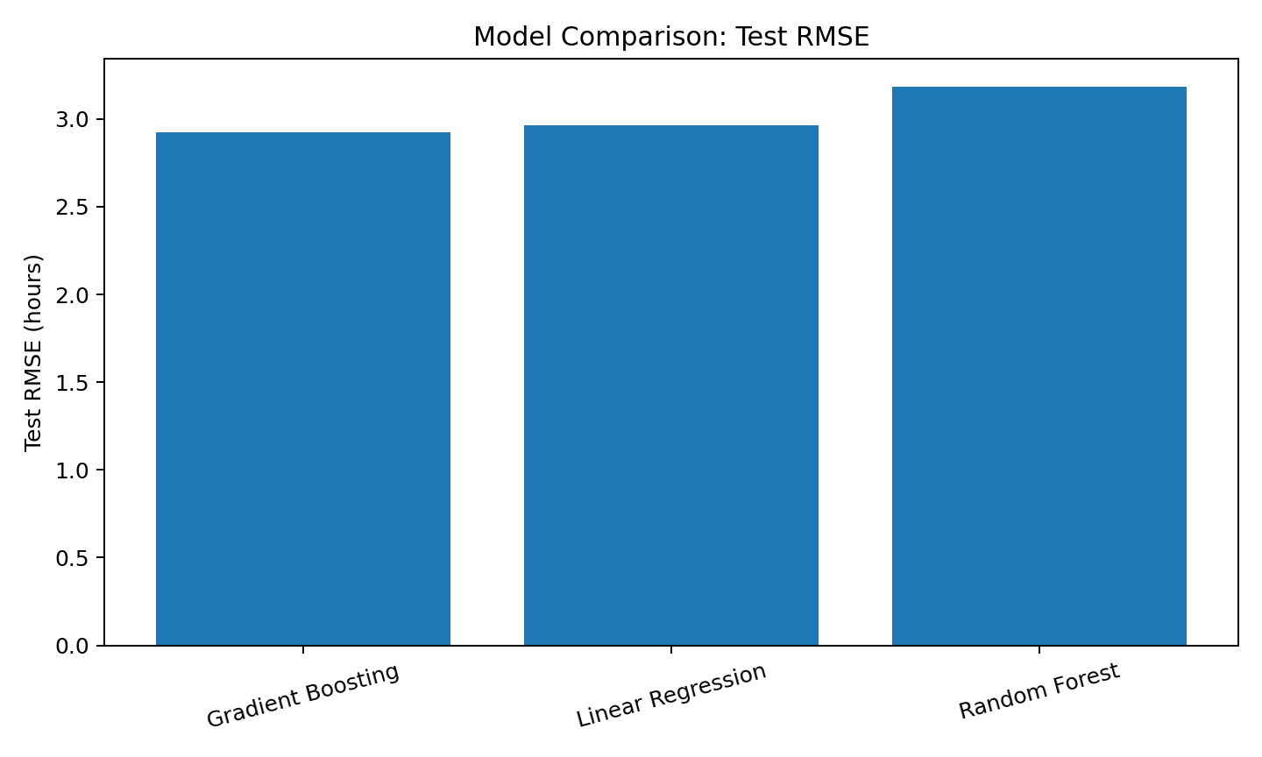

7. Cross-Validation and Hyperparameter Tuning
Five-fold shuffled cross-validation was used to assess whether the ranking of models was stable across different data partitions. The same preprocessing and estimator were evaluated together in a pipeline.
Model | CV MAE (hours) | CV RMSE (hours) | CV R²
Gradient Boosting | 2.344 | 2.936 | 0.703
Linear Regression | 2.393 | 2.989 | 0.692
Random Forest | 2.571 | 3.216 | 0.643
Gradient boosting was then tuned using RandomizedSearchCV with three-fold cross-validation on the training set. The search varied the number of estimators, learning rate, tree depth, minimum leaf size, and subsampling rate. The final model was evaluated only once on the held-out test set to preserve an unbiased final estimate.
Best hyperparameters found:
- model__subsample: 0.8
- model__n_estimators: 250
- model__min_samples_leaf: 8
- model__max_depth: 2
- model__learning_rate: 0.1
Tuned MAE (hours) | Tuned RMSE (hours) | Tuned R²
2.297 | 2.882 | 0.708
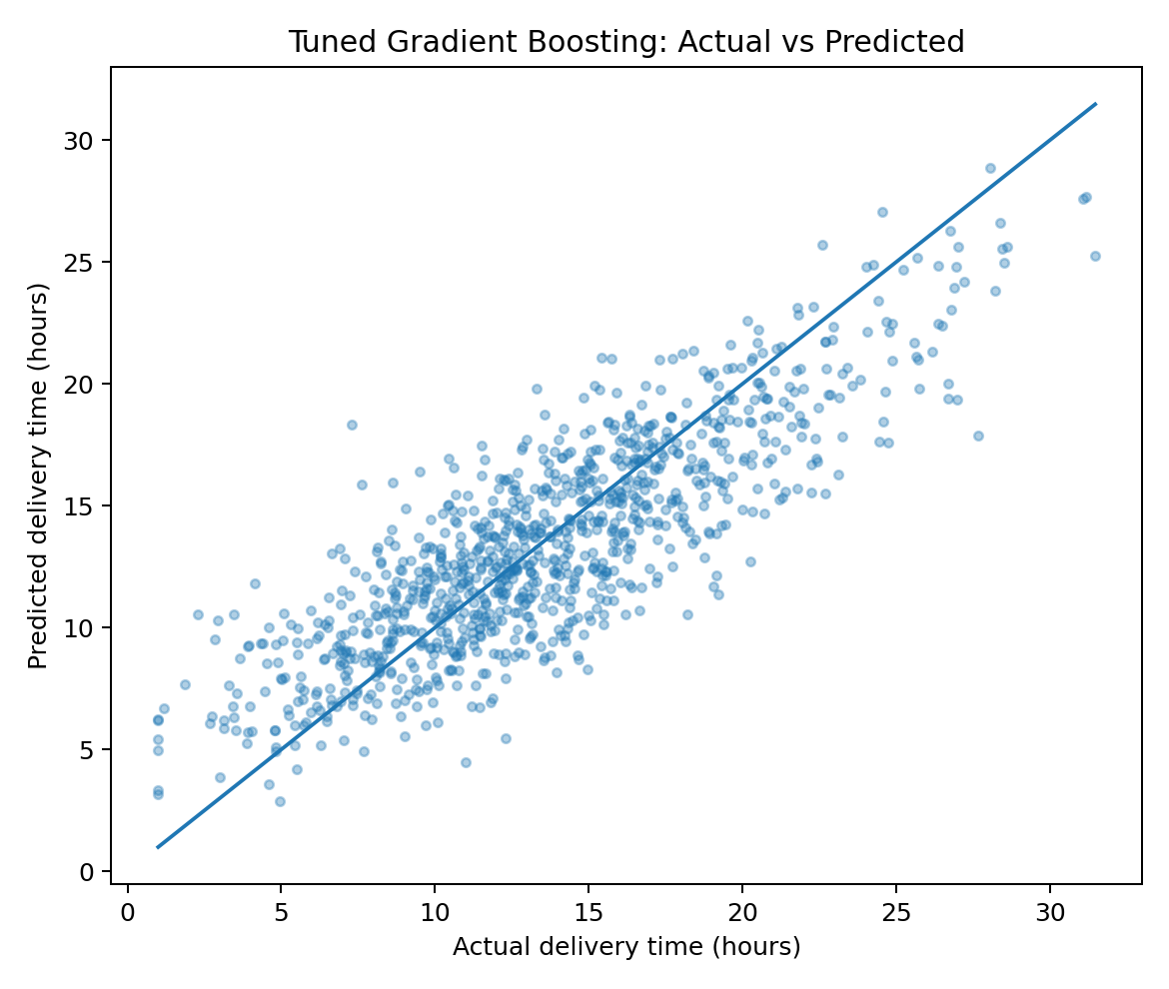

8. Python Implementation
The following excerpts demonstrate the core workflow. They are intentionally structured as reusable code rather than one-off calculations.
# Split data
X = df.drop(columns=["delivery_time_hours"])
y = df["delivery_time_hours"]
X_train, X_test, y_train, y_test = train_test_split(
X, y, test_size=0.20, random_state=42
)
# Preprocess numerical and categorical features
preprocess = ColumnTransformer([
("num", Pipeline([
("imputer", SimpleImputer(strategy="median")),
("scaler", StandardScaler())
]), numeric_features),
("cat", Pipeline([
("imputer", SimpleImputer(strategy="most_frequent")),
("onehot", OneHotEncoder(handle_unknown="ignore"))
]), categorical_features)
])
# Train a gradient boosting model
model = Pipeline([
("prep", preprocess),
("model", GradientBoostingRegressor(
n_estimators=250,
learning_rate=0.05,
max_depth=3,
random_state=42
))
])
model.fit(X_train, y_train)
pred = model.predict(X_test)
mae = mean_absolute_error(y_test, pred)
rmse = mean_squared_error(y_test, pred) ** 0.5
r2 = r2_score(y_test, pred)
# Five-fold cross-validation
cv = KFold(n_splits=5, shuffle=True, random_state=42)
scores = cross_validate(
model, X, y, cv=cv,
scoring={
"mae": "neg_mean_absolute_error",
"rmse": "neg_root_mean_squared_error",
"r2": "r2"
}
)
# Hyperparameter search
search = RandomizedSearchCV(
model,
param_distributions=param_dist,
n_iter=12,
scoring="neg_root_mean_squared_error",
cv=3,
random_state=42,
n_jobs=-1
)
search.fit(X_train, y_train)

9. Optimization Strategies
Prediction is useful only if it changes decisions. The forecast can be embedded in a decision-support layer that ranks shipments by predicted lateness risk and evaluates operational alternatives before dispatch.
Strategy | How the model supports it | Expected operational benefit
Dynamic dispatch timing | Avoid high-traffic periods when feasible; use predicted ETA to compare dispatch windows. | Lower travel delay and improve ETA reliability.
Warehouse workload balancing | Flag shipments likely to be delayed when warehouse congestion is high; rebalance workload or dock assignments. | Reduce pre-departure waiting time.
Stop consolidation | Use predicted delivery time to identify routes where one or more intermediate stops create excessive delay. | Reduce route duration and variability.
Carrier allocation | Route high-priority shipments toward carriers/lanes with stronger predicted performance. | Improve service-level attainment.
Exception management | Trigger human review for shipments whose predicted ETA exceeds a service threshold. | Focus operational attention where it has the highest value.
Capacity planning | Aggregate predicted shipment duration by hour/day to anticipate vehicle and staffing requirements. | Reduce overtime, idle capacity, and bottlenecks.

10. Optimization Scenario Analysis
A simple what-if analysis was performed on the test observations. The scenario changed three controllable conditions: (1) high traffic to medium traffic, (2) high warehouse congestion to medium, and (3) one fewer stop where the shipment had at least one stop. The trained model was then used to compare predicted delivery time before and after the changes.
Baseline predicted hours | Optimized predicted hours | Reduction (hours) | Reduction (%)
13.43 | 11.50 | 1.93 | 14.38
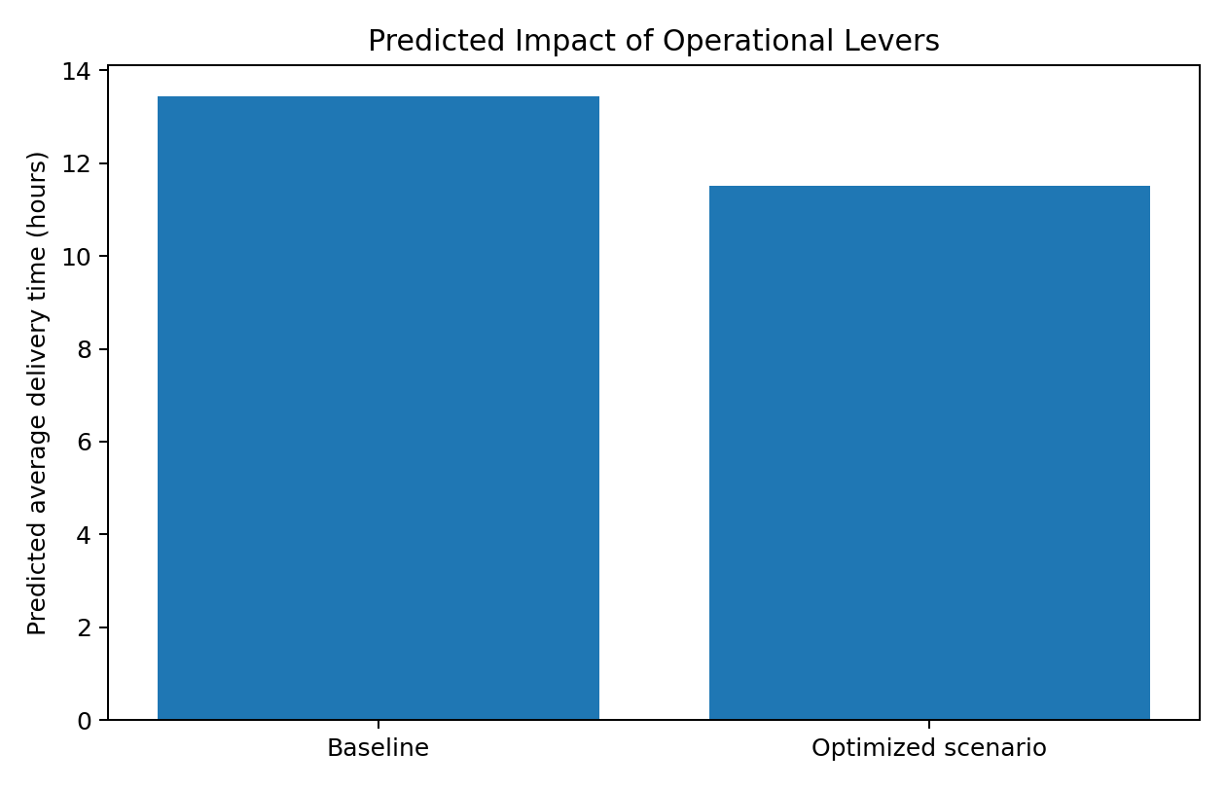
Important limitation: this is a scenario analysis, not a causal impact estimate. The model estimates what it predicts under altered inputs; actual operational changes may interact with capacity constraints, customer time windows, labor rules, and network effects.

11. Optimization Logic / Pseudocode
FOR each shipment scheduled for dispatch:
1. Generate baseline ETA using the predictive model.
2. Generate feasible alternatives:
- dispatch in an alternative time window
- assign another carrier
- consolidate/remove a feasible stop
- shift warehouse processing to another dock/team
3. Predict ETA for each alternative.
4. Calculate objective value:
cost + lateness_penalty + capacity_penalty
5. Reject alternatives violating service, capacity, or operational constraints.
6. Select the feasible alternative with the lowest objective value.
7. Recalculate ETA when material conditions change.
OBJECTIVE:
Minimize total logistics cost
+ penalty for late delivery
+ penalty for excess capacity usage
subject to vehicle, labor, service-level, and route constraints.

12. Actionable Recommendations
- Deploy the tuned gradient boosting model as an ETA service for dispatch and customer-facing systems, subject to monitoring.
- Use prediction thresholds to create an exception queue—for example, review shipments whose predicted ETA exceeds the promised service window.
- Prioritize data collection for traffic, actual warehouse queue time, route-level travel time, and timestamped delivery milestones because these can materially improve future models.
- Integrate the ETA model with a route/assignment optimizer rather than using predictions alone. The optimizer should account for vehicle capacity, driver hours, time windows, and service-level constraints.
- Run the scenario analysis as a controlled pilot before changing network policies. Compare predicted improvements with actual realized delivery time, cost, and customer-service metrics.
- Retrain the model periodically and monitor drift, especially after carrier changes, seasonal weather shifts, network redesigns, or major traffic-pattern changes.

13. Limitations and Risk Controls
- The dataset is simulated, so the numerical performance results do not represent a real logistics company's expected accuracy.
- The simulation encodes relationships by design; a real dataset may contain weaker, stronger, or different relationships.
- External variables such as road closures, vehicle breakdowns, driver availability, customer absence, and real-time GPS conditions are not included.
- Random train/test splitting is appropriate for this simulated independent-record example, but time-based splitting would be preferable for a production forecasting system with temporal drift.
- Model predictions should support—not automatically replace—operational decisions where safety, contractual constraints, or customer commitments are involved.

14. Conclusion
The project demonstrates an end-to-end predictive analytics workflow for logistics: define a measurable forecasting target, simulate and structure operational data, compare candidate models, validate performance, tune a promising ensemble, and translate predictions into operational decisions. Gradient boosting provides a strong balance of predictive capability and flexibility for this tabular logistics problem. The most important next step in a real implementation would be to replace the simulated records with historical shipment data and connect the predictive layer to a constrained optimization engine.

Appendix A. Reproducibility Notes
Software stack used for this report: Python, NumPy, pandas, scikit-learn, Matplotlib, and python-docx. Random seed = 42. Dataset size = 5,000. Train/test split = 80/20. Cross-validation = 5-fold for model comparison and 3-fold randomized search for gradient-boosting hyperparameters.

Appendix B. Core Dataset Preview
distance_km | traffic | weather | weight_kg | stops | dispatch_hour | warehouse_congestion | priority | carrier | delivery_time_hours
81.01 | Low | Clear | 11.36 | 3 | 5 | Low | Standard | Carrier_B | 12.19
108.19 | Low | Clear | 21.68 | 2 | 21 | High | Express | Carrier_A | 8.36
71.64 | High | Storm | 34.00 | 0 | 4 | Medium | Standard | Carrier_B | 24.70
64.53 | High | Clear | 15.49 | 0 | 10 | Medium | Standard | Carrier_A | 17.17
117.05 | Medium | Rain | 13.36 | 5 | 19 | Low | Standard | Carrier_C | 15.86
68.54 | Low | Clear | 16.14 | 2 | 21 | High | Express | Carrier_A | 8.57
90.34 | Medium | Rain | 13.51 | 3 | 10 | High | Standard | Carrier_A | 10.94
84.60 | High | Clear | 10.31 | 3 | 8 | Medium | Standard | Carrier_A | 12.71
116.99 | High | Rain | 9.79 | 4 | 11 | Low | Standard | Carrier_B | 21.68
56.89 | Medium | Clear | 5.13 | 8 | 14 | Low | Standard | Carrier_A | 16.33
End of report. All performance figures are based on the simulated dataset generated within this document's analysis workflow.

