Here we will see how my Sentiment Analysis model works

1. I AM REALLY ANNOYED BY YOUR CONSTANT COMPLAINING AND YOU NEVER OFFER ANY SOLUTIONS WHICH IS VERY UNHELPFUL AND NEGATIVE

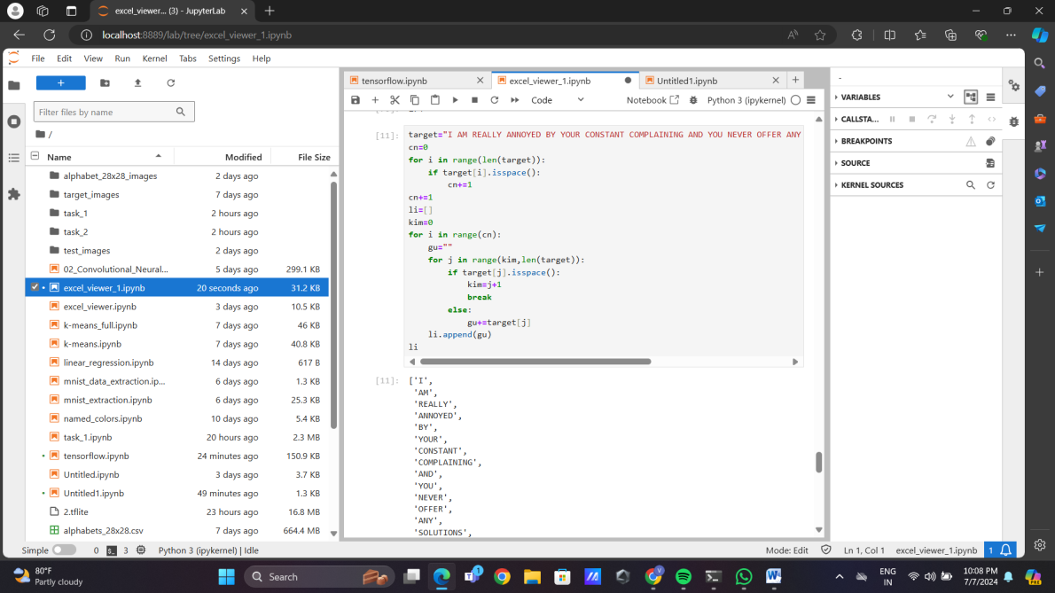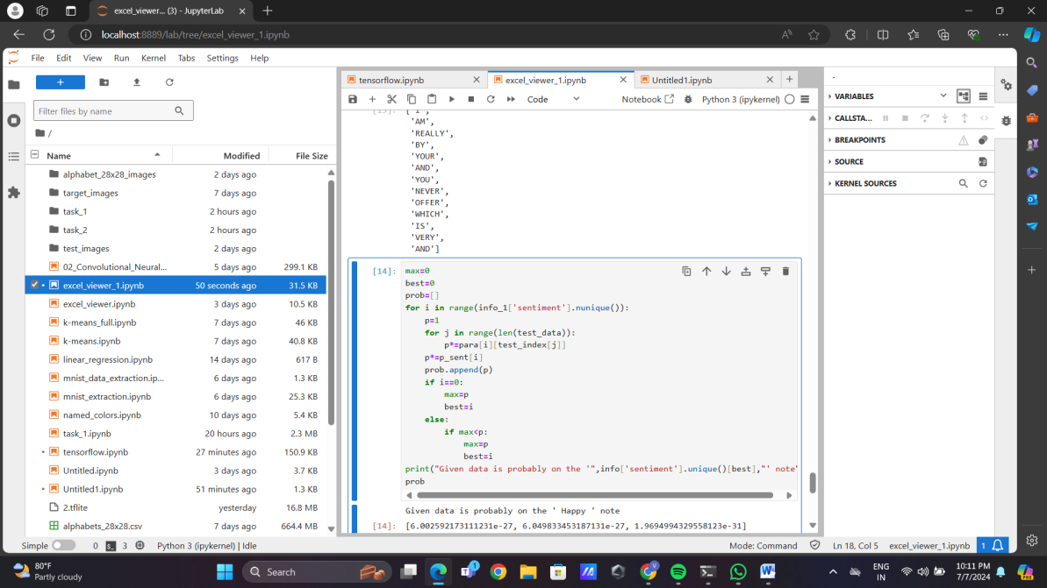

* My model predicts this as ‘Happy’ note, but actually this sentence is on ‘Angry’ note
* In first image we can see words like ANNOYED, COMPLAINING; but in second image they are not present. This indicates that these words are not part of training data. So these words are not taken into sentiment analysis. Therefore neglecting highly impactful words has led to a wrong outcome

1. IT IS FRUSTRATING THAT YOU NEVER PAY ATTENTION DURING DISCUSSIONS AND YOUR LACK OF FOCUS IS REALLY AFFECTING OUR PROGRESS

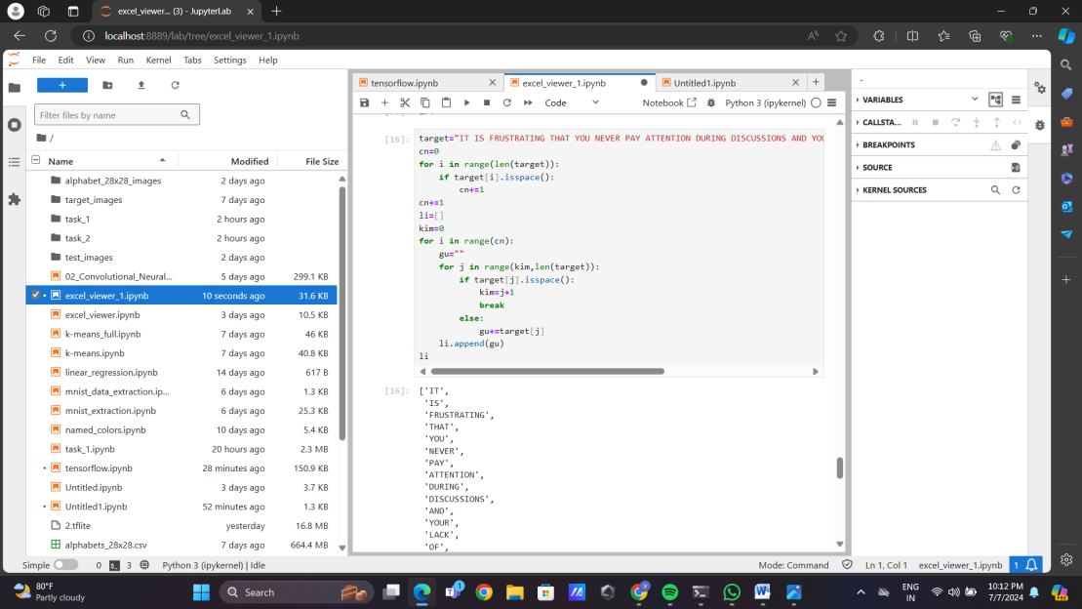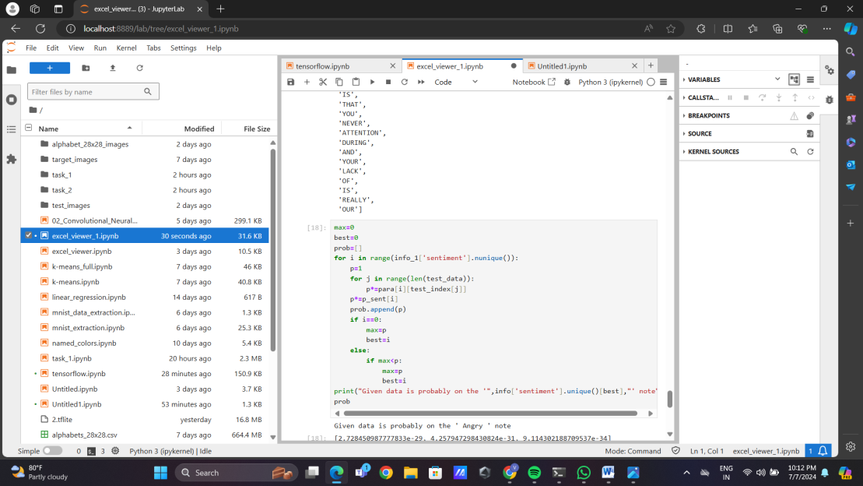

* My model predicts this as ‘Angry’ note, but actually this sentence is on ‘Angry’ note

1. I AM DELIGHTED BY YOUR FRIENDLINESS AND YOU ALWAYS MAKE EVERYONE FEEL WELCOME WHICH FOSTERS A SENSE OF COMMUNITY

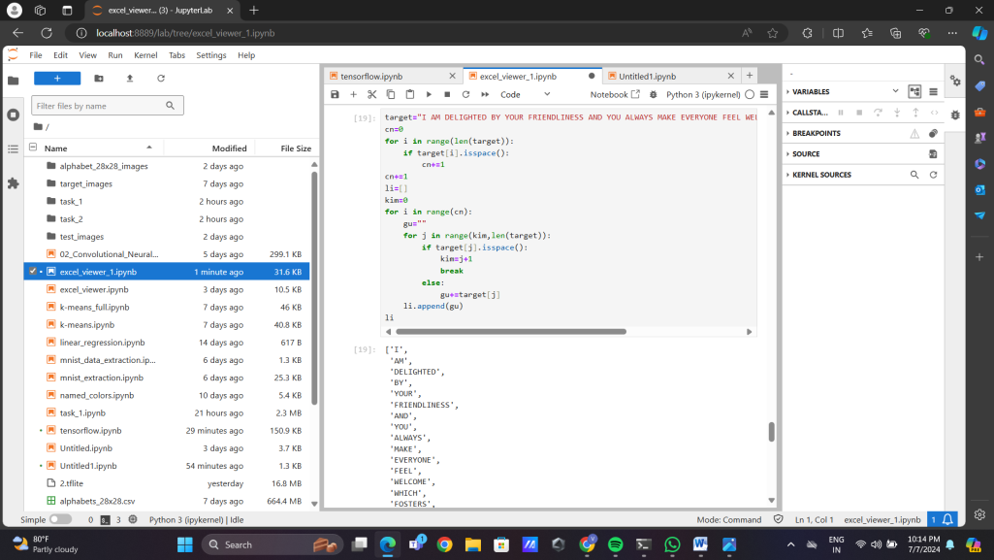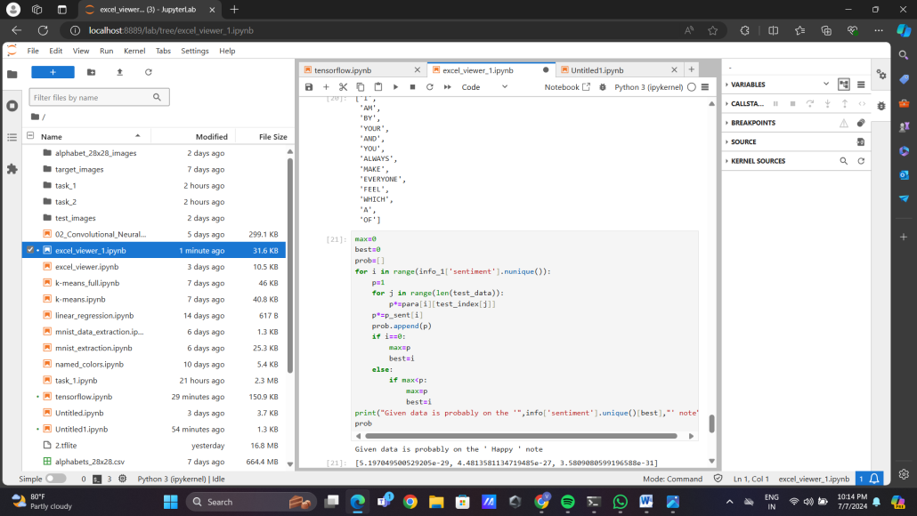

* My model predicts this as ‘Happy’ note, but actually this sentence is on ‘Happy’ note

1. IT IS WONDERFUL THAT YOU ALWAYS SHOW KINDNESS AND YOUR EMPATHY TOWARDS OTHERS IS TRULY HEARTWARMING AND APPRECIATED

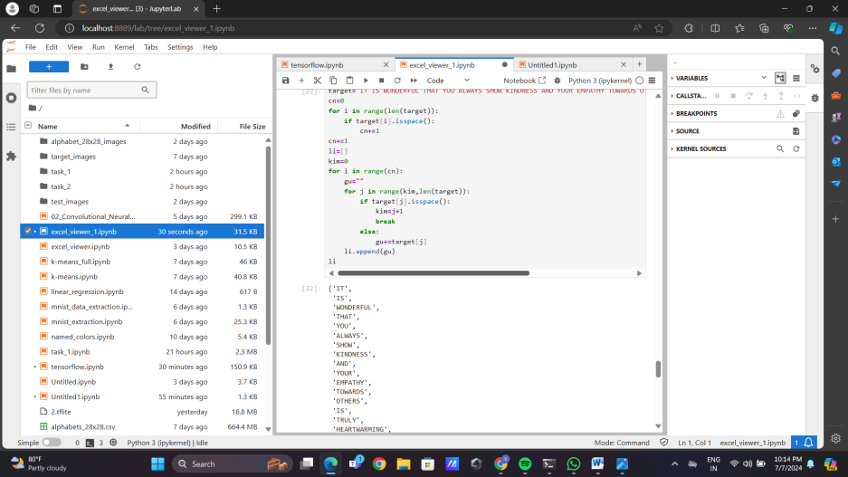

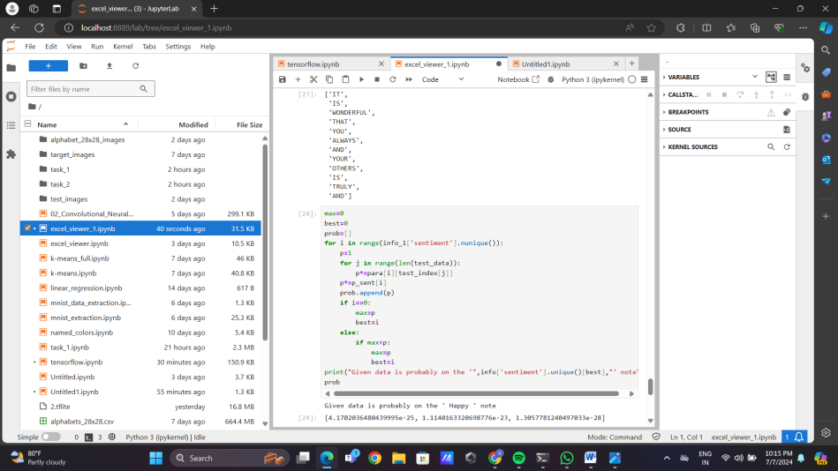

* My model predicts this as ‘Happy’ note, but actually this sentence is on ‘Happy’ note

1. YOUR ANALYSIS OF THE DATA WAS ACCURATE AND WELL PRESENTED PROVIDING A CLEAR UNDERSTANDING OF THE TRENDS AND PATTERNS

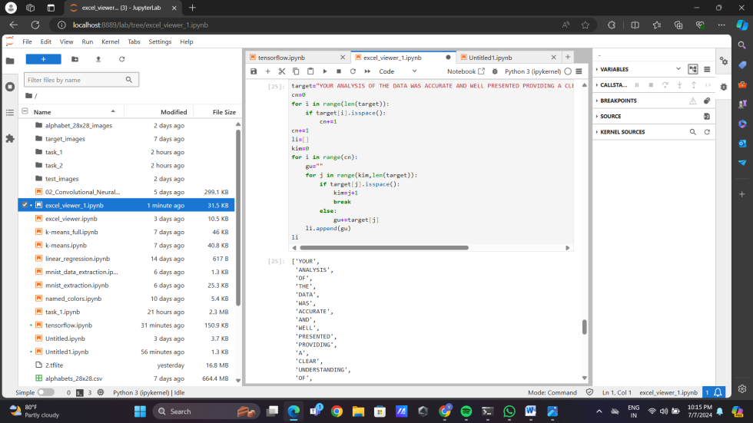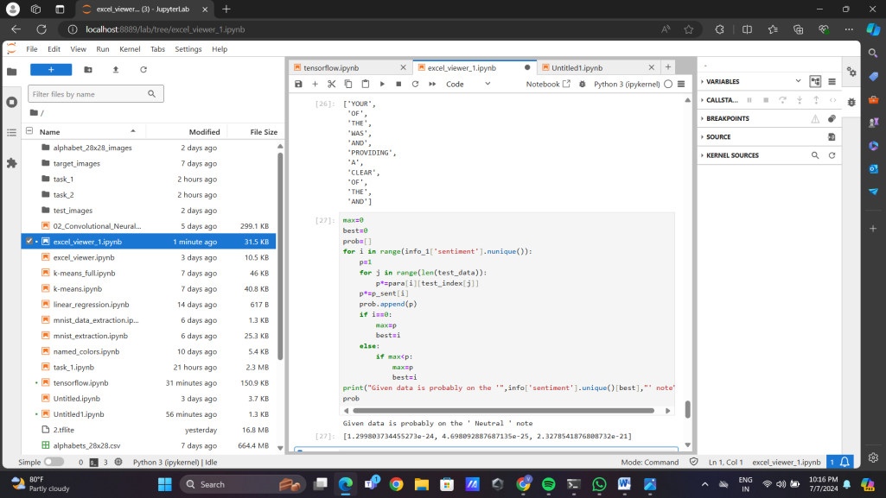

* My model predicts this as ‘Neutral’ note, but actually this sentence is on ‘Neutral’ note

1. THE MEETING MINUTES YOU PREPARED WERE DETAILED AND WELL ORGANIZED ACCURATELY REFLECTING THE DISCUSSIONS AND DECISIONS MADE

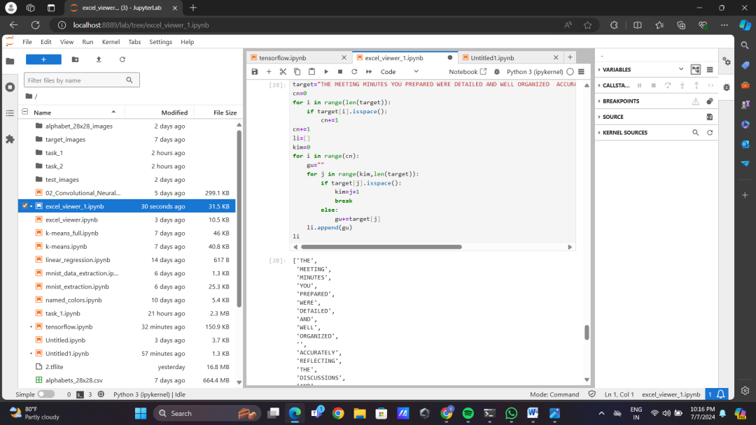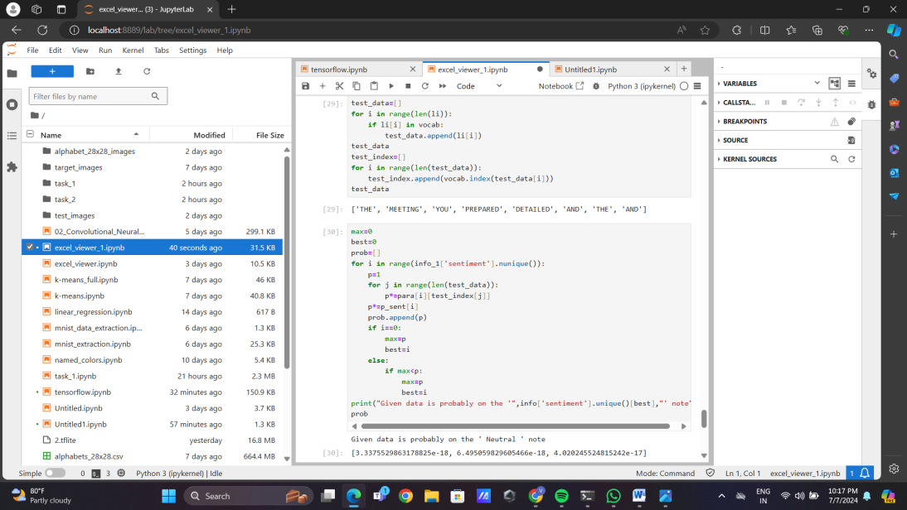

* My model predicts this as ‘Neutral’ note, but actually this sentence is on ‘Neutral’ note

From here we can see that my model has predicted 5 out of 6 sentiments correctly. So the issue in actual code is due to cv part. So I want to conclude that sentiment analysis part is working good. I feel my initial model for cv was too basic for this task hence I have attached ipynb file containing second model which I have been working on. Since its incomplete I am attaching it separately

I have taken inspiration for my second cv model from VGGNET-19. I have gone through its architecture and I have created my own version of it.

Reference link: <https://medium.com/@siddheshb008/vgg-net-architecture-explained-71179310050f>

From this I understood the architecture, then I saw the architecture of VGGNET-19 and tried to implement it

VGGNET-19 Reference link: <https://www.researchgate.net/figure/Fine-tuned-VGG19-CNN-architecture_fig2_338586804>

For the training set and validation set, I have converted the data from ‘alphabets_28x28.csv’ into images. Code for this is commented in second cell

Also I have tested my model with custom dataset which could be seen in cell 8(commented)