0.(Security Audit Checklist)

Please find below the information required for initiating the security audit process post the completion of the integration. Kindly share the required information/screenshot to collectnow-integrations@razorpay.com

1-Screen shot transaction flow: The complete transaction flow screenshots need to be captured. Right from the selection of the product/service, till the time the payment is success/failure.

Student insert the Application ID / Enrollment Number in the Box Above and Click on Validate Button. If Application ID / Enrollment Number matched with academy Records then related Details has been auto populate in the grid and the form will be disabled for Further modification.
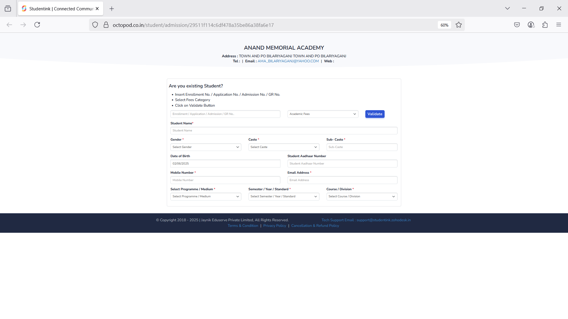

If Details not matched with the Existing Student details, then form will be available for users to enter the details and submit the form.

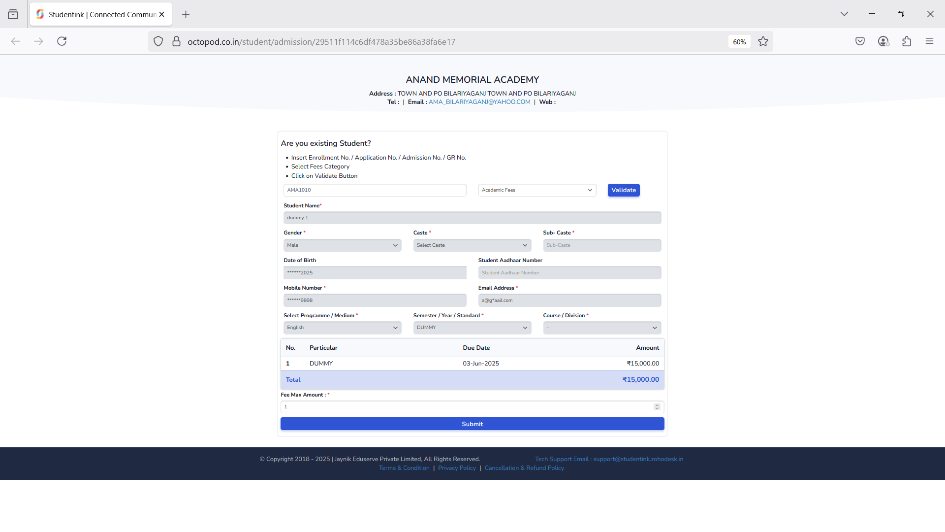

Once User enter fees and click on Submit Button then Related information saved in Student details and User can now able to do the Payment.
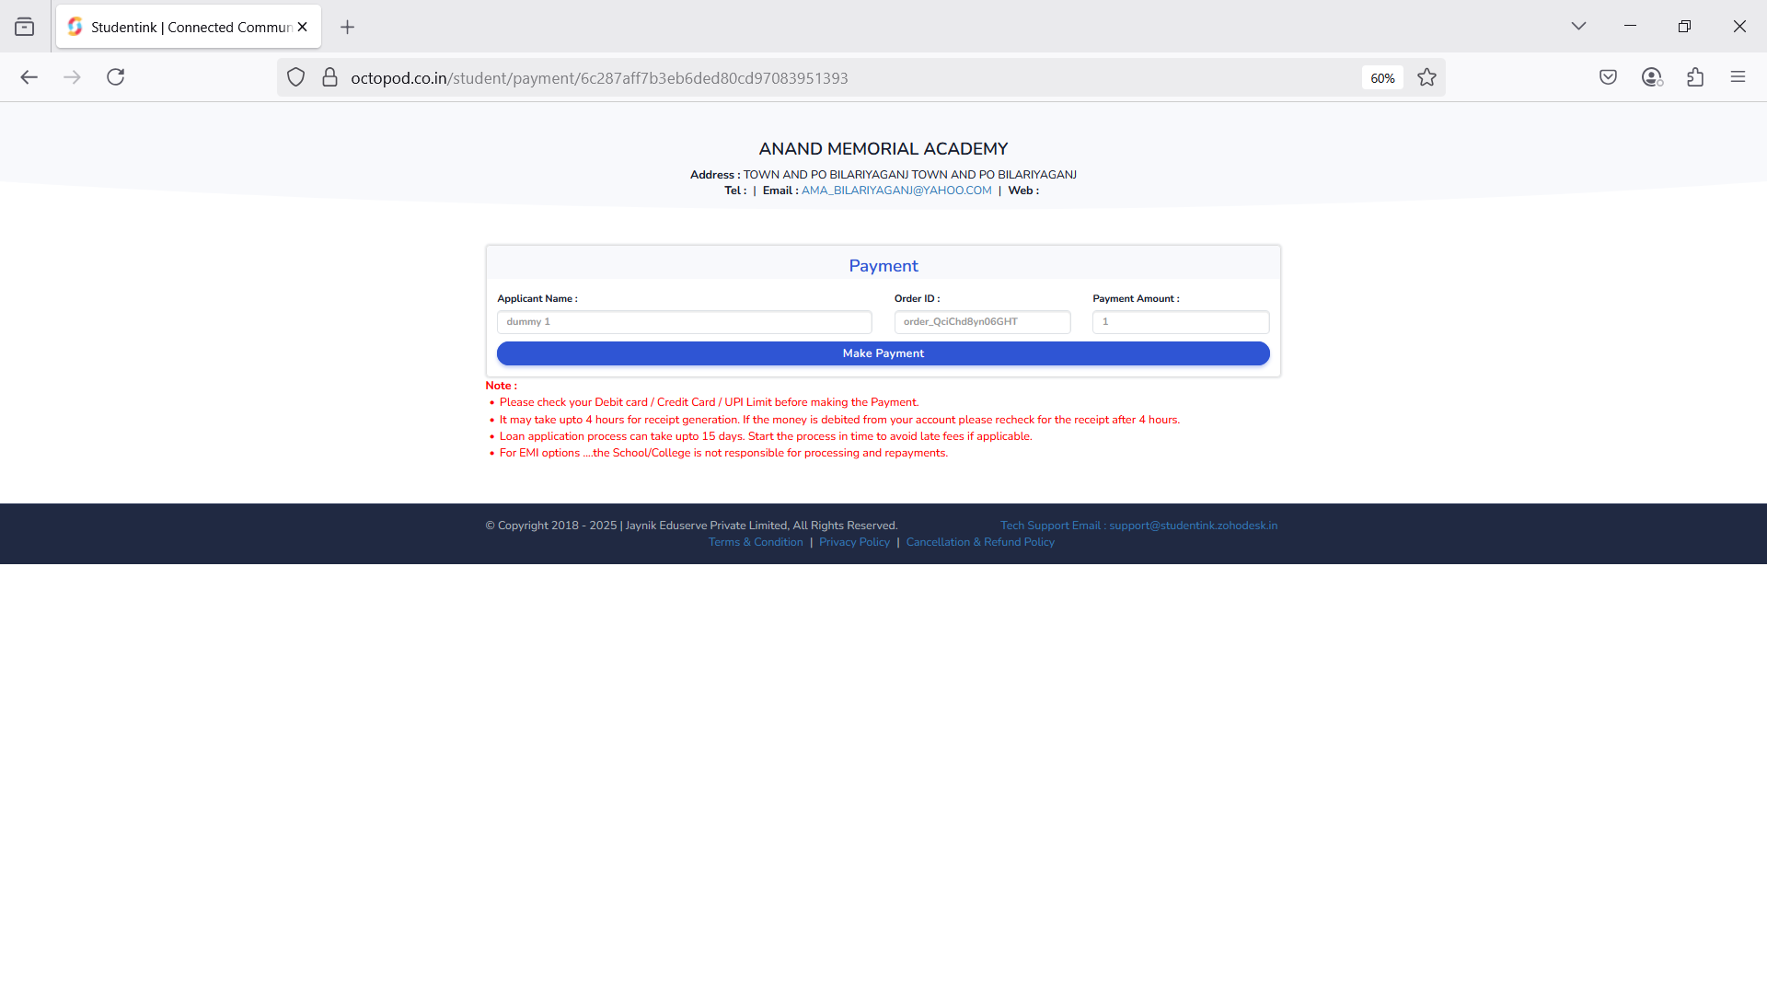

When User click on Make Payment Button Payment Gateway screen Visible.

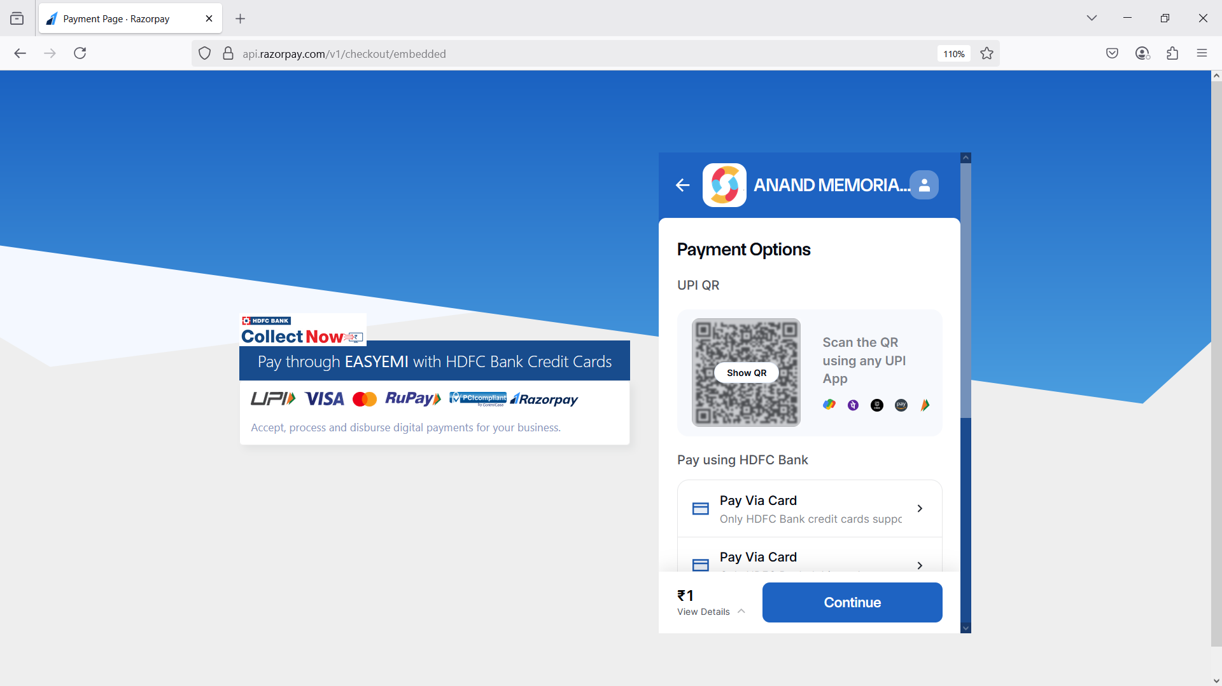

User selects the Payment Method as per the convenience and enters the Payment details. (Click on card Payment )

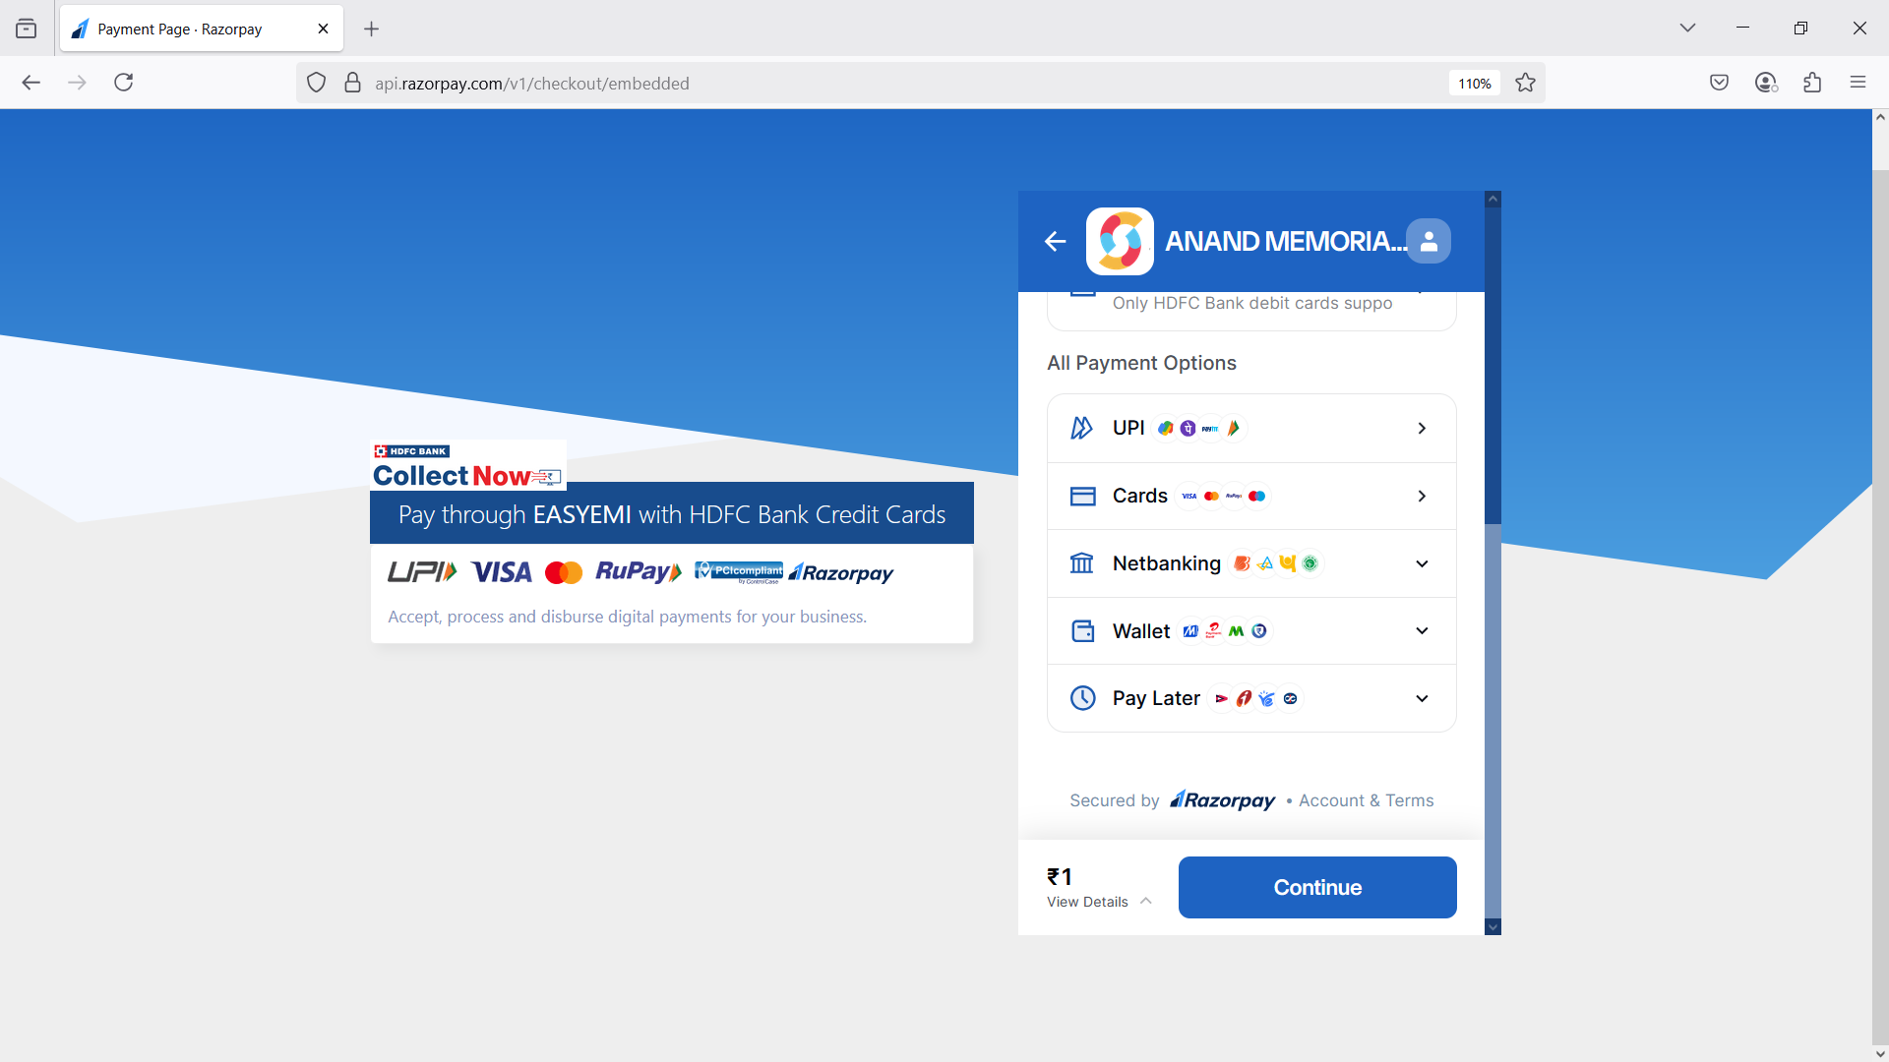

Enter Dummy card details.

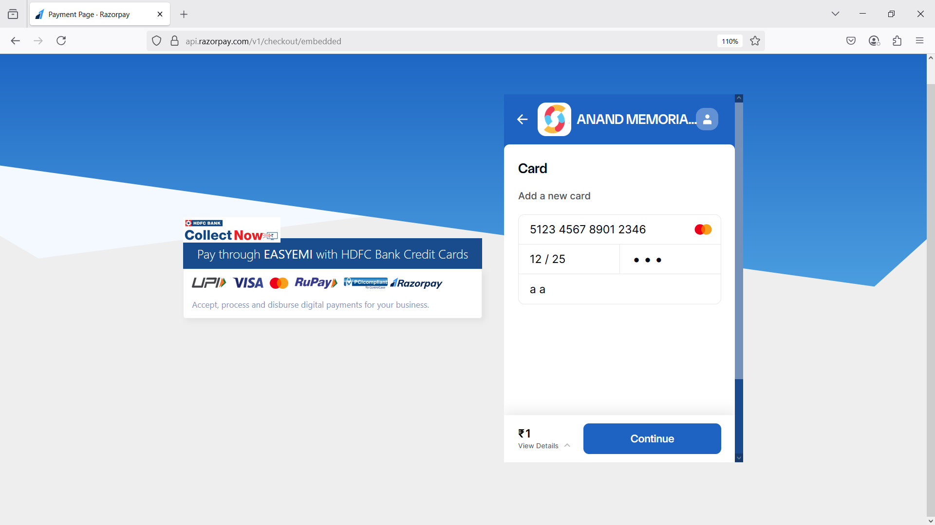

After Entering the Payment Details user click on Confirm Payment Button that will redirect to payment gateway.
You have to select payment status for only test mode.

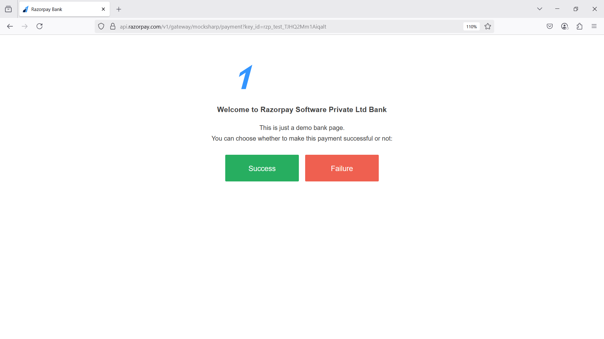

If the Payment Success then redirect on Receipt Page

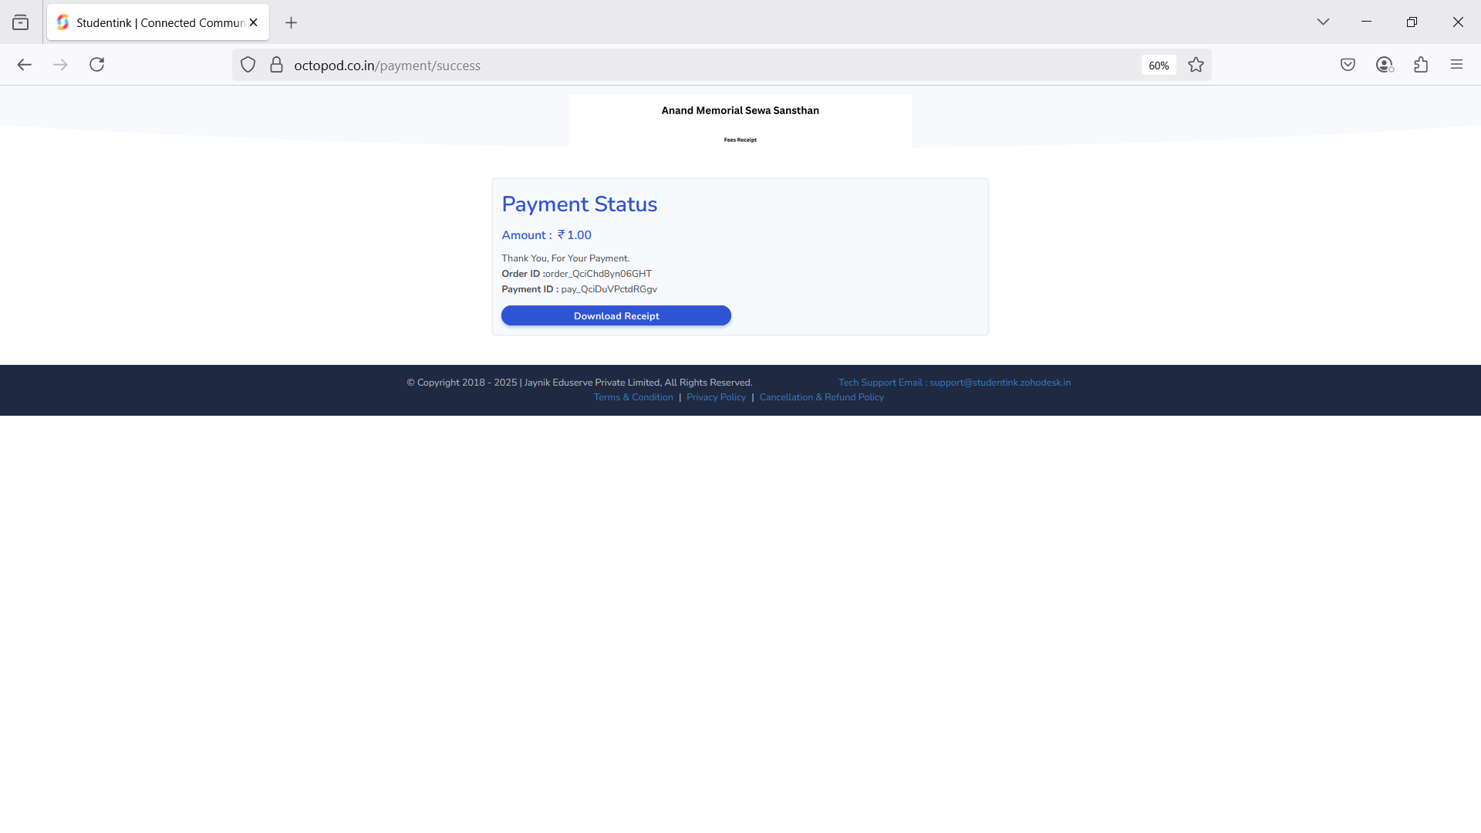

From the Success page they can tract Order ID, Payment ID, Pay Amount and Payment Status with Download Receipt option.

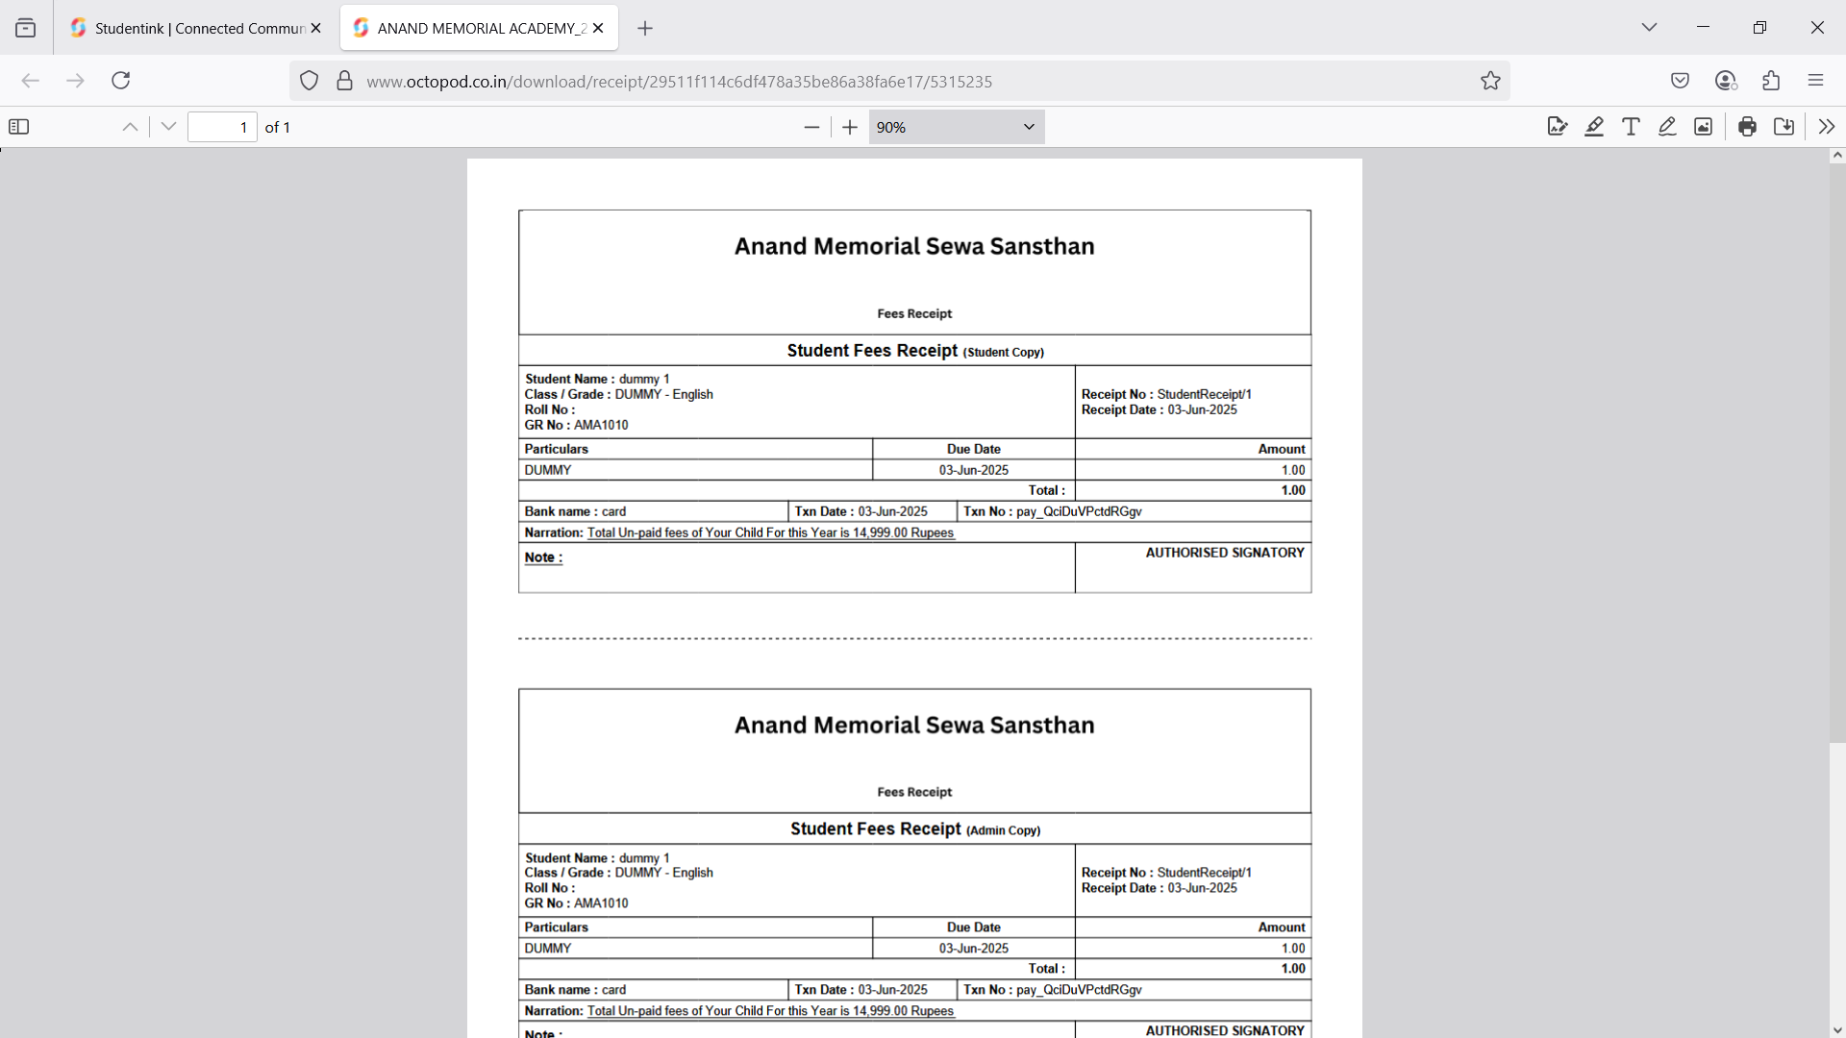

3. Status API implementation (in WEB integration)

- Confirmation from merchant / Developer for storing proper response in their data base.

Request response
[
"id" => "pay_QciDuVPctdRGgv"
"entity" => "payment"
"amount" => 100
"currency" => "INR"
"status" => "captured"
"order_id" => "order_QciChd8yn06GHT"
"invoice_id" => null
"international" => false
"method" => "card"
"amount_refunded" => 0
"refund_status" => null
"captured" => true
"description" => "FeesPayment"
"card_id" => "card_QciDuti7C90Zmn"
"card" => Razorpay\Api\Payment {#4164
#attributes: array:11 [
"id" => "card_QciDuti7C90Zmn"
"entity" => "card"
"name" => ""
"last4" => "2346"
"network" => "MasterCard"
"type" => "credit"
"issuer" => null
"international" => false
"emi" => false
"sub_type" => "consumer"
"token_iin" => null
]
}
"bank" => null
"wallet" => null
"vpa" => null
"email" => "a@gmail.com"
"contact" => "+919898989898"
"notes" => Razorpay\Api\Payment {#4151
#attributes: array:9 [
"AcademyID" => "3100"
"StudentID" => "1660477"
"VoucherID" => "5315111"
"merchant_param1" => "Academic"
"merchant_param2" => "dummy 1 "
"merchant_param3" => "DUMMY - English"
"merchant_param4" => "3100"
"merchant_param5" => "AMA1010"
"shipping address" => "NA"
]
}
"fee" => 0
"tax" => 0
"error_code" => null
"error_description" => null
"error_source" => null
"error_step" => null
"error_reason" => null
"acquirer_data" => Razorpay\Api\Payment {#4161
#attributes: array:1 [
"auth_code" => "729962"
]

3-Kindly refer below points before initiating the Security Audit Process, request your confirmation on the same.

1) Maintain database to store the transaction details/ status (YES)
2) Services/ payment confirmation to customer/ user will be provided on basis of Database Status (YES)
3) We perform 7-8 transactions in the Security Audit process. Kindly prepare the amount/ options/ links/ records for the same (YES)
4) Login credentials should be available till audit completion (YES)
5) Do not clear database records till audit completion (YES)
6) Provided UAT setup should be identical as per the production setup (YES)
7) Implementation of dual inquiry, i.e. "Status API" in response (Mandatory) (YES)
8) Implement the below Audit Checklist for integration process as well as Security Audit process

4-Audit Checklist
Note: All fields are mandatory kindly fill the below table and share the same. Also note that your below mentioned URL (home/login page) and Response URL should match with shared Screenshots URL.

MERCHANT NAME | Anand Memorial Sewa Sansthan
TID / ACCOUNT ID | QcdXsVn116HQ9U
URL : | https://octopod.co.in/student/admission/29511f114c6df478a35be86a38fa6e17
TRANSACTION URL is publicly accessible | (Yes)
LOGIN ID : (if any) | Enrollment No. / Application No. / Admission No. / GR No. – AMA1010
LOGIN PWD : (if any) | NA
RESPONSE URL : | https://octopod.co.in/payment/success
DEVELOPER CONTACT NO : | 7016125562
DEVELOPER EMAIL ID : | jitendra@student.ink
TYPE: | VAS
Programming Language | PHP Laravel
Seamless/Non-Seamless Integration | Non-Seamless Integration
Plugin Name and version (If Any) | NA
Transaction Flow verified: | Yes
Multiple Amount Values (If Applicable): | Yes
Transactions response is being stored in the database (including Failed) | (Yes)

