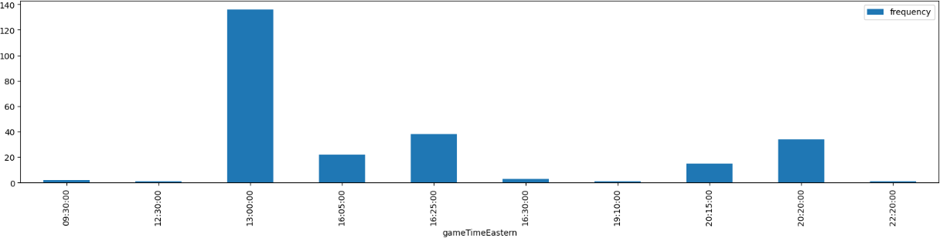

* **Description**: Gameday and frequency are plotted.
* **Purpose**: The main purpose is to get which day had most number of games.

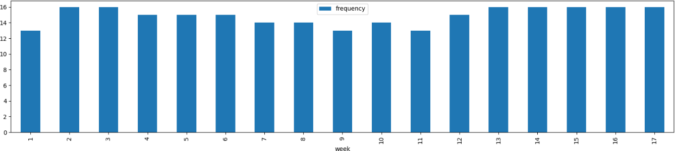

* **Description**: Shows the ages of the players.
* **Purpose**: To find out the age difference between the players.

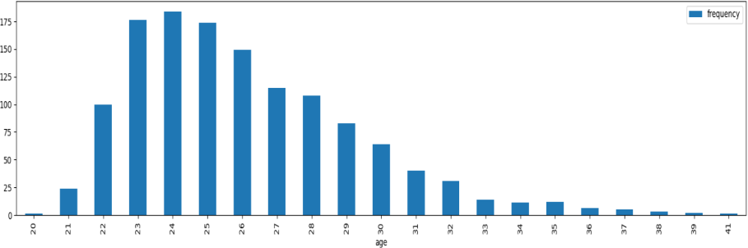

* **Description**: To find the position of the players.
* **Purpose**: To plot player number and their position.

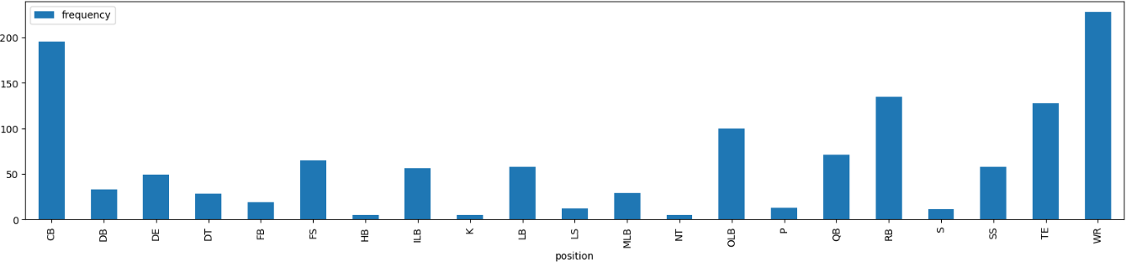

* **Description**: Displays the CB age of the players.

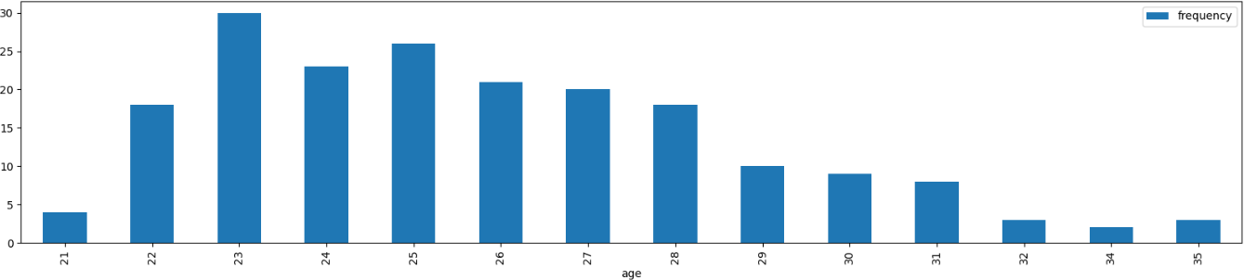

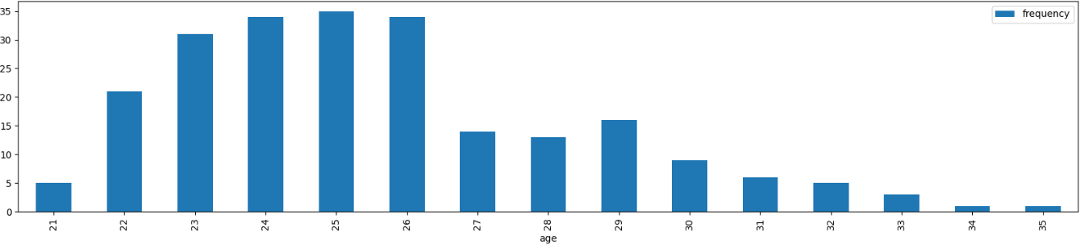

**Description**: Displays the WR age of the players.

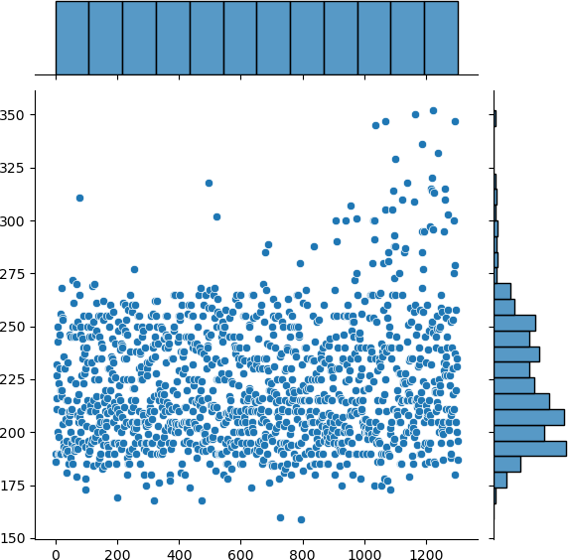

**Description**: weight of the players.

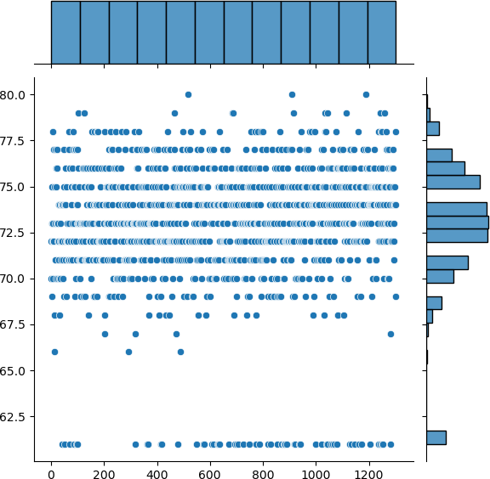

* **Description**: Height of the players,

**Football field creation**

