Deployed in Streamlit share saving the **openai key in streamlit secrets.**

App url after streamlit deployment:

<https://multilingual-storytelling-with-accentsgit-nazjcrogc5hlvcruj6kf.streamlit.app/>

**Github Source code:**

[**https://github.com/vishnupriya0512/Multilingual-Storytelling-with-Accents/tree/main**](https://github.com/vishnupriya0512/Multilingual-Storytelling-with-Accents/tree/main)

ScreenShot from streamlit share deployment.

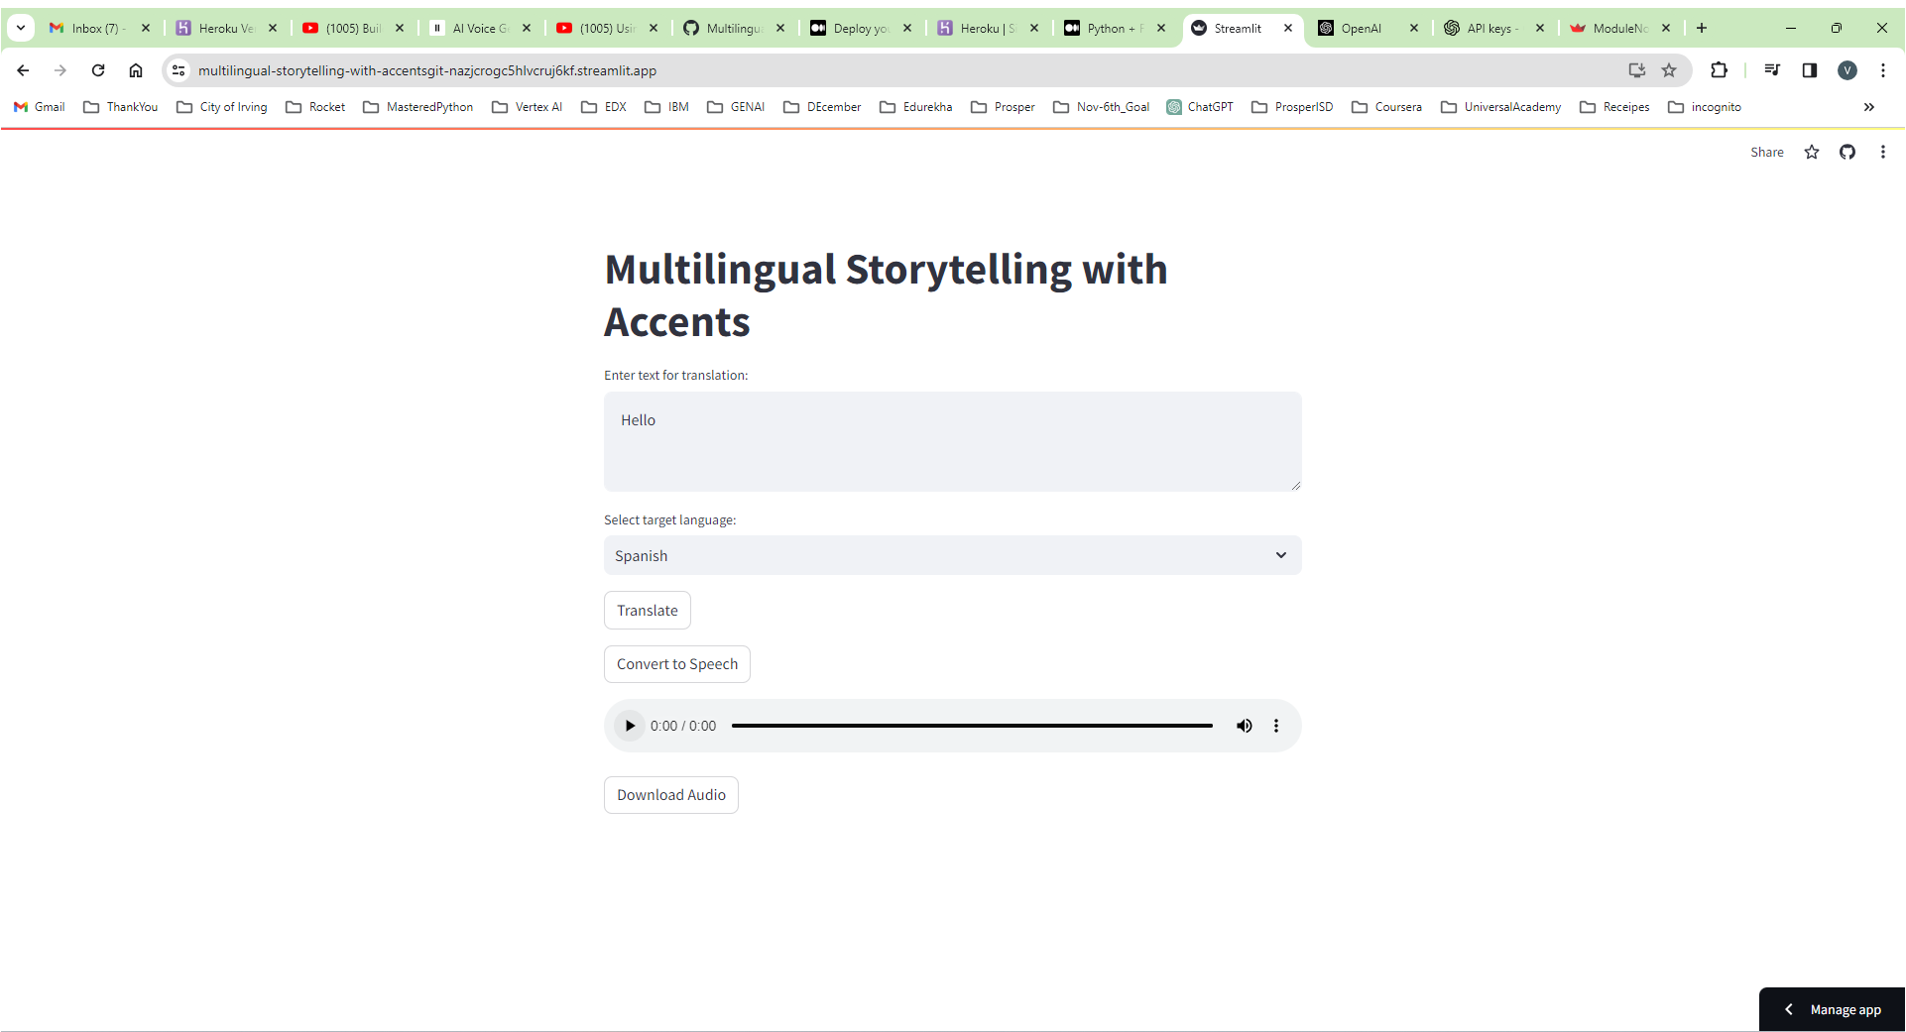

Screenshots from running the app in the local environment.

