**URLS**

**DESIGNATIONS URL**

**METHOD POST**

URL : <https://webapplication220190614075323.azurewebsites.net/Designation/Designation>

**METHOD GET**

URL : <https://webapplication220190614075323.azurewebsites.net/Designation/Designation>

**METHOD DELETE WITH DESIGNATION ID**

URL : <https://webapplication220190614075323.azurewebsites.net/Designation/DeleteDesignation/3>

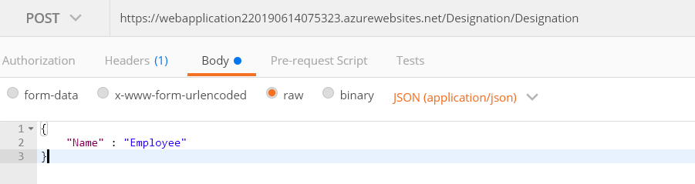

**MERCHANT URLS**

When we enter merchant details that data will go into both tables employee and merchant accordingly . So, after registration he can login with his details.

**METHOD POST**

URL : <https://webapplication220190614075323.azurewebsites.net/Merchant/Merchant>

**METHOD GET**

URL : <https://webapplication220190614075323.azurewebsites.net/Merchant/Merchant>

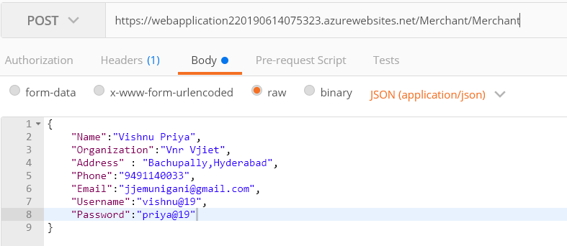

**EMPLOYEE URLS**

For all Employee apis we are passing merchant ids for identifying employees of only that merchant.

**METHOD TO GET ALL EMPLOYEES WITH MERCHANT ID**

URL : <https://webapplication220190614075323.azurewebsites.net/Employee/AllEmployee/1>

**METHOD TO GET PARTICULAR EMPLOYEE WITH MERCHANT ID AND EMPLOYEE ID**

URL **:** <https://webapplication220190614075323.azurewebsites.net/Employee/Employee/1/1>

**METHOD POST WITH MERCHANT ID**

URL **:** <https://webapplication220190614075323.azurewebsites.net/Employee/AddEmployee/1>

**METHOD DELETE WITH MERCHANT ID AND EMPLOYEE ID**

URL : <https://webapplication220190614075323.azurewebsites.net/Employee/DeleteEmployee/1/2>

**METHOD POST WITH MERCHANT ID AND USERNAME,PASSWORD IN BODY FOR VALIDATION**

URL : <https://webapplication220190614075323.azurewebsites.net/Employee/ValidateLogin/1>

