**CATEGORY URLS**

**METHOD TO GET ALL CATEGORIES OF MERCHANT**

URL: <https://webapplication220190616025624.azurewebsites.net/Category/AllCategory/1>

**METHOD GET WITH MERCHANT ID AND CATEGORY ID**

URL: <https://webapplication220190616025624.azurewebsites.net/Category/Category/1/1>

**METHOD POST WITH MERCHANT ID**

URL: <https://webapplication220190616025624.azurewebsites.net/Category/AddCategory/1>

**METHOD DELETE WITH MERCHANT ID AND CATEGORY ID**

URL: <https://webapplication220190616025624.azurewebsites.net/Category/DeleteCategory/1/1>

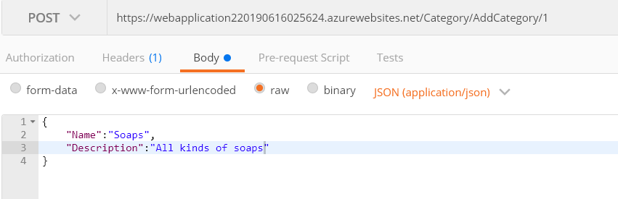

**PRODUCT URLS**

**METHOD TO GET ALL PRODUCTS OF MERCHANT**

URL: <https://webapplication220190616025624.azurewebsites.net/Product/AllProduct/1>

**METHOD GET WITH MERCHANT ID AND PRODUCT ID**

URL: <https://webapplication220190616025624.azurewebsites.net/Product/Product/1/1>

**METHOD POST WITH MERCHANT ID**

URL: <https://webapplication220190616025624.azurewebsites.net/Product/AddProduct/1>

**METHOD DELETE WITH MERCHANT ID AND PRODUCT ID**

URL: <https://webapplication220190616025624.azurewebsites.net/Product/DeleteProduct/1/1>

**METHOD TO GET ALL PRODUCTS OF CATEGORY WITH MERCHANT ID & CATEGORY ID**

URL: <https://webapplication220190616025624.azurewebsites.net/Product/GetAllProductsOfCategory/1/1>

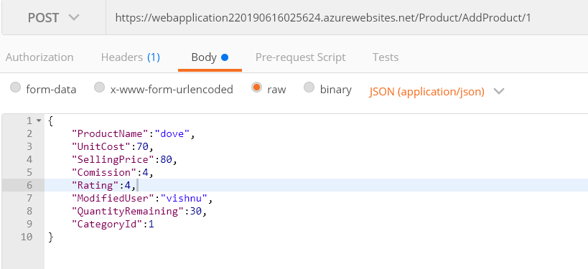

**CUSTOMER URLS**

**METHOD TO GET ALL CUSTOMERS OF MERCHANT**

URL: <https://webapplication220190616025624.azurewebsites.net/Customer/AllCustomer/1>

**METHOD GET WITH MERCHANT ID AND CUSTOMER ID**

URL: <https://webapplication220190616025624.azurewebsites.net/Customer/Customer/1/1>

**METHOD POST WITH MERCHANT ID**

URL: <https://webapplication220190616025624.azurewebsites.net/Customer/AddCustomer/1>

**METHOD DELETE WITH MERCHANT ID AND CUSTOMER ID**

URL: <https://webapplication220190616025624.azurewebsites.net/Customer/DeleteCustomer/1/1>

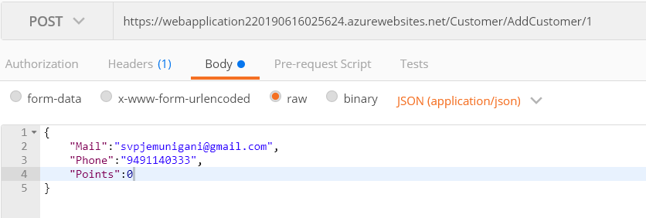

**TICKETING URLS**

**METHOD POST WITH MERCHANT ID, EMPLOYEE ID & CUSTOMER ID**

URL: <https://webapplication220190616025624.azurewebsites.net/Ticket/Ticket/1/1/1>

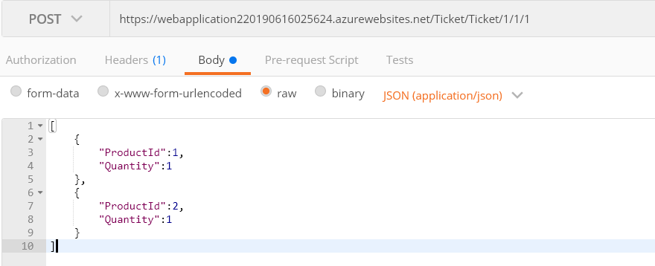

**METHOD GET TO GET ALL TICKETING DETAILS WITH MERCHANT ID**

URL: <https://webapplication220190616025624.azurewebsites.net/Ticket/AllTicket/1>

**METHOD GET TO GET ALL LINE PRODUCT DETAILS WITH MERCHANT ID**

URL: <https://webapplication220190616025624.azurewebsites.net/Ticket/AllTicketLine/1>

**METHOD DELETE TO DELETE ALL TICKETING & LINE PRODUCT DETAILS WITH MERCHANT ID & TICKET ID**

URL: <https://webapplication220190616025624.azurewebsites.net/Ticket/DeleteTicket/1/1>