**CUSTOMER URLS**

**METHOD TO GET ALL CUSTOMERS OF MERCHANT**

URL: <https://webapplication220190616025624.azurewebsites.net/Customer/AllCustomer/1>

**METHOD GET WITH MERCHANT ID AND CUSTOMER ID**

URL: <https://webapplication220190616025624.azurewebsites.net/Customer/Customer/1/1>

**METHOD POST WITH MERCHANT ID**

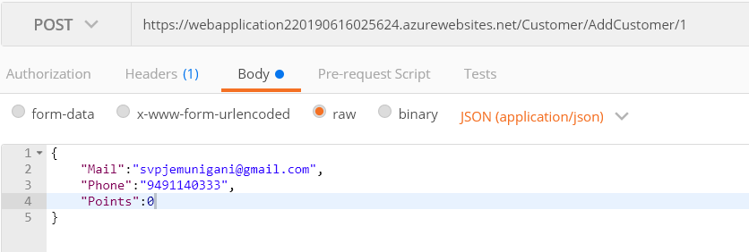

URL: <https://webapplication220190616025624.azurewebsites.net/Customer/AddCustomer/1>

**METHOD DELETE WITH MERCHANT ID AND CUSTOMER ID**

URL: <https://webapplication220190616025624.azurewebsites.net/Customer/DeleteCustomer/1/1>

**METHOD POST WITH MERCHANT ID AND PHONE NO TO GET CUSTOMER DETAIL**

URL: <https://webapplication220190616025624.azurewebsites.net/Customer/GetCustomerByPhone/1>

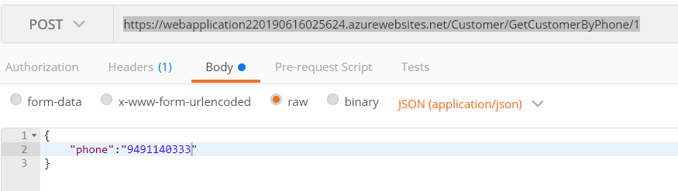

**METHOD POST WITH MERCHANT ID AND EMAIL TO GET CUSTOMER DETAIL**

URL: <https://webapplication220190616025624.azurewebsites.net/Customer/GetCustomerByEmail/1>

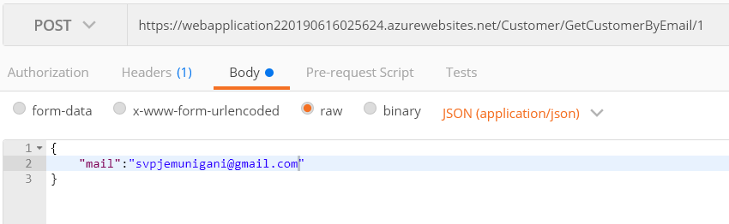

**TICKETING URLS**

**METHOD POST WITH MERCHANT ID, EMPLOYEE ID**

URL: <https://webapplication220190616025624.azurewebsites.net/Ticket/Ticket/1/1>

CustomerId is optional, if is not given it will assign default value 0 to customerId.

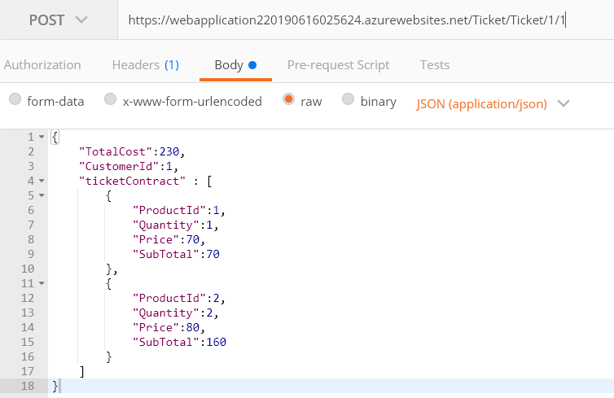

**METHOD GET TO GET ALL TICKETING DETAILS WITH MERCHANT ID**

URL: <https://webapplication220190616025624.azurewebsites.net/Ticket/AllTicket/1>

**METHOD GET TO GET ALL LINE PRODUCT DETAILS WITH MERCHANT ID**

URL: <https://webapplication220190616025624.azurewebsites.net/Ticket/AllTicketLine/1>

**METHOD DELETE TO DELETE ALL TICKETING & LINE PRODUCT DETAILS WITH MERCHANT ID & TICKET ID**

URL: <https://webapplication220190616025624.azurewebsites.net/Ticket/DeleteTicket/1/1>

**{**

**"TotalCost":230,**

**"CustomerId":1,**

**"ticketContract" : [**

**{**

**"ProductId":1,**

**"Quantity":1,**

**"Price":70,**

**"SubTotal":70**

**},**

**{**

**"ProductId":2,**

**"Quantity":2,**

**"Price":80,**

**"SubTotal":160**

**}**

**]**

**}**

**{**

**"mail": "svpjemunigani@gmail.com",**

**"phone": "9491140333",**

**"points": 0**

**}**