**PRODUCT REPORTING URLS**

**METHOD POST WITH MERCHANT ID ,START DATE AND END DATE**

URL: <https://webapplication220190616025624.azurewebsites.net/Reporting/Reporting/1>

**SEND DATA IN THE FORMAT YYYY-MM-DAY**

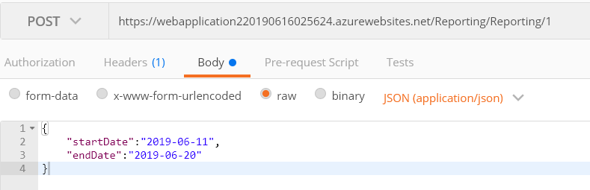

**RETURN OF POST**

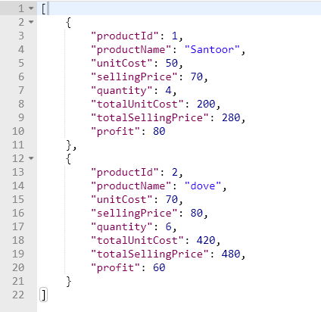

**EMPLOYEE REPORTING URLS**

**METHOD POST WITH MERCHANT ID ,START DATE AND END DATE**

URL: <https://webapplication220190616025624.azurewebsites.net/Reporting/EmployeeReporting/1>

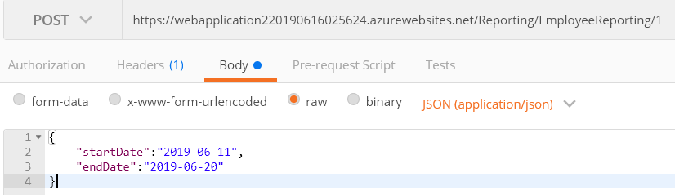

**RETURN OF POST**

