# E-Commerce Platform Search Function

## Analyze big O and best, week, average case for each search function.

Big O: upper bound case, the computational time increases as the input size increase. Helps to detect performance of algorithms.

Linear search:

Best case: O(1) – element found at start

Worst case: O(n) – element found at last

Avg case: O(n/2) or O(n) – element found at bw

Binary search:

Best case: O() – element found at mid

Worst case: O(n log n) – element found after division in half

Avg case: O(n log n) – element found after division in half

## Implementing linear search and binary search

Product class:

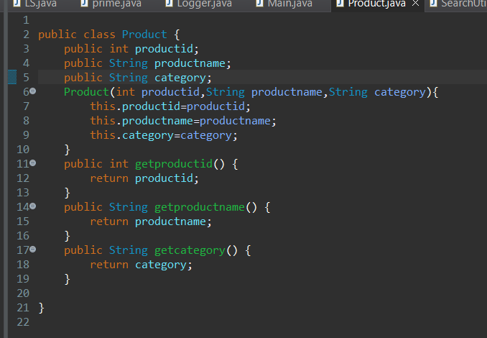

Search class:

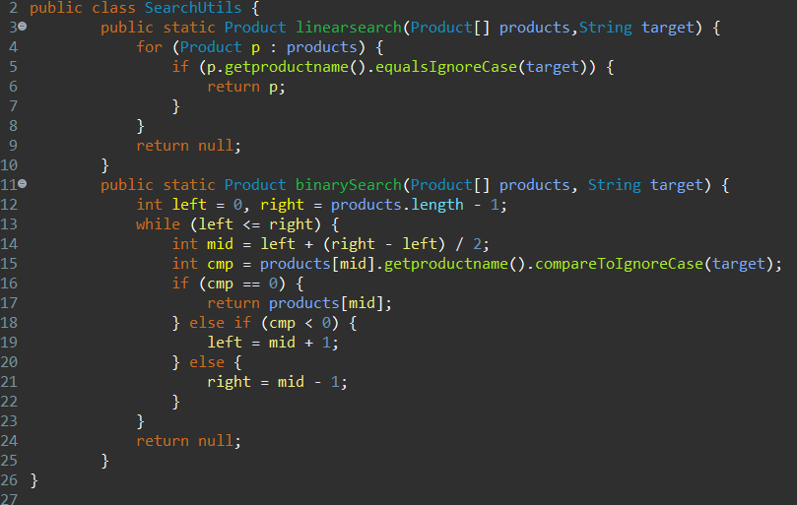

Main class:

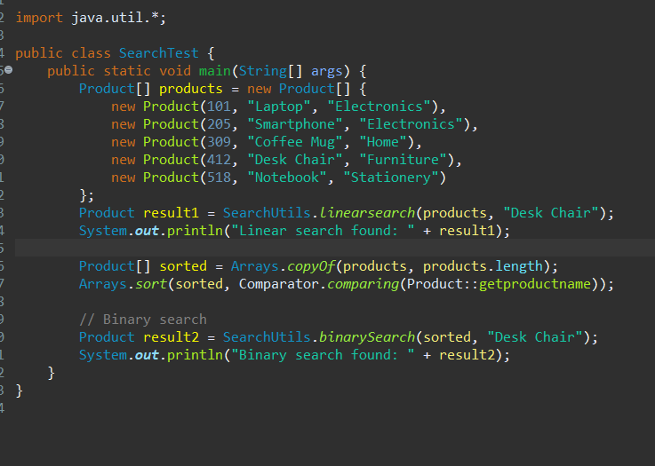

Output;

