# Financial Forecasting

Recursion:

When a method calls itself multiple no of times.

This makes computation easier

Financial class:

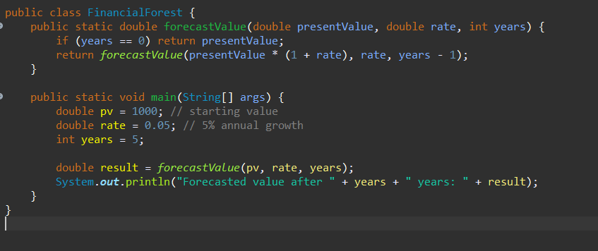

Output:

