# Week 2

## PL/SQL

## Exercise 1: Control Structures

## Scenario 1:

Output:

psql:commands.sql:86: NOTICE: Discount applied to customer Jane Smith (Age: 84, LoanID: 1, New Interest: 4)

## Scenario 2:

Output:

psql:commands.sql:116: NOTICE: Interest increased for customer Young Star (Age: 20, LoanID: 3, New Interest: 5.5)

## Scenario 3:

Output:

psql:commands.sql:145: NOTICE: Extra discount for high-balance customer Richie Rich (Balance: 10000, LoanID: 4, New Interest: 6.0)

## Exercise 3: Stored Procedures

## Scenario 1:

Output:

psql:commands.sql:159: NOTICE: Monthly interest applied to all savings accounts.

## Scenario 2:

Output:

psql:commands.sql:172: NOTICE: Bonus of %10 applied to IT department.

## Scenario 3:

Output:

psql:commands.sql:199: NOTICE: Transferred 500 from Account 1 to Account 2

## TDD using JUnit5 and Mockito

## Exercise 1: Setting Up Junit

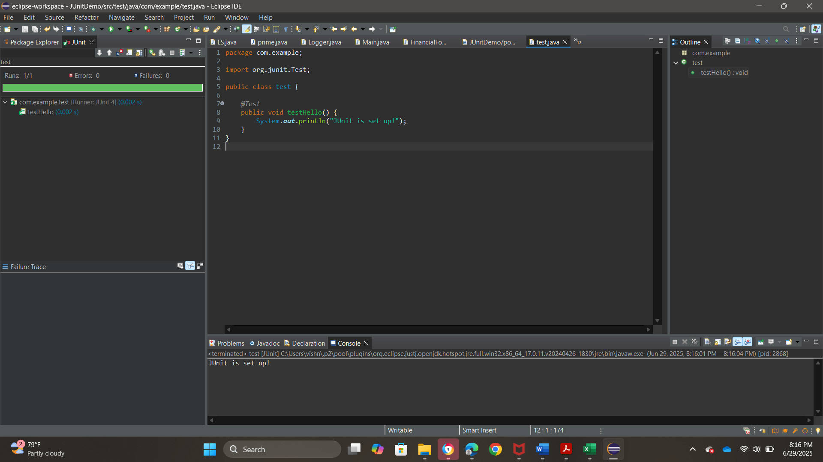

Output:

JUnit is set up!

## Exercise 3: Assertions in Junit

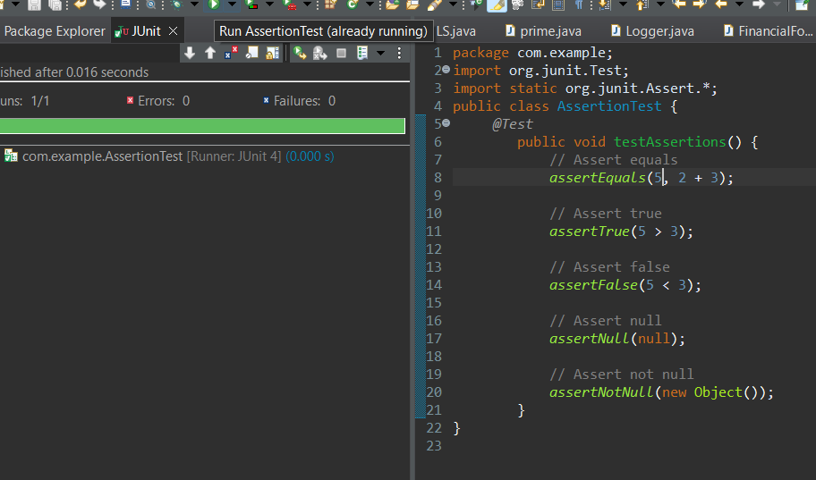

Output:

Green for test correct and red for test incorrect in Junit

## Exercise 4: Arrange-Act-Assert (AAA) Pattern, Test Fixtures, Setup and

Output:

Green in Junit and

## Mockito Exercises

## Exercise 1: Mocking and Stubbing

Create external api through interface

Create a class service

Create service test to test the call to service app -> assertEquals

Output;

## Exercise 2: Verifying Interactions

Verifying(mockapi)

Output;

