# Week 4 - Mandatory assignments

## Create a Spring Web Project using Maven

**Step 1:** create a maven project using spring initializer with group as com.cognizan , and artifact as sring-learn . also add dependencies like spring boot tool and spring web.

**Step 2:** download the zip file, extract it to eclipse workspace

**Step 3:** open maven project in eclipse , using file🡪open projects from file system , specify your spring learn directory

**Step 4:** check if correctly imported and has all the necessary files like main, test and pm.xml.

**Step 5:** run the SpringLearnApplication

**Output:**

## Spring Core – Load Country from Spring Configuration XML

**Step 1:** create a country class where we represent each country

**Step 2:** create a xml where you define how each country object is created and what value it has

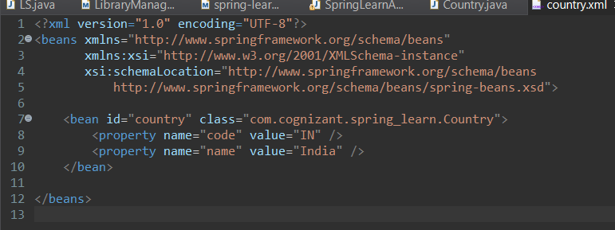

**Step 3:** we run the springbootapplication which starts our spring boot application , that will load the bean from our xml file

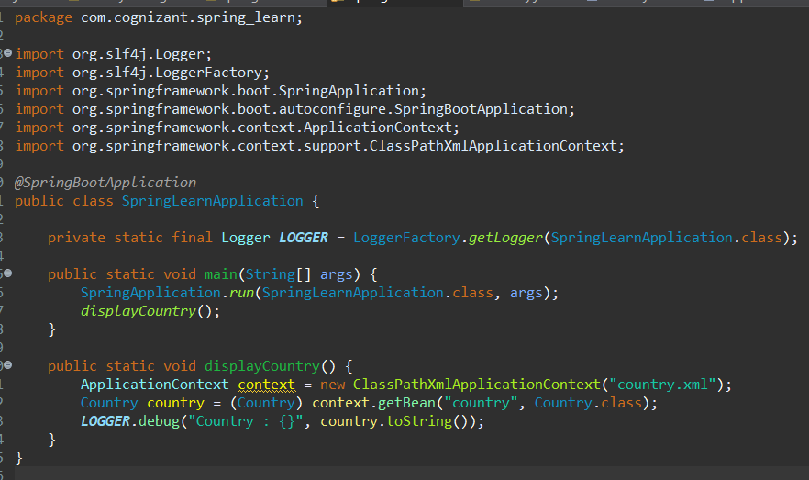

We have created a method display country, that reads my xml file , then creates an object and assigns in to india using setters. That logger.debug prints the op.

**Step 4:** in application.properties, we include **logging.level.com.cognizant.spring_learn=**DEBUG , which sets the logic level to debug that allows us to see all the getters setters and constructors.

**Output:**

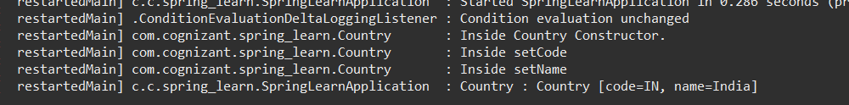

## Hello World RESTful Web Service

**Step 1:** create a package for controller, and create a controller class (HelloController) where we define what should happen when anyone visits the url /hello.

**Step 2:** set up the port in which application has to run in application.properties

**Step 3:** run spring boot application that sets up tomcat which loads all configuration and makes rest API available

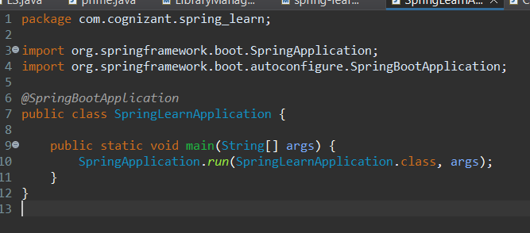

**Output:**

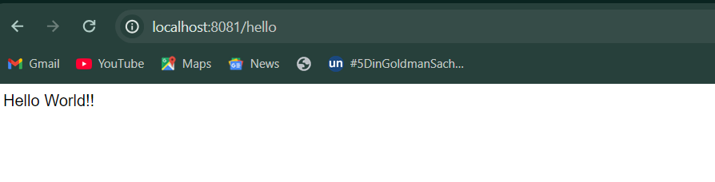

## REST - Country Web Service

**Step 1:** initialize a country with help of getters, setters and constructors through country class

**Step 2:** define country india with its code using the getters , setters and constructors defined by country class in country.xml file through bean.

**Step 3:** create CountryController class in controller package that is responsible for handling the request sent to /country as on anybody opens the url. It loads the data from country.xml and returns the data as json response.

**Output :**

## REST - Get all countries

**Step 1:** update country.xml to define all countries

**Step 2:** update CountryController to handle get requests to countries

**Output:**

