# Week 5 – Mandatory exercises

## Creating Microservices for account and loan

**Step 1:** create a spring maven project using spring initializer with dependencies spring boot tool and spring web , create a employee folder in d drive 123456, inside the folder add another folder called microservices and to this folder extract the downloaded zip file from spring initializer

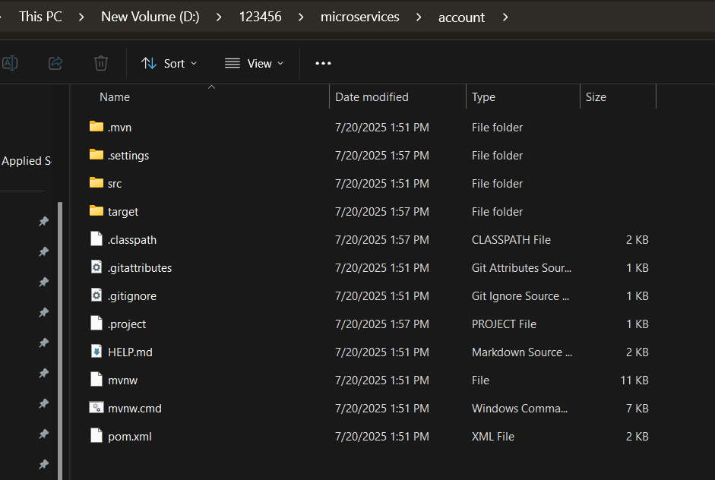

**Step 2:** extract this account folder in eclipse using file 🡪 import 🡪 maven 🡪 existing maven project 🡪 browse 🡪 folder

**Step 3:** create a controller package , and create a controller class AccountController that handles the http get requests, takes the account number from the url and sends a dummy json response

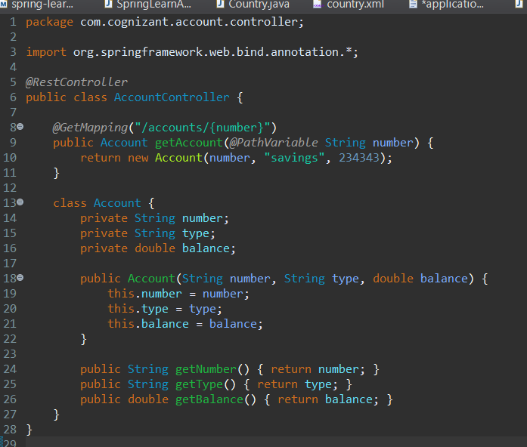

Step 4: run the spring application

Output:



 