# Week 6 – Mandatory Hands on

## Create a new React Application with the name “myfirstreact”, Run the application to print “welcome to the first session of React” as heading of that page

Step 1: Install Create-react-app by running the command “npx create-react-app myfirstreact”

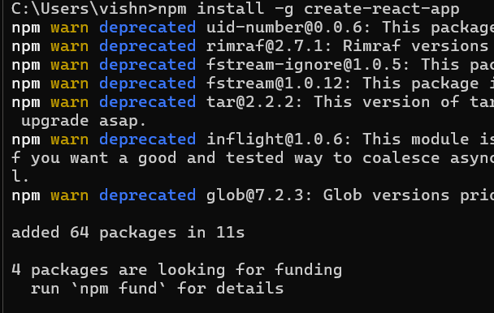

Step 2: create a React Application with the name of “myfirstreact”, type “create-react-app myfirstreact.

Step 3: type “code .” which redirects to vs code directory, under which youll find your react app’s “App.js” and update it

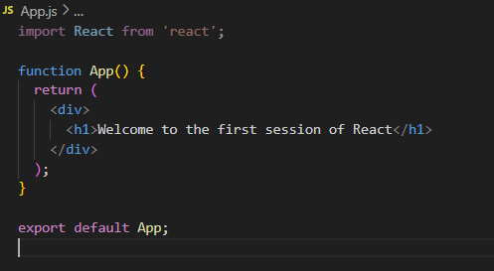

Step 4: run <http://localhost:3000>

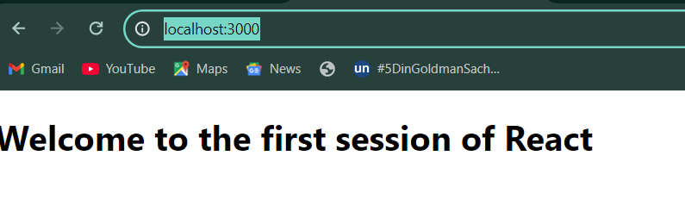

## Create a react app for Student Management Portal named StudentApp and create a components: Home,About,Contacts.

Step1: create a react project named studentapp using command “create-react-app studentapp”

Step 2: create a new folder names “components” in the src file of your project student app, under components create 3 fjs files named “home.js”, “about.js”, “contact.js”. Each of these is a React functional component that represents a part of the webpage.

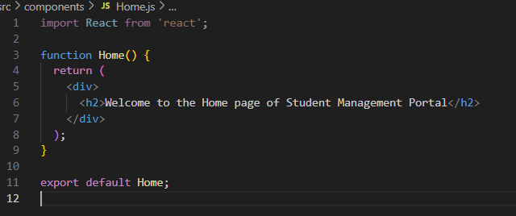

Step 3: update “app.js” to import these components in them.

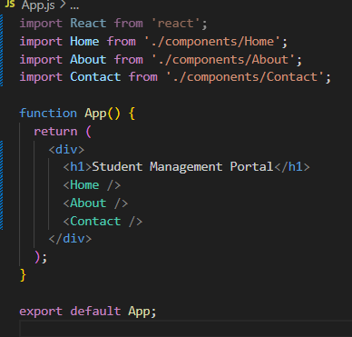

Step 4: run <http://localhost:3000>

p

## Create a react app for Student Management Portal named scorecalculatorapp and create a function component named “CalculateScore”.

Step 1: create a react project named scorecalculatorapp using command “create-react-app scorecalculatorapp”

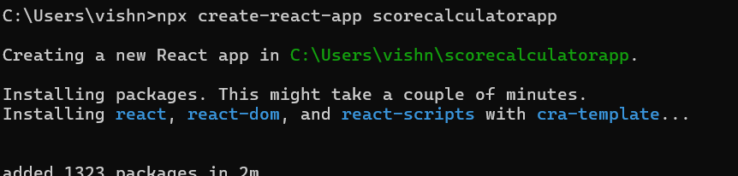

Step 2: go to src in vs code, create a folder named components and add a file names calculatescore

Step 3: create a new folder under src names Stylesheets and add a file named mystyle.css

Step 4: update app.js

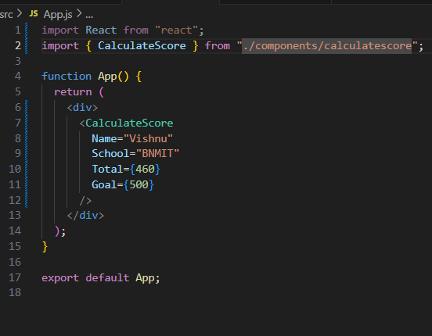

Step 5: run <http://localhost:3000>

## To implement componentDidMount() and componentDidCatch()

Step 1: create a react project named blogapp using command “create-react-app blogapp”

Step 2: create a Post.js file under src

Step 3: create Posts.js under src

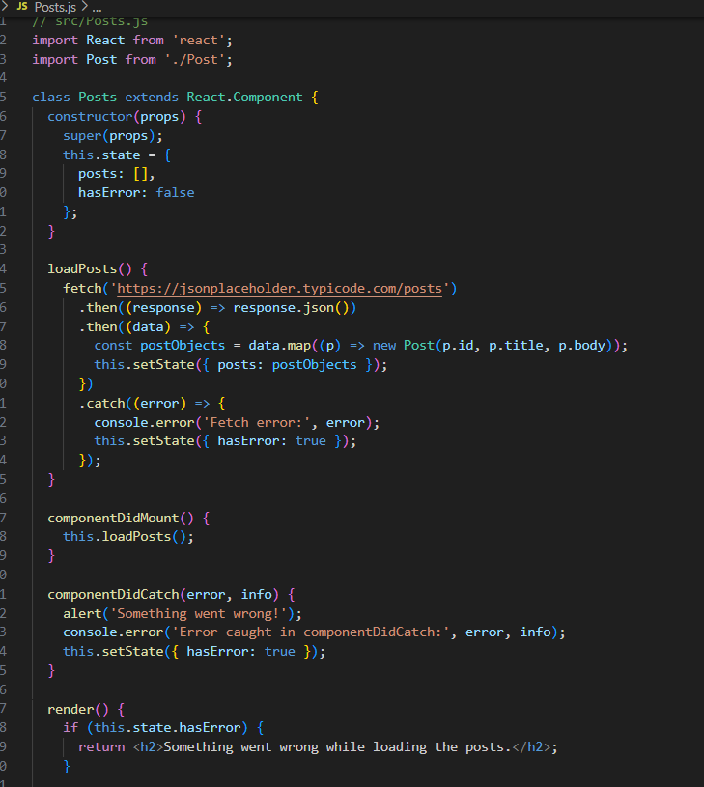

Step 4: update app.js

Step 5: run <http://localhost:3000>

