A Driving Decision Strategy (DDS) Based on Machine learning for an autonomous vehicle

In this paper author is describing concept for driving decision strategy by observing vehicle internal data such as steering and RPM level to predict various classes such as speed (steering), changing lane etc. All existing technique were concentrate on external data such as road condition and pedestrians etc but not concentrate on internal values. So to take efficient determination of steering condition and changing lane author is analysing internal data.

All internal data will be collected from sensor and then store on cloud and then application will read data from cloud and then apply machine learning algorithms to determine or predict steering condition or changing lane.

To implement this project author has introduce and algorithm called DDS (Driving Decision Strategy) algorithm which is based on genetic algorithm to choose optimal gene values which helps in taking better decision or prediction. DDS algorithm obtained input from sensor and then pass to genetic algorithm to choose optimal value which helps in faster and efficient prediction.

Propose DDS with genetic algorithm performance is comparing with existing machine learning algorithm such as Random Forest and MLP (multilayer perceptron algorithm.). Propose DDS shows better prediction accuracy compare to random forest and MLP.

To implement this project we are using historical vehicle trajectory dataset as we don’t have sensors to collect data so we are using trajectory dataset. In dataset if user is slowing down vehicle then it has some sensor value with class label as ‘lane changing’. Similarly based on values we have different classes in dataset. Machine learning algorithm will be trained on such dataset and then when we apply test data on trained model then algorithm will predict class for that test data. Below are the dataset details and this dataset saved inside ‘DrivingDataset’ folder.

**trajectory_id,start_time,end_time,rpm_average,rpm_medium,rpm_max,rpm_std,speed_average,speed_medium,speed_max,speed_std,labels**

20071010152332,2007-10-10T15:23:32.000000000,2007-10-10T15:32:59.000000000,2.21513818073,2.27421615004,2.85853043655,0.428624902772,-0.005093147516729999,-0.00230819670622,0.0647143832211,0.0377402391782,speed

20071011011520,2007-10-11T01:15:20.000000000,2007-10-11T01:22:10.000000000,3.71181007816,3.65065107266,6.35783373513,1.9271696164900003,-0.016218030061,-0.00147783417456,0.104789889519,0.09341315155410003,speed

20080628053717,2008-06-28T05:37:17.000000000,2008-06-28T05:46:42.000000000,4.65889245882,3.12829931751,13.0268086376,4.09914234541,0.00404703387141,0.0124246102197,2.11899984839,0.7521915347560001,steering_angle

20080628124807,2008-06-28T12:48:07.000000000,2008-06-28T12:57:16.000000000,1.71674094314,1.31398945454,18.5776836518,2.18497323244,-0.0312684175217,0.0308633583269,2.93888558793,0.7139256777420001,steering_angle

20080825044741,2008-08-25T04:47:41.000000000,2008-08-25T05:05:12.000000000,2.38238360506,1.5371758264500002,20.919113327999998,2.865359735,-0.00720368601786,-0.000910857743471,2.01833073218,0.471527016571,lane_change

In above dataset all bold names are the dataset column names and below it are the dataset values. In dataset we can see sensor report each record with trajectory id, date, time and with speed and rpm details. In last column we can see labels as LANE_CHANGE, STEERING ANGLE and SPEED and with above dataset values and with label we will train machine learning algorithm and calculate accuracy.

Below are the test data which will not have any class label and it will have only sensor values and by applying sensor values on trained model we can predict or determine driving decision.

**trajectory_id,start_time,end_time,rpm_average,rpm_medium,rpm_max,rpm_std,speed_average,speed_medium,speed_max,speed_std**

20080823105259,2008-08-23T10:52:59.000000000,2008-08-23T11:03:41.000000000,1.871265931,1.50554575041,31.326428333800006,2.51544461011,0.039840794139,0.0126100556557,10.1724891367,0.90256325184

20080821073812,2008-08-21T07:38:12.000000000,2008-08-21T08:30:53.000000000,4.17415377139,2.13114534045,22.3494958748,4.85923705089,0.00675714954958,0.003186830858360001,2.76052942367,0.469073794101

20080913092418,2008-09-13T09:24:18.000000000,2008-09-13T09:24:36.000000000,3.03831788365,2.6180090273700003,5.81633341636,1.6937811468,0.0559180233599,0.163687128621,1.43391460095,0.997515549234

In above test data we can see only test values are there but not class label and after applying above test data on machine learning trained model we can predict/determine driving strategy such as going on speed, changing lane or steering angle.

Note: when we run genetic algorithm then application will open 4 empty windows u just close those 4 empty window and first old window should be running

SCREEN SHOTS

To run project double click on ‘run.bat’ file to get below screen

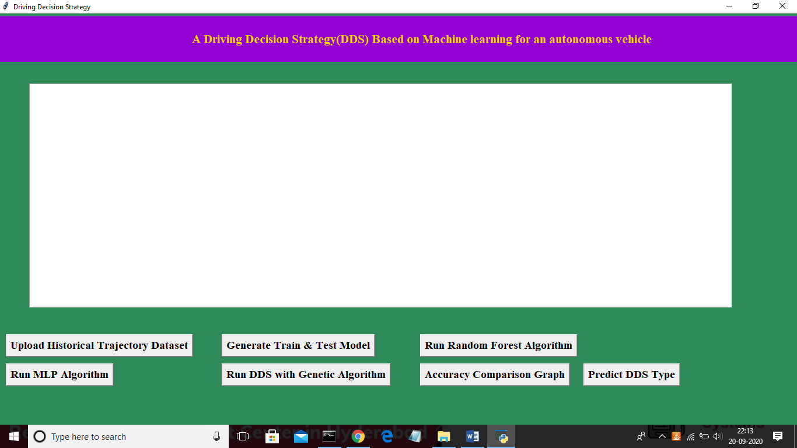

In above screen click on ‘Upload Historical Trajectory Dataset’ button and upload dataset

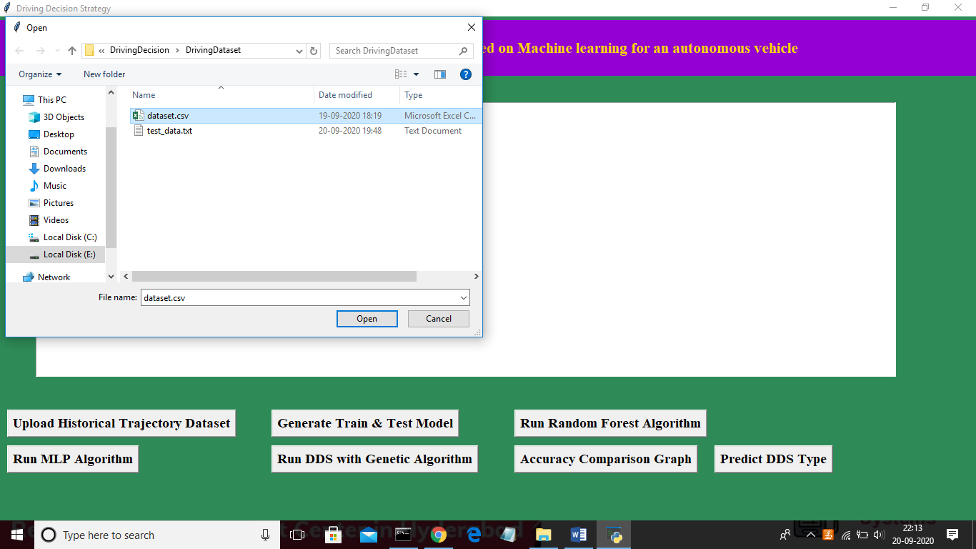

Now select ‘dataset.csv’ file and click on ‘Open’ button to load dataset and to get below screen

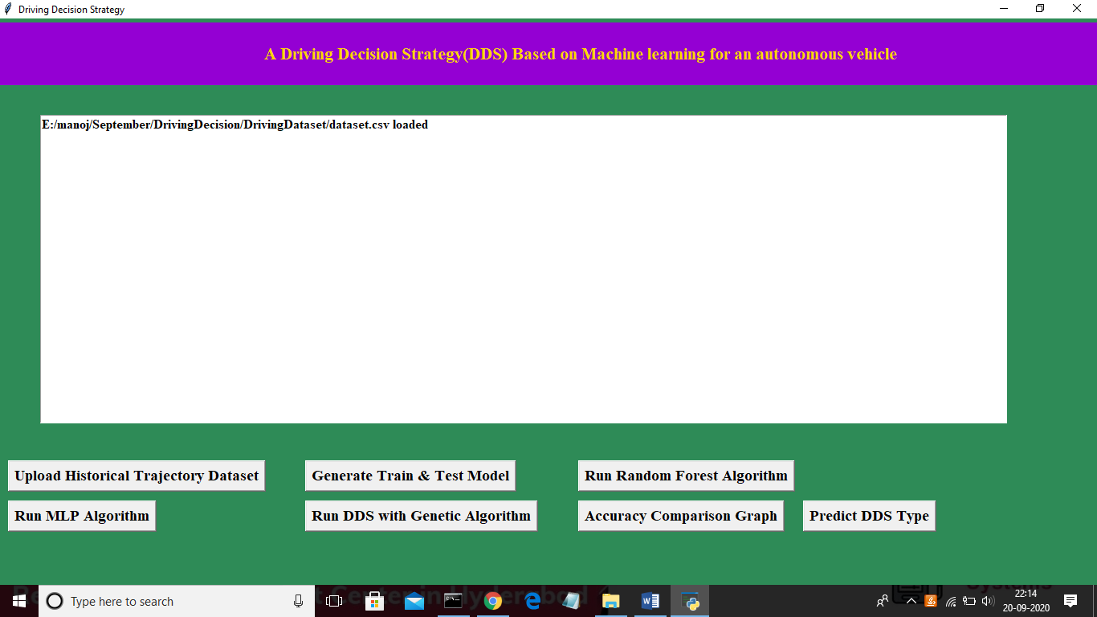

In above screen dataset is loaded and now click on ‘Generate Train & Test Model’ button to read dataset and to split dataset into train and test part to generate machine learning train model

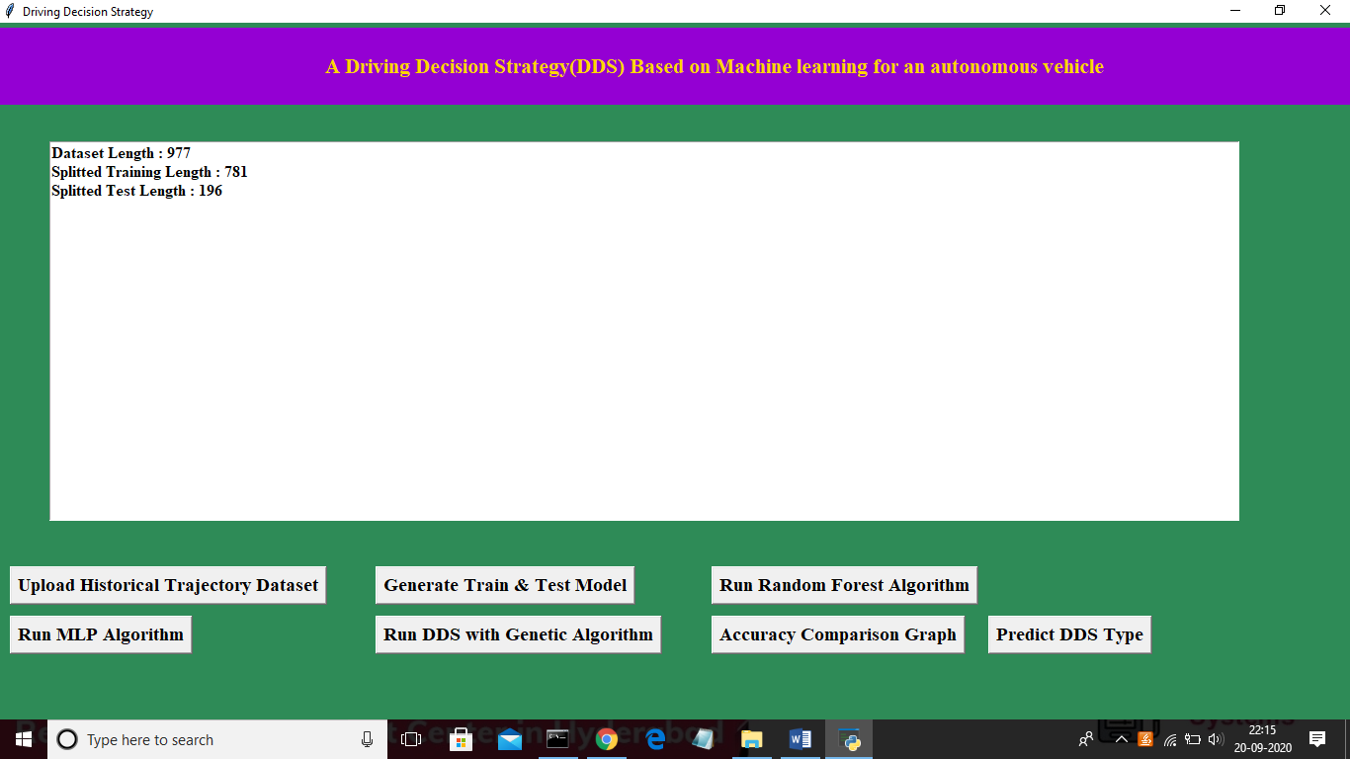

In above screen dataset contains 977 total trajectory records and application using 781 (80% of dataset) records for training and 196 (20% of dataset) for testing. Now both training and testing data is ready and now click on ‘Run Random Forest Algorithm’ button to train random forest classifier and to calculate its prediction accuracy on 20% test data

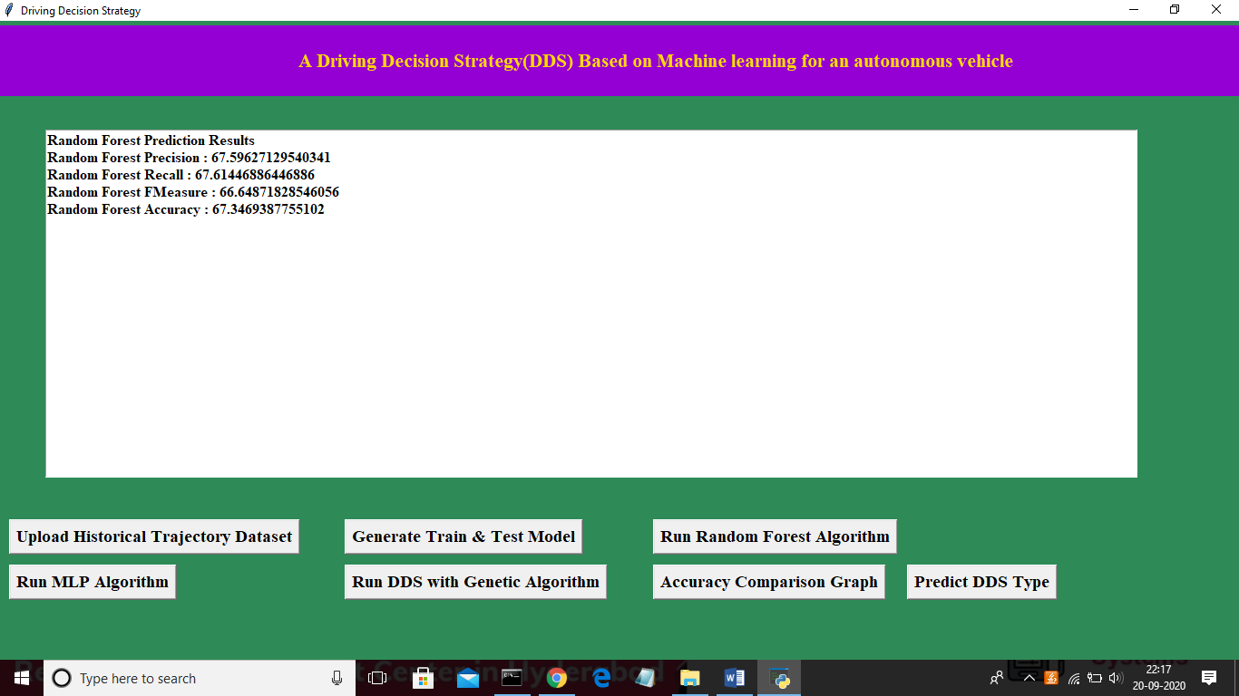

In above screen we calculated random forest accuracy, precision, recall and fmeasure and random forest got 67% prediction accuracy. Now click on ‘Run MLP Algorithm’ button to train MLP model and to calculate its accuracy

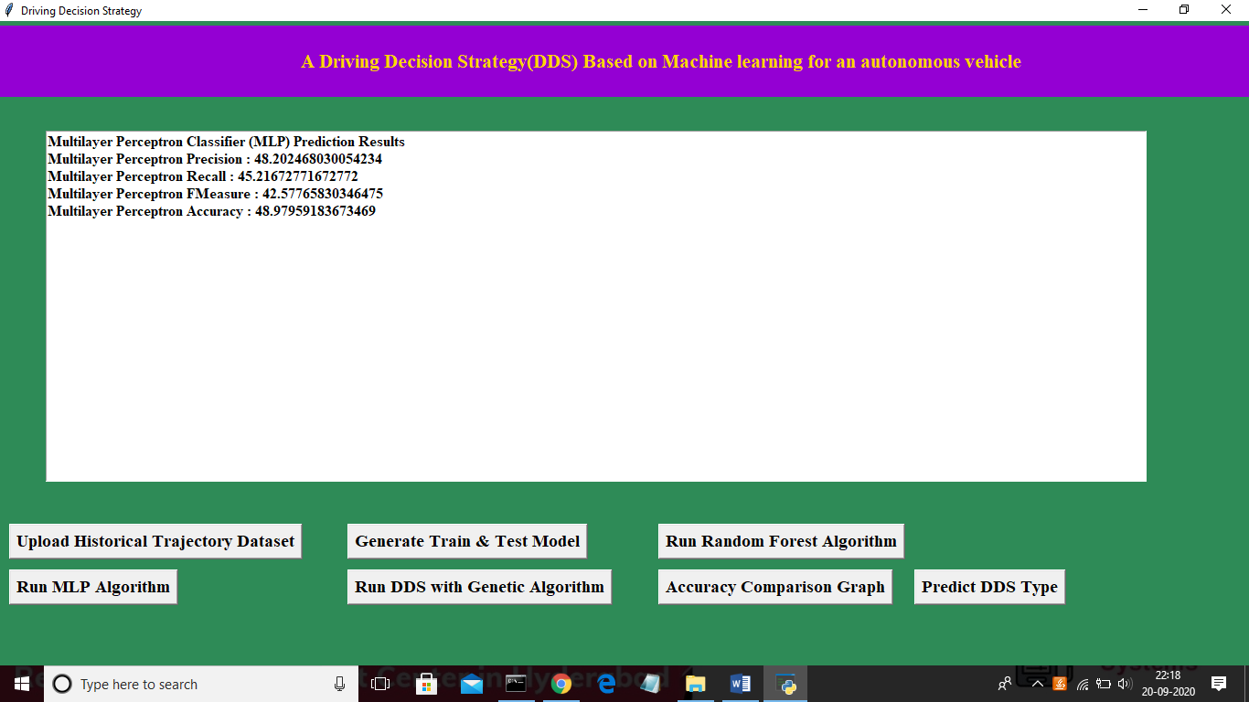

In above screen MLP got 48% prediction accuracy and in below screen we can see genetic algorithm code used for building propose DDS algorithm

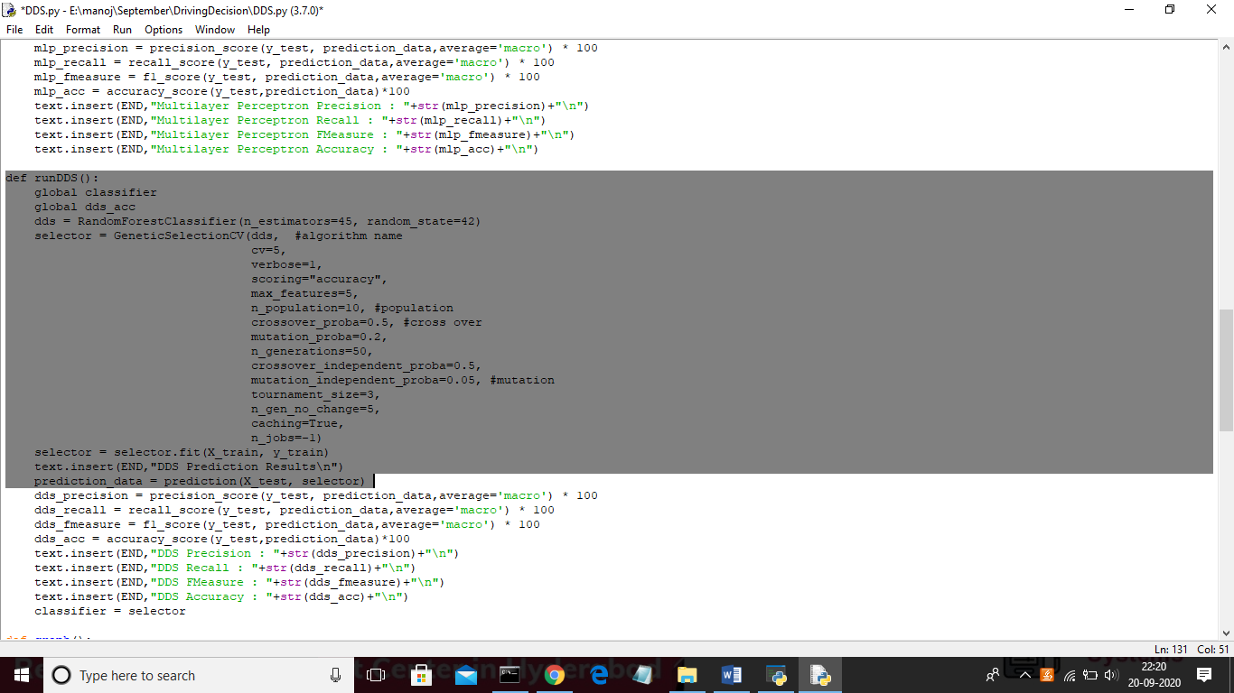

In above screen we can see genetic algorithm code used in DDS algorithm and now click on ‘Run DDS with Genetic Algorithm’ button to train DDS and to calculate its prediction accuracy

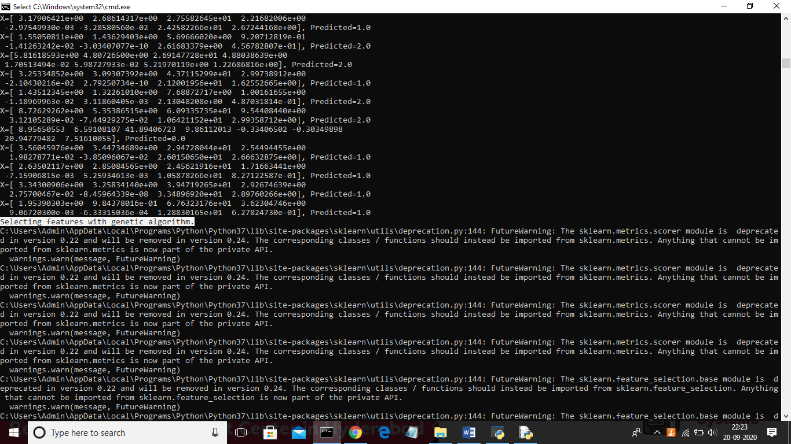

In above black console genetic algorithm starts optimal feature selection

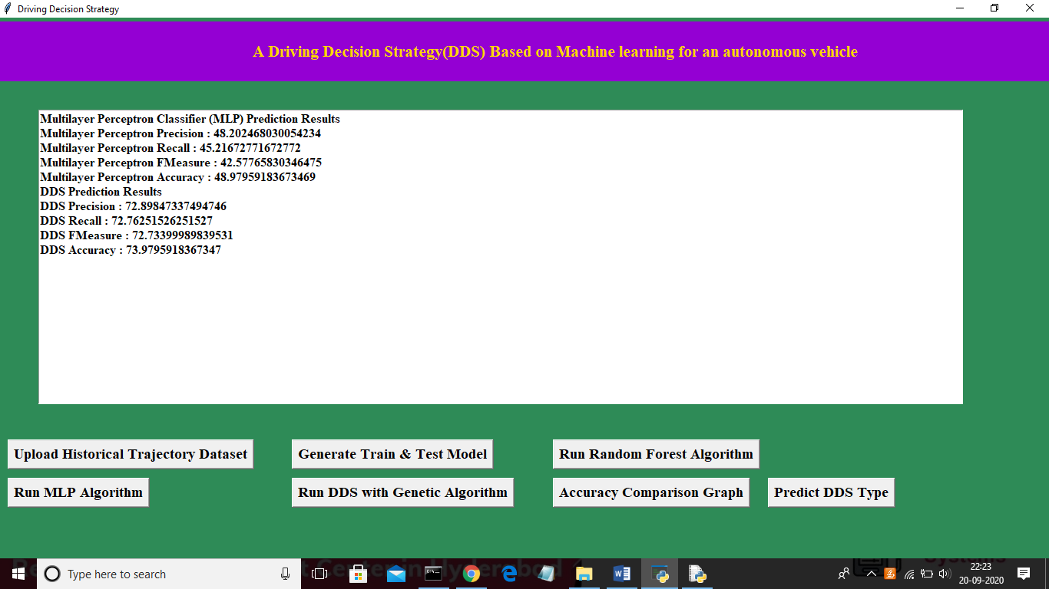

In above screen propose DDS algorithm got 73% prediction accuracy and now click on ‘Accuracy Comparison Graph’ button to get below graph

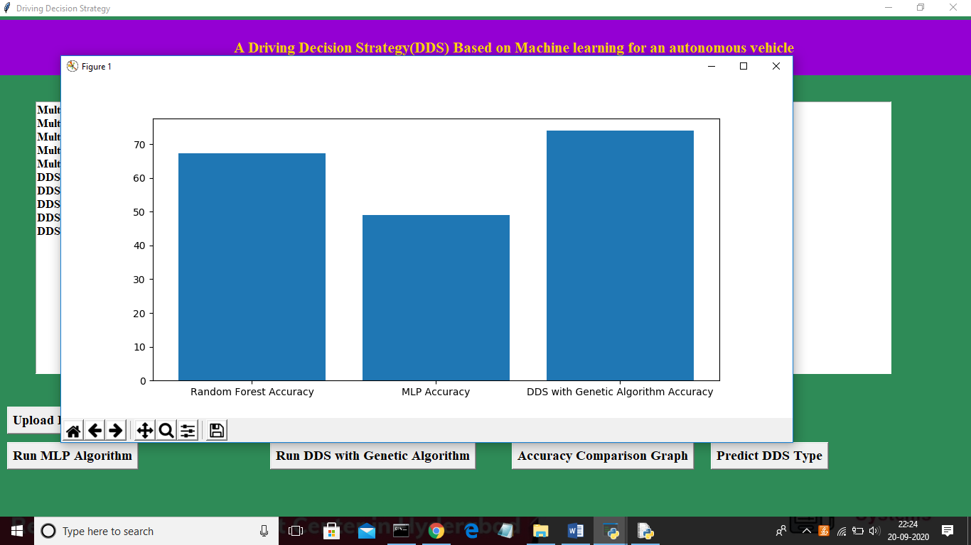

In above graph x-axis represents algorithm name and y-axis represents accuracy of those algorithms and from above graph we can conclude that DDS is performing well compare to other two algorithms. Now click on ‘Predict DDS Type’ button to predict test data

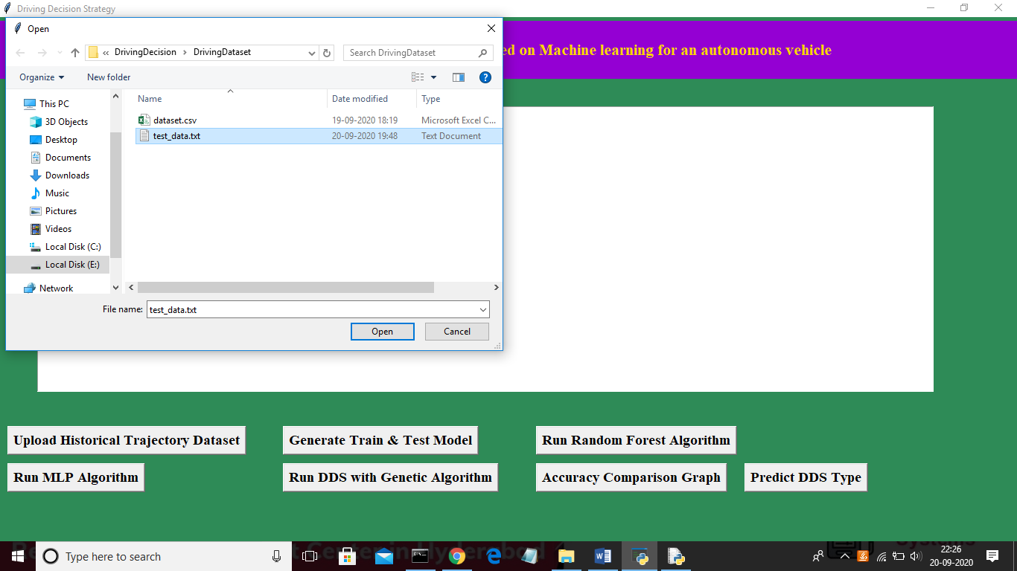

In above screen uploading ‘test_data.txt’ file and click on ‘Open’ button to predict driving decision

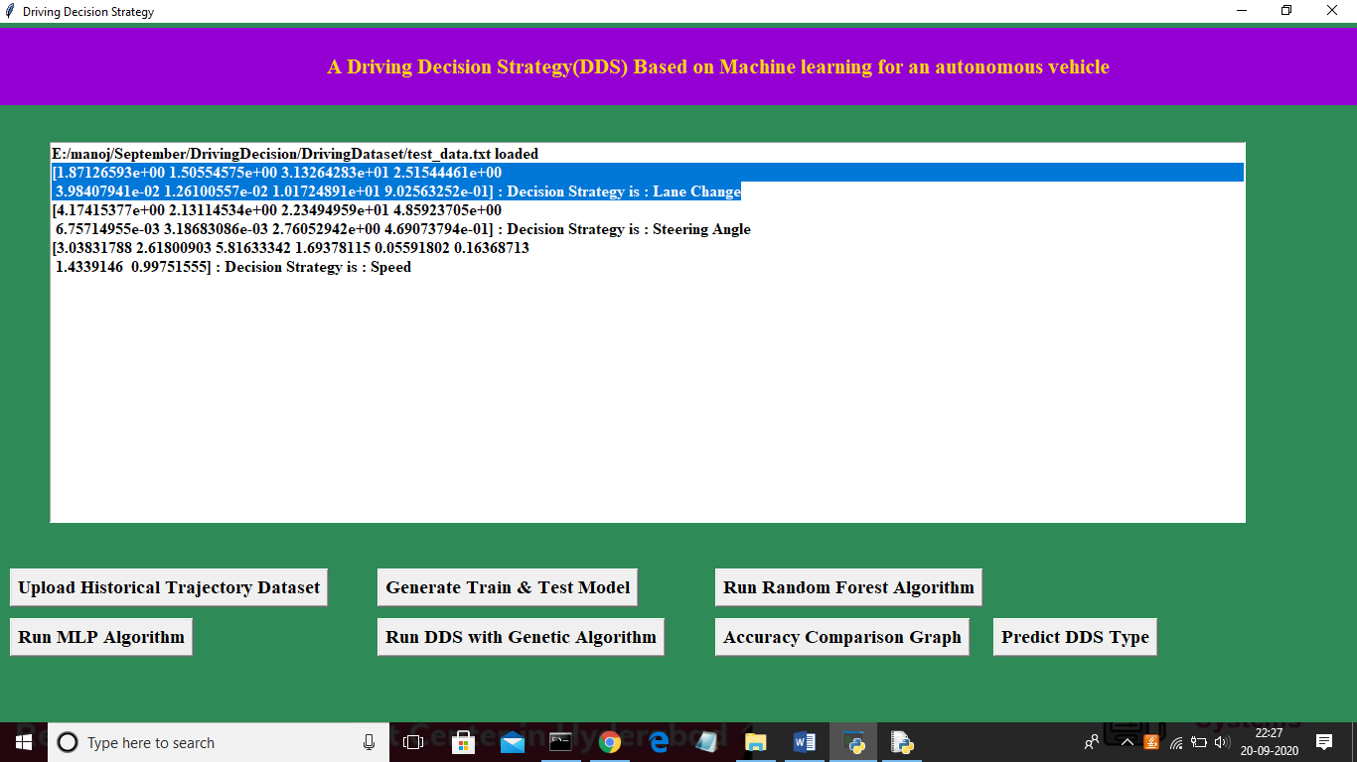

In above screen in selected first record we can see decision is Lane Change and for second record values we got decision as ‘steering angle’ and for third test record we got predicted value as vehicle is in speed mode.