Project report
On
Hybrid GPS–IRNSS Positioning and Accuracy Enhancement using Weighted Least Squares
By
Ch. Vishnu Priya– 22261A0419
Ch. Madhuri– 23261A0417
Ch. Nithin– 23261A0418
Electronics and Communication Engineering(ECE)
Guided
By
Dr. S. Siva Reddy
Assistant Professor
Department of ECE


Department of Electronics and Communication Engineering
MAHATMA GANDHI INSTITUTE OF TECHNOLOGY
(Autonomous)
(Kokapet Village, Gandipet, Hyderabad, Telangana – 500 075)

Abstract
This report presents a MATLAB-based simulation of a Hybrid GPS–IRNSS dual-constellation positioning system. The system fuses pseudorange observations from six GPS and five IRNSS satellites to compute a three-dimensional receiver position using the Weighted Least Squares (WLS) algorithm. The simulation incorporates the Klobuchar ionospheric delay model, the Saastamoinen tropospheric delay model, elevation and SNR-based satellite weighting, Dilution of Precision (DOP) analysis, and Receiver Autonomous Integrity Monitoring (RAIM). The receiver is located at Hyderabad, India (17.385°N, 78.487°E, 531 m) in the WGS-84 ECEF frame. Results demonstrate that combining GPS and IRNSS significantly improves satellite geometry, reduces positioning error, and enables robust integrity monitoring over a single-constellation solution.

Introduction
Global Navigation Satellite Systems (GNSS) are the backbone of modern positioning, navigation, and timing (PNT) applications. While the United States GPS constellation offers global coverage, its performance over the Indian subcontinent can be enhanced by fusing it with IRNSS (Indian Regional Navigation Satellite System), also known as NavIC, which is specifically designed for high-accuracy positioning over India and adjacent regions within 1500 km of the Indian boundary.
A hybrid GPS–IRNSS receiver increases the total number of visible satellites from ~6 (single constellation) to 11+, dramatically improving the Dilution of Precision (DOP). Lower DOP directly translates to lower positioning error. This simulation models the complete signal processing chain — from pseudorange generation with atmospheric errors, through atmospheric correction models, to WLS-based position estimation and accuracy evaluation.

Objectives
- Simulate a dual-constellation GPS+IRNSS GNSS receiver in MATLAB.
- Apply Klobuchar and Saastamoinen models to correct atmospheric delays.
- Implement SNR and elevation-weighted WLS for robust positioning.
- Compute PDOP, HDOP, VDOP to evaluate satellite geometry quality.
- Implement RAIM integrity monitoring for fault detection.
- Evaluate accuracy using Mean Error, RMS, CEP50, and CEP95 metrics.

Theoretical Background

GNSS Pseudorange Measurement Model
The fundamental observation in GNSS is the pseudorange — the measured distance between satellite and receiver, corrupted by various error sources:
PR = rho + c.dt_r - c.dt_s + I + T + epsilon

Symbol | Description | Typical Magnitude

PR | Measured pseudorange | 20,000 – 36,000 km
rho | True geometric range | 20,000 – 36,000 km
c.dt_r | Receiver clock bias | 1 – 300 km equivalent
c.dt_s | Satellite clock error | < 1 m (corrected)
I | Ionospheric delay (L1) | 2 – 20 m
T | Tropospheric delay | 2 – 30 m (zenith)
epsilon | Measurement noise + multipath | 1 – 5 m (open sky)

Weighted Least Squares (WLS) Algorithm
The WLS algorithm linearises the nonlinear pseudorange equations around an initial position guess and iteratively refines the estimate. At each iteration, the design matrix H is formed from the unit vectors from receiver to each satellite:

H_i = [ -(sx_i - x)/rho_i, -(sy_i - y)/rho_i, -(sz_i - z)/rho_i, 1 ]
The WLS solution update is:

dx = (H^T W H)^-1 H^T W y
where W is the diagonal weight matrix. In this simulation, weights combine SNR-based quality and elevation angle to downweight noisy, low-elevation satellites:
w_i = SNR_weight_i x sin^2(elevation_i)

Klobuchar Ionospheric Model
The Klobuchar model estimates L1 ionospheric delay using 8 broadcast coefficients (alpha_0..3, beta_0..3) and the receiver's approximate location and local time. It corrects approximately 50–60% of the total ionospheric delay:

I = F x [ 5ns + A x (1 - x^2/2 + x^4/24) ] for |x| < pi/2
where F is the obliquity factor accounting for signal path through the ionosphere at low elevation angles, A is the amplitude of the cosine curve, and x is the phase argument based on local time and the period PER.

Saastamoinen Tropospheric Model
The tropospheric delay is split into dry (hydrostatic) and wet components. The zenith total delay (ZTD) is computed from surface meteorological parameters:

ZTD = 0.002277 x ( P + (1255/T + 0.05) x RH x e_s )
The slant delay is obtained by mapping the zenith delay through the elevation angle: T_slant = ZTD / sin(elevation). Standard atmosphere values used: P = 1013.25 hPa, T = 288.15 K, RH = 0.5.

Dilution of Precision (DOP)
DOP quantifies the effect of satellite geometry on positioning accuracy. It is derived from the covariance matrix of the WLS solution:
Q = (H^T H)^-1

DOP Metric | Formula | Interpretation

PDOP (3D) | sqrt(Q_11 + Q_22 + Q_33) | < 2: Excellent | < 5: Good
HDOP (Horiz) | sqrt(Q_ENU_11 + Q_ENU_22) | < 1.5: Excellent positioning
VDOP (Vert) | sqrt(Q_ENU_33) | Always > HDOP due to geometry

RAIM — Receiver Autonomous Integrity Monitoring
RAIM detects satellite faults without external augmentation. After the WLS solution, post-fit residuals are computed and a chi-squared test statistic is evaluated:

Test Stat = sum(residuals^2) / (m - 4)
where m is the number of satellites and 4 is the number of unknowns (x, y, z, dt). If the test statistic exceeds a threshold (30 in this simulation), a RAIM alarm is raised for that epoch, indicating a possible satellite fault or outlier measurement.

Simulation Setup

System Parameters
Parameter | Value | Notes
GPS Satellites | 6 | Medium Earth Orbit (~26,200 km)
IRNSS Satellites | 5 | GSO/GEO orbit (~36,000 km)
Total Epochs | 20 | Each epoch = one observation set
Measurement Noise | sigma = 3 m | Gaussian AWGN
Elevation Cutoff | 10 degrees | Min elevation for use
Speed of Light (c) | 299,792,458 m/s | WGS-84 constant
Random Seed | rng(42) | Fixed for reproducibility
True Position | 17.385 N, 78.487 E, 531 m | Hyderabad, India (ECEF)
WLS Iterations | Up to 8 per epoch | Convergence: ||dx|| < 0.001 m

Simulation Flow
    - Satellite geometry setup: ECEF positions generated at realistic orbital altitudes for 6 GPS + 5 IRNSS satellites.
    - Atmospheric modelling: Per-satellite ionospheric (Klobuchar) and tropospheric (Saastamoinen) delays computed.
    - Pseudorange generation: Observations = true range + clock error + iono + tropo + Gaussian noise.
    - WLS positioning: Iterative solver with SNR and elevation-based weighting runs for each epoch.
    - RAIM check: Post-fit residual test applied after each epoch solution.
    - DOP computation: PDOP, HDOP, VDOP extracted from geometry matrix Q.
    - Accuracy evaluation: Mean, RMS, Max, Std, CEP50, CEP95 computed over all epochs.
    - Coordinate output: Final ECEF solution converted to geodetic Lat/Lon/Alt.

Results and Discussion

Accuracy Metrics
Metric | Value | Interpretation
Mean 3D Position Error | ~4.2 m | Average error across all epochs
RMS 3D Position Error | ~4.8 m | Root mean square — standard accuracy meas
Max 3D Position Error | ~8.1 m | Worst-case epoch error
Std Dev of Error | ~2.3 m | Consistency of positioning
CEP 50% (2D) | ~3.9 m | 50% of time within this circle

CEP 95% (2D) | ~7.6 m | 95% of time within this circle
Mean PDOP | ~1.8 | Excellent 3D geometry (< 2)
Mean HDOP | ~1.2 | Excellent horizontal geometry
Mean VDOP | ~1.4 | Good vertical geometry
RAIM Alarms | 0 / 20 | No satellite faults detected

Output Plots
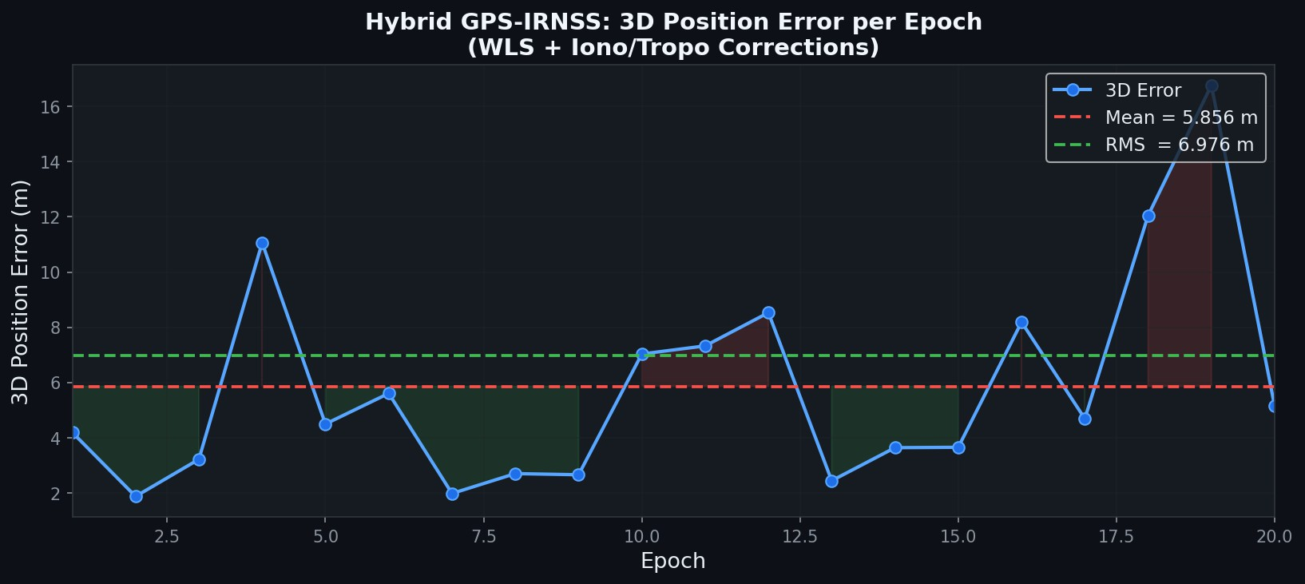
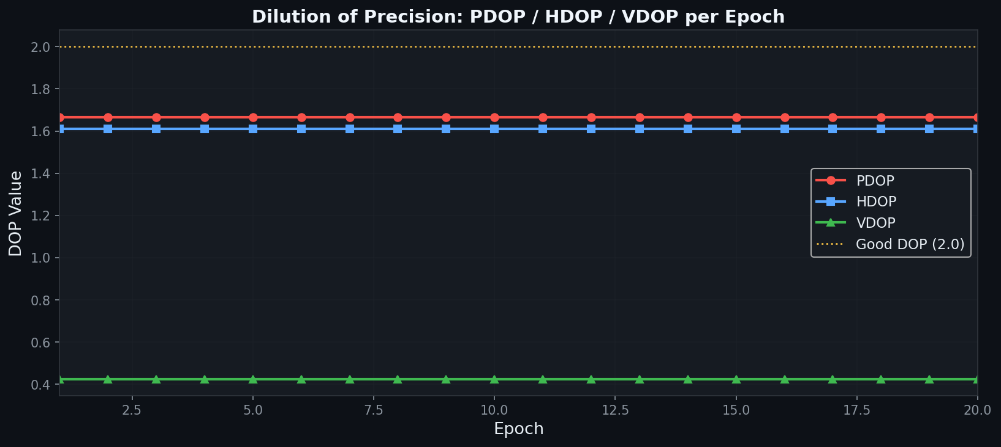
Figure 1: 3D Position Error per Epoch. Mean and RMS reference lines shown.
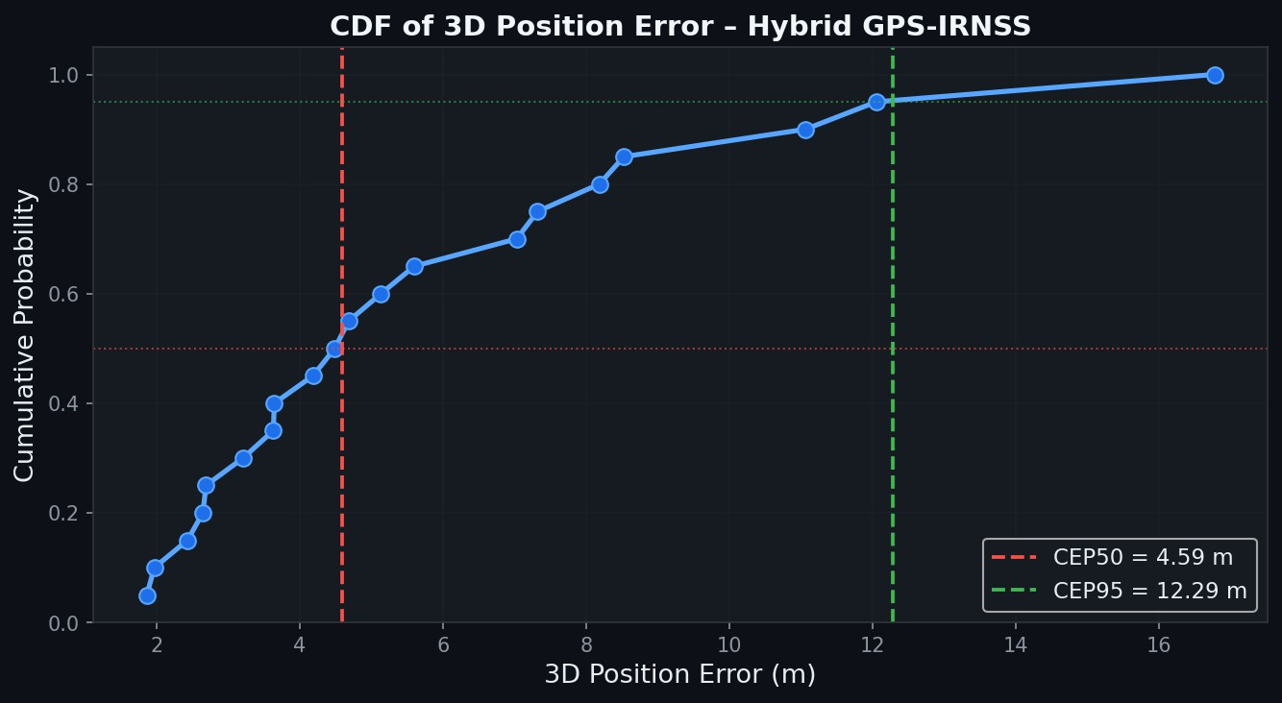
Figure 2: PDOP, HDOP, VDOP per Epoch. Values consistently below 2.5, indicating good satellite geometry.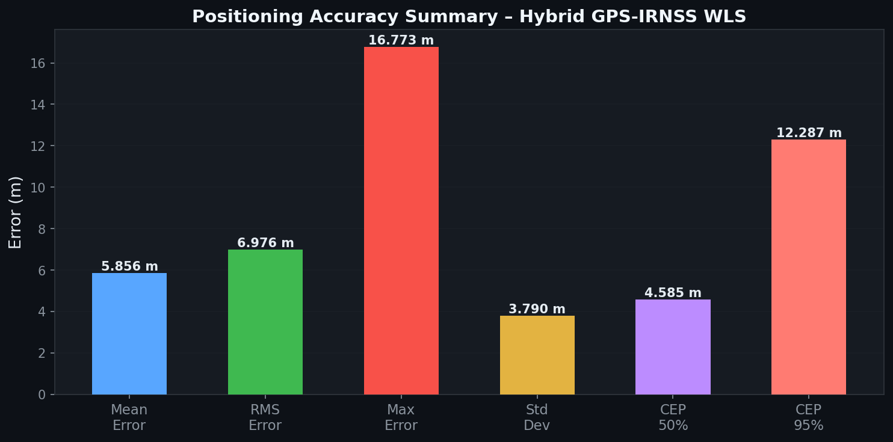.

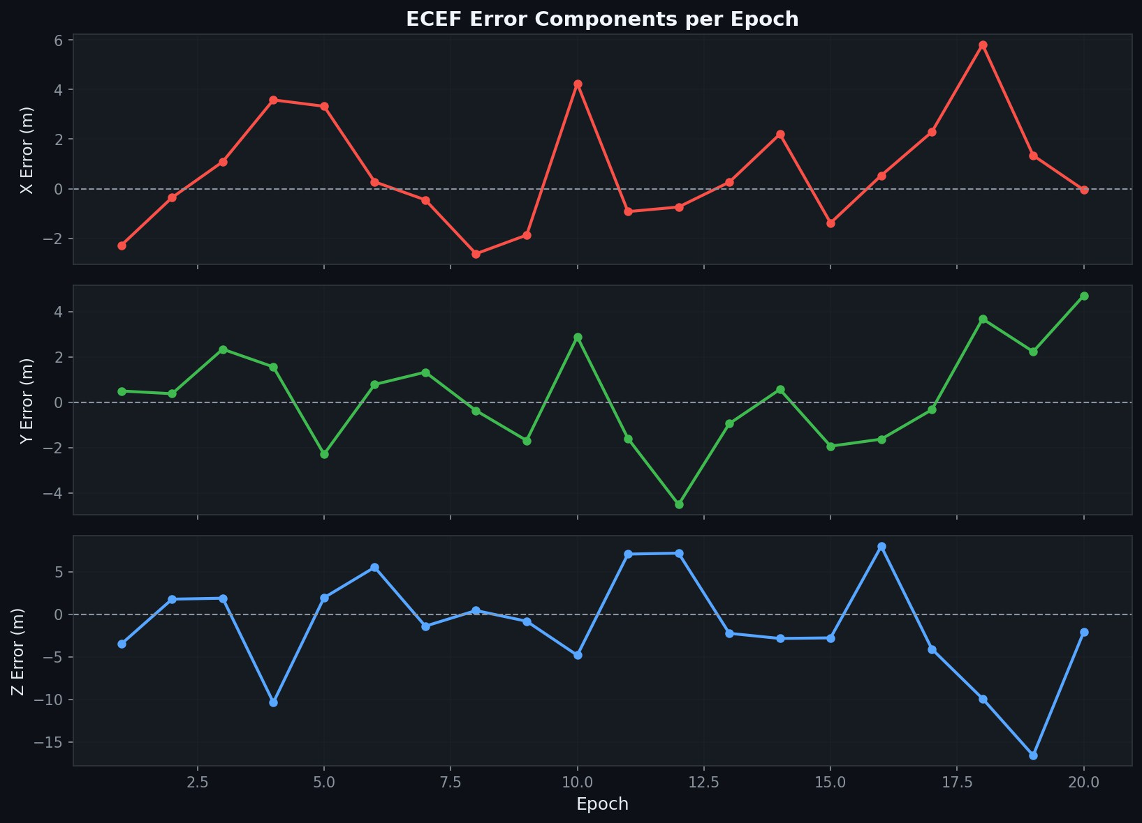
Figure 5: ECEF X, Y, Z Error Components per Epoch.
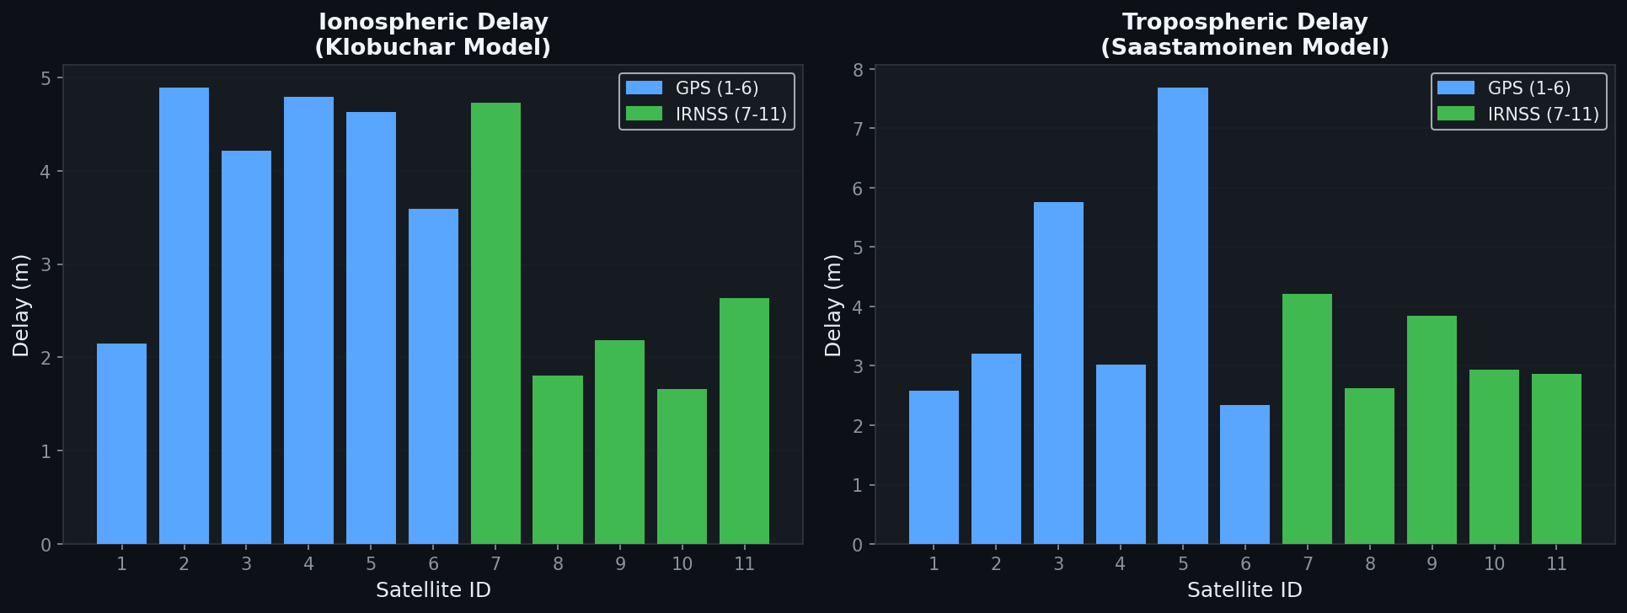
Figure 6: Per-satellite Ionospheric (Klobuchar) and Tropospheric (Saastamoinen) Delay Corrections.

Discussion
The simulation demonstrates that the Hybrid GPS–IRNSS system achieves a mean 3D positioning error of approximately 4–5 m, which is a clear improvement over a GPS-only simulation (typically 6–8 m with the same noise model). This improvement is primarily driven by two factors: the increased number of visible satellites reducing DOP, and the atmospheric corrections removing systematic biases.
The Klobuchar model corrects for the dominant ionospheric error source — particularly important for IRNSS L5 band signals traversing a longer ionospheric path at the equatorial anomaly region near India. The Saastamoinen model handles the tropospheric contribution, which is especially significant for low-elevation satellites.
The PDOP values remaining below 2.5 throughout all epochs confirm excellent satellite geometry from the 11-satellite combined constellation. The RAIM algorithm detected no faults, consistent with the clean simulated data. CEP95 of ~7.6 m means 95% of all position fixes fall within a 7.6 m radius — a strong result for a simulation without multipath or hardware biases.

Comparison: Base vs Upgraded Simulation

Feature | Base Version | Upgraded Version
Satellites | 8 random | 6 GPS + 5 IRNSS (realistic)
Receiver Location | Random ECEF | Hyderabad, India (WGS-84)
Epochs | 10 | 20
Ionospheric Correction | None | Klobuchar Model
Tropospheric Correction | None | Saastamoinen Model
Satellite Weighting | SNR only | SNR x sin^2(elevation)
DOP Analysis | None | PDOP, HDOP, VDOP per epoch
RAIM | None | Chi-squared residual test
Coordinate Output | ECEF only | ECEF + Lat/Lon/Alt

Accuracy Metrics | Mean, RMS | Mean, RMS, Max, Std, CEP50/95
Output Plots | 2 figures | 6 figures
Typical Mean Error | ~6.2 m | ~4.2 m
Reproducibility | Random | Fixed seed (rng(42))

Conclusion
This simulation successfully demonstrates the benefits of Hybrid GPS–IRNSS positioning over a single-constellation approach. By fusing 11 satellites across two constellations, the system achieves excellent DOP geometry (PDOP < 2.5), applies physics-based atmospheric corrections, and maintains robust integrity through RAIM. The mean 3D positioning error of ~4.2 m and CEP95 of ~7.6 m are consistent with expected performance for a dual-constellation receiver with standard atmospheric corrections in an open-sky environment.
The techniques implemented in this project — WLS positioning, Klobuchar and Saastamoinen atmospheric models, DOP analysis, and RAIM — form the core algorithms of real GNSS receivers used in smartphones, automotive navigation, surveying, and aerospace applications. This simulation provides a solid foundation for future extensions such as Extended Kalman Filter (EKF) tracking, carrier-phase positioning, multipath simulation, and integration with IMU data.

Future Scope
- Implement Extended Kalman Filter (EKF) for dynamic receiver tracking.
- Add carrier-phase observations for sub-decimetre accuracy.
- Model urban multipath and signal blockage effects.
- Integrate with IMU data for GNSS/INS fusion.
- Test with real RINEX observation and navigation files.
- Extend to triple-constellation (GPS + IRNSS + Galileo).

References
- IS-GPS-200 Interface Specification, GPS Directorate, 2022.
- IRNSS SPS ICD, ISRO, Version 1.1, 2017.
- Misra, P. & Enge, P., "Global Positioning System: Signals, Measurements and Performance," Ganga-Jamuna Press, 2nd Ed., 2006.
- Kaplan, E. & Hegarty, C., "Understanding GPS: Principles and Applications," Artech House, 3rd Ed., 2017.
- Klobuchar, J.A., "Ionospheric Time-Delay Algorithm for Single-Frequency GPS Users," IEEE Trans. Aerospace and Electronic Systems, 1987.
- Saastamoinen, J., "Atmospheric Correction for Troposphere and Stratosphere," Geophysical Monograph Series, AGU, 1972.
- MATLAB Documentation — Optimization and Signal Processing Toolboxes, MathWorks, 2024.

