ROBOTICAL TASK

Due to severe thunderstorm and rain in the coastal regions huge destructions have taken place. Many lives are lost and many are stuck in the storm affected regions waiting to be rescued. Rescue operation is in progress but there are some places where the rescue team cannot reach except that team to which you belong. Your main objective is to rescue the people stuck behind the rocks and take them to the safe zone where the doctors are present. You should be able face all the other hurdles that awaits you in your course of work…………….so get going………………ALL THE BEST!!!!!!!!!!!!!

GENERAL RULES:
- There will be two rounds of the event.
- Scoring will be on the basis of points scored and time will taken into consideration only in case of a tie.
- Damaging the arena will lead to direct disqualification.
- The team should comprise of maximum 4 members all of the same institute.
- The participants should carry their college id cards.
- If any team is not ready at the time specified then it would be considered as a walkover and will result in penalty of 50 points.
- Readymade logo kits, car bases and readymade development boards are not allowed.
- The maximum time allotted for the task is 6 minutes. Failing to complete within the time will result in penalty of 50 points.
- A team can call for one restart but with a penalty 50 points.
- The judges decision will be final and binding.

- BOT SPECIFICATION

1. The should have a size of 25cmx25cmx15cm
2. The maximum AC voltage can be 220V and 50Hz.
3. The voltage of the bot can be set to a maximum of 12V.
4. Participants should bring their own rectifiers or switched mode power supply(SMPS).
5. The participants can use motors of their own choice which they feel will correct for the given arena.
6. The bot may be wireless also. In this case you have to use 3-4 frequencies for your bot.
7. Tele-operated robots must be radio controlled by standard Hobby Radio Control
equipment, or use an approved custom system
8. Tethered control is not allowed. Pre 1991 non-narrow band radio systems are not allowed.

- ARENA SPECIFICATION

- The arena will be of dimensions 3mx3m. It has a height of 0.5m from the ground.

- The starting zone(green flag) will be of dimensions 30cmx30cm and the safe zone(red flag) will be of dimensions 15cmx15cm.
- The starting and safe zone will be diagonally opposite on the arena.
- The arena will have hurdles like pebbles, stones, open pit, mud patch etc.
- The bridge leading to the safe zone will have an inclination of 20 degrees.
- The task is indicated with flags behind the stone.
- Black colour indicates pebbles and blue indicates water.

ROUND 1:

The main objective is rescue the persons from the danger zone to the safe zone facing a number of hurdles. The hostages will be buried under sand. The bot has to uncover the hostage by removing the stone and then dig up the hostage. Depth of sand will be 10cm and hostages will be placed at a depth of 5cm and 8cm. A hostage is said to be ‘dug up’ when it is completely visible. The bot can also avoid the uncovering of the hostage but in that case will be awarded no points. The hostages have to be taken one by one to the safe zone. Score is the deciding factor.

ARENA ROUND 1:

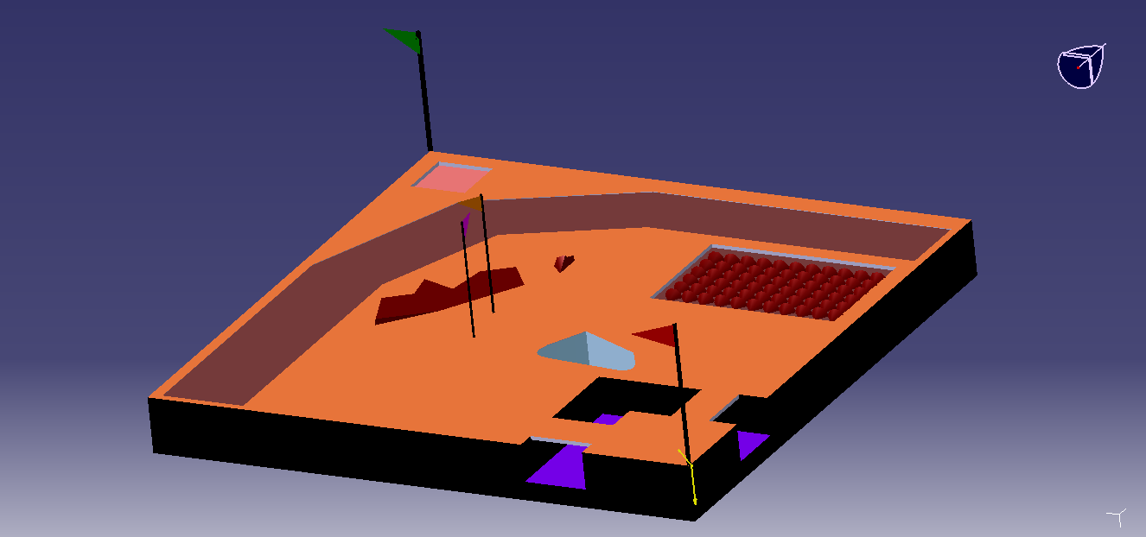

ROUND 2:
In this arena two bots start from their starting zone for the same task in the arena similar to round 1 with more hurdles. The hostages will be buried under sand. The bot has to uncover the hostage by removing the stone and then dig up the hostage. Depth of sand will be 10cm and hostages will be placed at a depth of 5cm and 8cm. A hostage is said to be ‘dug up’ when it is completely visible. The bot can also avoid the uncovering of the hostage but in that case will be awarded no points. The safe zones for the two bots will be diagonally opposite to there starting zones. The hostages have to be taken one by one to the safe zone. The bot which completes the task first wins.

ARENA ROUND 2:

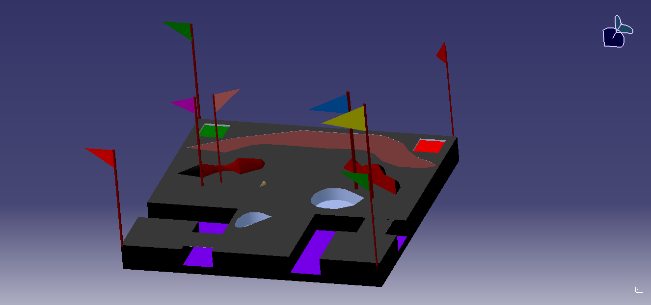
SCORING AND JUDGING:
- The total points allotted is 250.
- Uncovering the task awards you 50 points.
- Hurdles:
Mud path-25 points
Pebbles-25points

- Rescuing each hostage will award you 100
- Digging up the hostage awards 50 points.

Total time:6 minutes.

For more details contact:
Bijay Kumar- bijay_kumar37@gmail.com

ALL THE BEST.

