KLA IT Helpdesk Project Report

1. Introduction
The KLA IT Helpdesk is a centralized complaint management system designed to streamline the reporting, tracking, and resolution of IT-related issues within the organization. The system is built using the Laravel framework and Filament PHP to provide a robust, scalable, and user-friendly interface.

2. Module Explanation

2.1 Complaint Register (Core Module)
This is the primary module of the system, responsible for the end-to-end lifecycle of an IT complaint.
- Complaint Registration: Users can log new hardware or software issues, specifying the location and nature of the problem.
- Ticket Tracking: Each complaint is assigned a unique tracking ticket number for easy reference.
- Status History: Comprehensive tracking of status changes (e.g., Open, Assigned, Pending, Resolved) with remarks, ensuring full auditability.

2.2 IT Complaint Register Live Dashboard
A specialized, real-time dashboard designed for swift incident response, heavily utilized by the CHM (Computer Hardware Maintenance) team and Hardware Administrators.
- Live Screen for CHM: The Live dashboard provides technicians with an instant overview of all currently open and pending tickets. It auto-refreshes or allows rapid interaction without traditional page reloads.
- Take Ownership ("Take Ticket"): Technicians (CHM) and Hardware Admins can instantly assign an open ticket to themselves with a single click. This action automatically updates the ticket status from "Open" to "Assigned" and logs the assignment history.
- Unified Search: Features a streamlined search bar allowing CHM to quickly locate tickets by Ticket Number, Section, Technician Name, or Location.

2.3 WhatsApp Notification Integration
The system features an automated and highly formatted WhatsApp notification mechanism that keeps all stakeholders informed in real-time.
- Event-Driven Alerts: Automated messages are triggered at critical points in the complaint lifecycle: upon Ticket Creation, Technician Assignment, and Status Updates.
- Clean and Standardized Formatting: Notifications adhere to a professional template where the "Section" is prominently displayed at the top, followed by a non-breaking space aligned header (e.g., `*Name* [TicketNo]`). Empty fields are intelligently hidden to keep the message concise.
- Easy Forwarding: The meticulously structured message format allows technicians and administrators to easily forward the WhatsApp details to external vendors or other departments without needing to edit or clean up the message text manually.

2.4 Vendor Complaints
This module handles issues that require third-party vendor intervention, such as hardware replacements under warranty. It tracks vendor-specific details like Vendor Complaint IDs (e.g., "Complaint (No.12345)") and expected resolution dates.

2.5 User & Role Management
A comprehensive access control system based on organizational roles, managing employee and technician accounts to ensure data security.

2.6 Location & Infrastructure Management
A hierarchical mapping of the organizational physical layout (Administrative Offices, Floors, Rooms, and Sections) to precisely pinpoint complaint locations.

3. Role-Wise Login Details & Access Details
The system incorporates role-based access control (RBAC). Below are the details for each role and a screenshot of their respective dashboard views upon logging in.

3.1 Superadmin
Username/Email: superadmin@kla.com
Responsibilities: Complete oversight of the system. Has access to all modules including User Management, System Configuration, and all complaint registers.
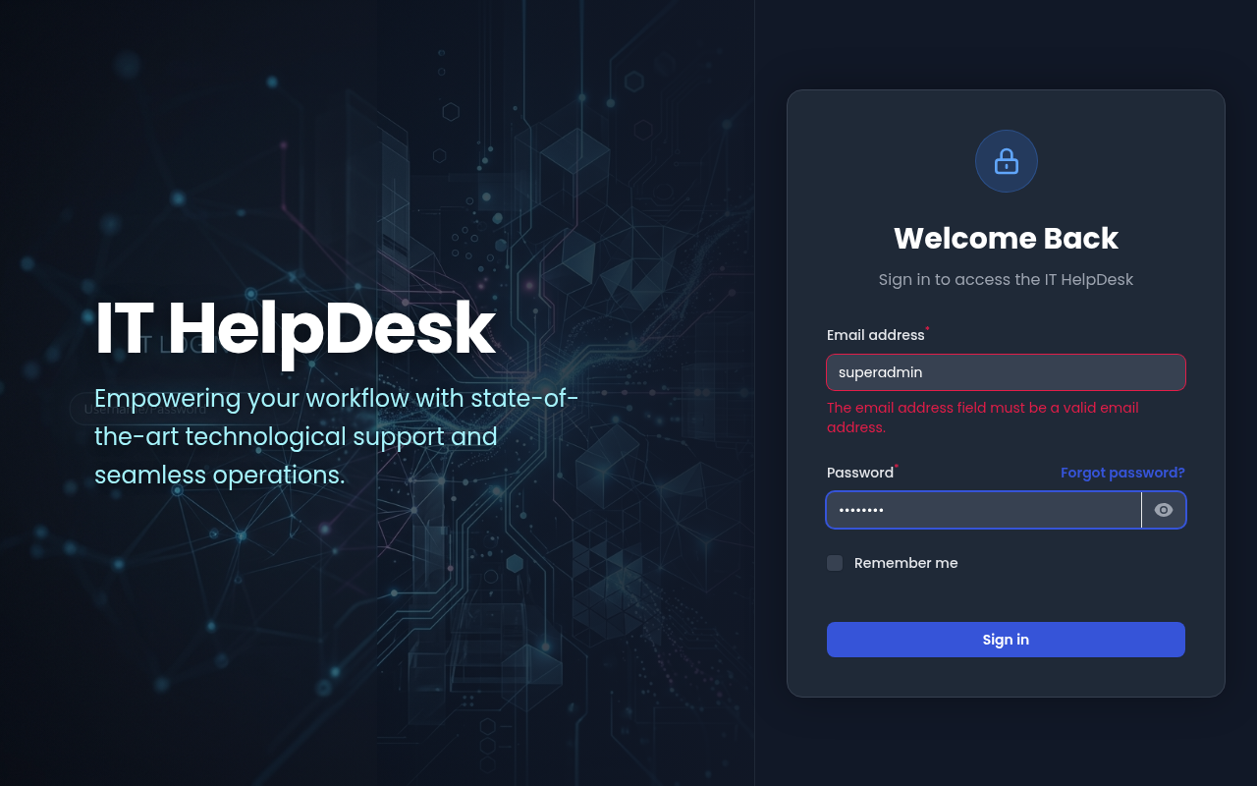

3.2 Hardware Administrator (hardwareadmin)
Username/Email: mgopiraj@niyamasabha.nic.in
Responsibilities: Manages IT operations. Can view all complaints, assign technicians to tickets via the Live Screen, manage infrastructure definitions, and handle vendor-level issues.
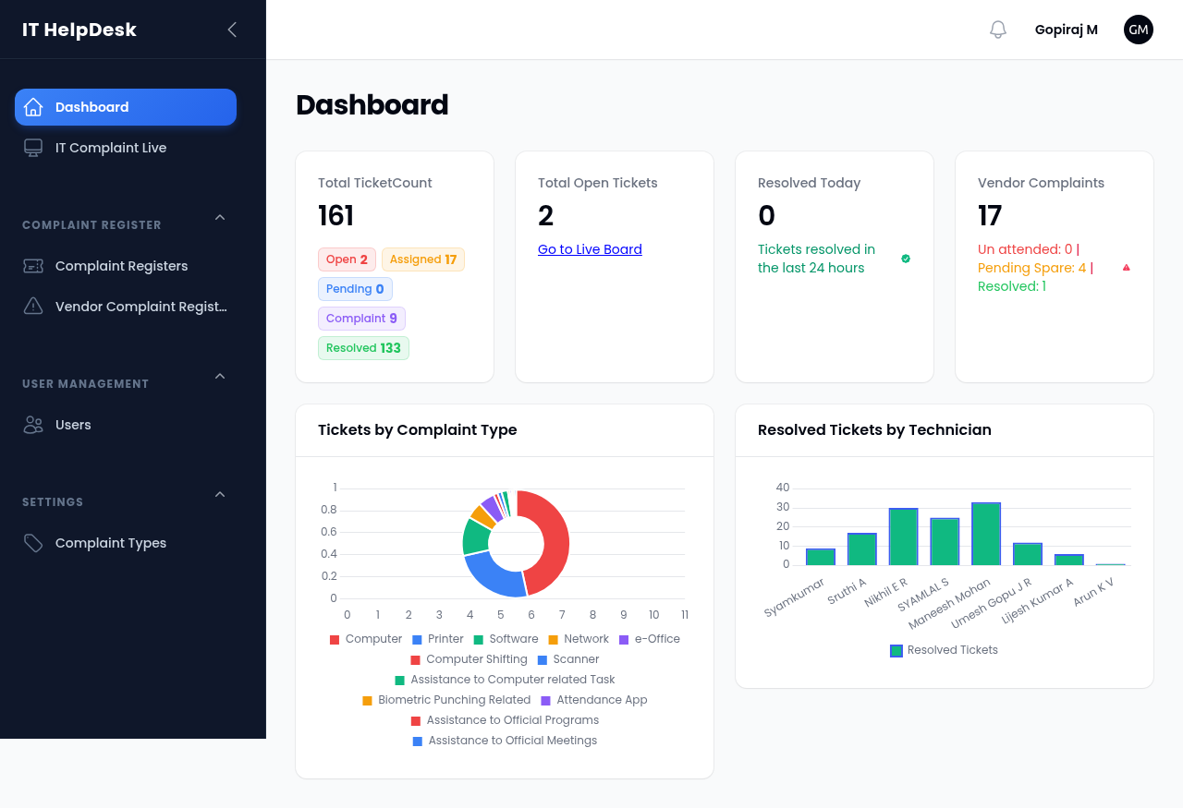

3.3 Computer Hardware Maintenance (chm) / Technician
Username/Email: syamjust4you@gmail.com
Responsibilities: Ground-level IT staff responsible for resolving issues. Their dashboard focuses heavily on the Live Complaint Register. They can take ownership of tickets ("Take Ticket"), update resolution details, and mark complaints as resolved.
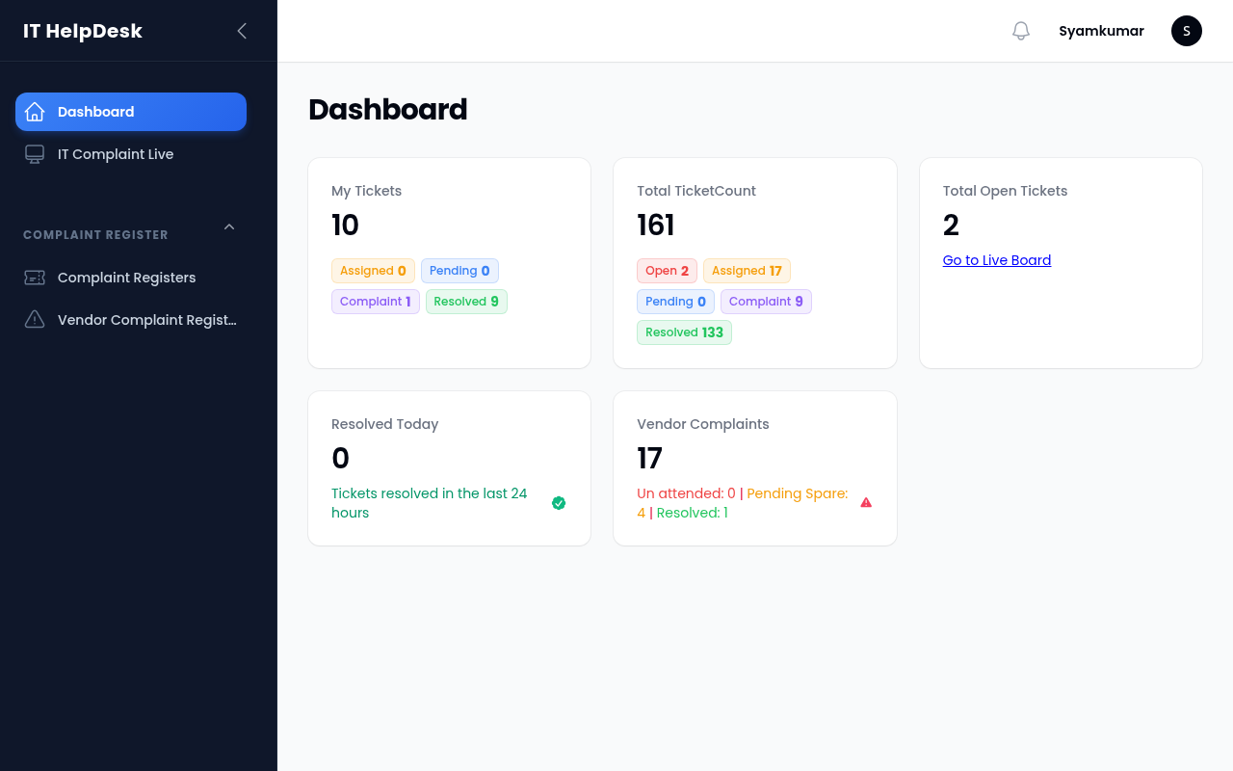

3.4 Administrator (admin)
Username/Email: madhavannair@niyamasabha.nic.in
Responsibilities: General administrative oversight. Can view reports and track system efficiency without being involved in day-to-day technical resolutions.
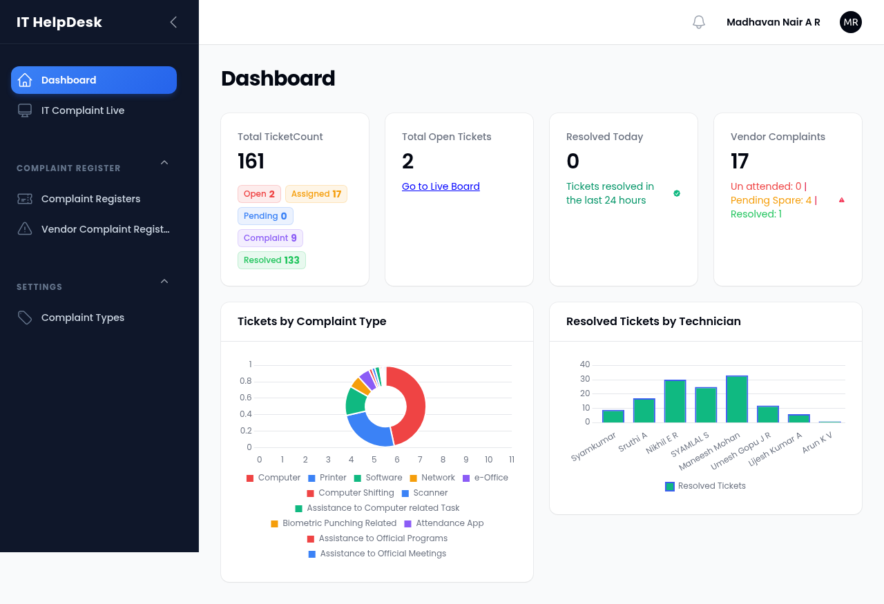

3.5 Department User / Helpdesk Staff (cowd)
Username/Email: sumiajilal@gmail.com
Responsibilities: Often acts as a primary logger of complaints or views specific departmental IT requests.
