MIDTERM

# Title

Social web application to create, Sharing, tracing and walking through routes

# Design:

I used Model View Control architecture to design my web application.

1. Architecture design

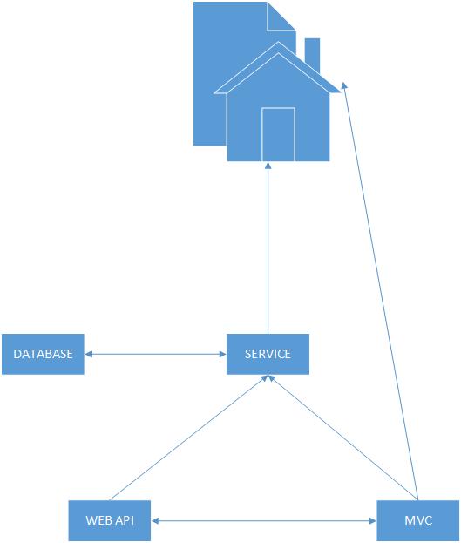

1. Class Diagram

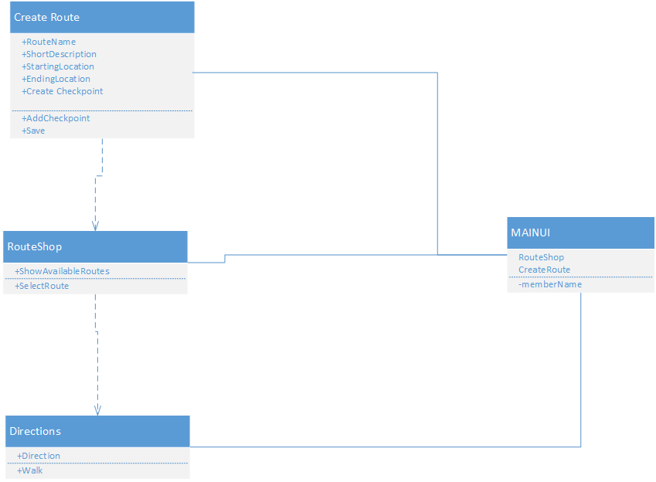

# Features Implemented:

1. Web services:

I used Google maps API v3 to get directions in route shop hyperlink.

Twitter Bootstrap API is used for the look and feel of the web application.

1. Database:

I created a database RoutesDB which consists of 3 tables as shown below

Checkpoints Table:

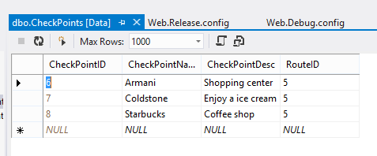

Points of interest table :

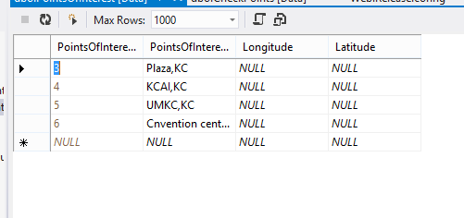

Routes table:

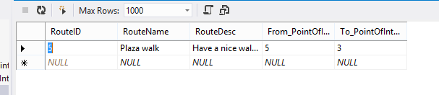

The routes table is used to save routes so that they can be called later, Points of interest are the default places we provide in a certain region and Finally Checkpoints table saves the main important places which are a must see places in that area.

C) Mobile design:

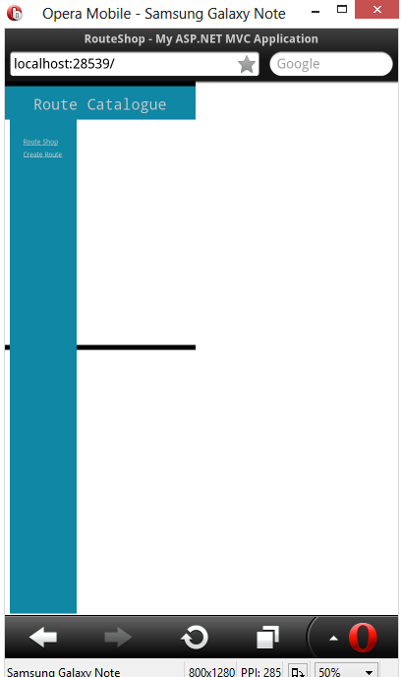

# SCREEN SHOTS:

Creating a route

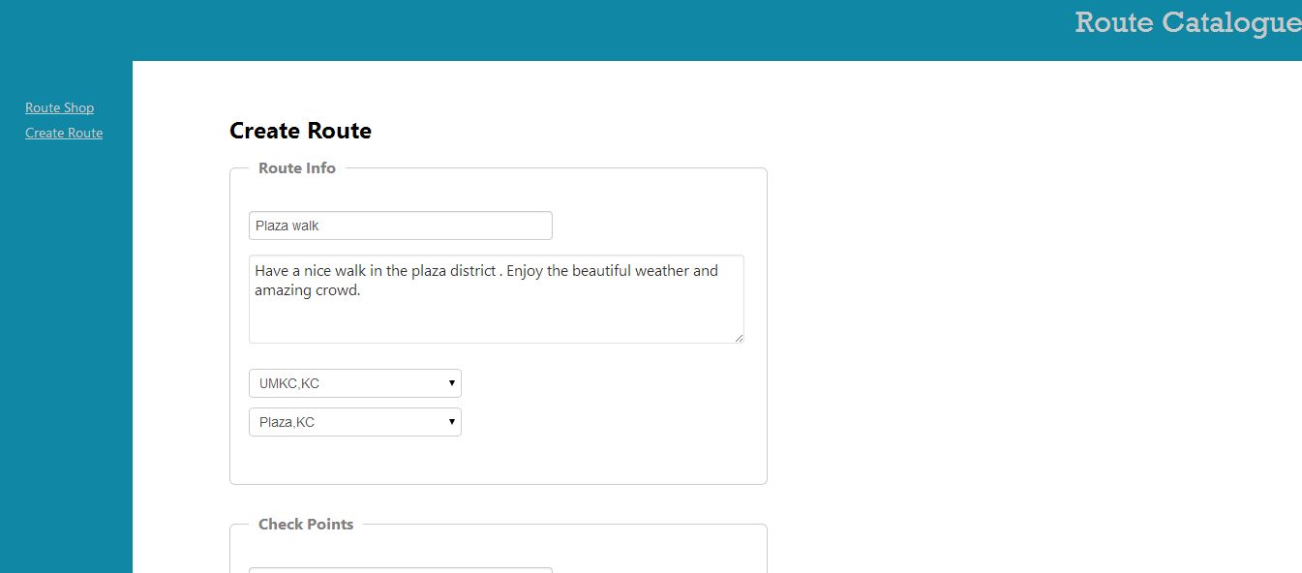

Creating Checkpoints: 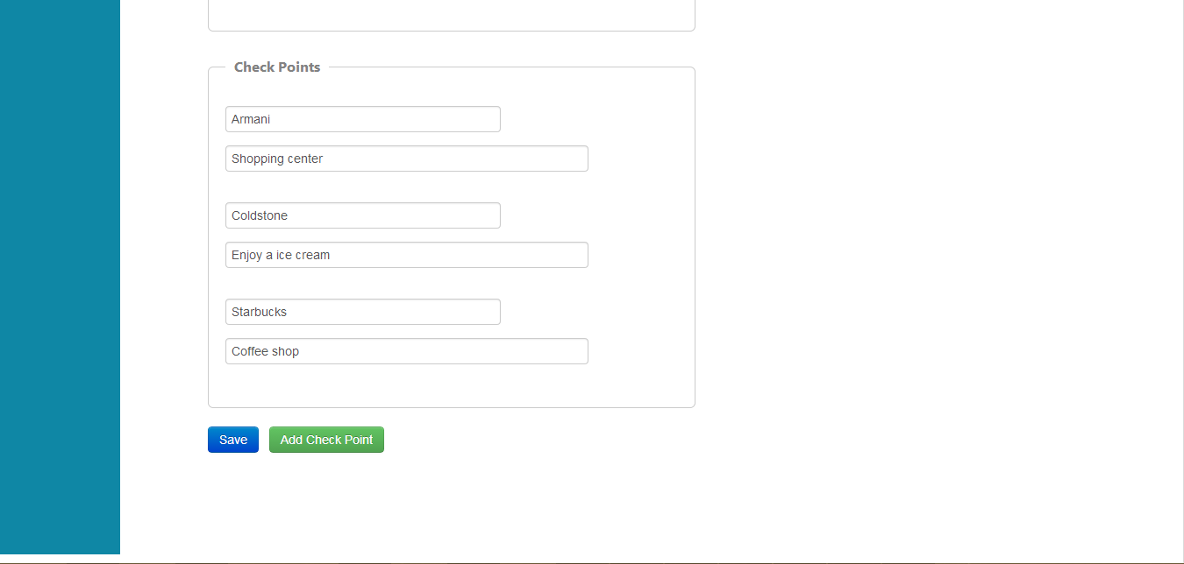

After this step we save our checkpoints and route which appear in the route shop

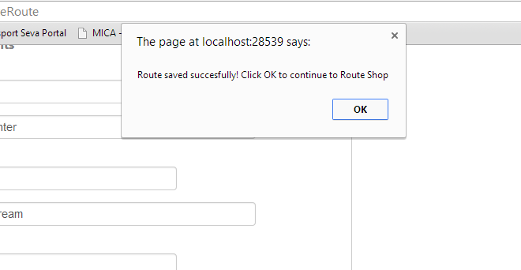

Route shop:

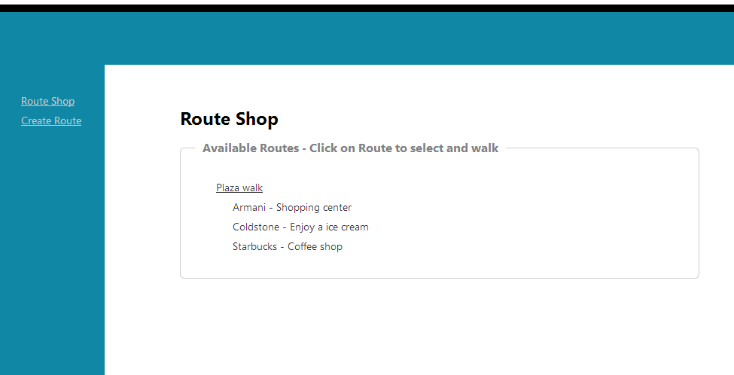

I created a demo route from UMKC to plaza

After we click on Plaza walk the direction menu appears

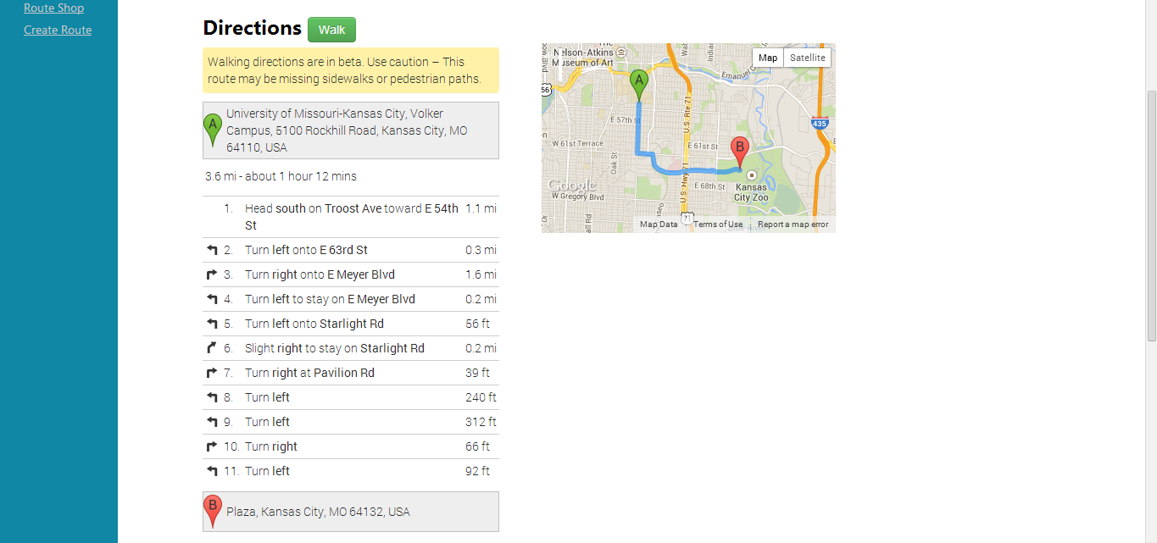

When we click the walk button it checks for the check points in the route

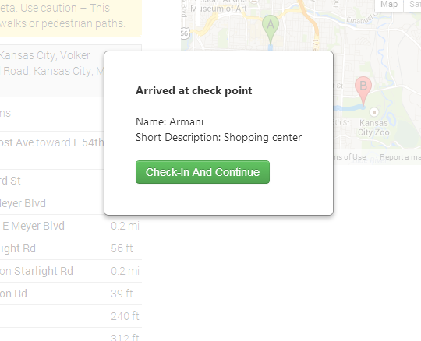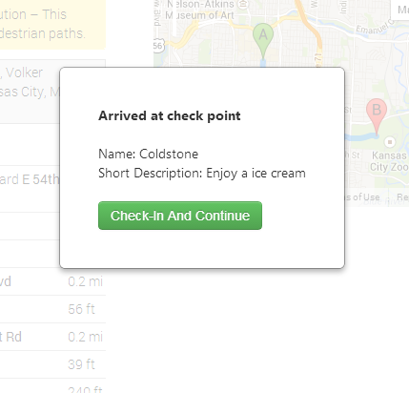

After we click Check-In and continue it shows that we have reached our destination

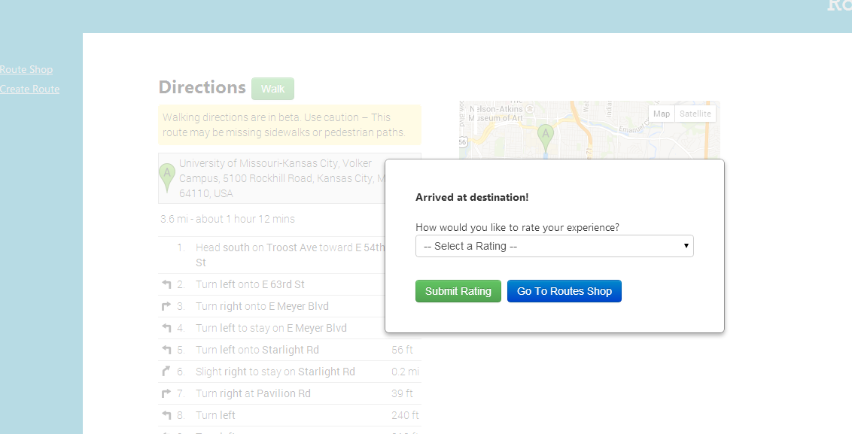

And ask Users to rate their experience.

GITHUB link: https://github.com/vishnurainigari/Midterm

Limitations: 1) not able to locate a user and show the places around him like four square

2) Mobile implementation still has errors.

References:

<https://developers.google.com/>.

<http://getbootstrap.com/>.

<http://www.asp.net/mvc/tutorials/controllers-and-routing>

<http://www.asp.net/>

http://www.w3schools.com/css/css_examples.asp