Kubernetes
- Cluster setup
- Create three VMs
- Cluster configuration includes one master node and two worker nodes
- ISO Image: Ubuntu 24.04.3
- CPU: 2 cores
- RAM: 2 GB (2048 MB)
- Disk: 20 GB
- Network:
  - Adapter 1: NAT (for internet access)
  - Adapter 2: Host-only Adapter
- Click → Finish
- Just record the IPs of all nodes with:
ip a
- Add all node hostnames and IP address to the /etc/hosts file of each node:
vim /etc/hosts
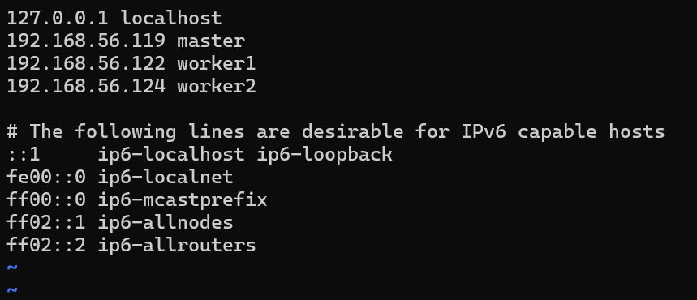
- Install the following software on all nodes
- Docker or container runtime
  - Install Docker package
apt-get install docker.io -y
  - Enable Docker to launch on boot
systemctl enable docker
  - Verify Docker is running
systemctl status docker
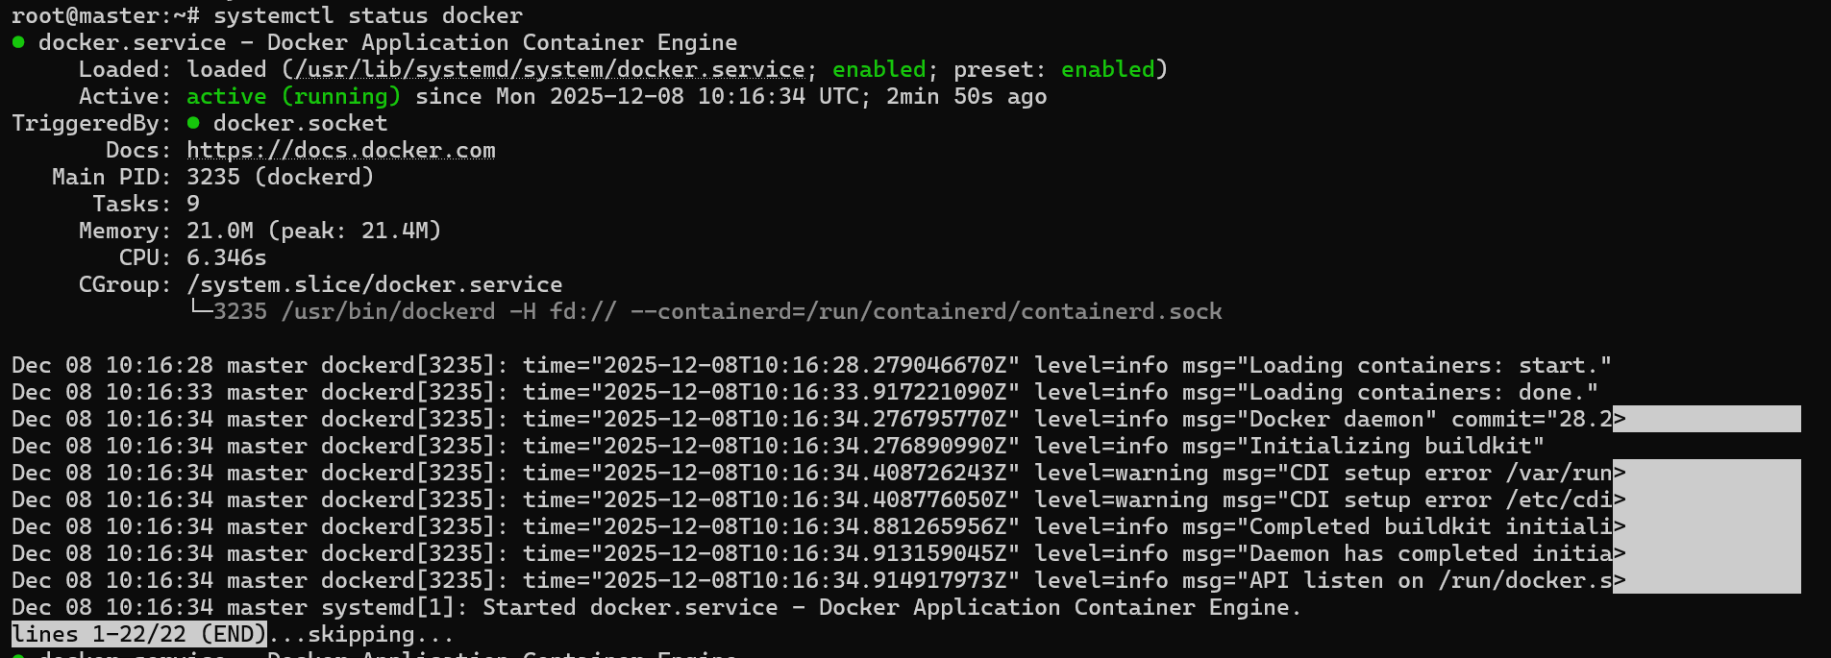
  - Change container configs SystemdCgroup=false to true in the config.toml file. Follow the below commands to create config.toml if doesn't exist it.
mkdir -p /etc/containerd

containerd config default | sudo tee /etc/containerd/config.toml

grep SystemdCgroup /etc/containerd/config.toml
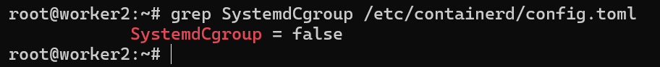
  - SystemdCgroup value is false, so we need to change to true
sed -i 's/SystemdCgroup \= false/SystemdCgroup \= true/g' /etc/containerd/config.toml

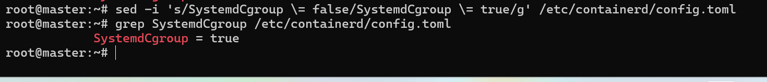
  - Restart the containerd
systemctl restart containerd
- Install kubeadm, kubelet, kubectl
apt-get install -y kubelet kubeadm kubectl
- Enable kubelet service
systemctl enable --now kubelet
- For configure Kubelet, need to add a line to disable read swap by kubelet
sed -i '5 i Environment="KUBELET_EXTRA_ARGS=--fail-swap-on=false"' /usr/lib/systemd/system/kubelet.service.d/10-kubeadm.conf

- Disable swap
- Display system memory usage for all nodes:
free -m
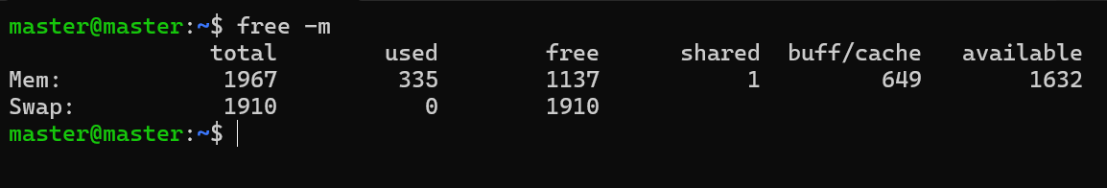
- Open /etc/fstab file of each node:
vim /etc/fstab
- Comment the line of the swap
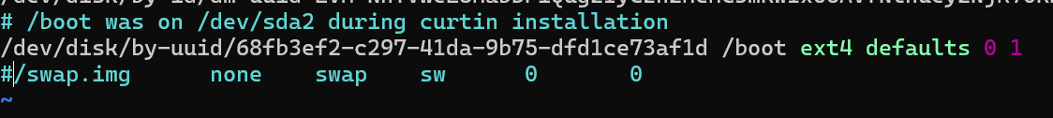
- Disable swap now
swapoff -a
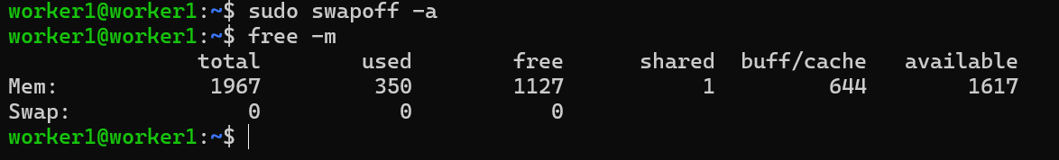
- Initialize the Kubernetes master node
- To initialize the cluster includes the pod network option (give address as your master Ips address and control plane as your master’s name)
kubeadm init --apiserver-advertise-address=192.168.56.119 --control-plane-endpoint=master --upload-certs --pod-network-cidr=10.12.0.0/16
- After installing the kubeadm on master node, configure kubectl to access the cluster
mkdir -p $HOME/.kube ##create .kude directory
cp -i /etc/kubernetes/admin.conf $HOME/.kube/config

- Join worker nodes
- Check your kubeadm initialization output to copy the exact command to join any number of worker nodes (below command is an example):
kubeadm join master:6443 --token 6ms6xl.yha0zo07984202co \
--discovery-token-ca-cert-hash sha256:87a9b0effee6b2cf1078456d4f69f9cf235ddecfa3888bffecd7bcf487e7c197

- Verify the cluster
- Verify the cluster is running using:
  - kubectl get nodes
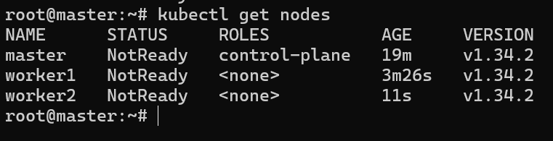
  - kubectl get pods -A
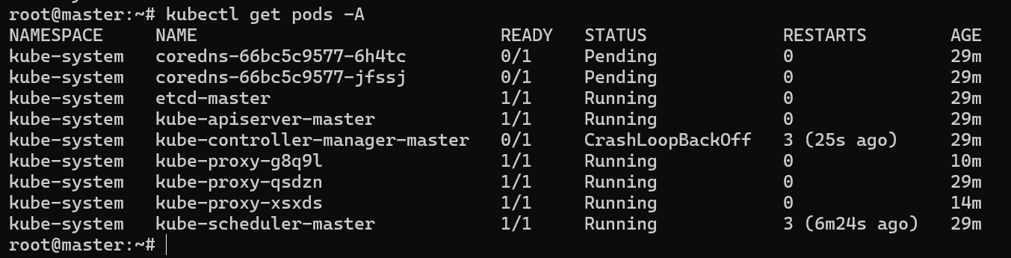
- Install a network plugin (Calico)
- Installing calico operator
kubectl create -f https://raw.githubusercontent.com/projectcalico/calico/v3.27.2/manifests/tigera-operator.yaml

tigera-operator is installed in namespaces
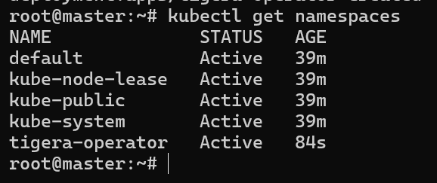
- To install the objects on this namespace
kubectl apply -f https://raw.githubusercontent.com/projectcalico/calico/v3.27.2/manifests/calico.yaml

- After installing the network plugin, check all pods are running
kubectl get pods -n kube-system
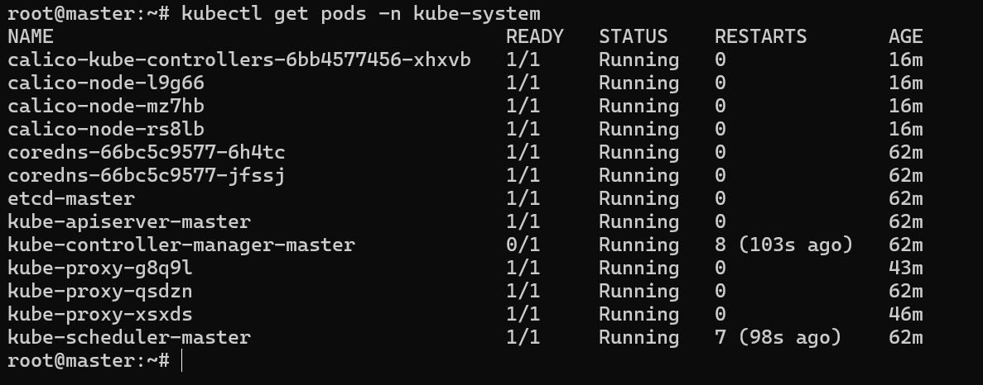
- After network plugin pods are running, check the nodes status it will be ready
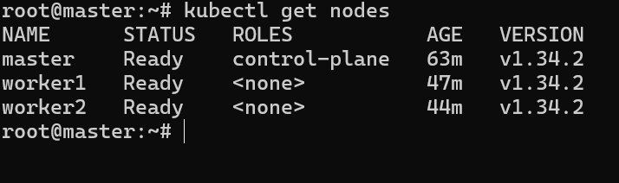

- ConfiMaps

- Deployments

- Ingress

- Namespace
Create a Kubernetes Namespace named jan2025 using an imperative command.
- Imperative Command to Create Namespace
kubectl create ns jan2025
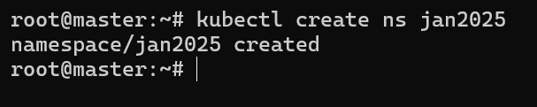
- Verify Namespace Creation
kubectl get ns
Or
kubectl get namespaces
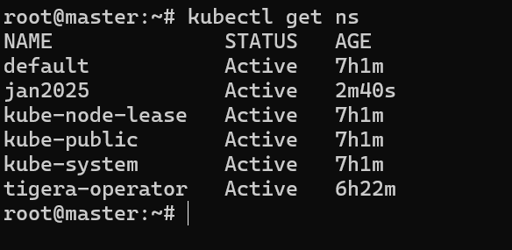
- Pod
- Namespace
  - Imperative Command to Create Namespace
kubectl create ns jan2025
- Pod Creation
  - kubectl run jan --image=nginx:1.14.2 --namespace jan2025
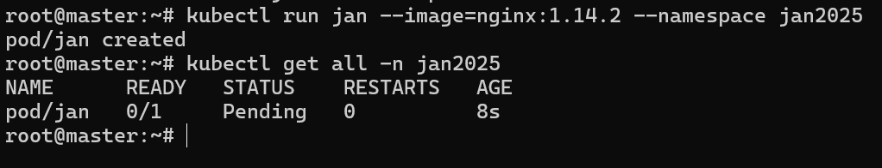
- Customize Web Page
- Validation
- Pod Administration

- Secrets

- Service

- User

