Software Requirements Specification
for
<Mobile Based Auto Grading Of Answersheets>

Prepared by
B15CS003,B15CS010,B15CS027,B15CS036

<13/02/18>
Table of Contents
Table of Contents ii
Revision History iii
1. Introduction 1
1.1 Purpose 1
1.2 Intended Audience and Reading Suggestions 1
1.3 Product Scope 1
1.4 References 1
1.5 Product Perspective 2

2. External Interface Requirements 3
2.1 User Interfaces 3
2.2 Application Flow
2.3 Hardware Interfaces 3
2.4 Software Interfaces 3

Revision History
Name | Date | Reason For Changes | Version
R&A Team | 13/02/18 | Project report

Introduction

Purpose
Big institutes use expensive OMR software along with the machines associated to evaluate the OMR sheets. Small institutes and individual teachers would not have the financial credibility to afford the costly setup and would have to manage it using manpower. So our idea is to use a simple mobile application with simple interface that would be understandable to all.

Intended Audience and Reading Suggestions
This is intended those who want’s to correct OMR sheets who does not have the financial credibility to afford the costly setup.

Product Scope
The “Mobile Based Auto Grading Of Answersheets” is a mobile application which helps people to correct OMR sheets without any expenses . The application should be free to download from either a mobile phone application store or similar services.
All system information is maintained in a database, which is located on a web-server. The application will give output as grade and marks..

References

[1] http://docs.opencv.org/2.4.9/modules/flann/doc/flan n_fast_approximate_nearest_neighbor_search.html

[2] Digital Image Processing (3rd Edition) -Rafael C. Gonzalez

[3] Learning OpenCV-Computer Vision with the OpenCV Library- Gary Bradski, Adrian Kaehler

[4] High Level Computer Vision Using OpenCVGraphics, Patterns and Images Tutorials (SIBGRAPI-T), 2011 24th SIBGRAPI Conference on 28-30 Aug. 2011

[5] Opencv implementation optimized for a cell broadband engine processor- Sugano, H. ; Dept. of Commun. & Comput. Eng., Kyoto Univ., Kyoto ; Miyamoto

[6] B. Girod. “EE 368 Digital Image Processing Notes”. EE 368 Digital Image Processing. Spring 2011-2012

[7] http://morf.lv/modules.php?name=tutorials&lasit=2 Features2D + Homography to find a known object,

[8] http://docs.opencv.org/doc/tutorials/features2d/feat ure_homography/feature_homography.html#featur e-homograp Overall Description

Product Perspective:

We explore an image-processing algorithm for auto grading of answer sheets using the mobile phone. Multiple-choice questions are widespread mechanism used by schools and universities to test student performance. They are common on standardized tests. Big organizations use OMR forms coupled with OMR software and dedicated scanner for grading multiple choice questions. But small institutes and individual teachers cannot afford this costly setup and have to do time consuming manual grading. So we propose a mobile application that can be used by anyone at any time to grade answer sheets and save the valuable time spent grading manually.

External Interface Requirements

User Interfaces
A first-time user of the mobile application should see the log-in page when he/she opens the application, see “login page”.If the user has not registered, he/she should be able to do that on the log-in page.
Every user should have a profile page where they can edit their e-mail address, phone number and password, see “profile page”

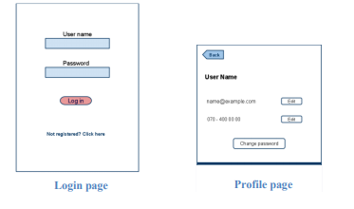

APPLICATION FLOW
Figure showen below the complete application flow. This section will describe how the whole application will works inside android smart phone. Inside this application when the main page appears on the screen there are three buttons. The first button named capture reference answer sheet, it is used to take the picture of the reference answer sheet and extract the correct answers from the image. The second button named capture student answersheet. It is used to take the picture of the student answer sheet and extract student responses to each question. The third and last button on the main page of the application called view result is used to compare the correct reference answers with student’s answers, and generate the result table containing highlighted correct and wrong answers with different colours .
- Capture Reference Answer Sheet
This application will perform its functions when the picture is clicked using android smart phone camera. When the capture reference answer sheet button is pressed the application will use the camera of android smart phone to click a clear image of reference answer sheet with correct answers. To extract the correct answers from the clicked image, our main image processing algorithm is invoked. A list data structure is used to store the extracted correct answers which is used later on, when result is generated by view result button.
- Capture Student Answer Sheet
The basic function performed by this button is almost same as Capture Reference Answer Sheet, except that the taken image is of student’s answer sheet. Again a list data structure is used to store the extracted student answers from the clicked image using image processing algorithm.
- View Result
There are two list data structures involved:-
- The list data structure which contain the correct answers from reference answer sheet and
- The list data structure which contain correct as well as wrong answers from the student answer sheet.

Both these are compared to generate a graded result table which will show correct answers and wrong answers with different colour highlighting.
- Correct answers are highlighted in green.
- Incorrect answers are shown in red and correct answer for it is shown in grey colour.

After the answers are displayed,more answer sheets can be processed without taking the snapshots os reference answer sheets.

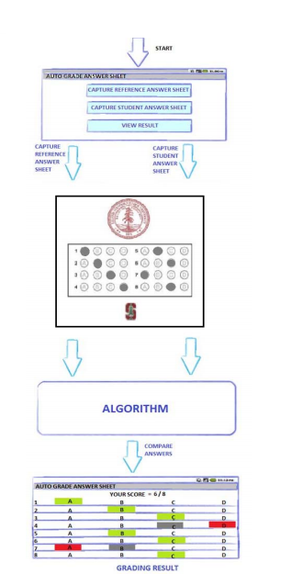

Hardware Interfaces
Since neither the mobile application nor the web portal have any designated hardware, it does not have any direct hardware interfaces.
The hardware connection to the database server is managed by the underlying operating system on the mobile phone and the web server.

Software Interfaces
The mobile application communicates with the Camera application in order to capture the OMR sheet.

