**1)ADD_Task**

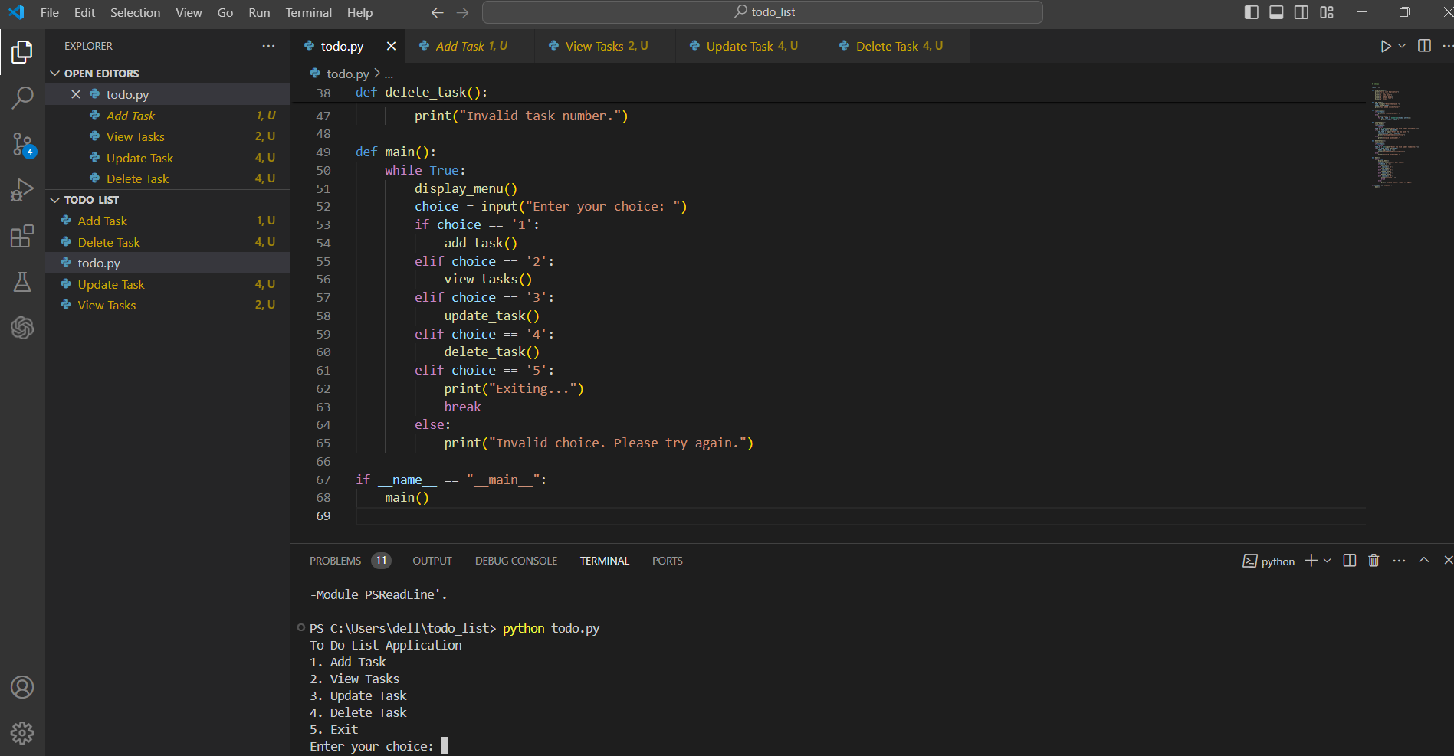

**2)TASK HAS BEEN ADDEDD**

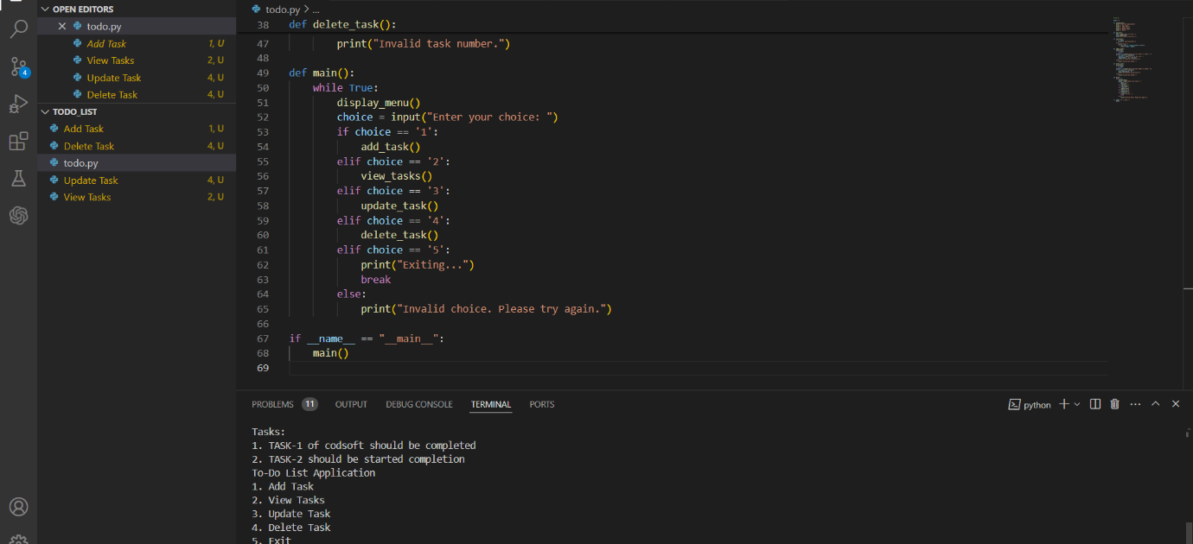

**3) ALL THE TASKS ARE VISIBLE** 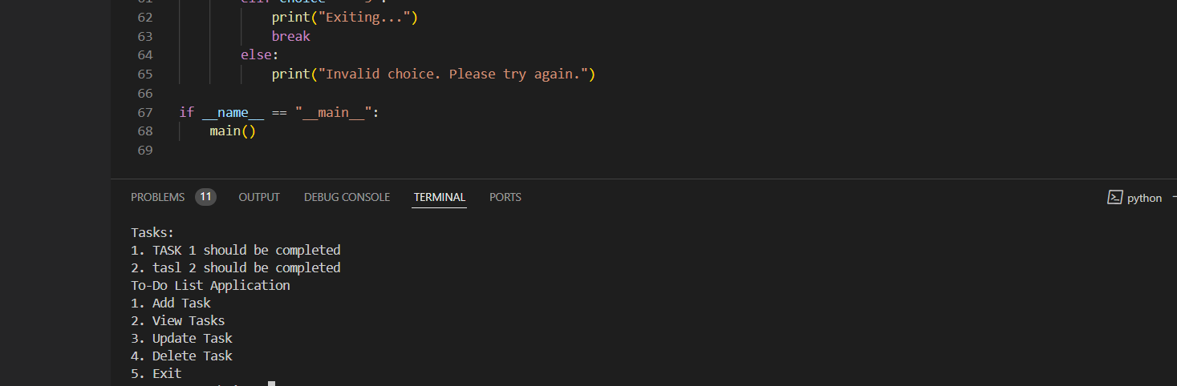

**4)TASK HAS BEEN SUCESSFULLY UPDATED**

