**CD01.4: Create Azure DevOps build agents**

**Build Agents:**

To build your code using Azure pipeline you need atleast one agent. When your pipeline runs, the system begins one or more jobs. An agent is Computing infrastructure with installed agent software that runs one job at a time.

There are two types of Agents.

* Self-hosted agents
* Microsoft-host agents

**Microsoft-hosted agent:**

If your pipelines are in Azure Pipelines, then you've got a convenient option to run your jobs using a **Microsoft-hosted agent**. With Microsoft-hosted agents, maintenance and upgrades are taken care of for you. Each time you run a pipeline, you get a fresh virtual machine. The virtual machine is discarded after one use. Microsoft-hosted agents can run jobs [directly on the VM](https://docs.microsoft.com/en-us/azure/devops/pipelines/process/phases?view=azure-devops) or [in a container](https://docs.microsoft.com/en-us/azure/devops/pipelines/process/container-phases?view=azure-devops).

Azure Pipelines provides a pre-defined agent pool named **Azure Pipelines** with Microsoft-hosted agents.

**Self-hosted agents:**

An agent that you set up and manage on your own to run jobs is a **self-hosted agent**. You can use self-hosted agents in Azure Pipelines. Self-hosted agents give you more control to install dependent software needed for your builds and deployments. Also, machine-level caches and configuration persist from run to run, which can boost speed.

For this agent agent pools has to be created by the user. To create agent pool follow below steps:

1. Log into [Azure DevOps](https://dev.azure.com/) and navigate to the appropriate Organization and Project.
2. Click on **Project Settings** and **Agent Pools**.

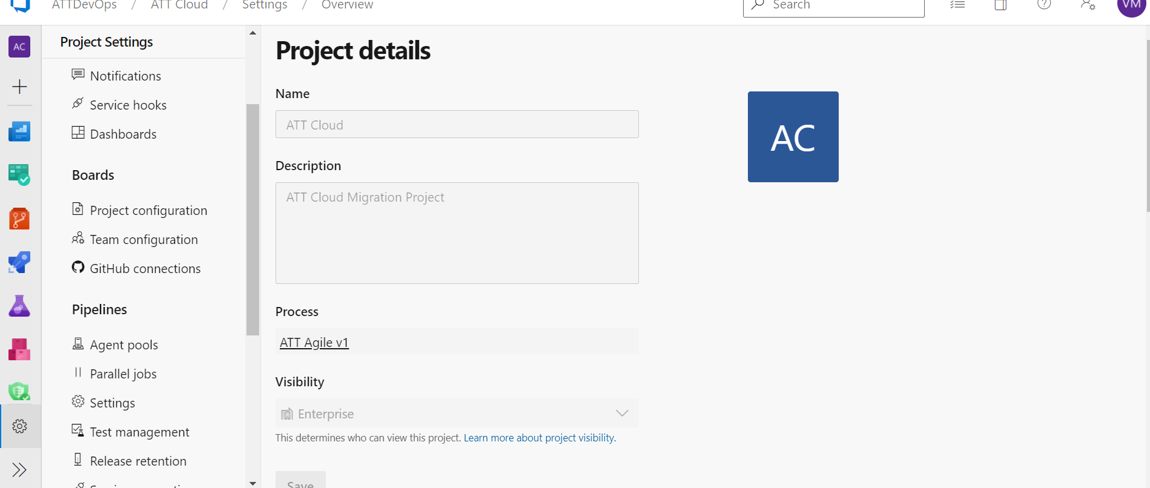

1. Click on **Add Pool** at the top right corner.

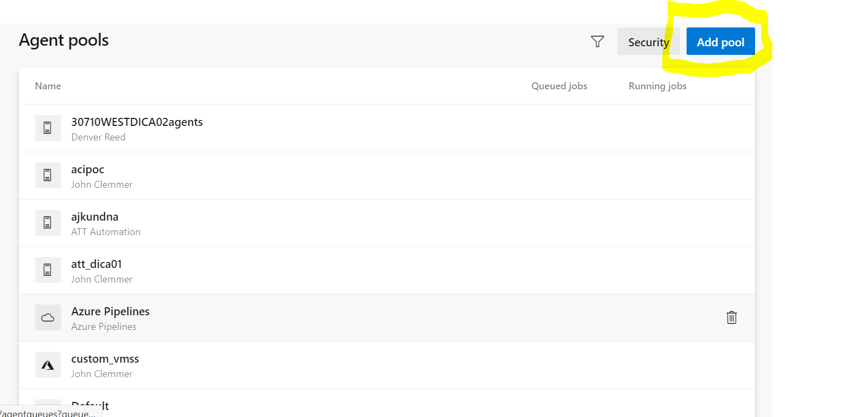

1. Select the Pool Type to be **Self-Hosted**.
2. Agent Pool Name must use this format: "**<MOTS_ID>agents**" (*e.g. 12345agents*)

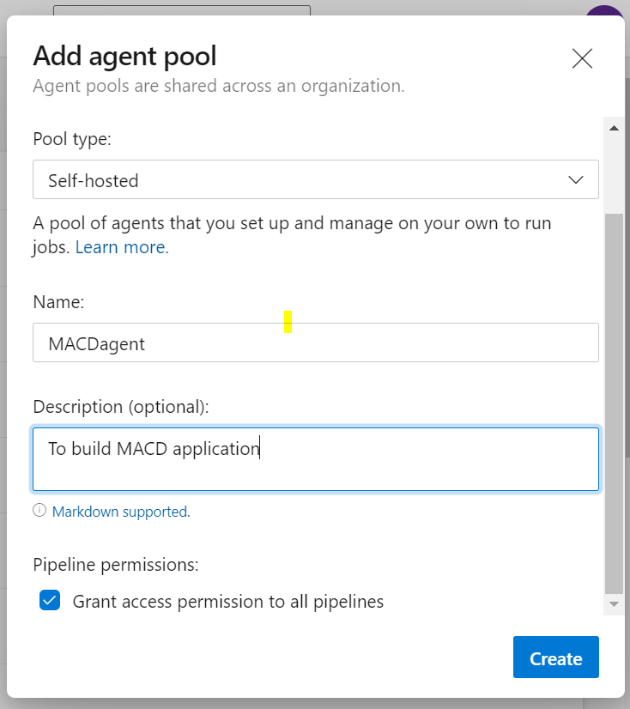

Note: If you grant permission to all pipelines, Agents in this pool can be used by all the pipelines in the organization.

**Generate Azure DevOps Personal Access Token**

Personal Access Tokens (PAT) are alternate passwords that can be used to authenticate into Azure DevOps. You will need a PAT for creating an agent pool and registering your agents that are created in the Terraform script. To create that PAT, ensure you have permissions (use the same account that created the agent pool) and do the following:

1. Sign into [Azure DevOps](https://dev.azure.com/) and navigate to the appropriate organization given by AT&T DevOps onboarding process (e.g. ACC-Azure-01)
2. From your home page, open your **User Settings** from the top right corner by your avatar, and then select **Personal Access Tokens**.

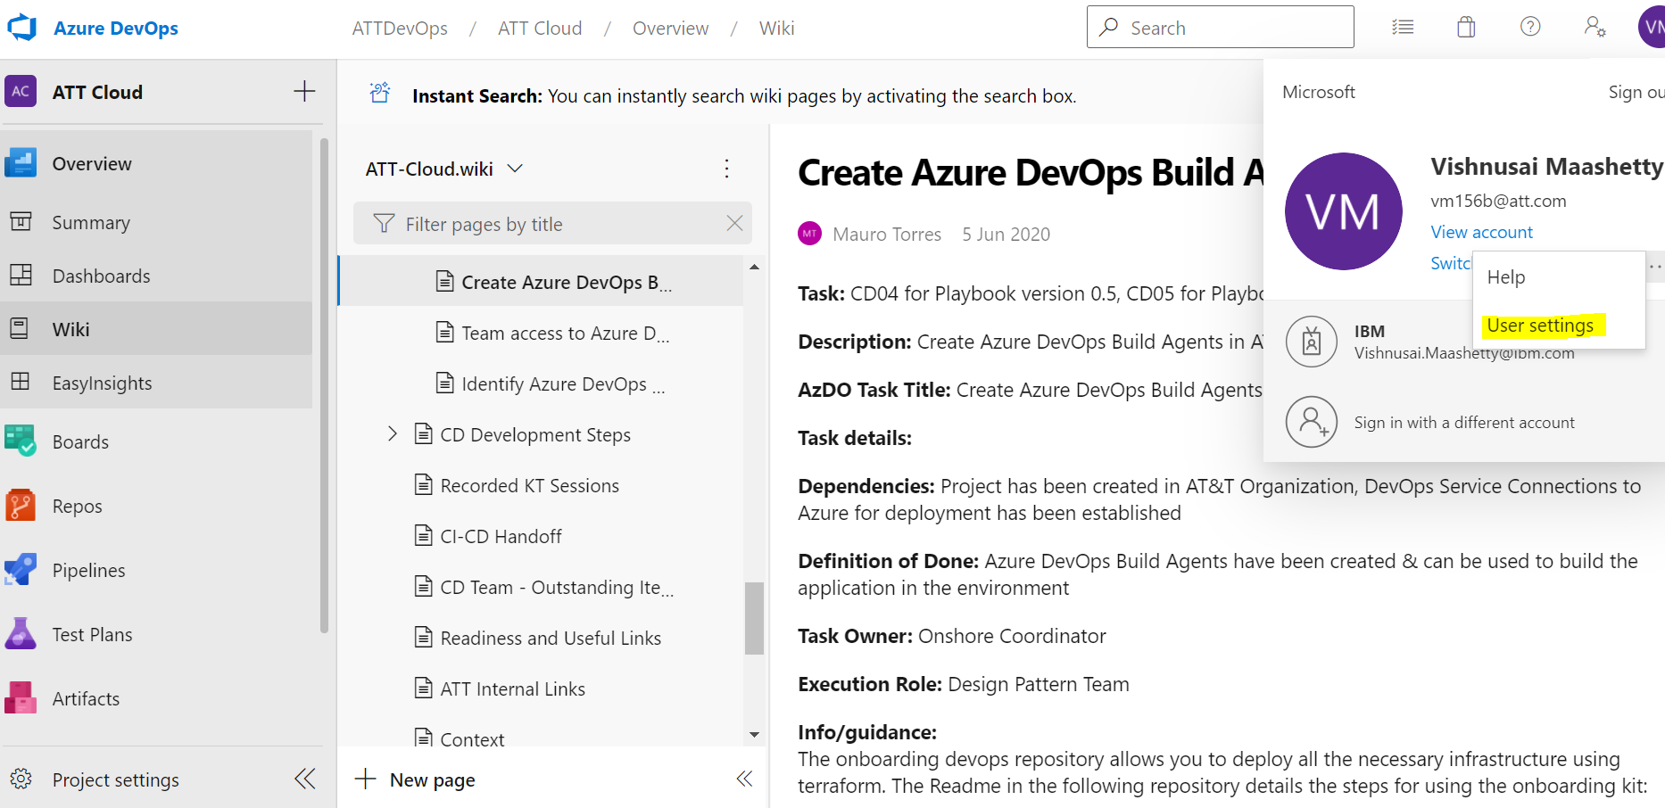

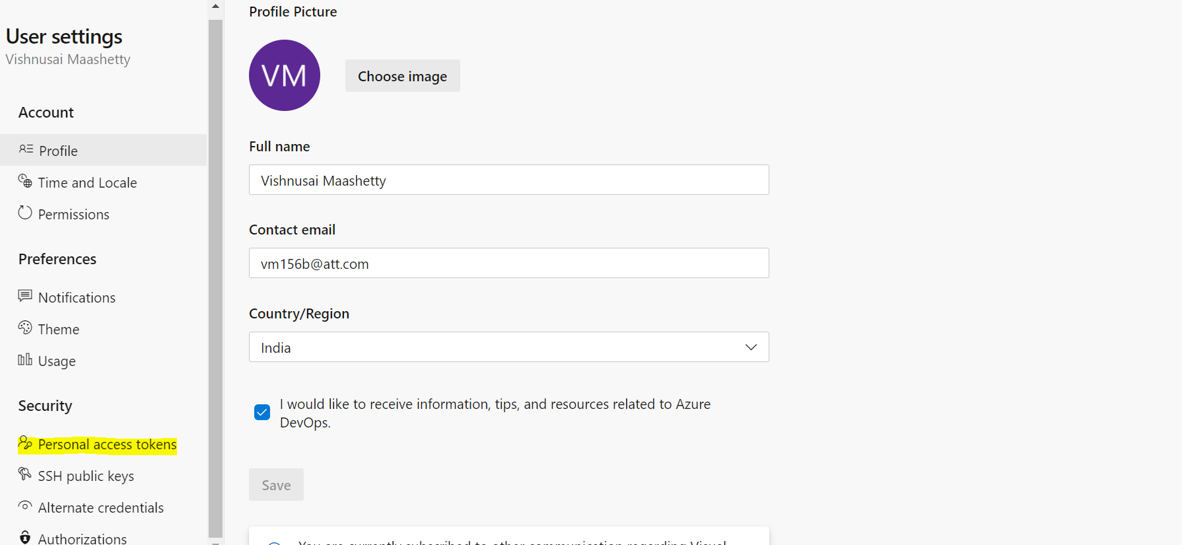

1. Click **+ New Token**.
2. Name your token (e.g "<MOTSID>agents PAT"), select your organization under Organization (e.g. ACC-Azure-01), and then choose a lifespan for your token (e.g. Custom - 1 year from now).
3. Under **Scopes**, select **Show all scopes** at the bottom of this window to see the complete list of scopes, select/check:
   1. **Read & Manage** under **Agent Pools**. This will allow you to pass the PAT into the Terraform script and register agents.

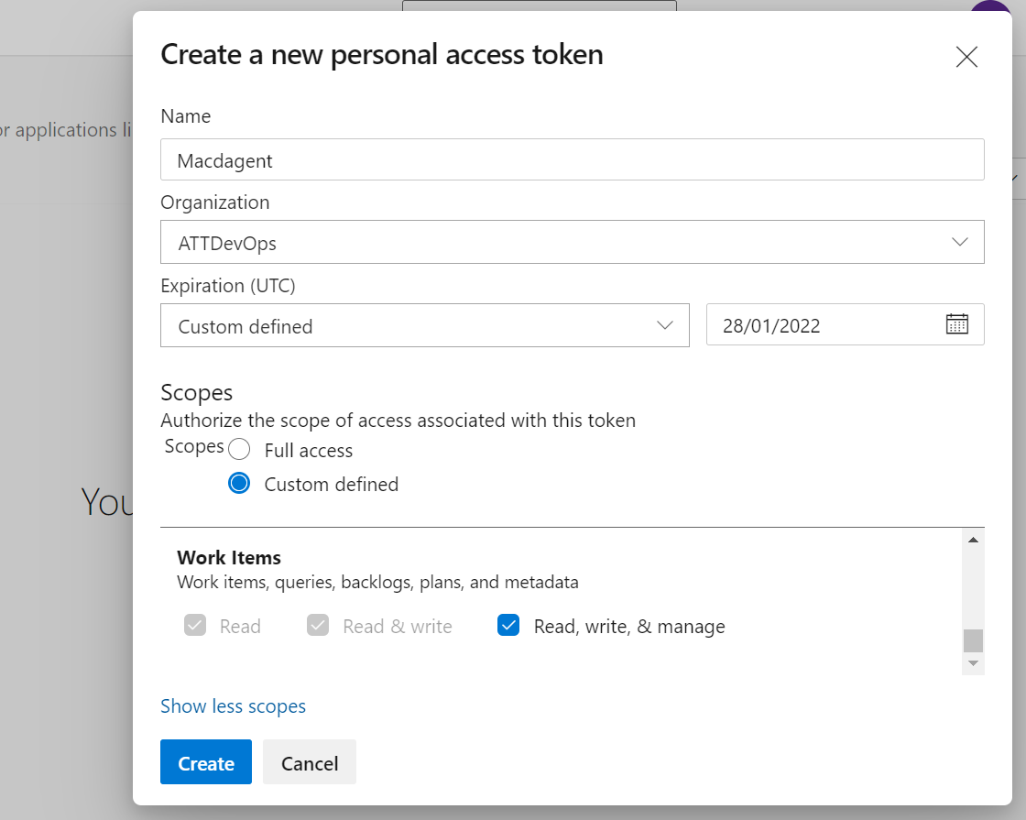

1. Click **Create**.

**Note: Be sure to copy the token value at this time because you will not be able to see it again!**

## ****Setup Maintenance Jobs****

To ensure the agents do not run out of space with data from previous runs, you will need to manually setup maintenance jobs as well. These jobs will run at a specified date and time that you select. To setup maintenance jobs, do the following:

1. Click on **Organization Settings** at the bottom left corner and then click on **Agent Pools**.

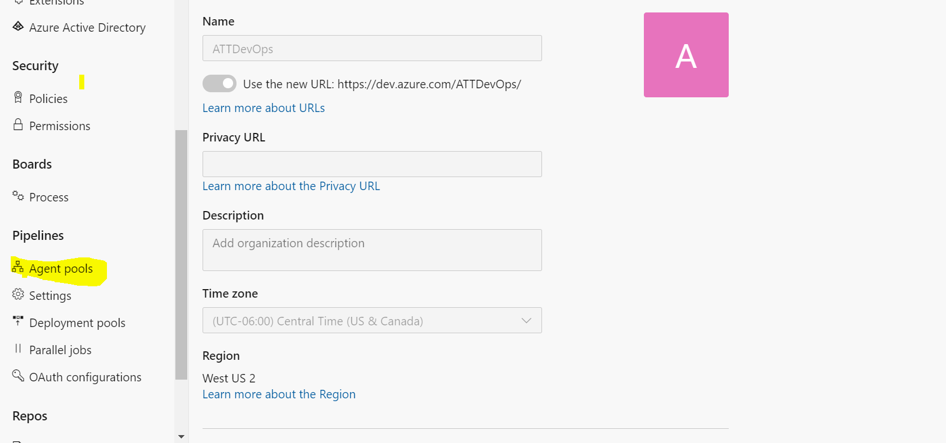

1. Click on the agent pool you created above and click on **Settings**.

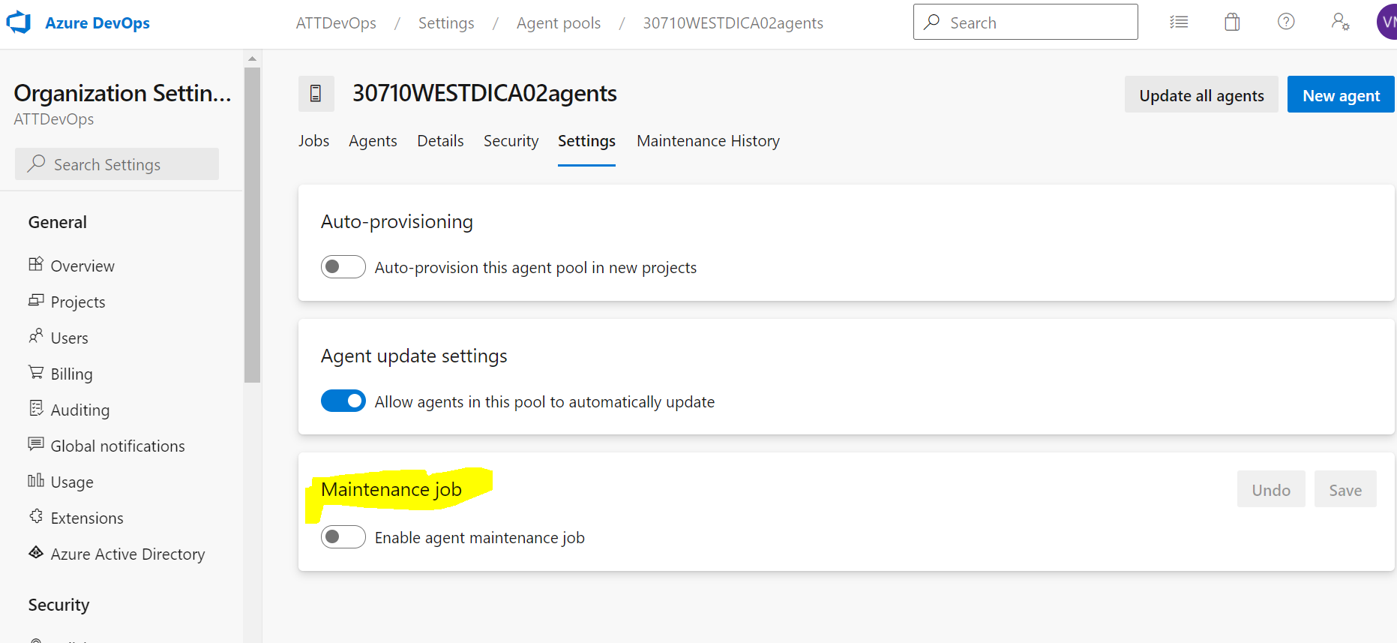

1. Toggle on the **Enable agent maintenance job**.
2. (The settings are up to the application team) We recommend changing the **Days to keep unused working directories** to 14 to ensure the agents do not run out of space. Everything else can remain the default value.
3. Under **Scheduling**, pick a day and time that will not interview with the application team's work.

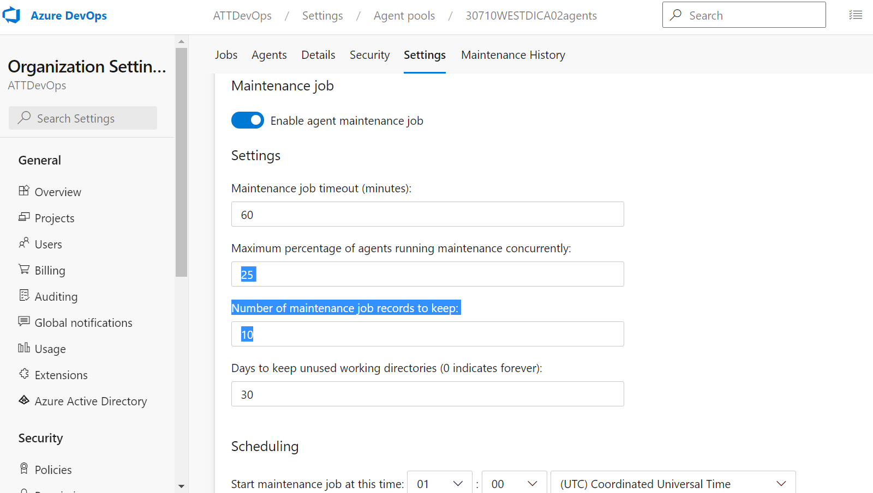

To Create New agent :

* 1. Goto Agent pools in Organization settings.
  2. Click on New agent button on the top right Corner.
  3. You can see below Window. Select the Operating system and click download

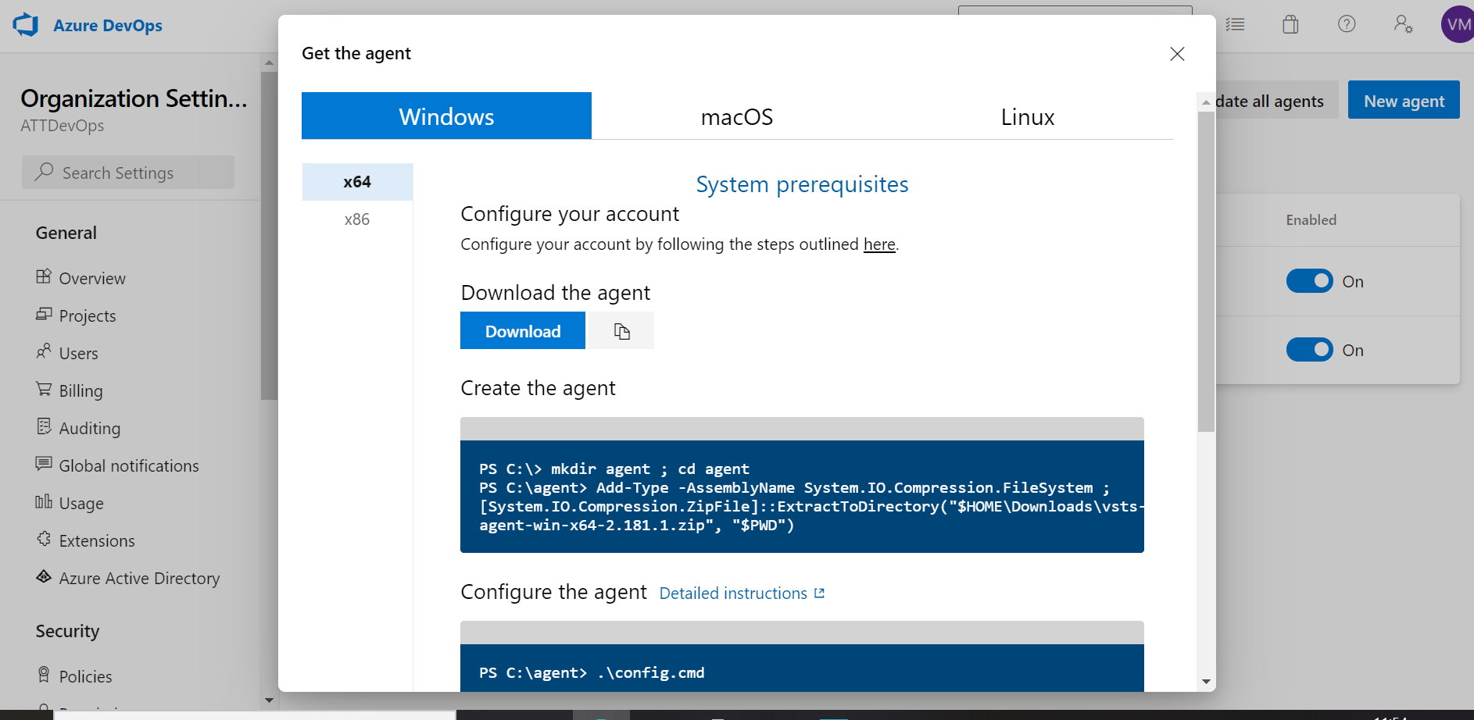

* 1. A zip will be downloaded. Extract the Zip file . You could see below files in the folder after extracting

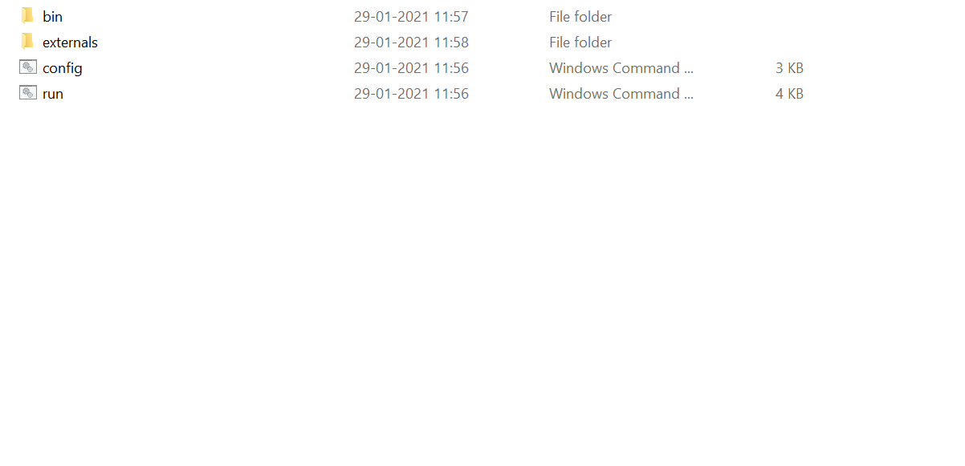

* 1. Run Config from command prompt . You will be prompted to enter below details
* Enter Server URL (Azure DevOps Organization URL given by AT&T DevOps Project onboarding process. Follows the format: <https://dev.azure.com/><ADO ORG>/ (e.g. <https://dev.azure.com/ACC-Azure-01/)>)
* Enter Personal Access Token
* Enter Agent Pool( In which pool you want this agent to be)
* Enter Agent Name( Any name for this particular agent)
* Enter Work folder ( Any folder path where you want to store build files)
  1. Check in Agents tabs whether the created agent is active or not

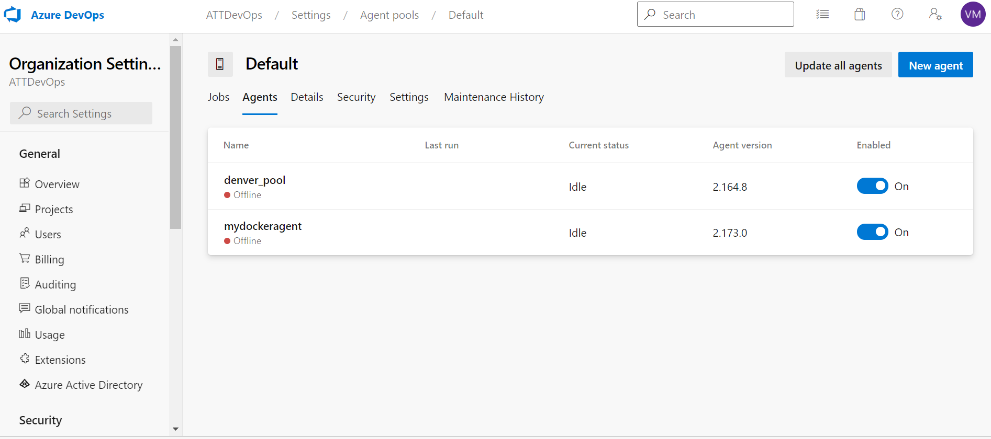

Service Connections:

To deploy your app to an Azure resource (to an app service or to a virtual machine), you need an Azure Resource Manager service connection.

* Navigate to your Organization (e.g. ACC-Azure-01) and Project.
* Click on **Project Settings** -> **Service Connections** -> **+ New Service Connection**.

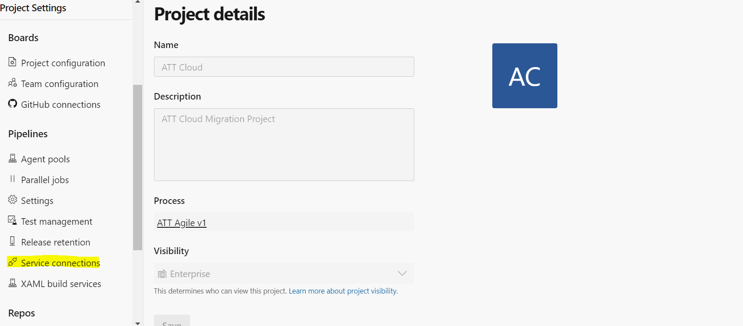

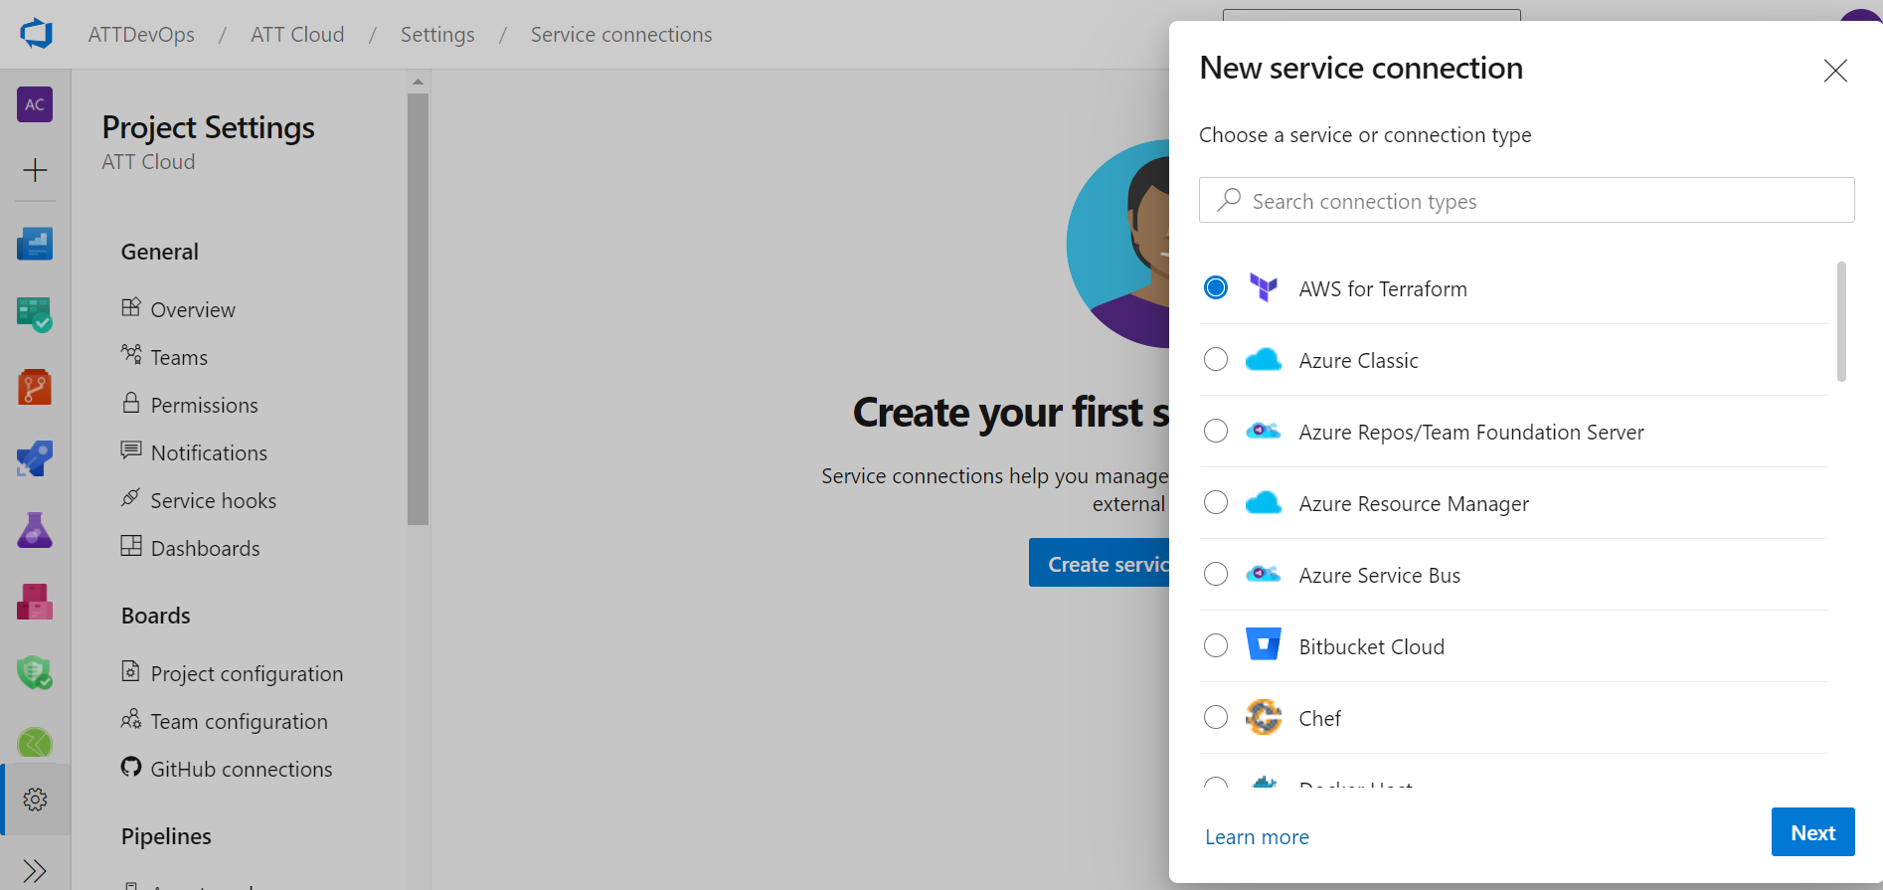

Above you will see the list connections can be made to different tools

* Select Resource manager from the list
* Select Service principle (automatic)

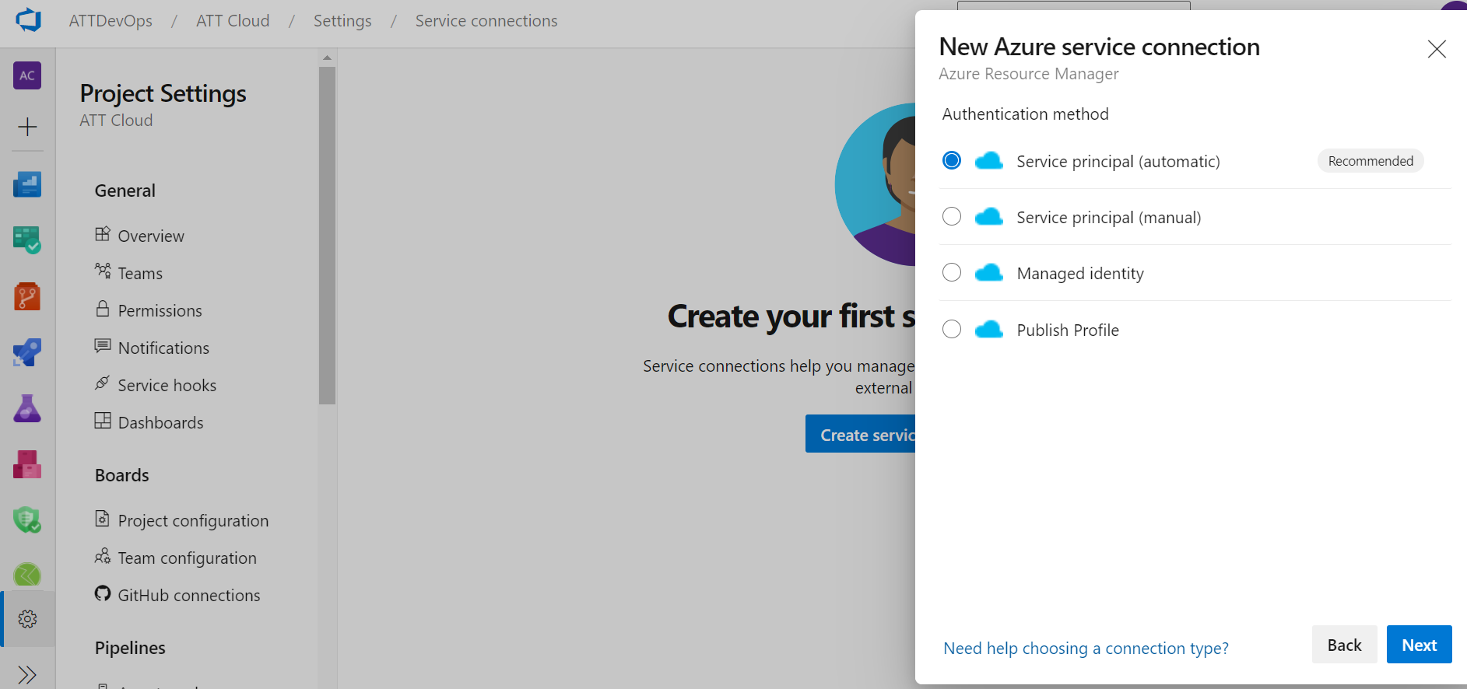

Enter subscription, resource manager and Connection name as shown in the figure and Click save

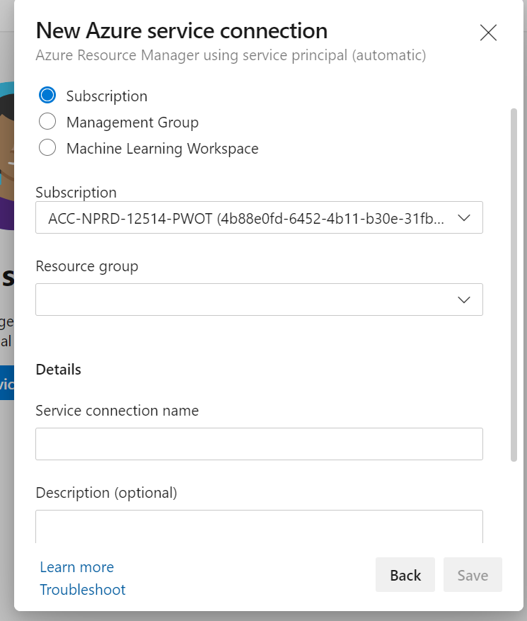

Select the service connection you want to manage.

In the **Overview** tab of the service connection, you can see the details of the service connection. Details include type, creator, and authentication type (Token, Username/Password o 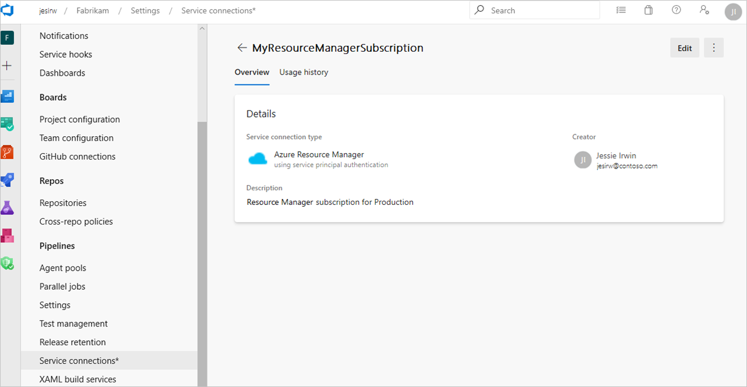

Next to the overview tab, you can see **Usage history** that shows the list of pipelines using the service connection. 