GitHUb: GitHub is a cloud based hoting service to manage git repositiory, but it adds many of its own features. While Git is a command line tool, GitHub provides a Web-based graphical interface. It also provides access control and several collaboration features, such as basic task management tools for every project.
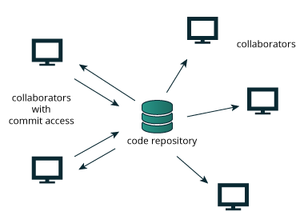

What are the Benefits of GitHub?

There are a number of reasons.. The first is that it enables slick and easy collaboration and version control. This allows you to work on code with anyone from anywhere. Additionally, many employers use GitHub. So, if you plan on getting a job, you’ll look really good if you already know your way around GitHub. And don’t forget about the connections, learning, and portfolio aspects. GitHub is a robust learning and collaboration platform. Take time to explore it and see just how much it can expand your programming knowledge.

Branch
A GitHub branch is used to work with different versions of a repository at the same time.
By default a repository has a master branch (a production branch).
Any other branch is a copy of the master branch (as it was at a point in time).
New Branches are for bug fixes and feature work separate from the master branch. When changes are ready, they can be merged into the master branch. If you make changes to the master branch while working on a new branch, these updates can be pulled in.

Git: Git is type of version control system(DVCS) that mean if have any changes in a file that have save
Each user has a local copy of the complete history of the project,which is known as a local repository

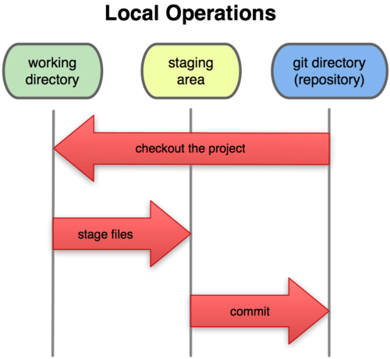

why need git:

Also, it is really helpful to prevent concurrent work from conflicting when multiple people are working in the same project. An individual may be working on the sidebar navigation while another one is simultaneously updating the header

Basic command of git:
- git --version: this command are used to check version of git

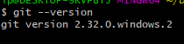
- git --help: this command are used to to provide description of all
Commands
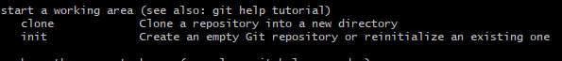

- ls -latr : to show hidden files

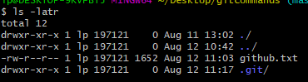

- 5. git add filename: move to staging area

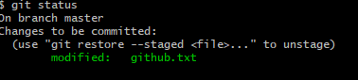

- 6. git add . : all file moves to staging area

- 7. git commit 'message': to commit all changes to save all modification

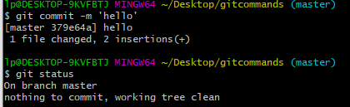

- 8.git commit -a -m 'msg': Skipp the staging area and direct commit
- 8.git checkout filename: To recover file(to match previous commit)
- 9.git checkout -f: To recover all deleted file
- git rm --cached file name:To remove from staging area(unstaging area)
- git log -p -neumeric number: Only how much show commit information

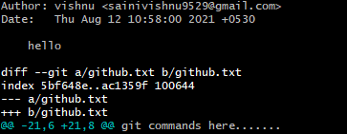
- git rm filename: To delete file from hard disk
- git log: To show all commit information

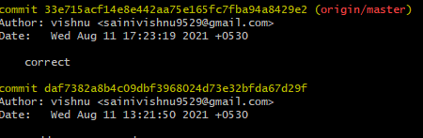

- 11.git init: To initilize a git repository

- 12.git status: To show modified files in working directory(where you work)
Or we can say that which file is tracked or not 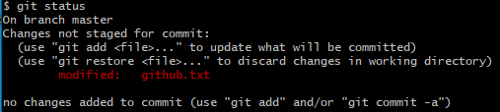

- .gitignor: It include which file you want to ignore(not upload)
- git branch :Show all branch
- git checkout branchname: Switch a particular branch
- git merge brance name: To merge to branch features into one
- git checkout -b name: Switch and create a branch
- git remote add origin url name: To connect remotely from github
- git push origin branch name:To upload on server
- git clone: To fetch a online repository

configuartion command
- git config --global user.name nameof user:
- git config --global user.email email address

