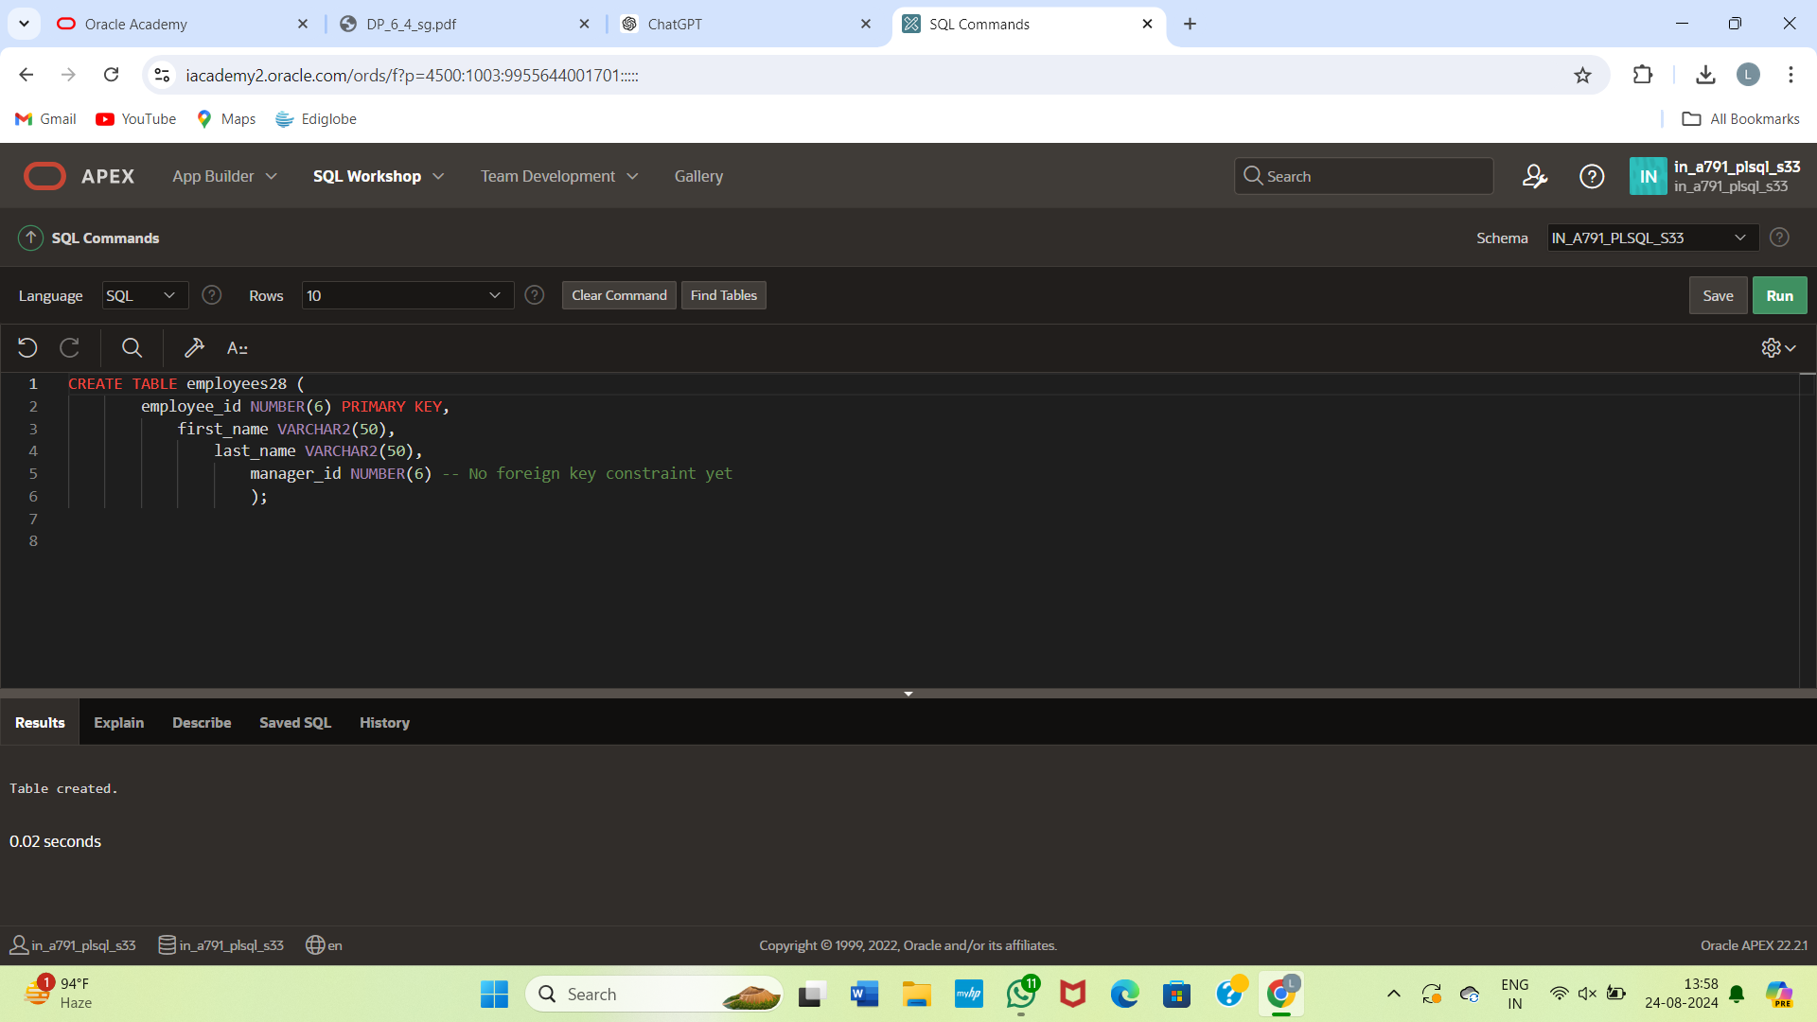\

CREATE TABLE employees (

employee_id NUMBER(6) PRIMARY KEY,

first_name VARCHAR2(50),

last_name VARCHAR2(50),

manager_id NUMBER(6)

);

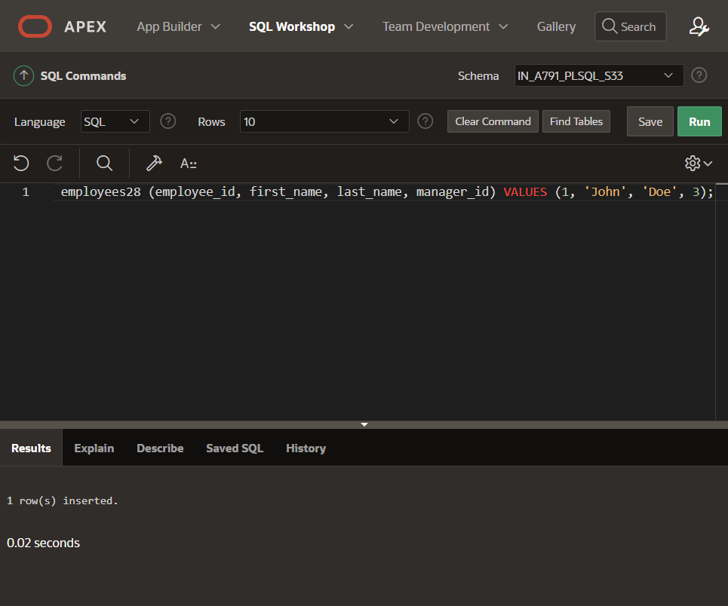

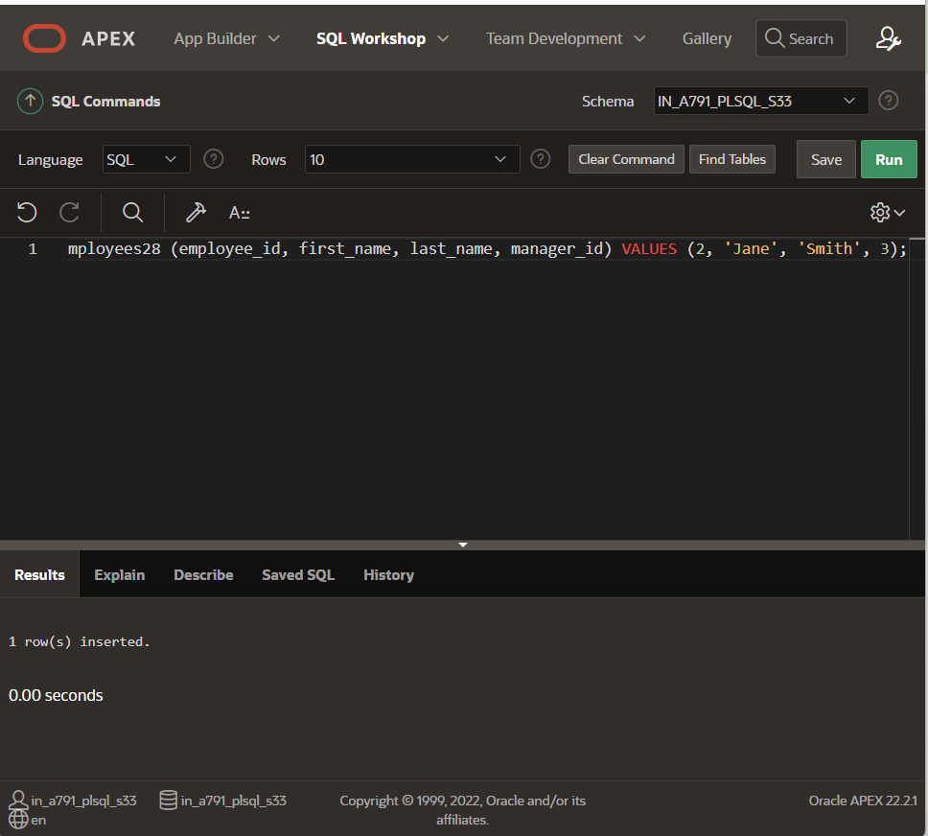

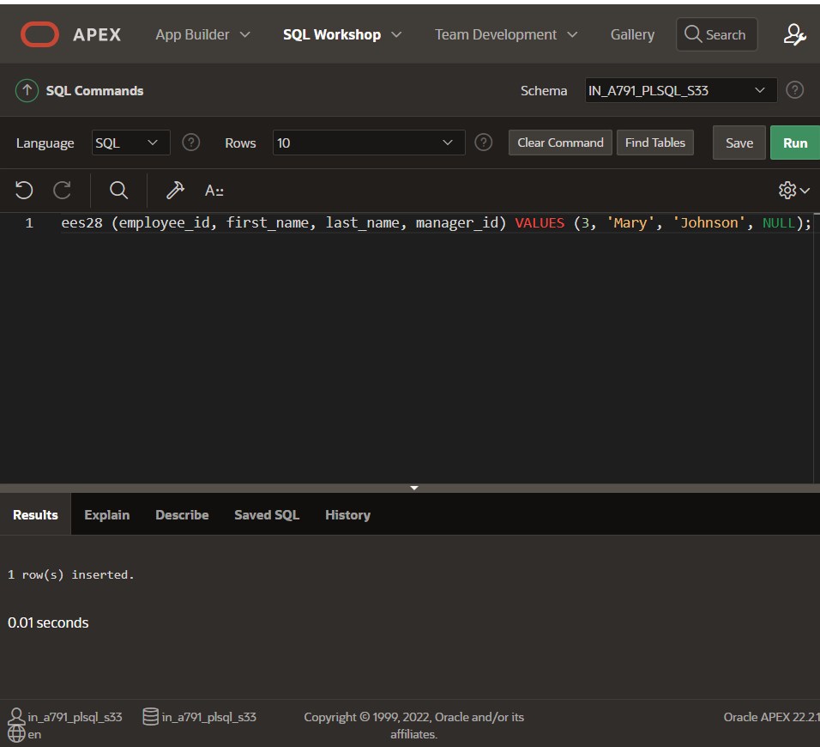

INSERT INTO employees (employee_id, first_name, last_name, manager_id) VALUES (1, 'John', 'Doe', 3);

INSERT INTO employees (employee_id, first_name, last_name, manager_id) VALUES (2, 'Jane', 'Smith', 3);

INSERT INTO employees (employee_id, first_name, last_name, manager_id) VALUES (3, 'Mary', 'Johnson', NULL);

INSERT INTO employees (employee_id, first_name, last_name, manager_id) VALUES (4, 'Mike', 'Brown', 1);

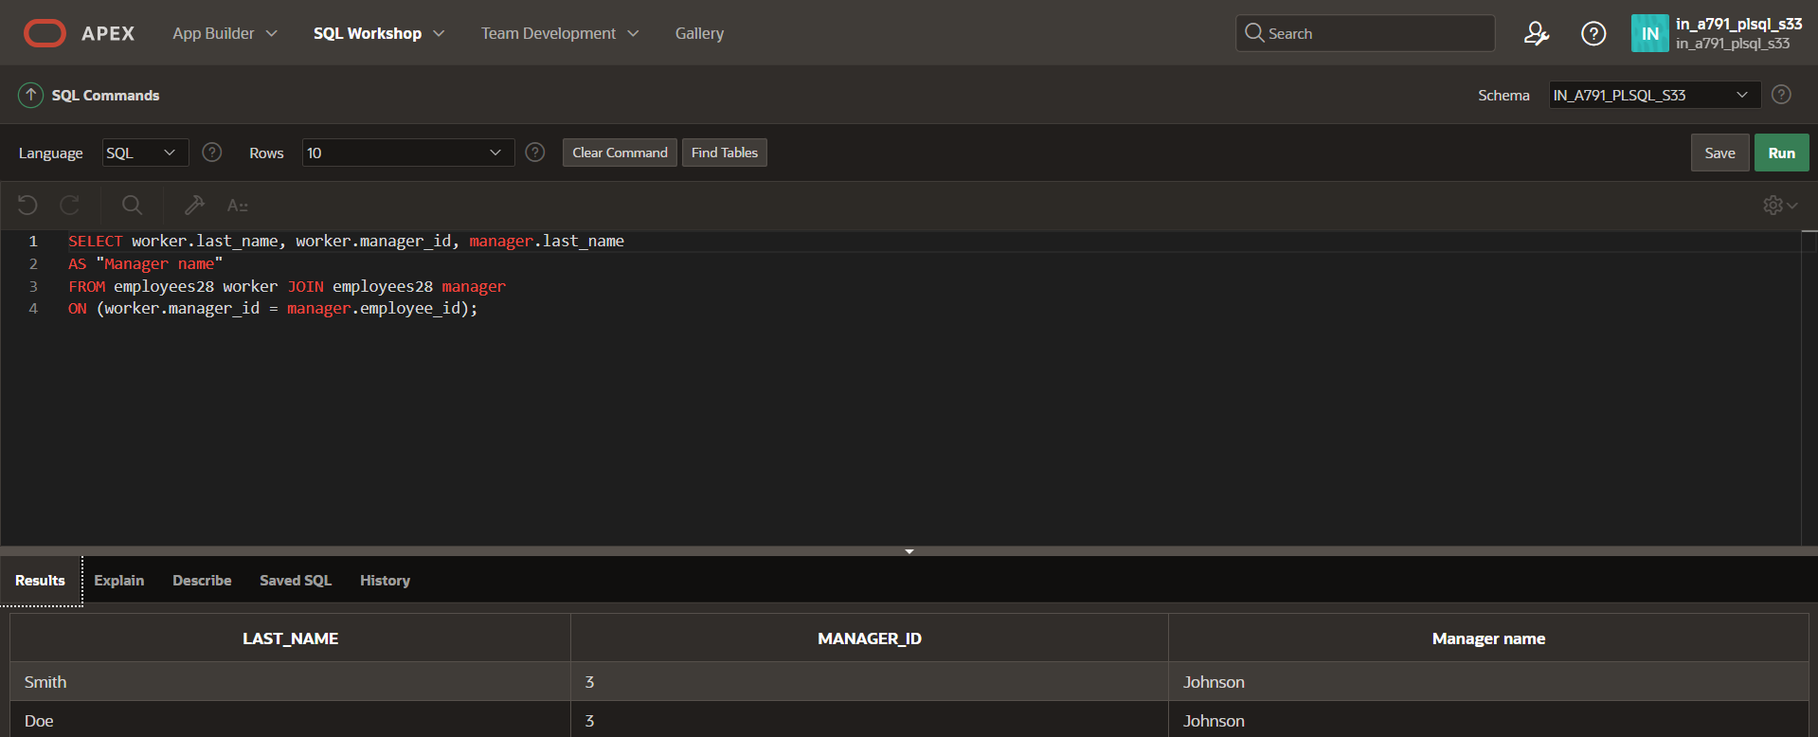

SELECT worker.last_name, worker.manager_id, manager.last_name AS "Manager name" FROM employees worker JOIN employees manager ON (worker.manager_id = manager.employee_id); for this create table