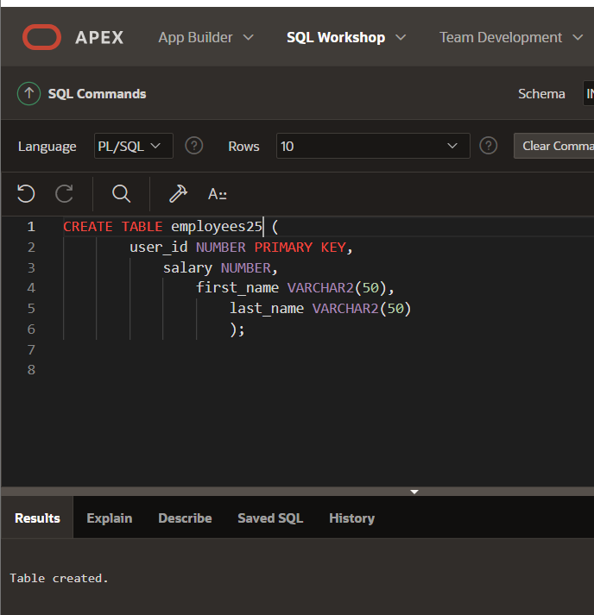

CREATE TABLE employees (

user_id NUMBER PRIMARY KEY,

salary NUMBER,

first_name VARCHAR2(50),

last_name VARCHAR2(50)

);

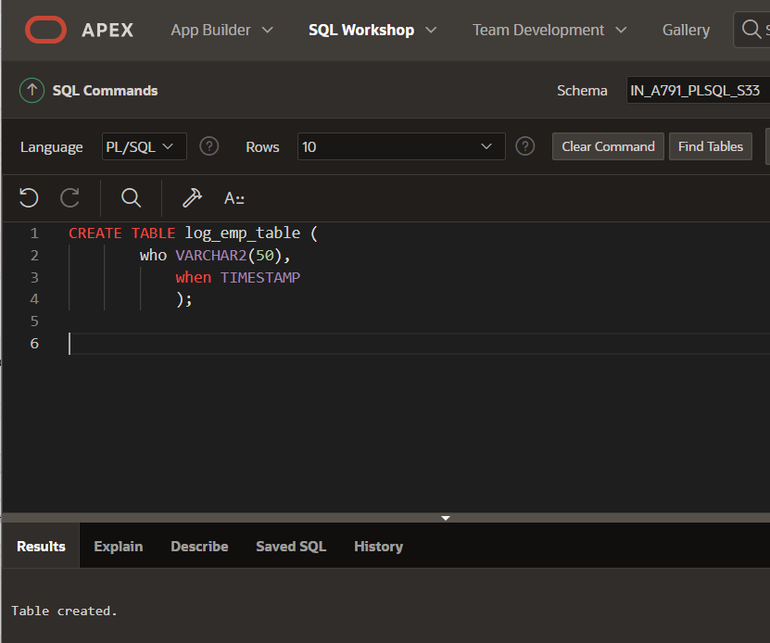

CREATE TABLE log_emp_table (

who VARCHAR2(50),

when TIMESTAMP

);

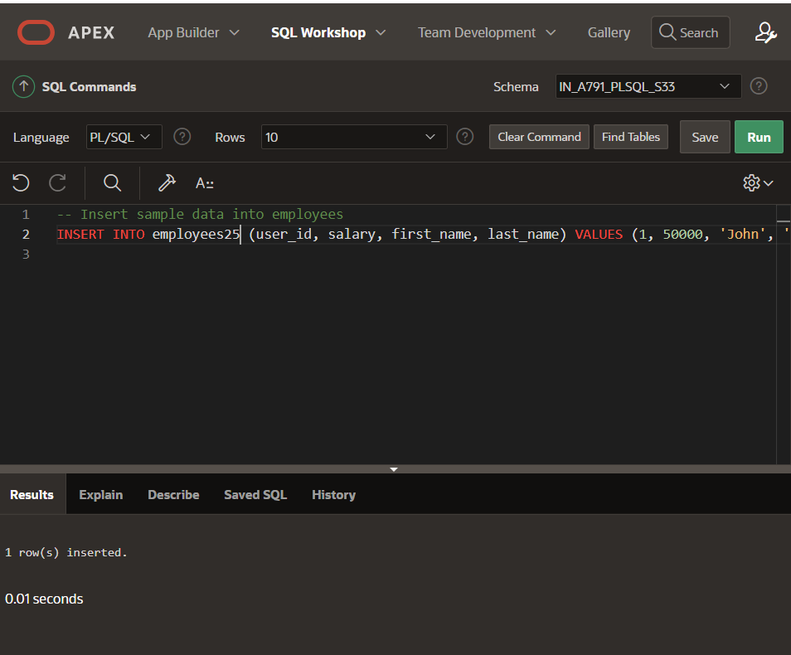

-- Insert sample data into employees

INSERT INTO employees (user_id, salary, first_name, last_name) VALUES (1, 50000, 'John', 'Doe');

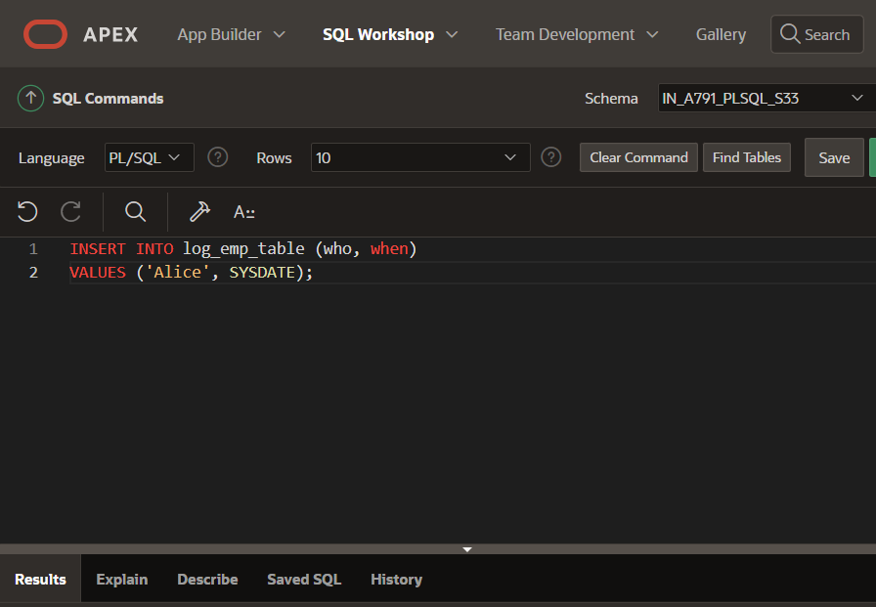

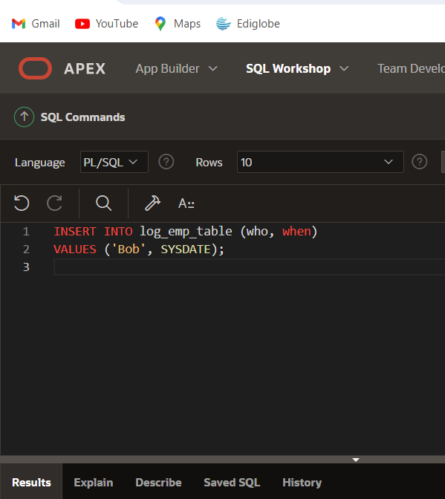

-- Manually insert values into log_emp_table for testing purposes

INSERT INTO log_emp_table (who, when)

VALUES ('TestUser', SYSDATE);

-- Insert another sample entry

INSERT INTO log_emp_table (who, when)

VALUES ('AnotherUser', SYSDATE);

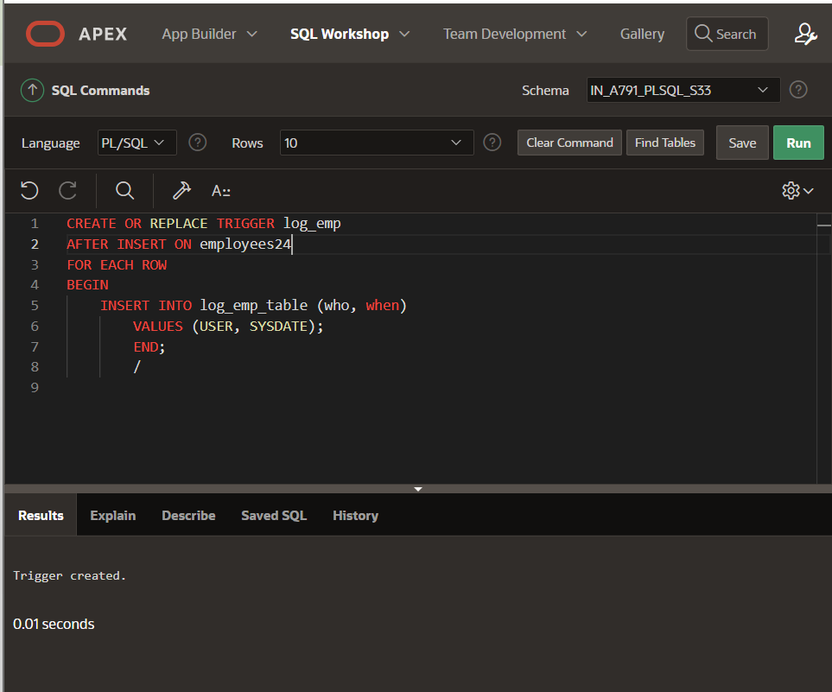

CREATE OR REPLACE TRIGGER log_emp

AFTER INSERT ON employees

FOR EACH ROW

BEGIN

INSERT INTO log_emp_table (who, when)

VALUES (USER, SYSDATE);

END;

/

-- Retrieve and view the inserted data

SELECT * FROM log_emp_table;

