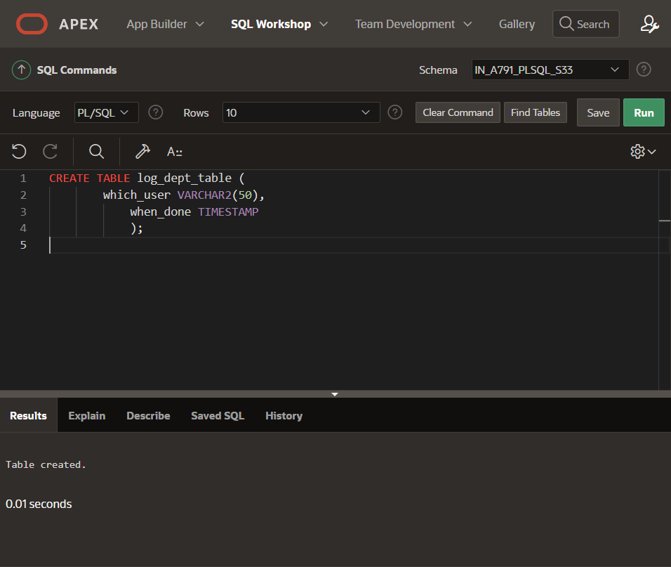

CREATE TABLE log_dept_table (

which_user VARCHAR2(50),

when_done TIMESTAMP

);

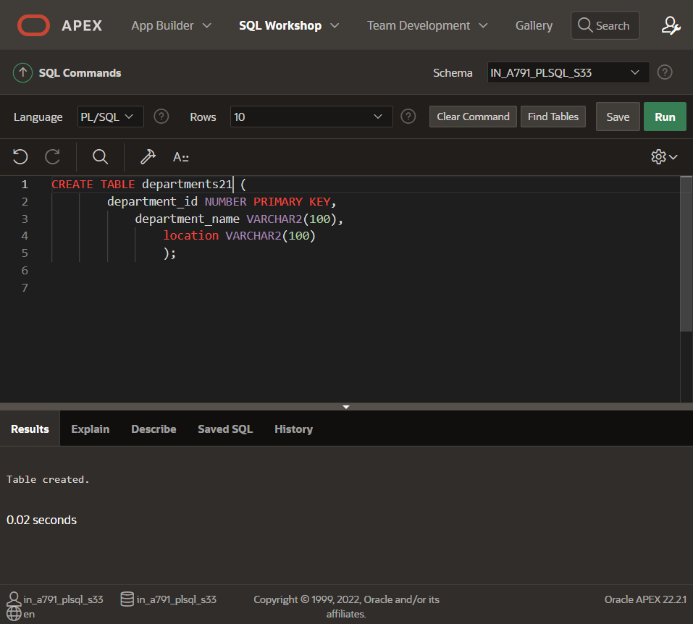

CREATE TABLE departments (

department_id NUMBER PRIMARY KEY,

department_name VARCHAR2(100),

location VARCHAR2(100)

);

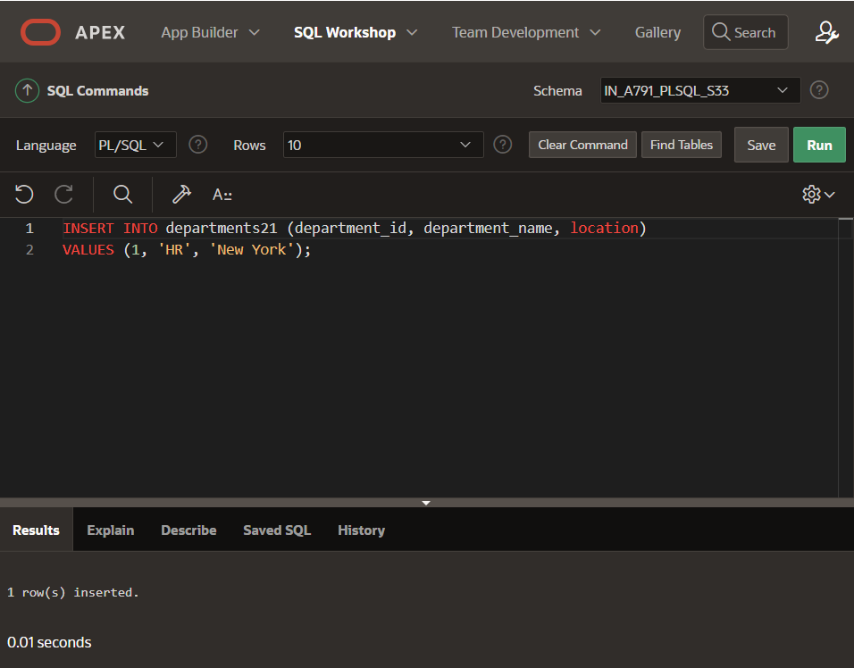INSERT INTO departments (department_id, department_name, location)

VALUES (1, 'HR', 'New York');

INSERT INTO departments (department_id, department_name, location)

VALUES (2, 'Finance', 'San Francisco');

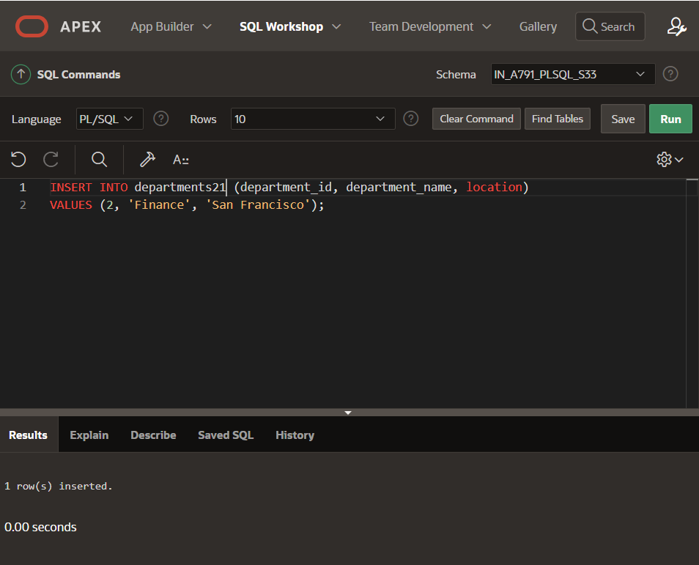

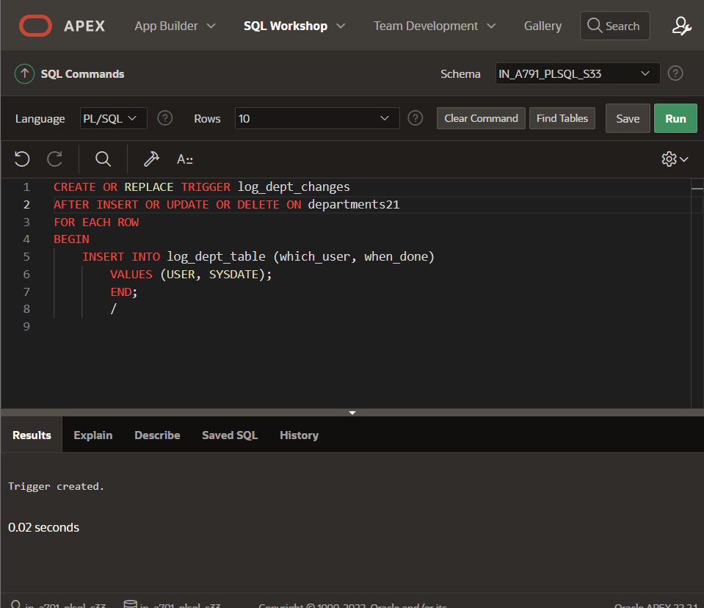

CREATE OR REPLACE TRIGGER log_dept_changes

AFTER INSERT OR UPDATE OR DELETE ON departments

FOR EACH ROW

BEGIN

INSERT INTO log_dept_table (which_user, when_done)

VALUES (USER, SYSDATE);

END;

/

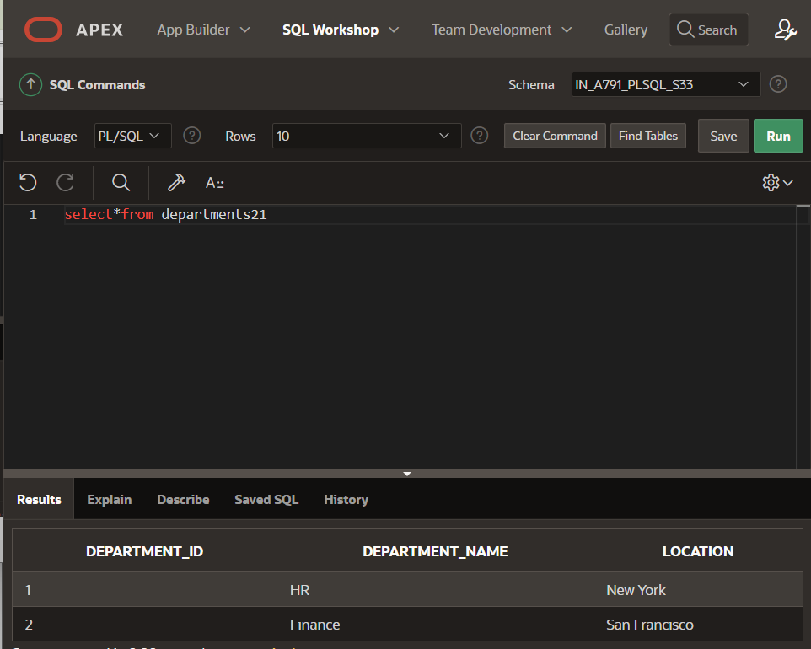

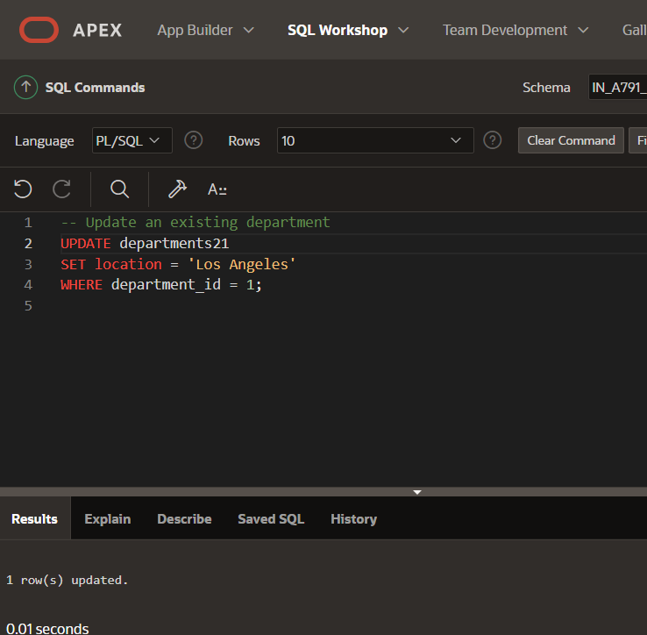

-- Update a department

UPDATE departments

SET location = 'Los Angeles'

WHERE department_id = 1;

-- Delete a department

DELETE FROM departments

WHERE department_id = 2;

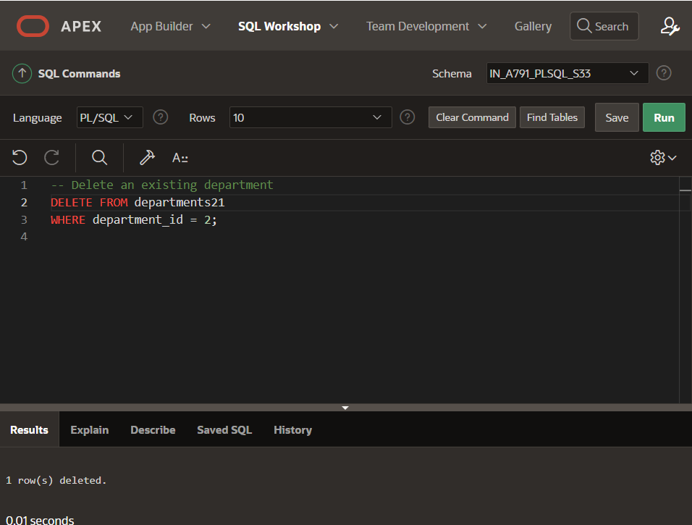

SELECT * FROM log_dept_table;

