To run project first double click on ‘runStream.bat’ file to start streaming program and to get below screen

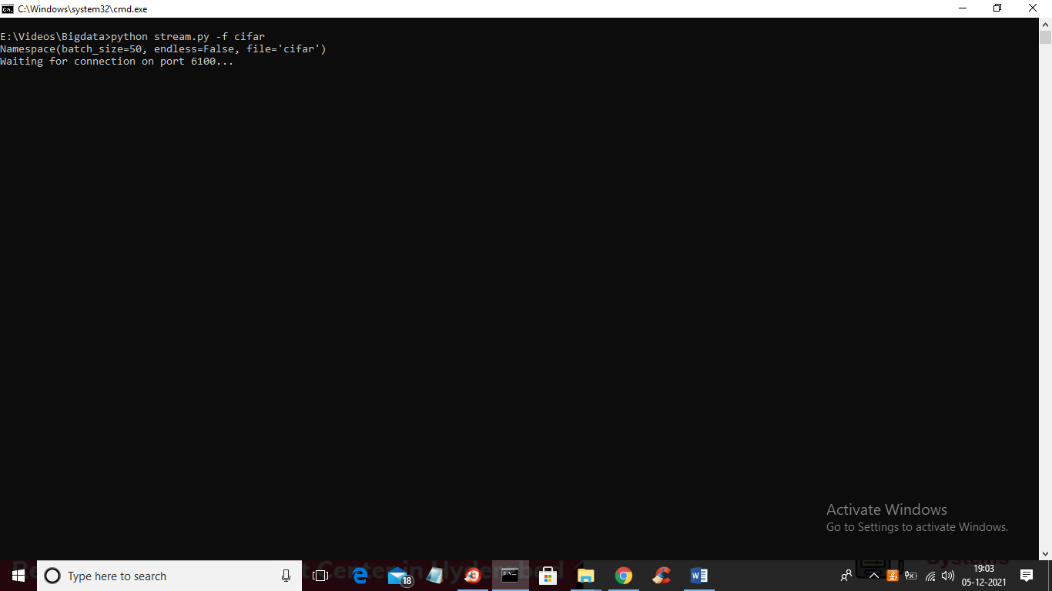

In above screen streaming program started and waiting for connection and now double click on ‘runProcessStream.bat’ file to read stream data then using SPARK ML application will train stream data using Random Forest Algorithm. In below screen we can see stream receiving and training with random forest

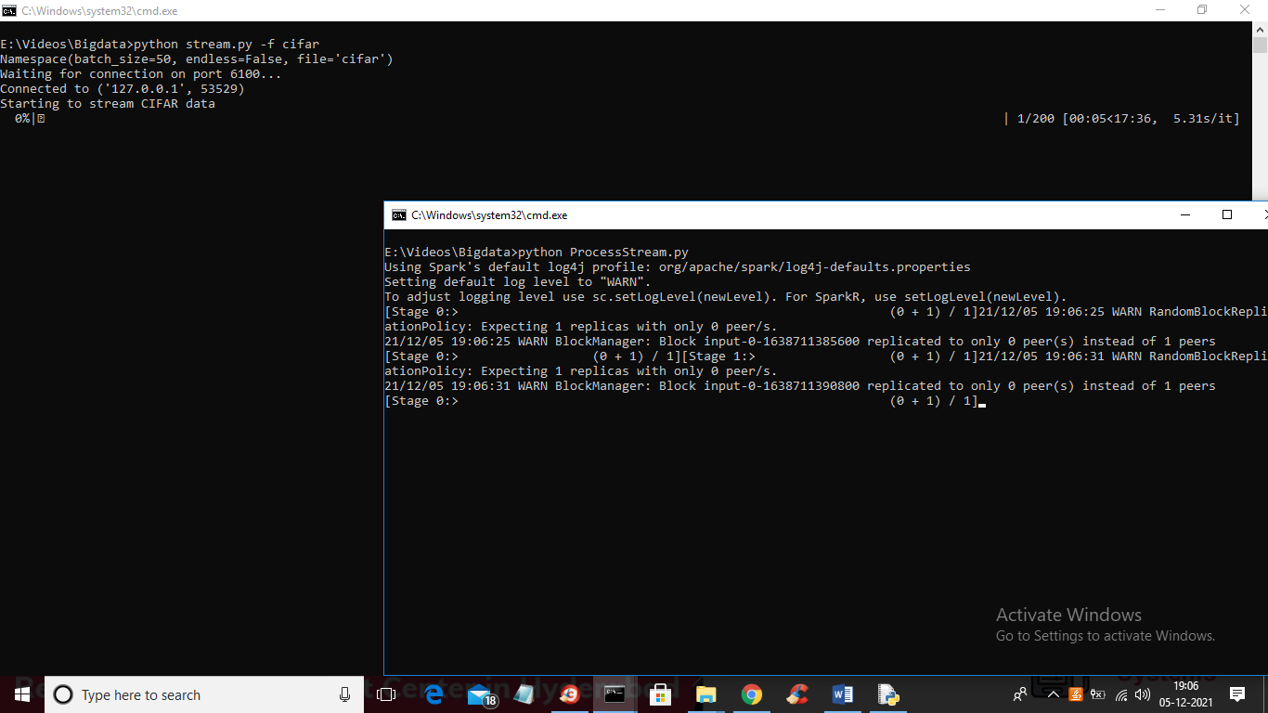

In above screen you can stream processor receiving stream from steam sender and then storing to build random forest classifier

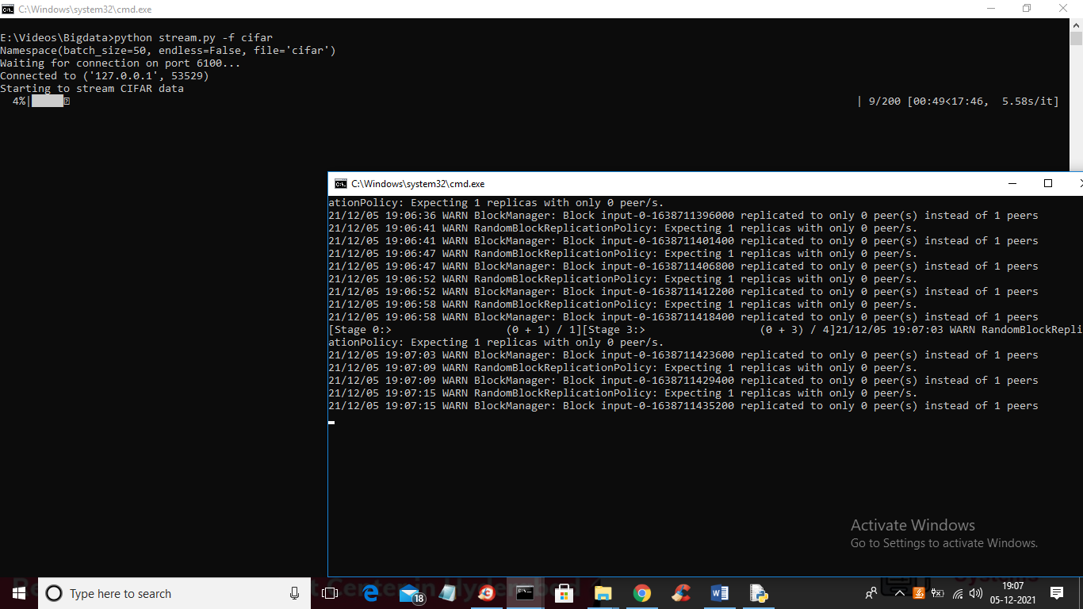

In above screen you can see progress of stream receiving

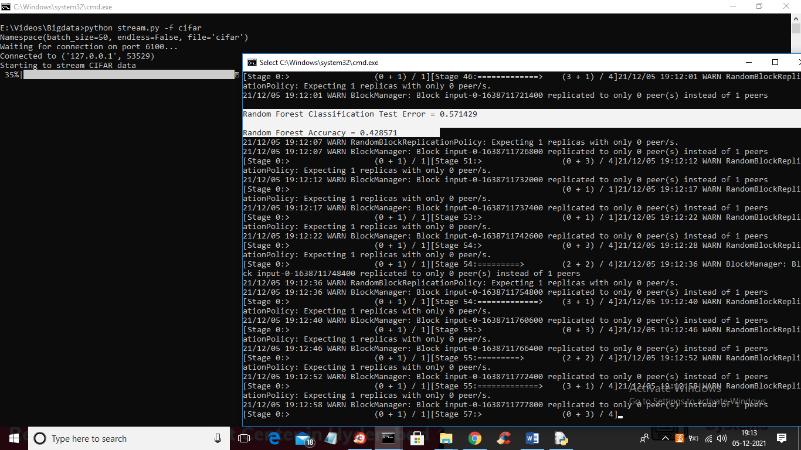

In above screen in white colour text you can see application receiving stream and then training with random forest and we got random forest training accuracy and error value.