Customer Churn Analysis
Insights and Recommendations
Dataset: Training_dataset_for_customer_churn.csv (64,374 customers, 12 columns)

Scope note
The analysis brief refers to learning hours, completion rate, satisfaction score and device/platform. The supplied dataset is a subscription churn dataset and contains none of these fields, so each analysis step was mapped to its closest equivalent: engagement = Usage Frequency and Last Interaction; completion/drop-off = Churn; satisfaction proxies = Support Calls and Total Spend; platform = Subscription Type and Contract Length.

1. Dataset and data quality
The dataset has 64,374 rows and 12 columns: nine numeric fields (CustomerID, Age, Tenure, Usage Frequency, Support Calls, Payment Delay, Total Spend, Last Interaction, Churn) and three categorical fields (Gender, Subscription Type, Contract Length). There are no missing values, duplicates or out-of-range values. Overall, 47.4% of customers churned.
- Data-quality warning: churn is about 26% for CustomerID up to 40,000 but about 83% above that. The file appears to be two datasets stacked together, so CustomerID was excluded from the analysis and exact churn percentages may not generalise to a live customer base.
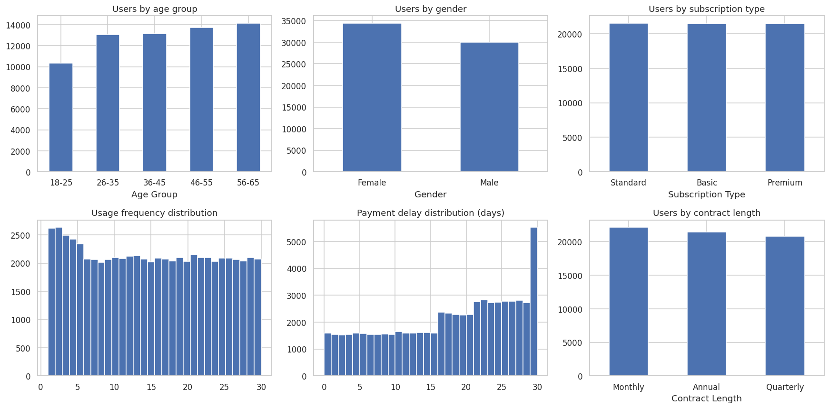
Figure 1: Distribution of users across demographics, plans and behaviour

2. Key business insights
- Payment delay is the dominant churn signal. Churn rises from 10% (0-10 days late) to 39% (11-20 days) and 77% (21-30 days).
- Heavy support contact predicts churn. Customers with 5 or more calls churn at about 61%, versus 23-29% for those with four or fewer. Churned customers averaged 6.4 calls against 4.5 for retained customers.
- Payment delay and support calls compound. Customers with more than 4 calls and more than 20 days delay churn at 89%; those with neither churn at 5%.
- Low usage adds risk, but less than billing and support issues. Users with usage of 1-10 churn at 55% versus 43% for everyone above that band.
- Longer-tenure customers churn more. Churn is about 32% for tenure up to 24 months and about 56% beyond, so loyalty is not protecting the base.
- Women and monthly-contract customers are the highest-risk segments. Female customers churn at 55% versus 39% for males; women on monthly contracts reach 62%.
- Plan tier and interaction recency barely matter. Basic, Standard and Premium show nearly identical churn (47-48%), usage and support volume, and Last Interaction has no correlation with churn.
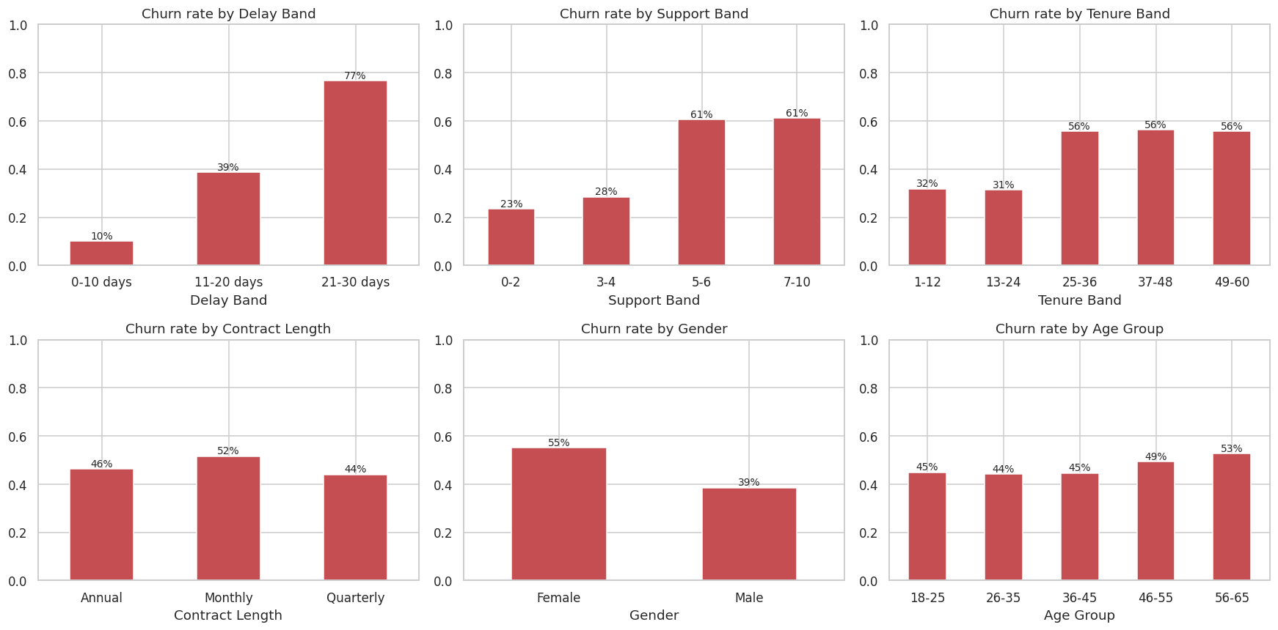
Figure 2: Churn rate by payment delay, support calls, tenure, contract, gender and age

Who is most engaged?
Engagement (usage frequency) is modest and flat across segments. Users aged 18-35 are slightly the most engaged (about 15.4 against 14.6-14.8 for ages 46-65), while subscription tier has no effect (15.1 for all three plans).
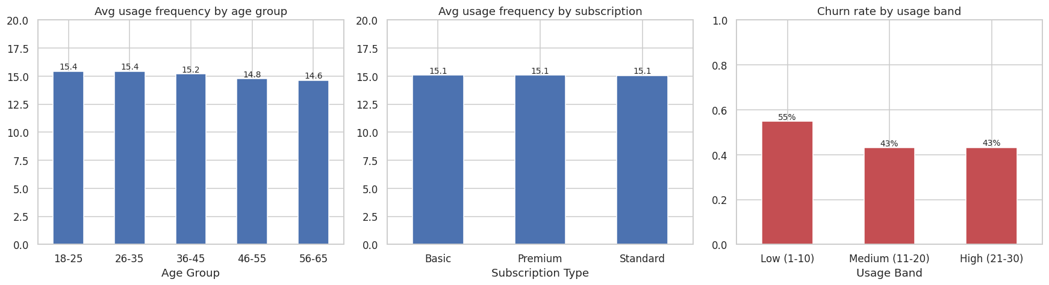
Figure 3: Engagement by age group and plan, and churn by usage band

Combined risk view
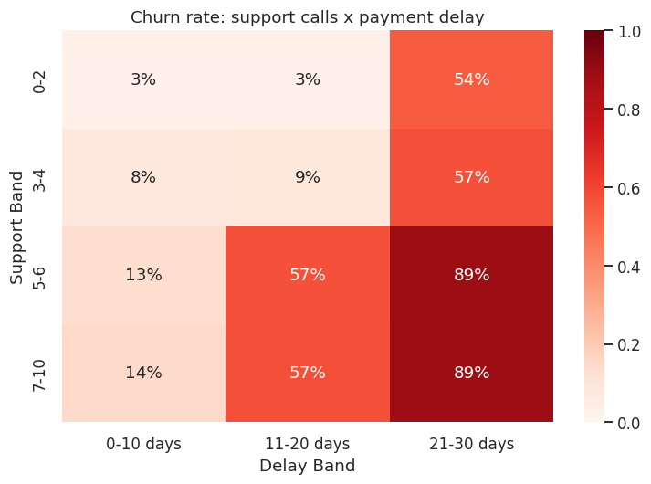
Figure 4: Churn rate by support calls and payment delay

Satisfaction proxies
With no satisfaction score available, support contact and spend were used as proxies. Churned customers make about 1.9 more support calls on average, and customers spending under 500 churn at 52-53% versus 43% above 500. Plan tier has almost no effect.
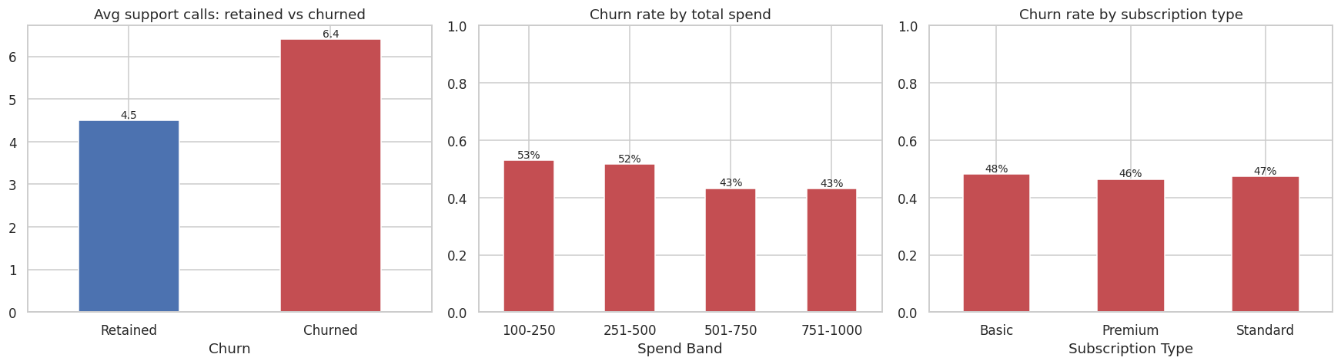
Figure 5: Support calls, spend and plan type versus churn

3. Recommendations
- Fix billing friction first. Introduce payment reminders, autopay incentives and flexible due dates, and intervene before a customer passes roughly 10 days of delay, where churn climbs steeply.
- Deploy an early-warning flag. Flag customers with payment delay above 20 days or more than 4 support calls and route them to a retention team; customers with both are nearly certain to leave.
- Improve first-contact resolution in support. Audit the causes of repeat calls, fix the top issues, and follow up proactively after a customer's fourth call.
- Re-engage low-usage and long-tenure customers. Use onboarding nudges for users with usage of 10 or below, and run win-back or loyalty offers around the 24-month mark.
- Shift monthly customers to longer contracts and investigate the gender gap. Offer quarterly or annual incentives, and research why female customers churn far more than male customers (product fit, service experience or a data artefact).

4. Caveats
- Findings are associations, not proven causes; a controlled test would be needed to confirm that a change reduces churn.
- The ID-ordering anomaly suggests a mixed-source sample, so rates should be validated on current data.
- Metrics requested in the brief (learning hours, completion rate, satisfaction score, device) are not in this dataset; equivalents were used.

