Spring 2024 : CS5720 Neural Networks and Deep Learning – ICP – 1

Assignment -1

Name: Vishnu Teja Ayyangar Nallan Chakravartula

Student ID: 700746150

Github Link: https://github.com/vishnutejaayyangar/ICP-1.git

Video Link: https://drive.google.com/file/d/1Usx2zRe0Qw55lqkw15hOTdHIEsa9jPYe/view?usp=drive_link

# Write a python program for the following.

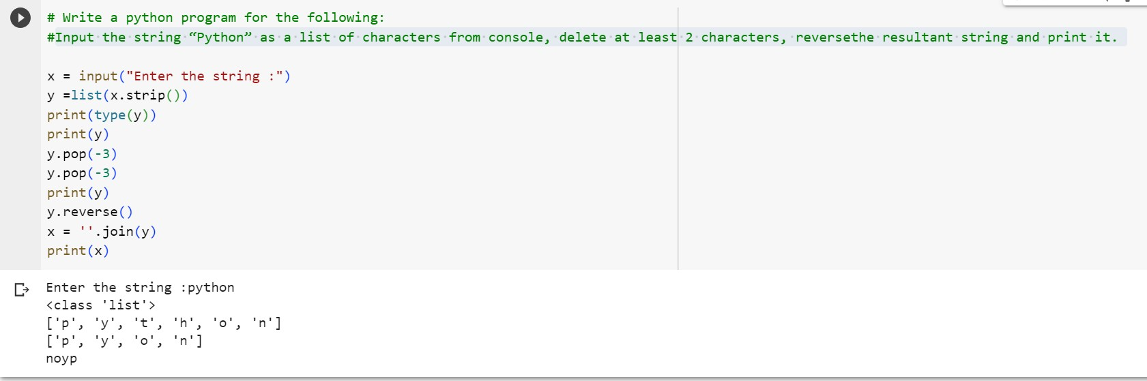Input the string “**Python**” as a list of characters from console, delete at least 2 characters, reverse the resultant string and print it.

* Take two numbers from user and perform at least 4 arithmetic operations on them

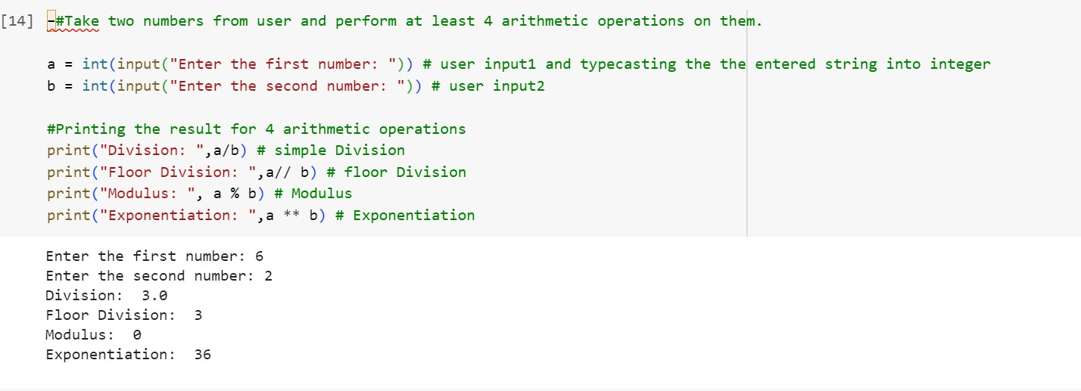

* Write a program that accepts a sentence and replace each occurrence of

**‘python’** with **‘pythons’**.

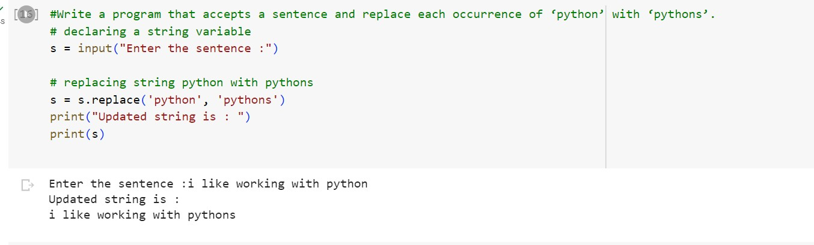

* Use the if statement conditions to write a program to print the letter

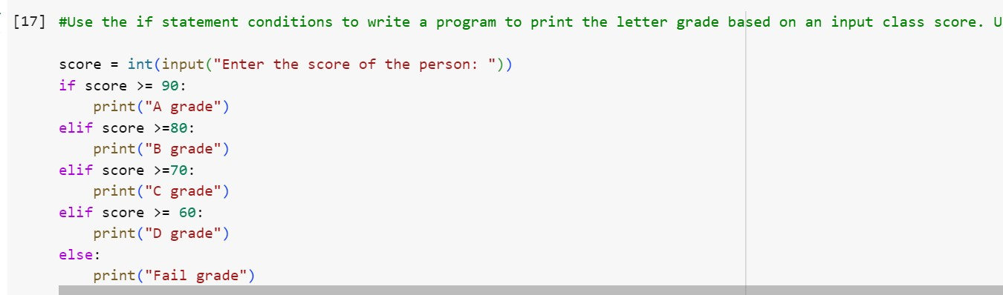grade based on an input class score. Use the grading scheme we are using in this class.

