Ansible
Ansible
Installation and configuration
Communication framework
Password less Authentication
Ansible command line
Ansible playbooks
Ansible roles
Ansible tags
Ansible Vault
Ansible variables- precedence
Ansible jinja2 templates
Ansible galaxy

Chef,Puppet,Ansible, Saltstack these tools are for the same purpose – configuration management.
System admin/Operational tasks
provision server
deploy
configure
Monitor
Scale
Secure
Application reliability and scalability directly affect the business profits
Difficult to manage thousands of servers.
As the application grows in functionality the day to day activities takes more time
We need to control and flexibility, as well as ease of use.
Automation:
Automation of these tasks is becoming extremely important, hence DevOps
Smart Automation is the key
Recognize the most common tasks and automate
-Defined way of doing things is Recipes
In today’s world everything is code
kernel
OS
shell
Application
Configuration management tools
Provisioning resources
Ansible
Ansible in short is an IT Automation, configuration management and provisioning tool.
Simple to start
Scales up on demand
No agents are needed
sshd on remote machine can be used
Parallel by default
Automaton language is like English
212 core modules

Ansible is a tool to manage systems and their configuration. Without the need for a client installed agent and with the ability to launch programs with command line, it seems to fit between classic configuration management like Puppet on one hand and ssh/dsh on the other.

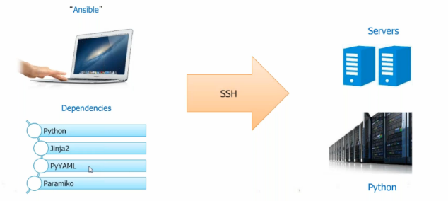

Ansible based on python
Jinja2 supports templates for Ansible – templating engine
PyYAML – yet another markup language – playbooks are written in this language
Paramiko – kind of ssh implementation.

Ansible Architecture

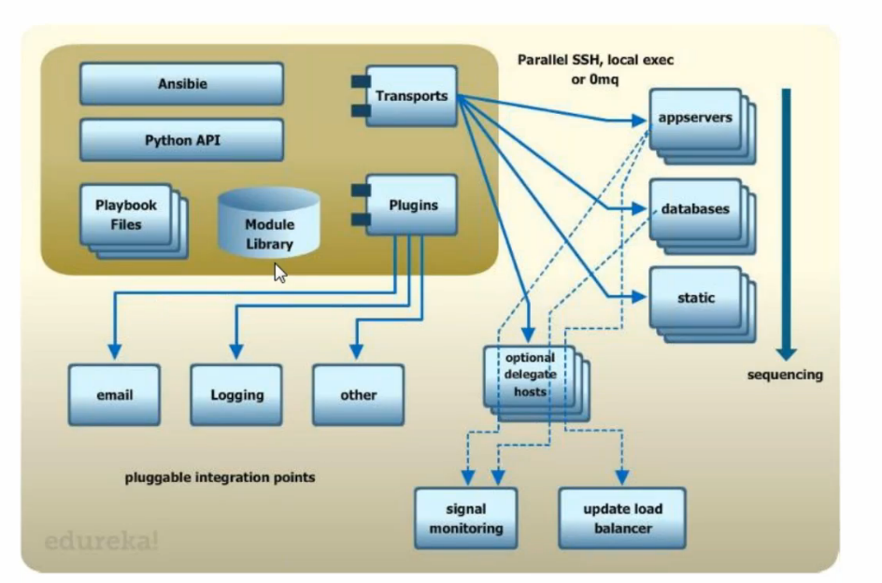

Playbook files – infrastructure as code is maintained in this files
Python API – execute commands using API
Module – is a resource – file/package/command/item trying to configure
transports – by default ssh – to talk to servers
plugins – email logging other
playbooks are executed on parallel fashion

Ansible terminology
Inventory: file contains list of hosts, groups or variables.
Modules: Actually do the work
Plugins: call back actions, and other hooks
Facts: Data gathered from target hosts
Playbooks: Collection of plays
Plays: Loops over a list of takes mapped to list of hosts
Tasks: Invokes a module to do the work

Ansible Install:

ssh-key has to setup on both the nodes
Ansible server talks to managed nodes using ssh
Default location of inventory: /etc/ansible/hosts
Its in INI format

Ansible repository Ansible Galaxy

How to use Ansible
ansbile inventory –m modulename
ansible-playbook
Ansible-playbook playbook.yml

Ansible command mode:
add hosts to /etc/ansible/hosts
and configure password less authentication
Ansible needs to know the hosts its going to serve. They can be managed on the central server in /etc/ansible/hosts or in a file configured in the shell variable ANSIBLE_HOSTS. The hosts can be listed as IP addresses or host names, and can contain additional information like user names, ssh port and so on:
Installation and configuration:
- Install ansible on the node using
yum install ansible
- Add nodes to ansible server using inventory file
/etc/ansible/hosts
- Generate ssh keys and setup password less authentication between server and clients
- Perform jobs either using ansible command line or playbooks.

Ansible command line:

[root@ctx1p05 RHEL5]# ansible all -m ping
ctx1p10.in.vp.com | SUCCESS => {
"changed": false,
"ping": "pong"
}
ctx1p11.in.vp.com | SUCCESS => {
"changed": false,
"ping": "pong"

[root@ctx1p05 RHEL5]# ansible all -a "touch /tmp/hello "
ctx1p10.in.vp.com | SUCCESS | rc=0 >>

ctx1p11.in.vp.com | SUCCESS | rc=0 >>
to execute command on local machine (ansible server)
ansible all -i "localhost," -c local -m shell -a 'echo hello world'

to execute command on remote single machine (ansible client)
ansible all -i "ctx1p10" -m shell -a 'echo hello world'

Grouping the nodes:
Nodes can be grouped into groups like webserver dbserver application server etc in hosts file

[root@ctx1p05 RHEL5]# ansible webservers -m ping
ctx1p10.in.vp.com | SUCCESS => {
"changed": false,
"ping": "pong"
}
[root@ctx1p05 RHEL5]#

[webservers]
ctx1p10.in.vp.com

[dbservers]
ctx1p11.in.vp.com

to execute a command on local/ansible server
ansible all -i "localhost," -c local -m shell -a 'hostname'

root@ctx1p05 ~]# ansible all -i "localhost," -c local -a 'hostname'
localhost | SUCCESS | rc=0 >>
ctx1p05.in.vpath.com
to execute command on single host
[root@ctx1p05 ~]# ansible all -i "reviewb.in.vpath.com," -a 'hostname'
reviewb.in.vpath.com | SUCCESS | rc=0 >>
reviewb.in.vpath.com

Ansible Playbooks:
A sample playbook:
[root@ctx1p05 playbooks]# cat httpd.yaml
---
- hosts: webservers
tasks:
- name: install httpd
yum: pkg=httpd state=installed
[root@ctx1p05 playbooks]#

[root@ctx1p05 playbooks]# ansible-playbook httpd.yaml

PLAY [webservers] **************************************************************

TASK [setup] *******************************************************************
ok: [ctx1p10.in.vp.com]

TASK [install httpd] ***********************************************************
changed: [ctx1p10.in.vp.com]

PLAY RECAP *********************************************************************
ctx1p10.in.vp.com : ok=2 changed=1 unreachable=0 failed=0

[root@ctx1p05 playbooks]#

Playbooks:
hosts defined on which target this configuration is pushed
user: to login to remote server
vars:
http_port:80
max_client: 200
Variables are declared and can be passed , wherever http_port is used, 80 will be replaced
Tasks: collection of actions we need to perform
each action will have a name
action will call the module
name: ensure apache is at the latest version
action: yum pkg=httpd state=latest
here yum is the module for rhel
we are passing some variables to yum
1st one is package name, 2nd one is action to install/remove/latest
for specific version we need to replace state with version
action: template src=httpd.j2 dest=/etc/httpd.conf
we want to create a file /etc/httpd.conf with template file httpd.j2
here we are using template
notify:
- restart apache
Whenever you perform this action (when template is notified), this action has to be performed
-name ensure httpd is running
action=service name =httpd state=started

handlers:
-name: restart apache
action: service name=httpd state=restarted

to understand handles, execute below playbook 2 times
[root@ctx1p05 playbooks]# cat template.yaml
---
- hosts: webservers
tasks:
- name: copy application code to destination on clients
template: src=index.html.j2 dest=/var/www/html/index.htm
notify: restart apache
handlers:
- name: restart apache
service: name=httpd state=restarted

1st run
[root@ctx1p05 playbooks]# ansible-playbook template.yaml

PLAY [webservers] **************************************************************

TASK [setup] *******************************************************************
ok: [ctx1p11.in.ibm.com]

TASK [copy application code to destnation on clients] **************************
ok: [ctx1p11.in.ibm.com]

PLAY RECAP *********************************************************************
ctx1p11.in.ibm.com : ok=2 changed=0 unreachable=0 failed=0

2nd run:
Modify something in index.html on ansible master and deploy
[root@ctx1p05 playbooks]# ansible-playbook template.yaml

PLAY [webservers] **************************************************************

TASK [setup] *******************************************************************
ok: [ctx1p11.in.ibm.com]

TASK [copy application code to destnation on clients] **************************
changed: [ctx1p11.in.ibm.com]

RUNNING HANDLER [restart apache] ***********************************************
changed: [ctx1p11.in.ibm.com]

PLAY RECAP *********************************************************************
ctx1p11.in.ibm.com : ok=3 changed=2 unreachable=0 failed=0
Note: if there is any change only handles will be used to restart service

To list all tasks in a module
[root@ctx1p05 playbooks]# ansible-playbook apache.yaml --list-tasks

playbook: apache.yaml

play #1 (webservers): webservers TAGS: []
tasks:
ensure apache is installed TAGS: []
ensure apache is running TAGS: []
copy files to document root TAGS: []
copy application code to document root TAGS: []
[root@ctx1p05 playbooks]#

[root@ctx1p05 playbooks]# ansible-playbook apache.yaml --list-tasks

playbook: apache.yaml

play #1 (webservers): webservers TAGS: []
tasks:
ensure apache is installed TAGS: []
ensure apache is running TAGS: []
copy files to document root TAGS: []
copy application code to document root TAGS: []
[root@ctx1p05 playbooks]# ansible-playbook --check apache.yaml

PLAY [webservers] **************************************************************

TASK [setup] *******************************************************************
ok: [ctx1p10.in.ibm.com]

TASK [ensure apache is installed] **********************************************
ok: [ctx1p10.in.ibm.com]

TASK [ensure apache is running] ************************************************
ok: [ctx1p10.in.ibm.com]

TASK [copy files to document root] *********************************************
ok: [ctx1p10.in.ibm.com]

TASK [copy application code to document root] **********************************
ok: [ctx1p10.in.ibm.com]

PLAY RECAP *********************************************************************
ctx1p10.in.ibm.com : ok=5 changed=0 unreachable=0 failed=0

ansible-playbook php.yaml --^Cmit @/etc/ansible/playbooks/php.retry
to retry a failed playbook execution

[root@ctx1p05 playbooks]# ansible-playbook php.yaml --limit @/etc/ansible/playbooks/intaractive.retry

PLAY [webservers] **************************************************************

TASK [setup] *******************************************************************
ok: [ctx1p10.in.ibm.com]

TASK [xyz] *********************************************************************
changed: [ctx1p10.in.ibm.com]

PLAY RECAP *********************************************************************
ctx1p10.in.ibm.com : ok=2 changed=1 unreachable=0 failed=0

Online Ansbile Playbook repository : Ansible – galaxy
Ansible tower – licensed version of Ansible
Ansible is not supported on Windows, its supported only on Linux

in Ansbile modules are tools
playbooks are instruction manuals
5 basic components in Ansible
1)Inventory:
A text file that contains information of servers and systems in the infrastructure
Group hosts into categories
Define any variables required by specific hosts (ex: ssh username and password)

2)Ansible configuration:
custom configuration can be defined here
3)Modules
It is the command center of the system
2 types
core modules – developed by Ansible
other modules – developed by community

4)Playbooks
Play: It is a single task or set of tasks which can be executed on hosts with the help of modules
it Is set of plays built in specific order sequence to produce an expected outcome
5) Ansible global configuration
It is a file that contains global variables

execution types:
remote
local : when python is not installed on the agent
ex: router
Handles: wait for event to occur
once event occurs with notify action, handler which is mapped that event will gets executed

--
hosts: webservers
user: root

example playbooks

[root@ctx1p05 playbooks]# cat apache.yaml
---
- hosts: webservers
tasks:
- name: ensure apache is installed
yum: pkg=httpd state=latest
- name: ensure apache is running
service: name=httpd state=running enabled=yes
- name: copy files to document root
copy: src=cloud.png dest=/var/www/html/cloud.png
- name: copy application code to document root
template: src=index.html.j2 dest=/var/www/html/index.html
notify: restart apache
handlers:
- name: restart apache
service: name=httpd state=restarted
[root@ctx1p05 playbooks]#

[root@ctx1p05 playbooks]# cat index.html.j2
<head>
<title>Vp Ansible Demo</title>
</head>
<body>
<h1>
Welcome to Visual path Ansible demo.
</h1>
<br/><br/><br/>
<p>
<img src="cloud.png" alt="Logo"/>
</p>
</body>
</html>
[root@ctx1p05 playbooks]#

roles:
[root@ctx1p05 playbooks]# cat myrole.yaml
---
- hosts: webservers
roles:
- webservers
[root@ctx1p05 playbooks]#

include:
[root@ctx1p05 playbooks]# cat myrole.yaml
---
- hosts: webservers
roles:
- webservers
[root@ctx1p05 playbooks]# cat sample.yaml
---
- hosts: webservers
tasks:
- include: /etc/ansible/tasks/file.yaml

- hosts: dbservers
tasks:
- include: /etc/ansible/tasks/file.yaml
[root@ctx1p05 playbooks]#

include is for making the code look simpler, manageable
small playbooks can be created and can be included
To see what hosts would be affected by a playbook before running it, try
root@ctx1p05 playbooks]# ansible-playbook apache.yaml --list-hosts
playbook: apache.yaml
play #1 (webservers): webservers TAGS: []
pattern: [u'webservers']
hosts (1):
ctx1p10.in.vp.com

Ansible all –list-hosts
shows the nodes
Ansible all –s –m shell –a “mount –a”
installed – will install
latest - will upgrade if available
absent – will remove
with –check option – dry run method, will not do changes to machine
deprication_warnings = make it to no in cfg

-v is for verbose
--vv explain completely
--vvv full versbose

tags
to execute based on the task

with_loop
to execute in a loop
Interactive play book

include:
[root@ctx1p05 playbooks]# cat sample.yaml
---
- hosts: webservers
tasks:
- include: /etc/ansible/tasks/file.yaml

- hosts: dbservers
tasks:
- include: /etc/ansible/tasks/file.yaml

Roles:

Yaml file will grow with time as and when the tasks are increased

Directory structures and templates

[root@ctx1p05 playbooks]# cat myrole.yaml
---
- hosts: webservers
roles:
- webservers
[root@ctx1p05 playbooks]#
Using ansible facts to get os family

---
- hosts: ext1
tasks:
- name: install httpd
yum: name=httpd state=present
when: ansible_os_family == "RedHat"
- name: install httpd
apt: name=httpd state=present
when: ansible_os_family == "Debian"
[root@ctx1p05 playbooks]#

Getting info about the facts
ansible ext1 -m setup --tree /tmp/facts

using user module to add user
ansible webservers –s –m user –a “name=user1 uid=20000 shell=/bin/bash”
including multiple roles in playbook:

[root@reviewb playbooks]# cat role.yaml
---
- hosts: webservers
roles:
- common
- webservers
[root@reviewb playbooks]#

[root@reviewb playbooks]# cat /etc/ansible/roles/common/tasks/main.yaml
- name: create a dummy file for common role
command: touch /tmp/dummy2role

[root@reviewb playbooks]# cat /etc/ansible/roles/webservers/tasks/main.yaml
- name: ensure apache is installed
yum: pkg=httpd state=latest
- name: ensure apache is running
service: name=httpd state=running enabled=yes
- name: copy files to document root
copy: src=cloud.png dest=/var/www/html/cloud.png
- name: copy application code to document root
template: src=index.html.j2 dest=/var/www/html/index.html
[root@reviewb playbooks]# cat /etc/ansible/roles/webservers/templates/index.html.j2
<head>
<title> Ansible </title>
</head>
<body>
<h1>
Welcome to Ansible Roles </h1>
<br/><br/><br/>
<p>
<img src="cloud.png" alt="Logo"/>
</p>
</body>
</html>

parallel vs serial execution:
change forks=15 in cfg file

[root@ctx1p05 playbooks]# cat parallel.yaml
Parallel execution:
---
- hosts: all
tasks:
- name: sleep for 5 seconds
shell: /bin/sleep 5

Serial execution:
[root@ctx1p05 playbooks]# cat serial.yaml
---
- hosts: all
serial: 1
tasks:
- name: sleep for 5 seconds
shell: /bin/sleep 5
[root@ctx1p05 playbooks]#
Serial:1 is for executing the playbook on single machine (one by one)
Serial:2 will execute on each of 2 machines (first 2 machines parallelly, then goes to third,forth)

pre and post tasks execution
[root@ctx1p05 playbooks]# cat preposttask.yaml
---
- hosts: webservers

serial: 1
pre_tasks:
- name: install package
yum: name=httpd state=installed
- name: copy new template
copy: src=/index1.html dest=/var/www/html/index.html
- name: restart http
service: name=httpd state=restarted
- name: sleep for 5 sec
shell: /bin/sleep 5
tasks:
- name: deploy website content
copy: src=/index2.html dest=/var/www/html/index.html
- name: restart http
service: name=httpd state=restarted
post_tasks:
- name:
service: name=httpd state=restarted
[root@ctx1p05 playbooks]#

Roles:
Roles define what each type of server has to perform
Sample:
- name: install and configure webservers
hosts: webservers
remote_user: ec2-user
sudo: yes
roles:
- webservers
- common

Here common and webservers role is associated with hosts webservers
[root@ctx1p05 playbooks]# cat myrole.yaml
---
- hosts: webservers
roles:
- webservers

[root@ctx1p05 playbooks]# cat /etc/ansible/roles/webservers/tasks/main.yaml
- name: ensure apache is installed
yum: pkg=httpd state=latest
- name: ensure apache is running
service: name=httpd state=running enabled=yes
- name: copy files to document root
copy: src=cloud.png dest=/var/www/html/cloud.png
- name: copy application code to document root
template: src=index.html.j2 dest=/var/www/html/index.html
notify: restart apache

Playbook to create users
[root@ctx1p05 playbooks]# cat create.yaml
---
- hosts: webservers
tasks:
- name: add several users
user: name={{ item.name }} state=present groups={{ item.groups }}
with_items:
- { name: 'testuser1', groups: 'root' }
- { name: 'testuser2', groups: 'root' }
[root@ctx1p05 playbooks]#

Playbook to explain notify:
imagine a setup where you copy a file, and if that file was copied (so not there before or changed in the meantime) , we need to restart sshd:
---
- hosts: webservers
remote_user: liquidat
tasks:
- name: copy file
copy: src=~/tmp/test.txt dest=~/test.txt
notify:
- restart sshd
handlers:
- name: restart sshd
service: name=sshd state=restarted
sudo: yes

Using Inventory file to provide the variables/values:

[root@ctx1p05 playbooks]# cat inventory
web1 ansible_ssh_host=9.184.184.145 ansible_ssh_user=john ansible_ssh_pass=root123
[root@ctx1p05 playbooks]# ansible web1 -i inventory -a "touch /tmp/hello15thfeb2017 "
web1 | SUCCESS | rc=0 >>

Executing a playbook/command line ansible using non-root user
Create the user called user1 on Ansible server, assign the password and generate the keys
Create another user called user1 on Ansible agent, assign the password.
Copy keys from server to agent using ssh-copy-id for user1
Then execute:
[user1@reviewb ~]$ ansible webservers1 -i inventory -a "touch /tmp/hello15thfeb2017 "

webservers1 | SUCCESS | rc=0 >>

[root@ctx1p05 playbooks]# cat echo2.yaml
---
- hosts: all
tasks:
- name: run echo command
command: /usr//bin/touch /tmp/hellofeb

ansible-playbook -i inventory echo2.yaml

Ansible Vault
Installing Ansible vault:
Comes by default with ansible
From Ansible 1.5, “Vault” is a feature that allows keeping sensitive data such as passwords or keys in encrypted files, rather than as plaintext in playbooks or roles. These vault files can then be distributed or placed in source control.

How to encrypt data
Encrypt files with ansible vault
- AES 256 encryption
Ansible will decrypt at the runtime

To encrypt the passwords for privacy ansible vault can be used

ansible-vault encrypt intaractive.yaml
ansible-playbook intaractive.yaml --ask-vault-pass

[root@ctx1p05 playbooks]# ansible-playbook intaractive.yaml --ask-vault-pass
Vault password:
Install which package? [telnet]:

PLAY [webservers] **************************************************************

TASK [setup] *******************************************************************
ok: [ctx1p11.in.ibm.com]

TASK [ensure apache is installed] **********************************************
ok: [ctx1p11.in.ibm.com]

PLAY RECAP *********************************************************************
ctx1p11.in.ibm.com : ok=2 changed=0 unreachable=0 failed=0

ansible-vault encrypt <> - to encrypt the file
ansible-valut edit <> - to edit the file
ansible-vault rekey – to change password

Ansible until loop:
Sometimes we may want to retry a task until a certain condition is met. Here’s an example:

[root@ctx1p05 playbooks]# cat until.yaml
- hosts: webservers

tasks:
- action: shell ifconfig
register: result
until: result.stdout.find("ens192") != -1
retries: 5
delay: 10
[root@ctx1p05 playbooks]# ansible-playbook until.yaml

PLAY [webservers] **************************************************************

TASK [setup] *******************************************************************
ok: [ctx1p11.in.ibm.com]

TASK [command] *****************************************************************
changed: [ctx1p11.in.ibm.com]

PLAY RECAP *********************************************************************
ctx1p11.in.ibm.com : ok=2 changed=1 unreachable=0 failed=0

[root@ctx1p05 playbooks]#
The above example run the shell module recursively till the module’s result has “all systems go” in its stdout or the task has been retried for 5 times with a delay of 10 seconds. The default value for “retries” is 3 and “delay” is 5.
The task returns the results returned by the last task run. The results of individual retries can be viewed by -vv option. The registered variable will also have a new key “attempts” which will have the number of the retries for the task.

Ansible if loop:

Jinja2 template language can be used to populate the template files on the destination with loops as below:
If loop
For loop

If loop can be used to populate the destination template file using input variables we specify during playbook execution.

[root@ctx1p05 role1]# pwd
/etc/ansible/roles/role1
[root@ctx1p05 role1]# ls -lrt
total 0
drwxr-xr-x. 2 root root 21 Feb 17 02:37 templates
drwxr-xr-x. 2 root root 21 Feb 17 02:42 vars
[root@ctx1p05 role1]#

[root@ctx1p05 role1]# cd templates/
[root@ctx1p05 templates]# ls -lrt
total 4
-rw-r--r--. 1 root root 295 Feb 17 02:37 myvar.j2
[root@ctx1p05 templates]# cat myvar.j2
{% if param1 is defined and param2 is defined and param3 is defined %}
myvariable: 'param1,param2,param3'
{% elif param1 is defined and param2 is defined %}
myvariable: 'param1,param2'
{% elif param1 is defined %}
myvariable: 'param1'
{% else %}
myvariable: 'default-param'
{% endif %}
[root@ctx1p05 templates]#

[root@ctx1p05 role1]# cd vars/
[root@ctx1p05 vars]# ls
main.yml
[root@ctx1p05 vars]# cat main.yml
myvariable: 'param1,param2'
[root@ctx1p05 vars]#

[root@ctx1p05 playbooks]# cat role1.yml
- hosts: xyz
gather_facts: yes
# connection: local
become: yes

tasks:

- template: src=/etc/ansible/roles/role1/templates/myvar.j2 dest=/etc/ansible/roles/role1/vars/main.yml

- debug: var=myvariable

roles:
- { role: role1 }
[root@ctx1p05 playbooks]#

[root@ctx1p05 playbooks]# ansible-playbook role1.yml -e "param1=value1 param2=value2 param3=value3"

PLAY [xyz] *********************************************************************

TASK [setup] *******************************************************************
ok: [ctx1p18.in.ibm.com]

TASK [template] ****************************************************************
changed: [ctx1p18.in.ibm.com]

TASK [debug] *******************************************************************
ok: [ctx1p18.in.ibm.com] => {
"myvariable": "param1,param2"
}

PLAY RECAP *********************************************************************
ctx1p18.in.ibm.com : ok=3 changed=1 unreachable=0 failed=0
On the destination machine:

root@ctx1p18:/etc/ansible/roles/role1/vars# cat main.yml
myvariable: 'param1,param2,param3'

example 2:

[root@ctx1p05 playbooks]# ansible-playbook role1.yml

PLAY [xyz] *********************************************************************

TASK [setup] *******************************************************************
ok: [ctx1p18.in.ibm.com]

TASK [template] ****************************************************************
changed: [ctx1p18.in.ibm.com]

TASK [debug] *******************************************************************
ok: [ctx1p18.in.ibm.com] => {
"myvariable": "param1,param2"
}

PLAY RECAP *********************************************************************
ctx1p18.in.ibm.com : ok=3 changed=1 unreachable=0 failed=0

[root@ctx1p05 playbooks]#
On destination machine:
root@ctx1p18:/etc/ansible/roles/role1/vars# cat main.yml
myvariable: 'default-param'

Template if loop:

[root@ctx1p05 playbooks]# pwd
/etc/ansible/playbooks
[root@ctx1p05 playbooks]# cat role2.yml
- hosts: xyz
gather_facts: yes
become: yes

tasks:

- template: src=/etc/ansible/roles/role2/templates/myvar.j2 dest=/etc/ansible/roles/role2/vars/main.yml

- debug: var=myvariable

roles:
- { role: role2 }
[root@ctx1p05 playbooks]#

[root@ctx1p05 role2]# pwd
/etc/ansible/roles/role2
[root@ctx1p05 role2]# ls -rlt
total 0
drwxr-xr-x. 2 root root 21 Feb 17 05:47 vars
drwxr-xr-x. 2 root root 21 Feb 17 06:00 templates
[root@ctx1p05 role2]# cat templates/myvar.j2
Tower name is: {{ hostvars['ctx1p18.in.ibm.com']['ansible_hostname'] }}
The epochs of the clients are:
{% for host in groups['xyz'] %}
- {{ hostvars[host]['ansible_date_time']['epoch'] }}
{% endfor %}
[root@ctx1p05 role2]#

[root@ctx1p05 playbooks]# ansible-playbook role2.yml

PLAY [xyz] *********************************************************************

TASK [setup] *******************************************************************
ok: [ctx1p18.in.ibm.com]

TASK [template] ****************************************************************
changed: [ctx1p18.in.ibm.com]

TASK [debug] *******************************************************************
ok: [ctx1p18.in.ibm.com] => {
"myvariable": "param1,param2"
}

PLAY RECAP *********************************************************************
ctx1p18.in.ibm.com : ok=3 changed=1 unreachable=0 failed=0

[root@ctx1p05 playbooks]#

root@ctx1p18:/etc/ansible/roles/role1/vars# cat /etc/ansible/roles/role2/vars/main.yml
Tower name is: ctx1p18
The epochs of the clients are:
- 1487329302

Writing variables to index.html using roles:
[root@ctx1p05 playbooks]# cat /etc/ansible/playbooks/role3.yml
- hosts: webservers
vars:
http_port: 80
company: example.com
roles:
- { role: role3 }

[root@ctx1p05 playbooks]# cat /etc/ansible/roles/role3/tasks/main.yml
---
- name: Copy index file.
template:
src: /etc/ansible/roles/role3/templates/myvar.j2
dest: /var/www/html/index.html

[root@ctx1p05 playbooks]# cat /etc/ansible/roles/role3/templates/myvar.j2
<head>
<title> Ansible </title>
</head>
<body>
<h1>
Welcome to Ansible {{ http_port }} {{ company }}
</h1>
<br/><br/><br/>
<p>
<img src="cloud.png" alt="Logo"/>
</p>
</body>
</html>

How to use facts variables inside template:
Get the facts from the below command:
ansible -m setup ctx1p11.in.ibm.com

example:
ctx1p11.in.ibm.com | SUCCESS => {
"ansible_facts": {
"ansible_all_ipv4_addresses": [
"9.182.76.101"
],
"ansible_all_ipv6_addresses": [
"fe80::d039:46f6:236:45f4"
],
"ansible_architecture": "x86_64",
"ansible_bios_date": "10/13/2009",
"ansible_bios_version": "6.00",
"ansible_cmdline": {
"BOOT_IMAGE": "/vmlinuz-3.10.0-514.el7.x86_64",
"LANG": "en_US.UTF-8",
"crashkernel": "auto",
"quiet": true,
"rd.lvm.lv": "rhel/swap",
"rhgb": true,
"ro": true,
"root": "/dev/mapper/rhel-root"
These variables can be directly used in tempaltes
Example: To display on site using index.html

Galaxy:
Download a role nfs server setup and use it to export a file system
Download the role and copy , extract it to roles
Create a playbook
[root@ctx1p05 playbooks]# cat nfs.yaml
---
- hosts: webservers
roles:
- ansible-role-nfs-master

Go thr readme
Provide directory name in defaults/main.yml

[root@ctx1p05 ansible-role-nfs-master]# cat defaults/main.yml
---
nfs_exports: [/abc]

nfs_exports: { "/home/public *(rw,sync,no_root_squash)" }

Ansible galaxy role mysql
Download the cookbook
Check the compatible versions/OS matrix
Download and create a playbook and use it to install mysql
geerlingguy.mysql
ansible-galaxy install geerlingguy.mysql

Ansible variable precedence:

Variables precedence or priority is in this order:
Variables declared in playbooks along with role
Variables declared in vars directory in the role
Variables defined in defaults

How to declare variables in playbook
Example 1:
[root@ctx1p05 playbooks]# cat role3.yml-bk
- hosts: webservers
vars:
http_port: 80
company: example.com
roles:
- { role: role3 }

[root@ctx1p05 role3]# cat templates/myvar.j2
<head>
<title> Ansible </title>
</head>
<body>
<h1>
Welcome to Ansible ROLES
</h1>
<h1>
Welcome to {{ company }}
</h1>
<h1>
Port is {{ port_num }}
</h1>

<br/><br/><br/>
<p>
<img src="cloud.png" alt="Logo"/>
</p>
</body>
[root@ctx1p05 role3]# cat tasks/main.yml
---
- name: Copy index file.
template:
src: /etc/ansible/roles/role3/templates/myvar.j2
dest: /var/www/html/index.html

Example2:
[root@ctx1p05 playbooks]# cat role3.yml
- hosts: webservers
roles:
- role3
[root@ctx1p05 playbooks]# cd /etc/ansible/roles/role3/
[root@ctx1p05 role3]# ls
tasks templates vars
[root@ctx1p05 role3]# cat vars/main.yml
port_num: 8081
company: XYZ123

[root@ctx1p05 role3]# cat /etc/ansible/playbooks/role3.yml
- hosts: webservers
roles:
- { role: role3, port_num: 9090 } ➔ this has the highest precedence

[root@ctx1p05 role3]# cat vars/main.yml
port_num: 8081
company: XYZ123
[root@ctx1p05 role3]# cat templates/myvar.j2
<head>
<title> Ansible </title>
</head>
<body>
<h1>
Welcome to Ansible ROLES
</h1>
<h1>
Welcome to {{ company }}
</h1>
<h1>
Port is {{ port_num }}
</h1>
<h1>
My host name is {{ hostvars[groups['webservers'][0]].ansible_default_ipv4 }}
</h1>
<br/><br/><br/>
<p>
<img src="cloud.png" alt="Logo"/>
</p>
</body>

File module to create a file/directory
[root@ctx1p05 playbooks]# cat file.yml
---
- hosts: webservers
tasks:
- name: create a directory
file:
path: /etc/xyz
state: directory
mode: 755

if state=directory → creates directory
if nothing is given -> creates file

Register module to store value from command line:

[root@ctx1p05 playbooks]# cat register.yml
---
- hosts: webservers
tasks:
- shell: cat /etc/motd
register: motd_contents

- name: motd contains the word hi
shell: echo "motd contains the word hi"
when: motd_contents.stdout.find('hi') != -1

[root@ctx1p05 playbooks]# ansible-playbook register.yml

PLAY [webservers] **************************************************************

TASK [setup] *******************************************************************
ok: [ctx1p11.in.ibm.com]

TASK [command] *****************************************************************
changed: [ctx1p11.in.ibm.com]

TASK [motd contains the word hi] ***********************************************
changed: [ctx1p11.in.ibm.com]

PLAY RECAP *********************************************************************
ctx1p11.in.ibm.com : ok=3 changed=2 unreachable=0 failed=0

Ansible cheatsheat
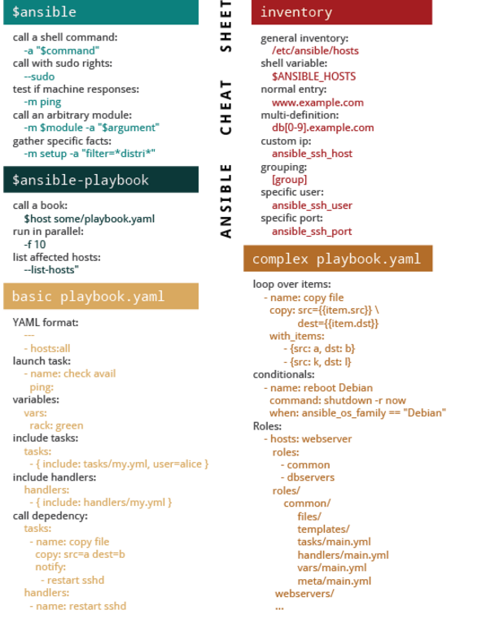

Create user yaml:
---
- hosts: webservers
tasks:
- name: create user
user:
name: user12345
comment: "user12345 "
uid: 1090
shell: "/bin/bash"
createhome: yes
home: "/home/user12345"
password: kieVINJhMcitY

to generate password in encrypted format:
openssl passwd

run_once keyword:
run_once: true to run task only once per playbook run.
Example:
[root@reviewb playbooks]# cat run_once.yaml
---
- hosts: webservers
tasks:
- name: create a dummy file
command: touch /tmp/dummymay30
run_once: true
even though there are 2 hosts in webservers, it will be executed only on 1 host.

