Jenkins
Agenda:
1. Installing Jenkins, setting up, configuration
2. Security LDAP - authorization
3. How to schedule a job
4. integration:
Integration with GIT/GITHUB
Integration with Ant
Integration with Maven
Integration with Ansible
Integration with Nexus
5.Troubleshooting (location of log files of startup, failed plugin and etc)
6. how to schedule backups
7. restore from backups
8. Configure Slaves
9. Monitoring the workload
10. Managing plugins

What is Jenkins:
Leading open source continuous Integration server
Highly configurable system by itself
400+ community developed plugins
Multi platform
Easy to use
Free & Open source
https://jenkins.io/index.html

Features:
- Jenkins provides continuous Integration services for software deployment.
- Based on tomcat
- Originally started as Hudson then renamed as Jenkins
- leading open source continuous integration server.
- Flexibility
- Jenkins is a highly configurable system by itself.
- 400+ community developed plugins
- Less Effort to Integrate existing existing test buckets.
- Multi platform
- Easy to use
- Free & Open Source
- Documentation: https://jenkins.io/index.html
Failing is Ok, but we need to fail fast
Catching a bug in test costs less than catching in production
Code quality review
Proper documentation
This can be done using custom scripts, but as the project increases it is difficult to maintain.
There was split in Hudson when oracle took over SUN,
90% Hudson and Jenkins are same

Build can be started by
Commit a version in version control
Scheduling via cron like mechanism
Tests can be executed every week/hour etc
If A fails do B, if A passes do C – jobs can be dependent like a pipeline
What is a build:
Build has many components – one of them is version control
No matters how many times a code changes, build has to happen, code has to be compiled.
Build also has to be tested
Communicate the results to all stake holders
- Product owner
- System admin
- QA
- Developer
History – can be maintained

Continuous delivery vs Continuous deployment
Continuous Deployment: deploying the product to customers continuously without approval, this is automatic
Continuous delivery: approval is needed, ready to deploy. This is not automatic
Test cases have to be automated for Continuous Integration

Download Jenkins:
Download LTS – long term support , not weekly build which is not safe
Download native packages not war packages
Jenkins rpm comes with webserver

Download Stable Jenkins rpm from http://pkg.jenkins-ci.org/redhat-stable/

- Install it using rpm –ivh

root@ctx3p12 MISC]# rpm -ivh jenkins-2.9-1.1.noarch.rpm
warning: jenkins-2.9-1.1.noarch.rpm: Header V4 DSA/SHA1 Signature, key ID d50582e6: NOKEY
Preparing... ################################# [100%]
Updating / installing...
1:jenkins-2.9-1.1 ################################# [100%]

- Install Java using yum
- Start the Jenkins service
[root@ctx3p12 MISC]# sudo systemctl start jenkins.service
[root@ctx3p12 MISC]# cat /var/lib/jenkins/secrets/initialAdminPassword
a45c1a99da7c49518ce07b7db91950e4
[root@ctx3p12 MISC]#
firewall-cmd --permanent --zone=public --add-port=8080/tcp
to open port 8080 on Jenkins server

Jenkins by default listens on port 8080

So open http://FQDN:8080
To change port
/etc/sysconfig/jenkins
http port to 8089

jenkins home
/var/lib/jenkins/config.xml
How to install
sudo yum -y install java
java is a prerequisite for Jenkins.
yum whatprovides service

sudo wget -O /etc/yum.repos.d/jenkins.repo http://pkg.jenkins-ci.org/redhat/jenkins.repo
- Downloads the repo file from Jenkins site
sudo rpm --import https://jenkins-ci.org/redhat/jenkins-ci.org.key
- Imports the key from Jenkins site for authentication

sudo yum install jenkins
- Downloads and installs the Jenkins packages from Jenkins repository

sudo systemctl status jenkins.service
- Start the service and check the status – it should be Active

Download Jenkins
Install it
Configure plugins
Install all of them
Install GIT related them
Installing all may slow down Jenkins
Its not recommended to enable auto refresh

URL/restart → will restart Jenkins
Manage Jenkins → Configure global security → click on enable security
Authorization → any one can do any thing
Security realm Jenkins own user database
LDAP is for corporate security to sign up using intranet id

Manage Jenkins → project based authority → enable everything for admin enable all permissions
Setup security
Click on Enable security

Difference between save and apply
Apply will remain in the same, save will go back to previous page

Manage Jenkins -> configure system
No. of executors – no. of core you have on CPU
GIT hub server - create user id in git hub server
Add git hub server
Go to client
Git clone https://githubg.com/RSCTFVT/
Commit back from SVN
Add a file here
Git add *
Git commit –m “some commit”

Jenkins was developed by Kohsuke Kawaguchi.

Backup of Jenkins:
- Take backup of home directory using tar -cvf command
tar -cvf jenkins-backup-21dec.tar Jenkins
gzip jenkins-backup-21dec.tar
then copy it to other machine
Incase of crash, extract this file in newly created Jenkins server
- Take backup of single job using xml
http://ctx3p11.in.company.com:8080/job/RSCTBAT/config.xml
open a job with config.xml extension and take backup in a file.

After installation:
[root@jupiter-vm751 ~]# cat /var/lib/jenkins/secrets/initialAdminPassword
1b5561f487c14ea3b9c6c386eca33cfc

Configuring Slaves:

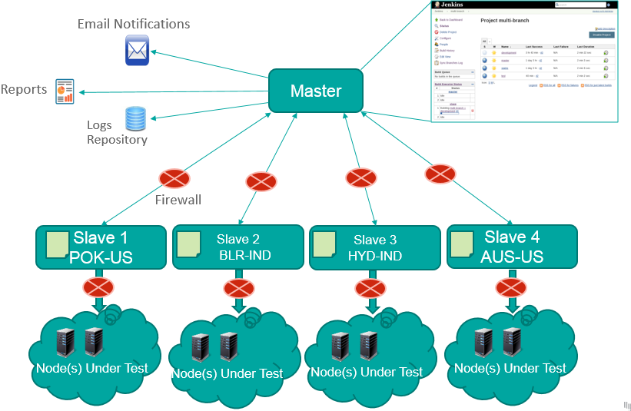

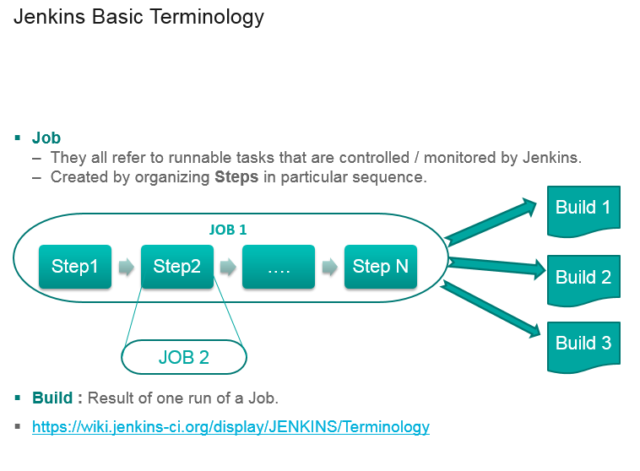

GIT
Git is becoming popular in Devops world
Git is to keep track of changes
Ansible/puppet/chef/vagrant – files we store on GITHUB

Why GIT :
- Build & Release - devops eng works with developers
- For storing automation scripts
- Open source - so many open source projects are hosted on GIT (Linux, chef, puppet etc)

System admins take backup by copying.
Cp file file_1
Cp file_1 file_2

Its difficult to track
Or we can name with date

That is also difficult to track
If there are many scripts – how to handle ?

There should be a centralized location to keep track of all changes – that is called version control system
Don’t keep track
Save numbered zip file
Fomal version control

Diff , windiff – can see the difference
Even that is difficult
Developed by Linux torwalds – keep track of source code
Used for just for source code
Do not use for file storage

Its fast
Don’t need access to server
Good at merging simultaneous changes
Everyone is using it
Bitbucket is alternative

GIT HUB – to store our scripts
Singup to github
Just give username and password
Login to it
Create new repository

Other CI tools:
Hudson
Bamboo
Microsoft tfs – team foundation server
Mercuyrail

Configuring slaves on the Jenkins master:
- Create jenkins user on the slave
useradd -d "/home/jenkins" -c "jenkins user" -s "/bin/bash" -m jenkins
and set the password to slave as root
passwd Jenkins

- Configure password less authentication on the server and slave for the Jenkins user
Login as Jenkins to master and execute
ssh-copy-id -i ~/.ssh/id_rsa.pub jenkins@rscthydnet1
- Go to Jenkins → manage nodes → New node,
- Select as Permanent agent
- Select options as below

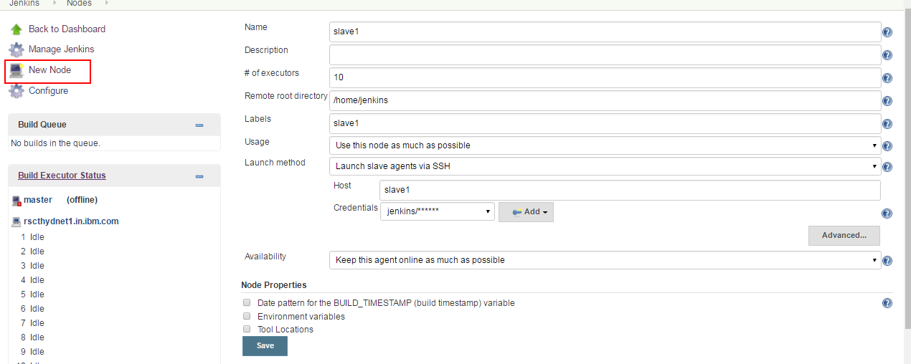

Once slave is added, make it online by
Clicking on
Manage Jenkins → Manage Node → Click on Slave → Launch agent
This will make the slave online

Integration with GIT:
Install git on slave
Register your self on github and create a sample project

Add giit plugin to Jenkins
Create a new job
Select Source Code Management as git

Provide the Repository URL as the git url (copy from clone or download option on git hub)
Provide the credentials (Same as github)

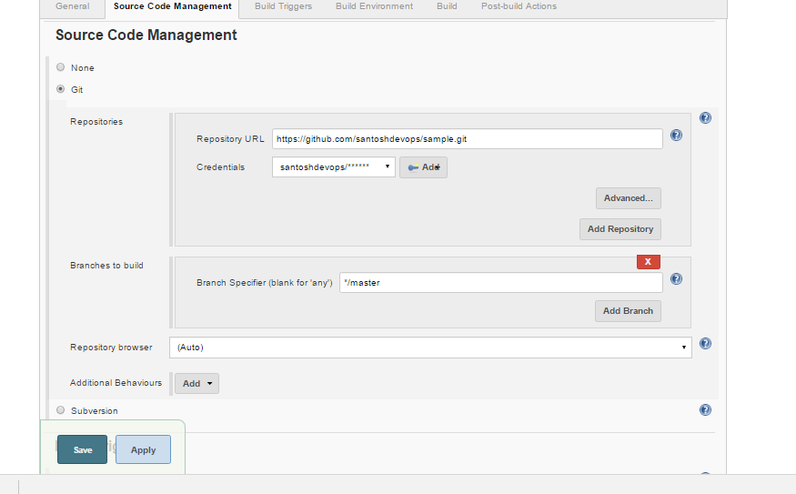

Select build triggers as Poll SCM for every minute - * * * * *

To run this project on a particular slave
Click the checkbox
Restrict where this project can be run and select lable of the slave.

Ant:

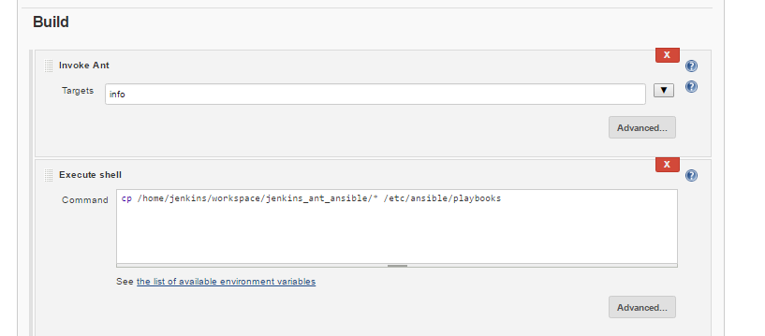

Ansible

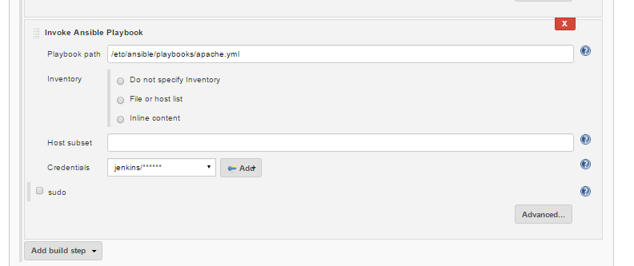

Integration with Nexus build repository:
Nexus is a build repository stores the builds in a hierarchical directory structure.
Nexus can
- Gives a centralized repository for managing all popular component formats.
- Gain insight into component security, license, and quality issues.
- Improve productivity by efficiently distributing components to developers around the corner, or around the world.
- Modernize software development with intelligent staging and release functionality.
- Sleep comfortably with world-class support and training.

How to install Nexus:
cd /usr/local/
wget http://sonatype.org/downloads/nexus-latest-bundle.tar.gz
gunzip nexus-latest-bundle.tar.gz
tar -xvf nexus-latest-bundle.tar
mv nexus-2.14.3-02 sonatype-work /usr/local

ln -s nexus-2.14.3-02 nexus

cd nexus
export RUN_AS_USER=root

./nexus start

Make sure nexus is running by executing “ ps -ef | grep -i nexus
“
admin/admin123 – default password for nexus login.
Open nexus GUI:
URL: http://rscthydnet2:8081/nexus/#welcome

Create a repository in Nexus to host builds

Go to repository → add hosted repository

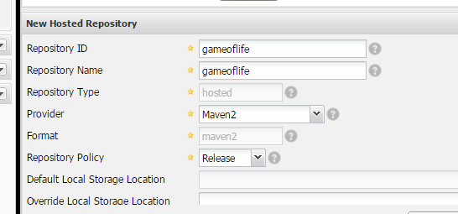

In the Jenkins add the plugin Nexus Artifact Uploader
Also install the zen timestamp plugin to use $BUILD_TIMESTAMP variable in the job

Configure the job as below

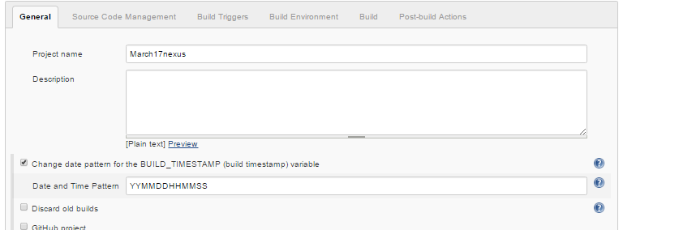

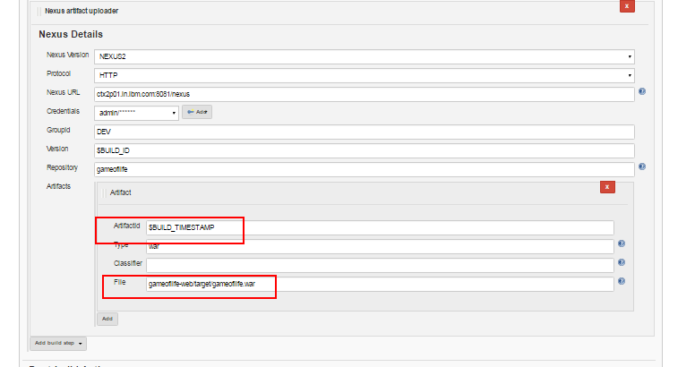

After job is executed nexus creates repos as below
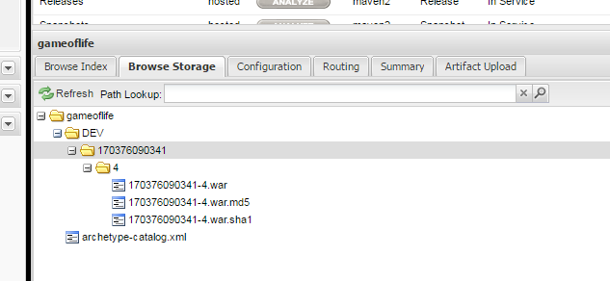

And it can be accessed using a link

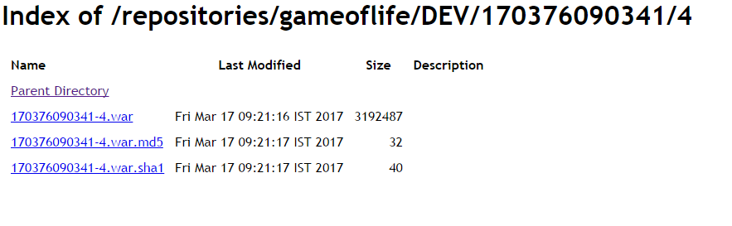

Jenkins logs:
Jenkins logs will be stored under :
/var/log/jenkins/jenkins.log
Some commonly used plugins:
Extended choice parameter
Build with parameters
Rebuild now
Html report generator
Junit report generator
Thinkbackup
Monitoring

Crontab syntax:

* * * * *
minutes 0-59
hours 0-12
day of the month 1-31
month of the year 1-12
day of the week sun,mon,tue,wed,thu,fri,sat
command/script

crontab - utility to schedule the jobs
10AM - good morning
9AM, 5PM - cleanup the logs
1st of month --> msg

10 * * * * echo Hi --> every 10 minutes

* 10 * * * date >> /file --> every day 10AM

* 17 * * * /scr --> every day 17th hour - 5PM

* 10,17 * * * /script

* 10,11,12,17 * * /script

* * 1 * * /scr --> every month on 1st

To have upstream job and downstream job:
Use a plugin called Jobfan in
While creating job, we can have a condition like, if Job A is built successfully then only start the job B.
If build is successful, then go for test.

