VISHNU THUMPUDI

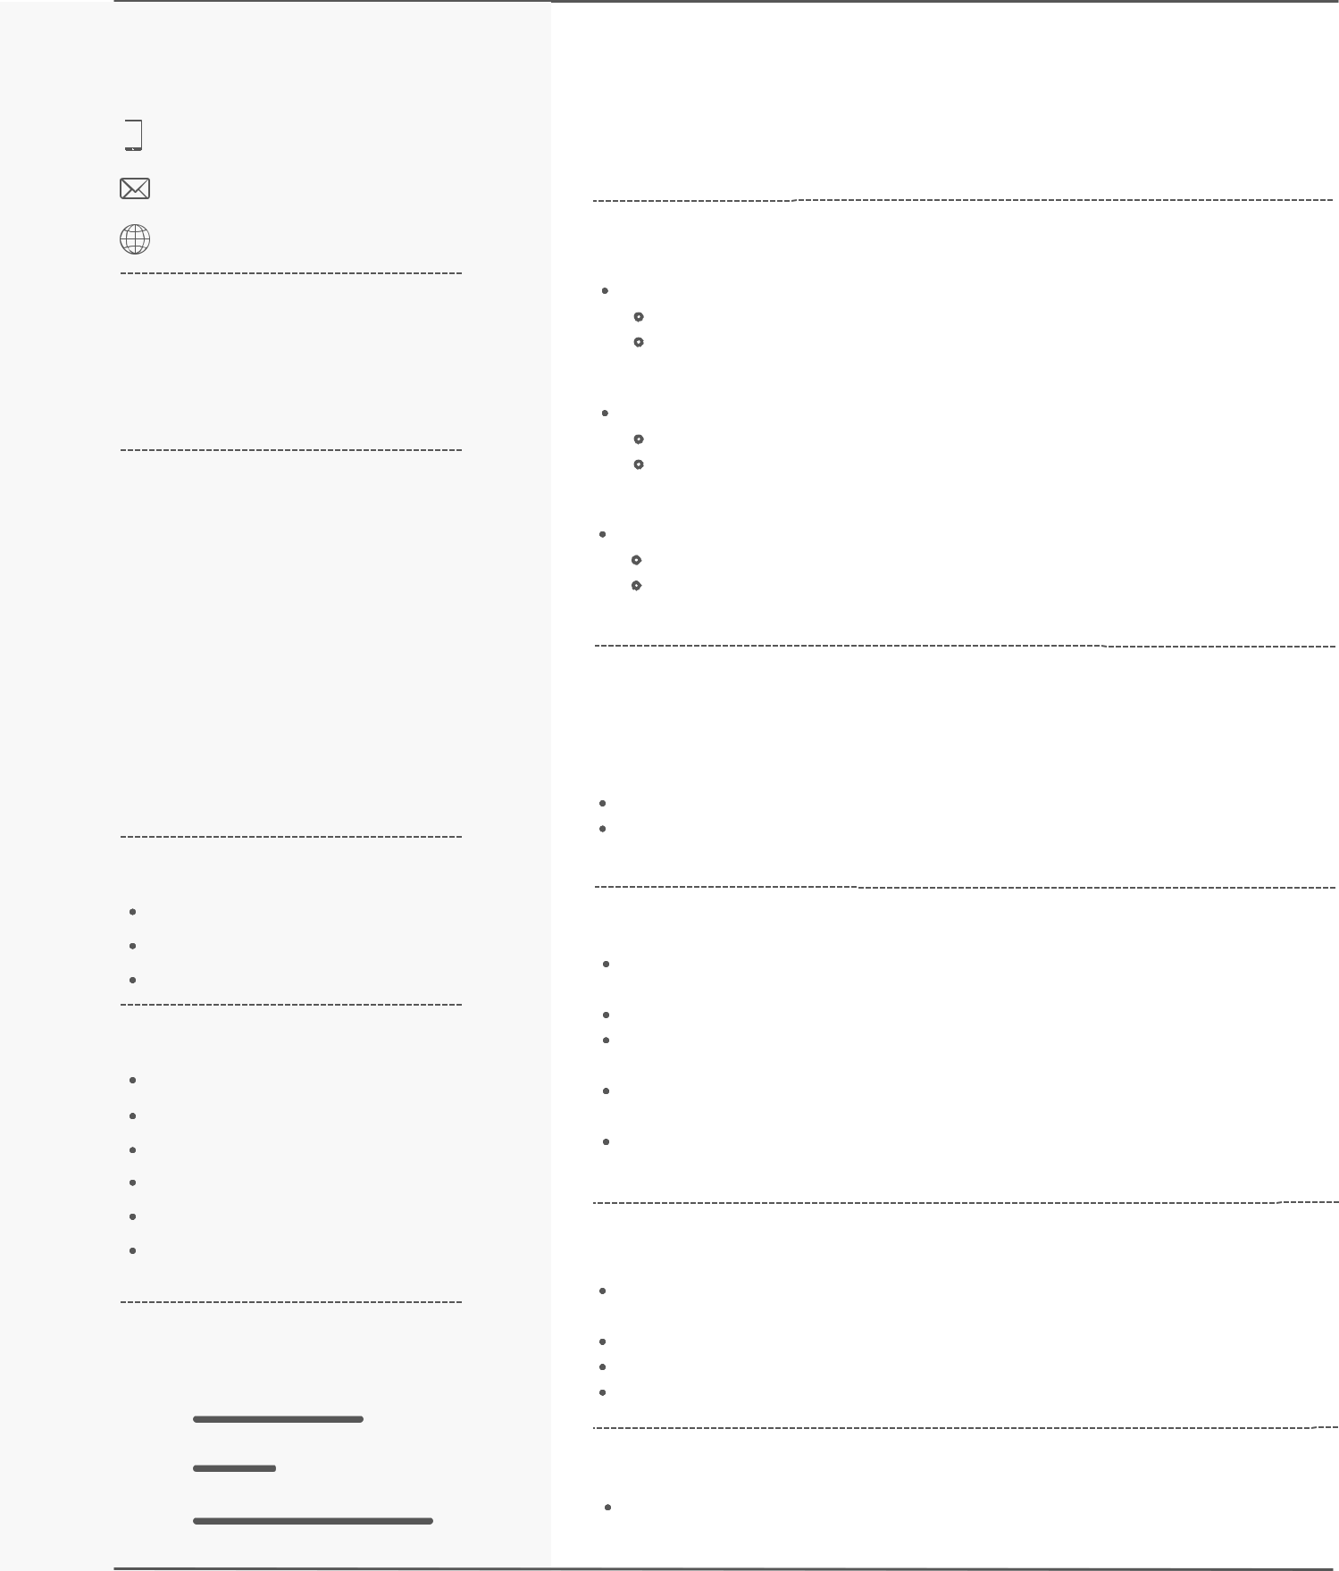

**CONTACT**

+91 7702809180

vishnuthumpudi@gmail.com

www.linkedin.com/in/vthumpudi21

**SKILLS**

Python C++

Git & Github SQL

Android Studio Java

**EDUCATION**

**B.Tech Bioinformatics**

**SASTRA UNIVERSITY**

2020-2024(Pursuing) CGPA : 7.5852 **Intermediate**

**S K V S Junior Kalasala**

2018-2020 CGPA : 91.9

**10th**

**Viswasanthi EM High School**

2005-2018 CGPA : 9.5

**SOFT SKILLS**

Time Management

Effective Communication

Team work

**INTERESTS & HOBBIES**

Reading Technology Blogs

Listening Music

Travelling

Developing Applications

Debugging

Cycling

**LANGUAGES**

English

Hindi

Telugu

**OBJECTIVE**

Seeking for an entry-level position in an organization where I can utilize my skills and educational background, passion for learning, and my dedication to contribute effectively to the company's success and further develop my professional skills & capabilities.

**PROJECTS :**

Weather Application for Android - March 2023 - April 2023

Technology Used : Java

Developed an intuitive and feature-rich Android application that delivers accurate

and real-time weather information to users

Lipinski Rule of 5 - Web Application - August 2023

Technology Used : Javascript

Developed an user-friendly Web Application designed to assess the drug-likeness

of chemical compounds based on Lipinski's Rule of 5.

Machine Learning for Molecular Dynamics - July 2023- Present

Technology Used : Python

Developing an feature-rich model using Misato Dataset that delivers accurate predictions for properties at frame-level and trajectory-level

**POSITION OF RESPONSIBILITY :**

**Core Team Member - Daksh Workshops Team**

Daksh Oct 2022-Present

DAKSH is the annual techno management fest of SASTRA University.

Ever since its establishment it has been a platform for a multitude of students and aspirants to unravel their talents and showcase their technical prowers.

**ACHEIVEMENTS & CERTIFICATIONS :**

Certified in Python, Problem Solving, and SQL from Hackerrank (Basic), and 3-star rating in Python.

Completed Agile Methodology Virtual Experience Program with Cognizant. Certified in 'A Beginners Guide to Open Source Software Development' by Linux Foundation.

Achieved Microsoft Azure Fundamentals Course certification from LinkedIn Learning.

Completed Software Engineering Virtual Experience Programme with certificate from Goldman Sachs.

**WORKSHOPS & EVENTS :**

Participated in Kubernetes and DevOps using Azure conference at Microsoft Reactor, Bengaluru.

Attended Google I/O (2022, 2023) and Firebase Summit 2022

Joined Google Cloud Next'23, DockerCon 2023, and Github Universe 2023.

Participated in Microsoft Build 2023 and NVIDIA GTC 2020.

**DECLARATION :**

I hereby declare that the above provided information is true to the best of my knowledge