MDM2 – Case Study: Assistive Robotics for
Improvement of Life Quality
One-Page Proposal
Team | 5
Members | Vishnu Thaimachedath Nandakumar, Jeethu Thambi & Thadepalli Nikitha
Project Title | Wearable Wrist Rehabilitation Using Dual-Channel Functional Electrical Stimulation (FES)
GitHub Repository URL | https://github.com/vishnutnGithub/assistive-robotics-life-quality.git
Contact Email | jeethu.thambi@stud.th-deg.de  vishnu.thaimachedath-nandakumar@stud.th-deg.de
Industrial Application (target domain/use-case) | Healthcare / Assistive Robotics / Home Rehabilitation
Keywords (3–6) | Functional Electrical Stimulation (FES), wrist rehabilitation, wearable robotics, sensor fusion, assistive technology
Submission Date (YYYY-MM-DD) | 2026-04-10
Gantt Chart | 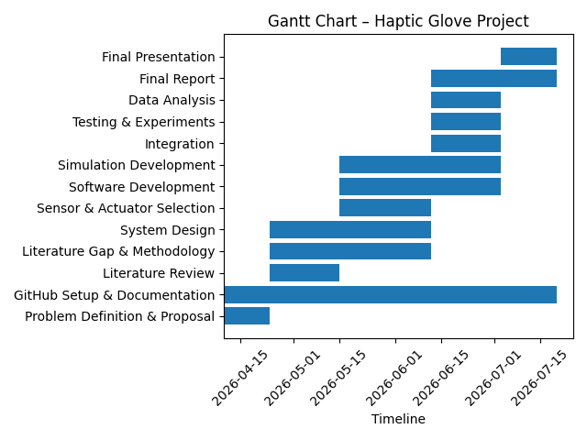

1) Problem Statement & Measurable Outcomes (3–4 sentences) | Stroke and other neurological or musculoskeletal conditions frequently impair hand and upper-limb function, including wrist rotation (pronation/supination), limiting daily activities. Traditional rehabilitation requires frequent clinic visits and typically assists rotation using heavy mechanical actuators. This project proposes a wearable system that uses dual-channel Functional Electrical Stimulation (FES) to assist both grip and wrist rotation without any mechanical actuator.  Measurable outcomes (KPIs):  - Reliable FES-triggered grip closure on FSR threshold detection  - FES-assisted wrist rotation up to a 60° target angle  - Total system mass kept under 150 g  - Control logic validated via MATLAB simulation and structured self-wear testing
2) Motivation & Assistive Relevance (2–3 sentences) | Patients recovering from stroke or spinal cord injury often retain partial voluntary grip but struggle specifically with forearm rotation — an area comparatively underexplored in lightweight wearable rehabilitation. A low-cost, motor-free FES-based device makes combined grip-and-rotation therapy feasible for home use, where mechanical exoskeletons remain impractical due to weight and cost. This is increasingly important as demand for home-based rehabilitation continues to grow.
3) Method & Feasibility (≤6 sentences) | Four actuation approaches — electric motor, pneumatic, series elastic actuator, and hydraulic — were compared against Functional Electrical Stimulation across weight, cost, and mechanical complexity, with FES selected for eliminating the need for any mechanical actuator. System behaviour (grip-then-rotate sequencing) was first validated through MATLAB simulation of a threshold-triggered finite-state machine before hardware implementation. The validated logic was then ported to ESP32 firmware, integrating FSR grip sensors, an IMU rotation sensor, and a dual-channel FES stimulator. In place of clinical trials, validation is performed through structured self-wear testing by the project team across defined movement scenarios (grip only, rotation only, combined sequence, multiple rotation targets, repeated trials).
4) Milestones & Timeline (short table/list) | Phase | Task | Target  P1 — Proposal — April 10  P2 — Literature map, baseline sim & bibliography report — April 24  P3 — Methodology — May 15  P4 — Demo, experiments & analysis — June 12  P5 — Final presentation & report — July 3
5) Risks & Ethics (1–2 sentences) | Electrical stimulation delivered through skin electrodes requires medical-grade, electrically isolated circuitry to ensure user safety, and all self-testing was conducted with an immediate stop capability. Design claims avoid overstating clinical efficacy at this prototype stage, and all technical and academic sources are properly cited.

BILL OF MATERIALS
PROJECT NAME: WEARABLE WRIST REHABILITATION USING DUAL-CHANNEL FES
ITEMS | DESCRIPTION | QTY | COST (approx.)
ESP32 Microcontroller | Central controller | 1 | € 8.00
FSR Sensor | FSR 402, fingertip grip sensing | 5 | € 30.00
IMU Sensor | MPU-6050 / BNO055, rotation tracking | 1 | € 10.00
Motor Driver | ULN2803A Darlington array | 1 | € 2.00
Vibration Motor | Haptic feedback, back of fingers | 5 | € 10.00
RGB LED | Visual feedback | 1 | € 1.00
FES Stimulator Module | Dual-channel, medical-grade, isolated | 1 | € 120.00
FES Electrode Pads | Channel 1 (grip) + Channel 2 (rotation) | 4 | € 15.00
Battery | Li-ion, rechargeable | 1 | € 12.00
USB-C Charging Module | Battery charging circuit | 1 | € 5.00
Glove Base | Nylon-spandex tactical/athletic glove | 1 | € 15.00
Silicone Reinforcement Patches | Fingertip sensor mounting | 5 | € 5.00
Forearm Band | Fabric/elastic with Velcro closure | 1 | € 8.00
TOTAL |  |  | € 241.00
Costs are approximate component-level estimates based on typical retailer pricing, not confirmed purchase receipts.

