I have compared the logic for Output types Y024 and Y034 and most of the logic is similar and found one extra condition in Y024 as shown in below. It Due to that text is not displaying.
Y034:
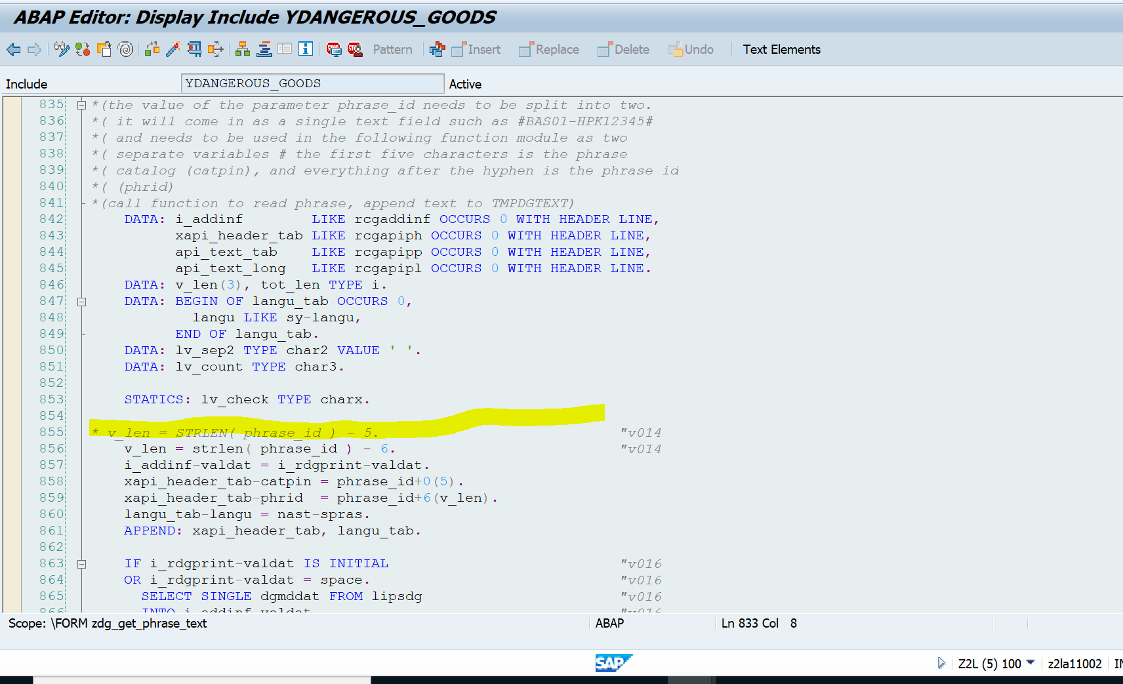
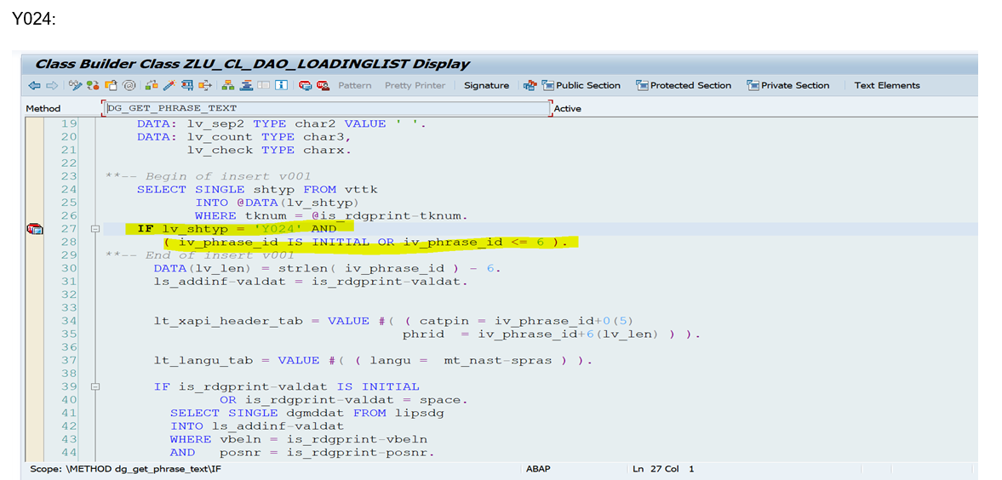

If I have skipped that condition and the text is displaying as expected. Please find the screenshot of it.

