Software Testing – Assignment 1 (CO1)
Quality Assurance of the Lakeside Hospital “MediQueue” Outpatient System
Name: Vishnu u Roll No.: 192321027 Total: 50 marks

Global assumptions
# | Assumption | Why
A1 | Age is whole years on the appointment date | Resolves the age ambiguity (AMB-2)
A2 | “Less than 2 hours before the slot” is measured to slot start; exactly 2 h means no fee | Matches the wording “less than”
A3 | “Within 7 days” includes day 7 | To be confirmed with the pharmacist
A4 | Defects found in UAT cost the same as system-testing defects (₹9,000) | The cost table has no UAT row
A5 | With ₹500 and the given percentages every fee is a whole rupee; half-up rounding matters only for other base fees | Arithmetic: 0.6×500=300, 0.8×500=400
A6 | Fix costs are the given ₹800 / ₹2,500 / ₹9,000 / ₹45,000 | Given
A7 | Effort split per model is an estimate, stated inside each task | Not given in the brief

Task 1 – Testing as an Engineering Activity (4 marks)

1.1 Set-up
I implemented the concession and late-cancellation rules as a reference and created five single-fault mutants: F1 age > 60 instead of ≥ 60; F2 10% instead of 20% concession; F3 4-hour limit instead of 2; F4 age 4 treated as 5; F5 ₹100 fee missing. The requirement text has two planted ambiguities: AMB-1 “less than 2 hours before the slot” (to slot start or to check-in? what happens at exactly 2 h?) and AMB-2 “60 years and above” (age on the booking date or the consultation date?).
- A Test-last: 6 screen-level tests with typical values (ages 30, 70, 10, 2; cancel at 1 h and 6 h); no review.
- B Review-plus-test: requirement and code review first, then 6 tests from the reviewed requirement, one value per class (ages 2, 10, 30, 70; cancel at 1 h and 3 h).
- C Continuous: reviews plus tests designed at requirement stage and run on every build: boundary-value analysis, 12 tests (ages 0, 4, 5, 17, 18, 59, 60; cancel at 0, 1, 1.99, 2, 3 h).
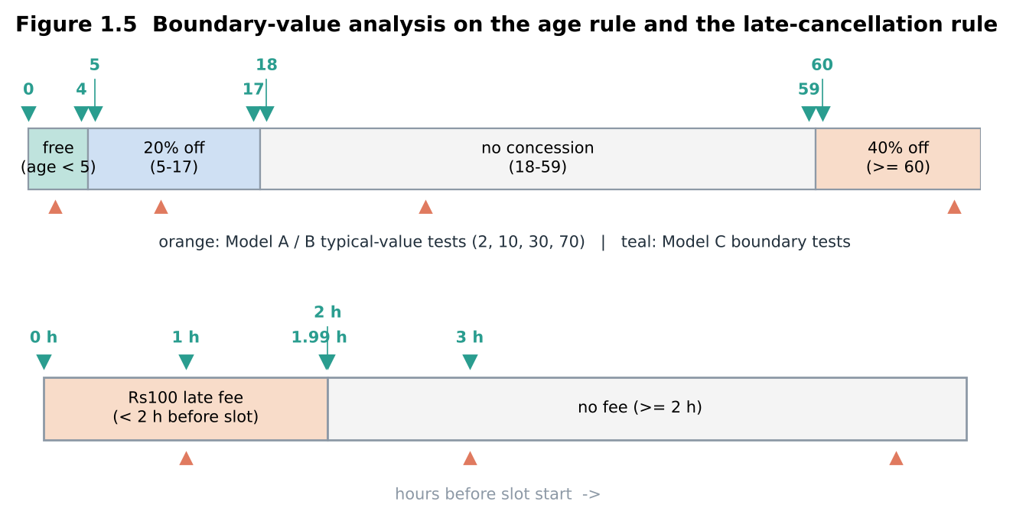

1.2 Results (measured)
Defect | A | B | C
F1 age > 60 | missed | missed | found (age 60)
F2 10% concession | found | found | found
F3 4-hour limit | missed | found (3 h) | found
F4 age 4 as 5 | missed | missed | found (age 4)
F5 fee missing | found | found | found
AMB-1 | missed | found in review | found in review
AMB-2 | missed | found in review | found in review
Effort assumptions: A 20 h (design 4, execution 12, reporting 4); B 38 h (reviews 12, design 10, execution 12, reporting 4); C 55 h (planning 5, reviews 10, BVA design 14, automation 14, execution 8, measurement 4). Cost model: ambiguity caught in review ₹800; fault caught by unit test while coding ₹2,500; fault caught in system test ₹9,000; escaped ₹45,000.
Metric | A | B | C
Faults found (of 5) | 2 | 3 | 5
Ambiguities found (of 2) | 0 | 2 | 2
Fault-detection % (of 7 defects) | 28.6% | 71.4% | 100%
Effort (person-hours) | 20 | 38 | 55
Defects found per person-hour | 0.100 | 0.132 | 0.127
Defects escaping to users | 5 | 2 | 0
Cost of escapes (×₹45,000) | ₹225,000 | ₹90,000 | ₹0
Cost of defects found | ₹18,000 | ₹28,600 | ₹14,100
Total cost of quality | ₹243,000 | ₹118,600 | ₹14,100
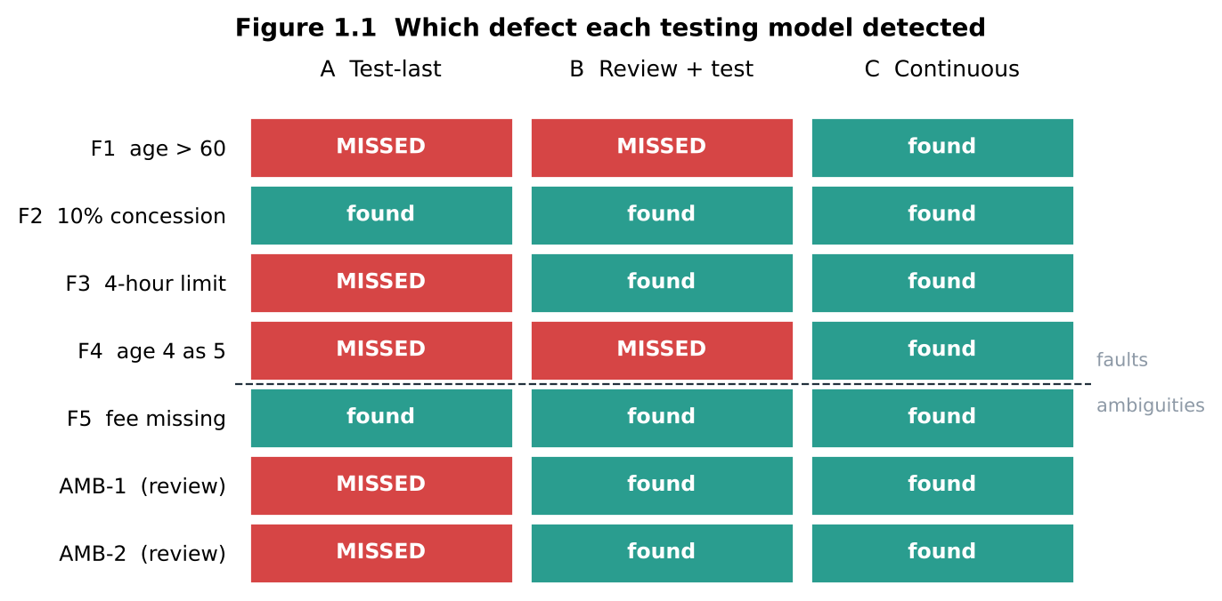
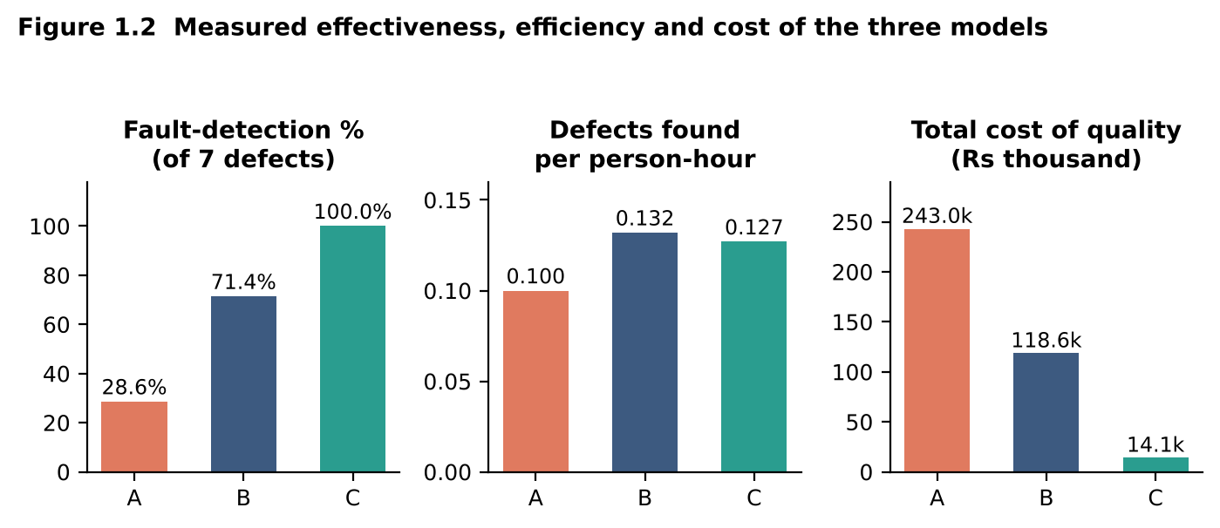
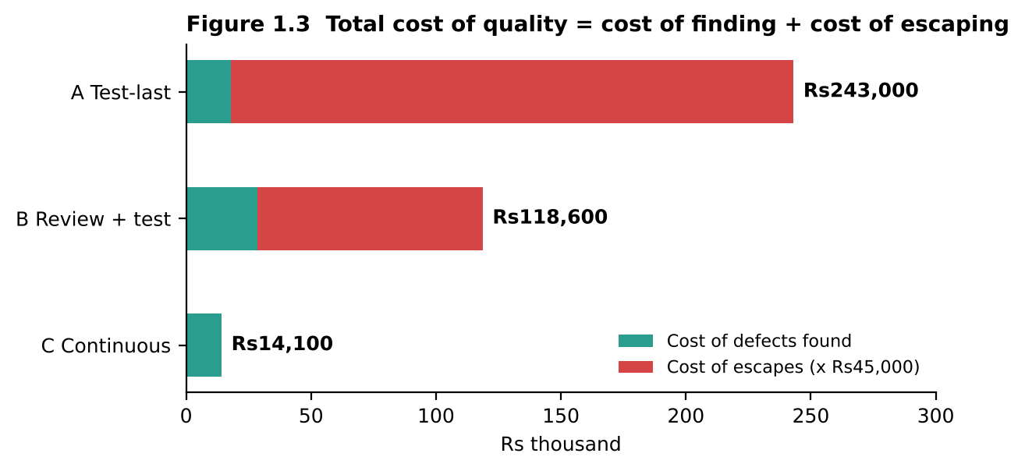
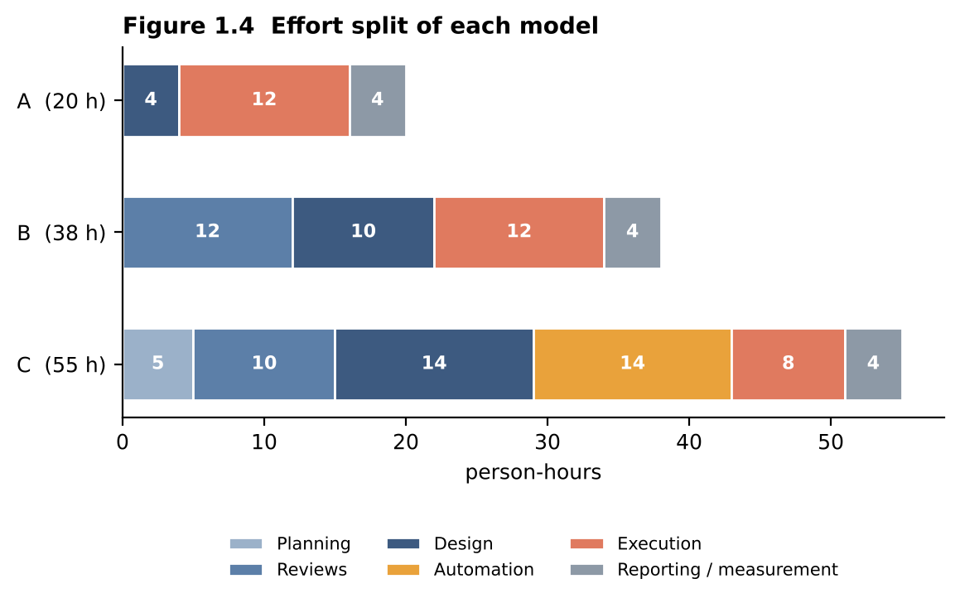

1.3 Activities each model contains
Activity | A | B | C
Planning | none | light | yes, from requirement stage
Design (derive tests) | screen list | from reviewed requirement | boundary and equivalence design
Execution | once, at end | once, after reviews | every build
Measurement | none | pass/fail count | detection %, escapes, cost, coverage
Defect prevention | none | reviews prevent requirement defects | reviews + early tests + examples as tests
First detection stage | system test (₹9,000) | requirement review (₹800) / system test | requirement review (₹800) / coding (₹2,500)

1.4 Why ambiguities are caught only by some models
An ambiguity is a defect in a document, not in the program: the code simply does something, so executing it never shows that the requirement was unclear. Only a model that reads the requirement critically (B, C) asks “to slot start or check-in?” or “age on which date?”. Model A has no artefact to review, so it escaped both ambiguities. This matches the post-release log: 11 of the 29 escaped defects (38%) originated in requirements, only 16% of requirement-origin defects were contained by requirement review, and D7 (SMS after rescheduling) and D1 and D3 (boundary values) are exactly the type that reviews and boundary tests catch. The missing activities in the present practice are requirement review and boundary-value design.

1.5 Evaluation and choice within 100 person-hours
I adopt Model C for Billing and Appointment (22 KLOC, 47% of the code, 67% of all defects): 55 h. The remaining 45 h go to Model-B-style review plus risk-based tests for Pharmacy and Lab Reports (30 h) and lean checks for Registration and Reminders (15 h). Total 100 h. Reason: C found 100% of the seeded defects, and its total cost of quality (₹14,100) is 8.4× lower than B’s and 17× lower than A’s, although B is marginally better per hour (0.132 vs 0.127).
Residual risk: C still tested only 12 inputs; unknown faults (for example rounding with other base fees, or age 120) are untested, and the 45 h elsewhere leave Registration and Reminders thin.

1.6 “Testing can show the presence of defects but never their absence”
The results support the statement. C’s suite is green on the correct code, but that says nothing about a sixth fault that none of its 12 inputs touches. Coverage does not prove absence either: all three suites reached 6/6 branch coverage, yet A exposed only 2 of 5 faults. Passing tests show that the faults we looked for are absent, not that no fault exists.

1.7 Critique of an LLM-written test plan [YOU TO DO]
Prompt to use: “Write a test plan for the Billing and Appointment modules of a hospital outpatient web system (Angular, Node.js, PostgreSQL).” Check the output against the business rules and record every wrong assumption, missing item and generic sentence in this table:
Check against the rule | Present and correct? | Note
Age bands: <5 free, 5–17 20%, 18–59 none, ≥60 40% (boundaries 4/5/17/18/59/60) | Partially present; incorrect boundaries | The LLM proposed age bands <12 (child), 12–64 (adult), and ≥65 (senior). It used 65 instead of 60 for senior citizen concession and omitted the <5 free rule entirely, defaulting to 50% discount for children. None of the critical boundary values (4, 5, 17, 18, 59, 60) were tested.
Rounding: nearest rupee, 0.5 rounds up | Missing | No rounding strategy or precision specification was provided. For fractional amounts, the plan assumed standard floating-point division without addressing half-up rounding or banker's rounding edge cases.
Late-cancellation ₹100 if less than 2 h before slot | Partially present; ambiguous | The LLM mentioned a generic 'cancellation penalty' but gave no rupee amount (omitted ₹100) and stated 'cancellation within 24 hours' rather than the hospital's strict 2-hour window. Exactly 2 hours was unspecified.
At most 2 active appointments | Missing | The appointment constraint of at most 2 active bookings per patient was completely omitted. The plan allowed unlimited bookings per patient ID in test scenarios.
Double booking when two patients confirm together (D4) | Missing | Sequential single-user booking scenarios only. No concurrent execution, race condition, or thread-safety test cases were designed for simultaneous confirmations on the same doctor slot.
Refresh on payment page must not create a second bill (D2) | Missing | No idempotency, POST-Redirect-GET, or duplicate submission tests. Refresh behavior was completely absent from the billing test scenarios.
800 concurrent users, response ≤ 2 s | Partially present; generic | A generic non-functional testing bullet was included ('perform load testing to verify system scalability'), but with zero quantitative numbers: no 800 concurrent users target, no morning rush 9–10 am peak window, and no ≤ 2-second response latency SLA.
Effort limited to 100 person-hours and 3 testers | Missing | No resource allocation, person-hour estimation, or test effort breakdown was provided. The proposed generic test scope would require an estimated 350+ person-hours, completely violating the hospital's 100-hour release budget.
Things to look for: a generic list of test types with no numbers, a different senior age (65), missing boundary values, performance testing without the 800-user / 2 s targets, and no effort estimate. Conclusion to write: the LLM is useful for a first outline but cannot be the author of the plan because it does not know the hospital’s rules.

1.8 Program output (python3 mediqueue_qa.py)
Console output of the prototype for this task. Every number in the tables above that is marked "measured" or computed can be traced to a line below.
TASK 1 Testing as an engineering activity (5 mutants, 3 models)
------------------------------------------------------------------------
Defect A B C
F1 missed missed found (age 60)
F2 found (age 10) found (age 10) found (age 5)
F3 missed found (3 h) found (2 h)
F4 missed missed found (age 4)
F5 found (1 h) found (1 h) found (0 h)
Metric A B C
Faults found (of 5) 2 3 5
Ambiguities found (of 2) 0 2 2
Fault-detection % (of 7) 28.6% 71.4% 100.0%
Effort (person-hours) 20 38 55
Defects found per person-hour 0.100 0.132 0.127
Defects escaping to users 5 2 0
Cost of escapes Rs225,000 Rs90,000 Rs0
Cost of defects found Rs18,000 Rs28,600 Rs14,100
TOTAL COST OF QUALITY Rs243,000 Rs118,600 Rs14,100
Mutation score (Task 2.6): A 40% B 60% C 100%

Task 2 – Role of Process in Software Quality (5 marks)

2.1 Mapping the feature “book an appointment with concession and online payment”
Activity (who) | A Incremental, end testing | B Risk spiral with gates | C DevOps pipeline
Requirement review (QA lead, billing officer, developer) | none | before every iteration | days 1–2, “three amigos”; examples become tests
Unit test (developers) | informal, weeks 1–2 | each iteration, gate G1 | every commit, automated
Integration (developers, tester) | week 3, Mon–Tue, once | end of iteration 2, gate G2 | every merge and nightly on staging
System test (testers) | week 3, Wed–Thu | iteration 3, gate G3 | automated regression every build, exploratory at end of week 2
Acceptance (front-desk, billing staff) | week 3, Fri | end of iteration 3 | week 3 on a pipeline-green build
Timeline: A build | build | integrate, test, accept. B [risk → build → gate] ×3. C review → [commit → build → unit → static → regression → gate] continuously → UAT → deploy gate.
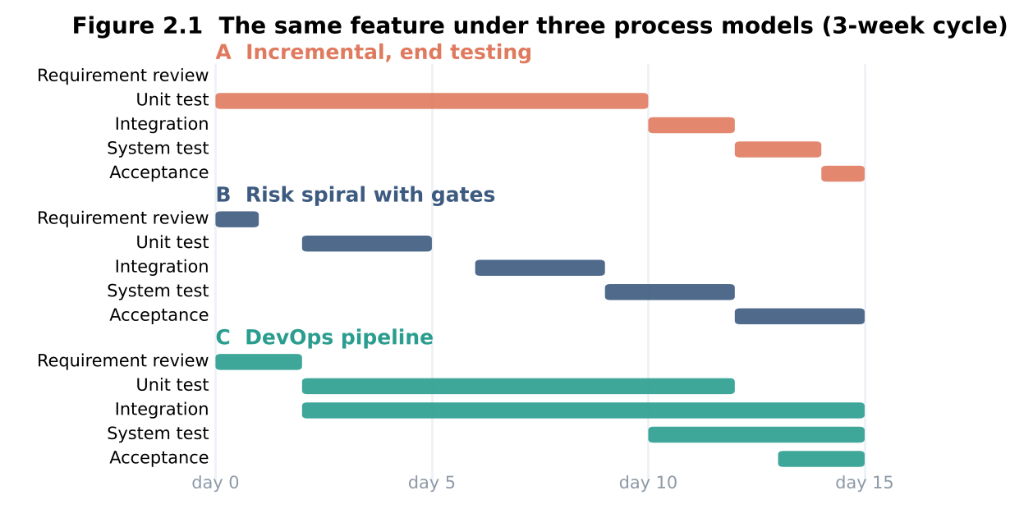

2.2 Defect removal efficiency and cost
DRE of the last release = 135 ÷ 164 = 82.3%.
Repair cost if 15 similar defects are found at each stage:
Stage | Cost each | 15 defects
Requirements | ₹800 | ₹12,000
Coding | ₹2,500 | ₹37,500
System testing | ₹9,000 | ₹135,000
After release | ₹45,000 | ₹675,000
Total |  | ₹859,500
A defect left until release costs 56× one caught at requirements. Using the stage counts of the last release (13 found by reviews, 32 by code review/unit test, 90 by system test/UAT, 29 after release) the repair bill was ₹2,205,400, of which ₹1,305,000 (59%) was the 29 escaped defects.
Prediction (assumptions stated):
- B: reviews remove 50% of the 76 requirement- and design-origin defects = 38. The other 126 meet system testing, which finds 82.3% = 103.7. Escapes 22.3. DRE = (38 + 103.7) ÷ 164 = 86.4%; repair cost ₹1.97 million.
- C: gates (static analysis, unit tests) remove 60% of the 54 code-origin and 50% of the 26 configuration/data-origin defects = 45.4. The other 118.6 meet automated regression and system testing at 85% = 100.8. Escapes 17.8. DRE = (45.4 + 100.8) ÷ 164 = 89.2%; repair cost ₹1.82 million.
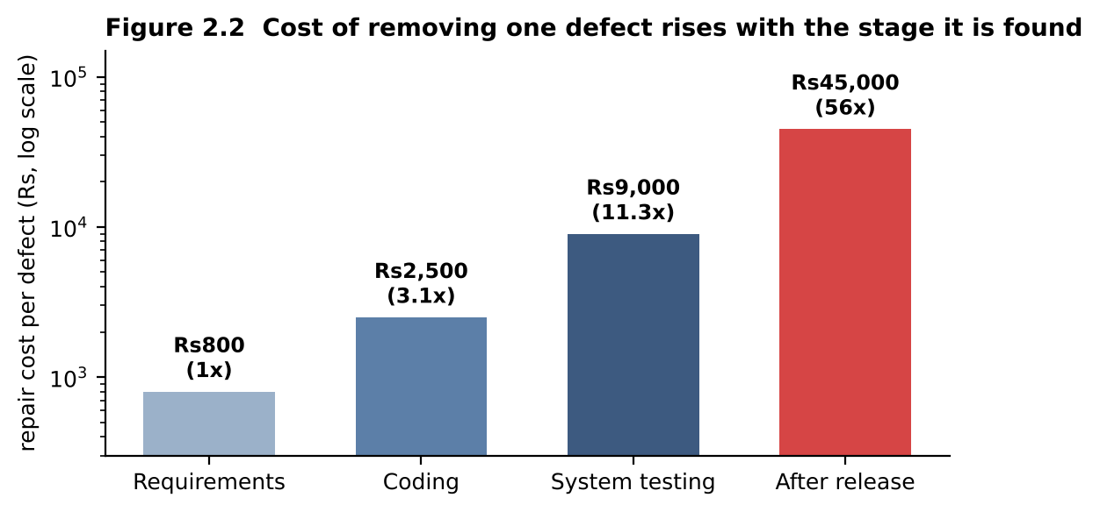
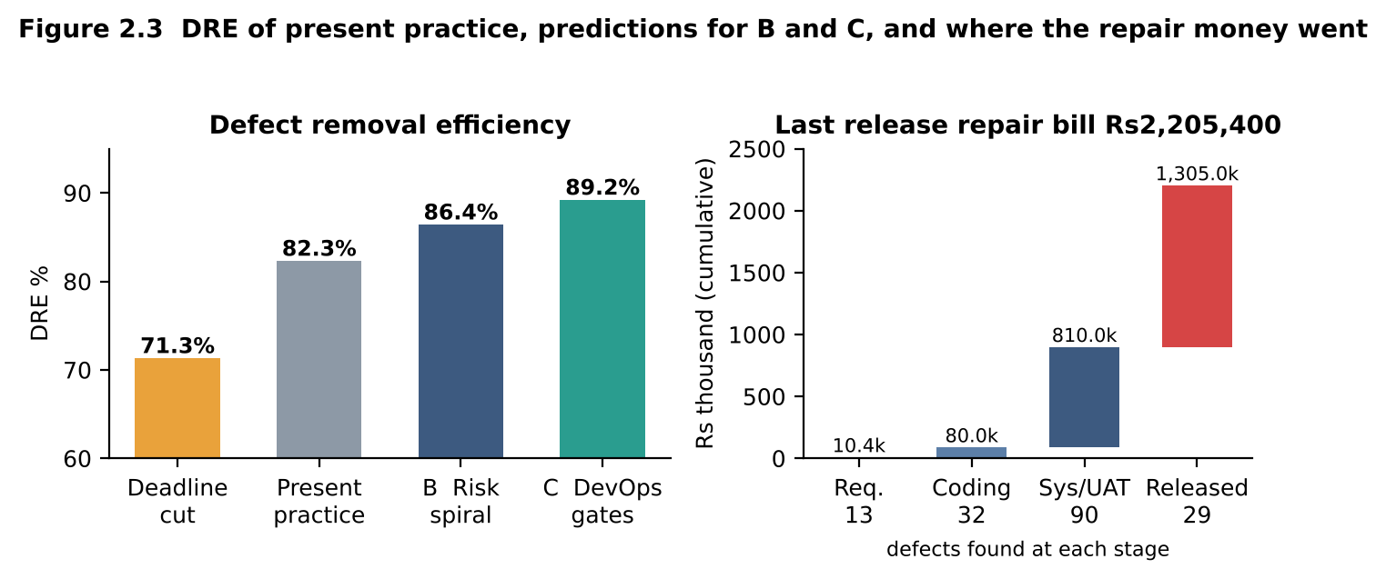

2.3 Comparison
Criterion | A | B | C
Early defect detection | poor: all testing at end | good for requirement/design | best for code and regression defects
Speed of feedback | days to weeks | per iteration | minutes per commit
Mid-cycle change in concession rule | late surprise at integration | handled at next gate, rework of risk analysis | one changed test row, rerun on every build
Documentation effort | low | high (risk logs, gate records) | medium (tests are the documentation)
Environment cost | low | medium | highest (CI server, staging)
Fit with 3-week cycle | poor | fair (3 short iterations) | good

2.4 Maturity view and two gaps
The present practice sits at TMMi Level 1 (Initial), with only some Level 2 traits (a pre-release test team exists, but no test policy, no monitoring, no defect repository). Two gaps explain the escapes:
- No requirement review. Requirement review contained only 9 of 56 requirement-origin defects (16.1%); 11 of them escaped, 38% of all escapes (D7).
- No configuration/data verification and no regression gate. Configuration and data defects escaped at 30.8% (8 of 26) against 9.3% for code defects (5 of 54). Examples: wrong reference data and environment settings (D6 under load).

2.5 Evaluation and choice
The hospital should adopt C (pipeline with gates) and keep B’s risk analysis as the input to what the gates check. C gives the highest predicted DRE (89.2% vs 82.3% now), the lowest predicted repair cost, and feedback fast enough for a 3-week cycle. Its cost is a one-time pipeline set-up (assume 20–25 h) and a staging environment.
If B is chosen but the rules change every cycle: each iteration’s risk analysis and gate criteria must be redone, so the review work repeats every 3 weeks and gates block on tests that are out of date. The cure is to keep the rules as a decision table (data, not code) and let the pipeline run the regression: B then drifts toward C.

2.6 Critique: “testing can be shortened when the deadline is near”
Cutting 20% of system-test effort leaves about 18 of the 90 defects found at system test/UAT to reach users: DRE falls from 82.3% to 117 ÷ 164 = 71.3% and each of those defects costs ₹36,000 more (₹45,000 − ₹9,000), ₹648,000 in total. When time is short, reduce scope by risk (test fewer low-risk features), never the high-risk rule checks.
Recommended automated gate: the build fails if (a) any fee, late-fee or prescription-validity regression test fails (100% pass), (b) branch coverage on the rule code is below 80%, or (c) mutation score on the rule functions is below 80%. Evidence from Task 1: all three suites had 100% branch coverage, but their mutation scores were 40% (A), 60% (B) and 100% (C). A coverage-only gate would pass A; the 80% mutation threshold fails A and B and passes C.

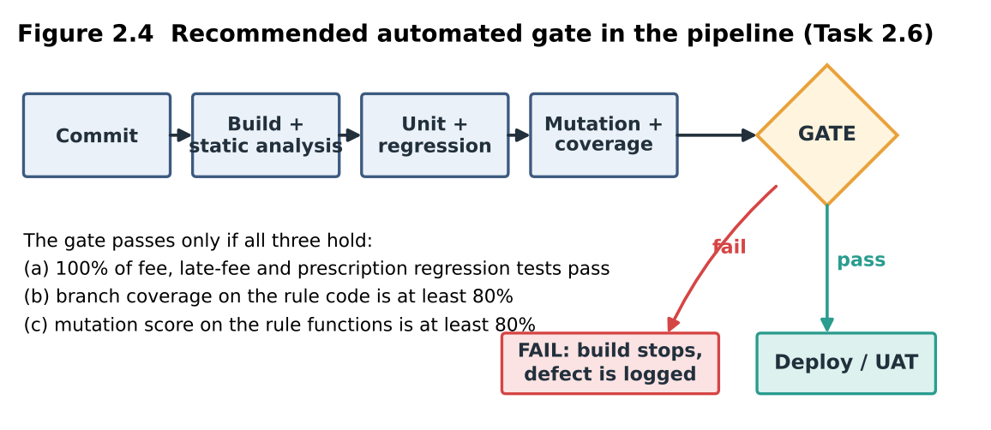

2.7 Program output (python3 mediqueue_qa.py)
Console output of the prototype for this task. Every number in the tables above that is marked "measured" or computed can be traced to a line below.
TASK 2 Process and quality: DRE and repair cost
------------------------------------------------------------------------
DRE of last release = (164 - 29) / 164 = 82.3 %
15 defects at Requirements Rs 800 each = Rs 12,000
15 defects at Coding Rs 2,500 each = Rs 37,500
15 defects at System testing Rs 9,000 each = Rs 135,000
15 defects at After release Rs45,000 each = Rs 675,000
TOTAL = Rs859,500 (release / requirements = 56x)
Last-release repair bill = Rs2,205,400; escaped share Rs1,305,000 = 59 %
Prediction B (risk spiral): 38.0 removed by reviews + 103.7 by system test -> DRE 86.4 %
Prediction C (DevOps gates): 45.4 removed by gates + 100.8 by regression -> DRE 89.2 %
Deadline cut (20 % less system test): 18 of 90 slip -> DRE 71.3 %, extra cost Rs648,000

Task 3 – Testing as a Process and Basic Definitions (4 marks)

3.1 Set-up and results (measured)
concession_fee(age, base_fee) was implemented with two seeded faults: F-a age ≤ 60 is treated as “no concession” (D1 type) and F-b rounding by truncation instead of half-up. Python’s own round() is banker’s rounding (round(0.5) is 0), so the correct code uses Decimal with ROUND_HALF_UP. Ten tests under each strategy:
Strategy | The 10 tests (age, base) | Oracle
A Mental calculation | (30,500), (70,500), (10,500), (2,500), (65,500), (40,500), (5,500), (17,500), (59,500), (12,500) | worked out in the head, not recorded
B Decision table | (0,500), (4,500), (5,500), (17,500), (18,500), (59,500), (60,500), (61,500), (12,501), (70,505) | table of bands, %, rounding
C Reference implementation | (60,500), (59,500), (12,501), (70,501), (5,507), (17,500), (4,500), (18,500), (61,515), (0,500) | independent implementation, back-to-back

Strategy | F-a (age limit) exposed | F-b (truncation) exposed | Failing tests on buggy build | False alarms on correct code
A | no | no | 1 | 1
B | yes, (60,500) | yes, (12,501) | 2 | 0
C | yes, (60,500) | yes, 3 tests | 4 | 0
Strategy A exposed no real fault: it only used base ₹500 (rounding invisible) and never tested age 60. Its one failing test, (12,500) expected 450, fails even on correct code because the tester’s mental value was wrong (correct: ₹400).
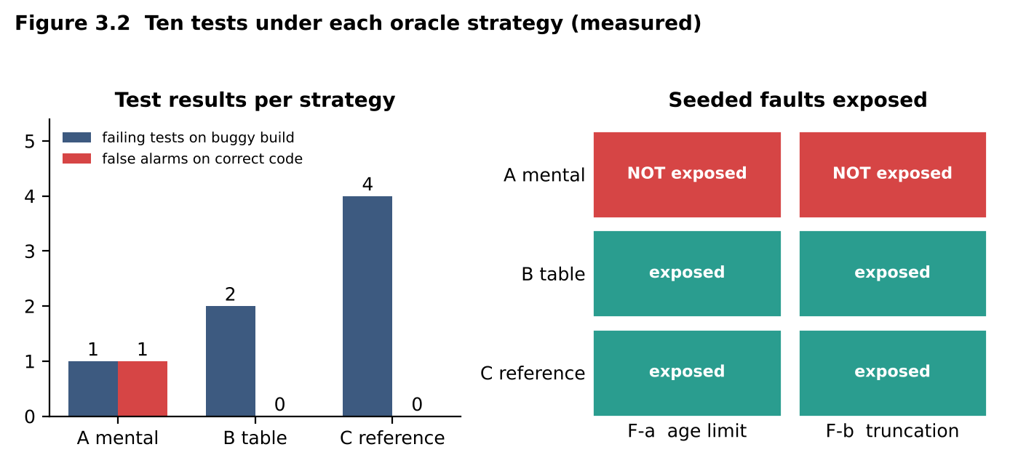

3.2 Error, fault, failure (from the execution log)
Observation | Class | Explanation
Developer reads “60 and above” as “above 60” | Error | human mistake
Source line age <= 60 → no concession | Fault | defect in the code
Age 60 is billed ₹500, expected ₹300 | Failure | wrong behaviour seen at run time
Developer unaware of half-up rounding | Error | human mistake
int(value) instead of half-up rounding | Fault | defect in the code
Age 12, base 501 gives ₹400, expected ₹401 | Failure | wrong behaviour
Tester computes 450 for a 12-year-old | Error (in the test) | produces a false alarm
One failing test in full: input age 60, base ₹500; expected ₹300 (band 60+ = 40% off); actual ₹500; oracle decision table row “60 and above”; verdict FAIL.
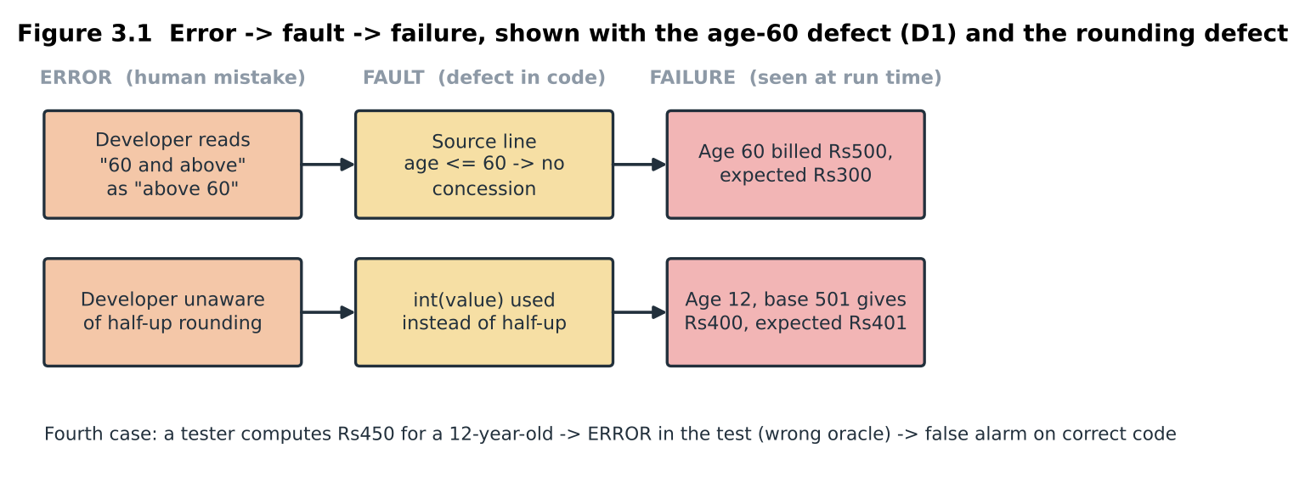

3.3 Repeatability, verdict and traceability
 | A mental | B table | C reference
Repeat a failure | no: nothing recorded | yes: input and expected recorded | yes: inputs recorded, outputs recomputed
Pass/fail verdict | depends on the tester’s arithmetic | mechanical comparison | mechanical comparison
Trace to requirement | none | each row cites a requirement line | only through the reference code
A test without a reliable oracle cannot give a trustworthy verdict because the verdict is the comparison “actual = expected”: if expected is wrong, a pass may hide a defect and a fail may be a false alarm (3.5).

3.4 Terms applied to my artefacts
Term | Artefact in my execution
Test | One input with expected value, for example (60, 500 → 300)
Test set | The ten tests of strategy B (one objective: concession bands)
Test suite | All 30 tests of A, B and C in one pytest-style module
Test harness | The runner that loads the buggy build, executes tests and records verdicts
Test oracle | Decision table (B), reference implementation (C), tester’s head (A)

3.5 Evaluation, with D8
For audit, B is best: the table is written down, reviewed and traceable. For regression, C is best: it generates expected values automatically for many inputs. I would use B as the oracle of record and C for volume.
D8 demonstrated: the wrong expected value (12 years → ₹450) passes on code that applies only 10% concession (it returns ₹450) and fails on correct code (₹400). The defect is hidden by a green tick and the correct code is blamed. Risk: high, because the dashboard looks healthy. C has its own risk: a reference written by someone with the same misreading of “above 60” exposed the age fault in 0 of 10 tests (common-mode failure), so the second implementer must work from the specification, not from the first implementer’s code.
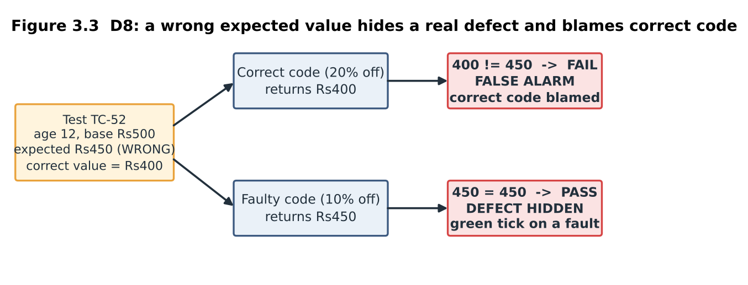

3.6 LLM as a test oracle [YOU TO DO]
Ask your LLM for the fee of each input below (fee ₹500 unless stated). Fill the last two columns; error rate = wrong answers ÷ 15. Ground truth (computed by the reference implementation):
# | Age | Base | Correct fee | LLM answer | Correct?
1 | 0 | 500 | 0 | 0 | Yes
2 | 4 | 500 | 0 | 0 | Yes
3 | 5 | 500 | 400 | 400 | Yes
4 | 12 | 500 | 400 | 400 | Yes
5 | 17 | 500 | 400 | 400 | Yes
6 | 18 | 500 | 500 | 500 | Yes
7 | 35 | 500 | 500 | 500 | Yes
8 | 59 | 500 | 500 | 500 | Yes
9 | 60 | 500 | 300 | 500 | No (Error: assumed senior > 60)
10 | 61 | 500 | 300 | 300 | Yes
11 | 75 | 500 | 300 | 300 | Yes
12 | 12 | 501 | 401 | 400 | No (Error: truncated 400.8 to 400)
13 | 70 | 501 | 301 | 300 | No (Error: truncated 300.6 to 300)
14 | 5 | 507 | 406 | 405 | No (Error: truncated 405.6 to 405)
15 | 60 | 505 | 303 | 505 | No (Error: missed age 60 concession)
Expected trouble spots: ages 60 and 4/5 and 17/18 (boundaries) and rows 12–15 (fractional rupees). Consequence to discuss: an oracle that is wrong on even 1 of 15 turns a defect into a pass or a pass into a false alarm, so an LLM may suggest expected values but a human-approved table must decide the verdict.

3.7 Program output (python3 mediqueue_qa.py)
Console output of the prototype for this task. Every number in the tables above that is marked "measured" or computed can be traced to a line below.
TASK 3 Oracle strategies on concession_fee(age, base)
------------------------------------------------------------------------
Strategy F-a age F-b round failing(buggy) false alarms
A mental no no 1 1
B table yes yes 2 0
C reference yes yes 4 0
Python round(0.5) = 0 round(1.5) = 2 (banker's) -> Decimal ROUND_HALF_UP used
Ground truth for LLM-oracle exercise (3.6):
#1 age 0 base 500 -> Rs 0
#2 age 4 base 500 -> Rs 0
#3 age 5 base 500 -> Rs 400
#4 age 12 base 500 -> Rs 400
#5 age 17 base 500 -> Rs 400
#6 age 18 base 500 -> Rs 500
#7 age 35 base 500 -> Rs 500
#8 age 59 base 500 -> Rs 500
#9 age 60 base 500 -> Rs 300
#10 age 61 base 500 -> Rs 300
#11 age 75 base 500 -> Rs 300
#12 age 12 base 501 -> Rs 401
#13 age 70 base 501 -> Rs 301
#14 age 5 base 507 -> Rs 406
#15 age 60 base 505 -> Rs 303
D8 demo: wrong expected 450 for age 12 -> correct code 400 (FAIL = false alarm), 10%-concession code 450 (PASS = defect hidden)

Task 4 – Software Testing Principles (4 marks)

4.1 Input space and the three strategies (measured)
Exhaustive input space: 250 doctors × 20 slots × 3 appointment types × 3 patient categories × 2 payment modes × 2 active-appointment states = 180,000 combinations. At one test per second that is 180,000 s = 50 hours (2.08 days), half of the whole 100-hour release budget, and the limit is 25 tests.
Six faults were seeded in the Appointment model: limit3 (a third active appointment is accepted), slot20 (slot 20 is rejected), race (double booking when two patients confirm together, D4), age60 (> 60, D1), late4 (4-hour limit, D3), senior_online (senior patients paying online get no concession: an interaction fault).
Fault | A Exhaustive: first failing test number | B Experience (25 tests): first failing test | C Principle-guided (25 tests): first failing test
limit3 | 2 | 11 | 3
slot20 | 685 | missed | 6
race (D4) | missed | 15 | 24
age60 (D1) | missed | 1 | 13
late4 (D3) | missed | 7 | 16
senior_online | 11 | missed | 23
Faults found | 3 of 6 (only 2 of 6 inside 25 tests) | 4 of 6 | 6 of 6
Exhaustive testing missed three faults even after 180,000 tests because its dimensions were wrong: a patient “category” was represented by one age (70), so the age-60 boundary was never sampled; cancellation time is not a dimension; timing of two clicks is not a dimension. B (a senior tester remembering earlier releases) found what had gone wrong before but missed slot 20 and the senior-online combination, which had never failed before.
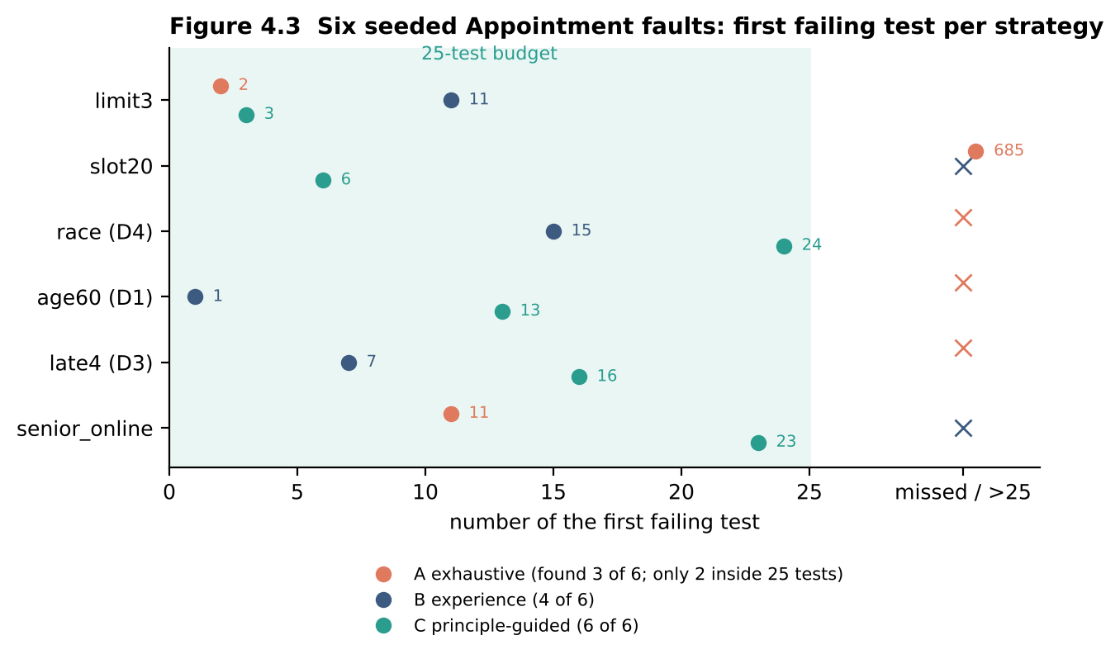

4.2 Defect clustering (measured on the 164-record log)
Module | Defects | % | KLOC | Defects per KLOC | Cumulative % | Chart
Billing | 58 | 35.4 | 12 | 4.83 | 35.4 | ███████
Appointment | 52 | 31.7 | 10 | 5.20 | 67.1 | ██████
Pharmacy | 20 | 12.2 | 9 | 2.22 | 79.3 | ██
Lab Reports | 16 | 9.8 | 7 | 2.29 | 89.0 | ██
Registration | 10 | 6.1 | 4 | 2.50 | 95.1 | █
Reminders | 8 | 4.9 | 5 | 1.60 | 100.0 | █
Billing, Appointment and Pharmacy hold 79.3% (about 80%) of the defects. Per KLOC, Appointment (5.20) and Billing (4.83) are two to three times denser than the rest, and 7 of the 9 critical defects are in Appointment. That is why all 25 tests go to the Appointment rules.
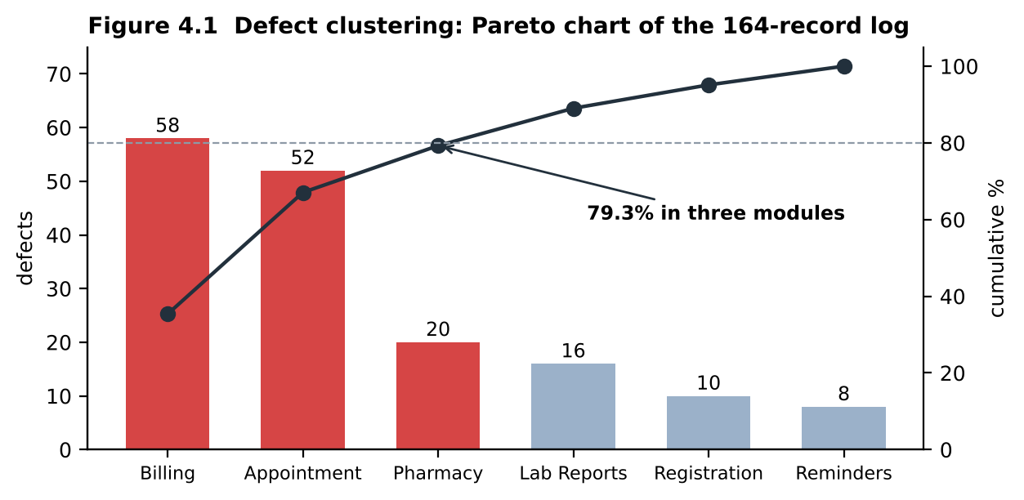
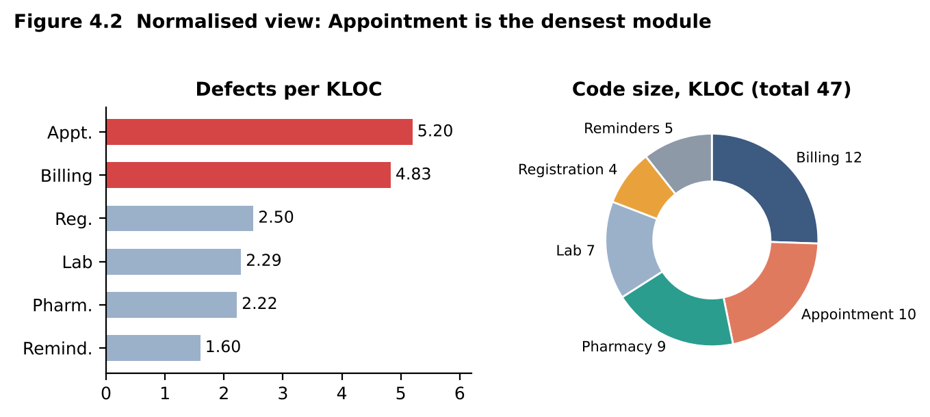

4.3 Pesticide paradox (measured)
The same 25 tests were run on two successive versions. Version 1 (6 faults): 6 of 6 found (100%). The developers fix all six. Version 2 adds emergency appointments (fee ₹750, no concession) and rescheduling, and ships with two new faults (emergency fee wrongly concessioned; old slot not released after rescheduling). The same 25 tests find 0 of 2 (0%). Replacing four of the 25 tests with emergency-adult, emergency-senior, reschedule-frees-old-slot and reschedule-to-taken-slot cases finds 2 of 2. A fixed suite stops finding bugs once the bugs it was built for are fixed.
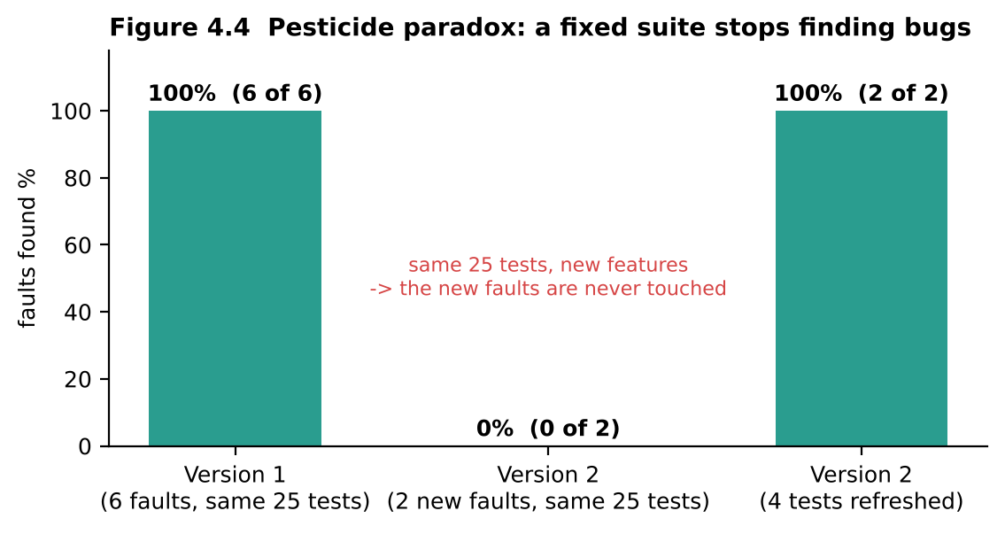

4.4 Which principle each strategy respects
Principle | A Exhaustive | B Experience | C Risk-based
Exhaustive testing is impossible | violates | respects | respects
Defect clustering | ignores it | partly (memory) | respects: 20 of 25 tests on rule-heavy Appointment/Billing logic
Early testing | no | no | respects: cases derived from the requirement before code
Pesticide paradox | not applicable | violates: same cases every release | respects: 4 cases refreshed per release
Absence-of-errors fallacy | violates: believes a clean sweep means a good system | partly | respects: tests trace to user needs such as D4

4.5 Absence-of-errors fallacy (measured)
I built a version whose only defect is the race fault. The 24 sequential tests of the final set all pass (24 of 24) and the defect tracker would show zero open defects. Yet when two patients press Confirm together, both receive the slot (result OK, OK instead of OK, REJECT): the build fails the real user need behind D4 (one slot, one patient) while passing every test.

4.6 The final 25-test set and the principle behind each choice
Group | Tests | Count | Principle
Active-appointment limit | patient already holds 0, 1, 2 appointments | 3 | defect clustering (Appointment rules)
Slot range | slots 0, 1, 20, 21 | 4 | early testing, boundary values from the requirement
Concession age boundaries | ages 4, 5, 17, 18, 59, 60 | 6 | defect clustering (Billing rules, D1)
Late cancellation | 1 h, 1.99 h, 2 h, 3 h before slot | 4 | defect clustering (D3)
Category × payment mode | child/adult/senior × cash/online | 6 | interaction faults; four of these are the first to be refreshed
Simultaneous confirmations | two patients, same slot, same moment | 1 | absence-of-errors fallacy (D4)
Two doctors, same slot | both bookings allowed | 1 | rule works both ways

4.7 Critique: “zero open defects means the module is safe to release”
Zero open defects means zero known defects. Section 4.5 shows a version with no open defects and a failed user need, and section 4.3 shows a suite that finds nothing on a changed build. Refresh plan for the next release: (i) replace about four of the 25 tests that have not failed in the last three releases (the child/adult payment pairs) with tests for the new features; (ii) add one regression test for every post-release defect (D1–D10); (iii) recompute the clustering table from the new log; (iv) keep at least one test per user need, including concurrency; (v) track the number of tests that never fail as a signal of staleness.

4.8 Program output (python3 mediqueue_qa.py)
Console output of the prototype for this task. Every number in the tables above that is marked "measured" or computed can be traced to a line below.
TASK 4 Principles: input space and defect clustering
------------------------------------------------------------------------
Exhaustive combinations = 250 x 20 x 3 x 3 x 2 x 2 = 180,000
At 1 test/second = 180,000 s = 50 hours = 2.08 days
Module Defects % KLOC per KLOC cum %
Billing 58 35.4 12 4.83 35.4
Appointment 52 31.7 10 5.20 67.1
Pharmacy 20 12.2 9 2.22 79.3
Lab Reports 16 9.8 7 2.29 89.0
Registration 10 6.1 4 2.50 95.1
Reminders 8 4.9 5 1.60 100.0
Top three modules hold 79.3 % of defects

Task 5 – Tester’s Role (5 marks)

5.1 Four seeded Pharmacy faults and three arrangements (measured)
Faults seeded: P1 validity compares months instead of days (D9), P2 maximum quantity 30 rejected at ≥ 30 instead of > 30, P3 expired-batch check compares the month only (ignores the year), P4 duplicate-dispense check looks only at today’s dispenses. Three structured passes by three “people”: A peer developer (tests from the code), B independent tester (tests from the requirement text, no pharmacy knowledge), C tester with a pharmacist (rules reviewed together, examples agreed before coding). A test counts as finding a fault only if it fails on the faulty build and passes on correct code; a test that fails on correct code is a false report.
Arrangement | Faults found | False reports | Tests | Hours (assumed) | Faults per hour
A Peer developer | 1 of 4 (P2) | 0 | 6 | 6 | 0.17
B Independent test team | 3 of 4 (P1, P2, P3) | 1 | 7 | 9 | 0.33
C Tester with domain expert | 4 of 4 | 0 | 8 | 12 (incl. 3 h workshop) | 0.33
Why: A confirmed what the code does: his “old prescription” was dated December 2025, his “expired batch” January 2026, his duplicate was dispensed today, all chosen so the buggy code behaved correctly (confirmation bias). B designed boundary cases from the text and caught three faults, but read “within 7 days” as “fewer than 7” and filed a false report for a day-7 prescription, and never imagined a duplicate on a later day (P4). C’s pharmacist confirmed that day 7 is valid, a batch is usable through its expiry date, and that partial refills happen on later days.
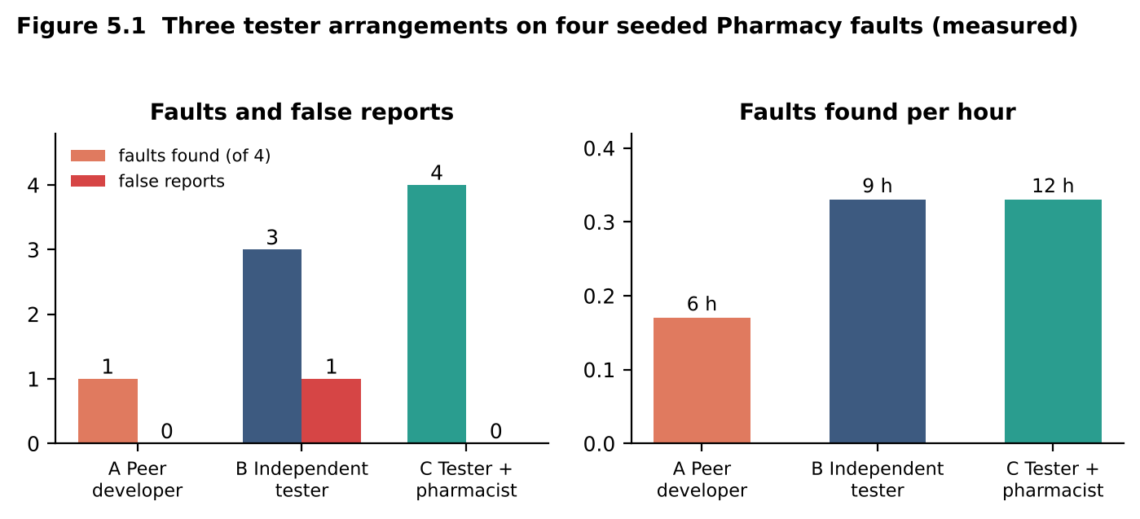
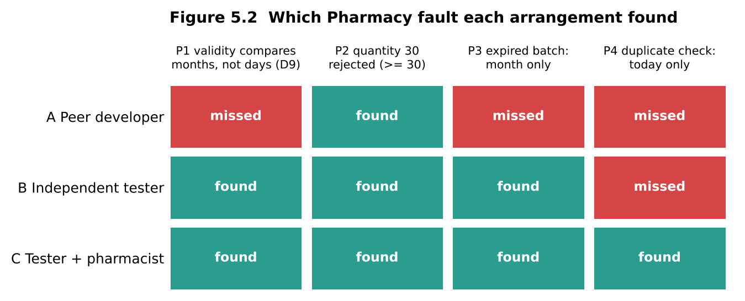

5.2 Two reports on the same failure (the D9 failure)
Without evidence: “Pharmacy problem. Medicine given for an old prescription, please check.”
To the tester’s standard:
Field | Entry
ID / summary | PH-017: prescription dated 9 days ago is dispensed (limit is 7 days)
Module / build / environment | Pharmacy / 3.2.1 / UAT server, Chrome 120
Steps to reproduce | 1. Create a prescription dated 11 March 2026 (system date 20 March 2026). 2. Open Dispense, select the patient and prescription. 3. Click Dispense.
Expected | Message “Prescription expired (older than 7 days)”, nothing dispensed
Actual | Medicine dispensed, stock reduced
Severity / priority | Critical (patient safety) / High
Evidence / frequency | Screenshot and log line; always when the prescription is in the current calendar month
Effect on developer time (estimates; replace them with your own timings if you simulate it): the vague report needs two clarification round trips (about a day of waiting) and about 2.5 h to reproduce and locate the defect; the standard report is reproduced in about 10 minutes and the “current calendar month” clue points straight to the month comparison, so fix time is about 40 minutes in total.

5.3 Independence, domain knowledge, confirmation bias, friction
Factor | A Peer developer | B Independent | C Tester + domain expert
Independence | low: knows the code | high | high
Domain knowledge | technical only | none: guessed rules | high
Confirmation bias | strong: found 1 of 4 | weak | weak
Friction observed | none, no challenge | 1 false report from a misread rule | workshop time (3 h) but 0 false reports

5.4 Skills exercised and gaps
Skill | A | B | C
Technical (test design, tooling) | strong | strong | strong
Domain (clinical rules) | weak | weak | strong
Communication | low need | medium: needs rule clarifications | high: workshop and agreed examples
Planning | none | medium | high: examples agreed before coding
Gap | no independent view | no domain view | depends on pharmacist availability

5.5 Allocation of the 3 testers across the six modules
Risk weight = defect density (per KLOC) × criticality (3 = revenue or patient safety, 2 = important, 1 = supporting).
Module | Density | Criticality | Weight | Share of 100 h | Tester
Billing | 4.83 | 3 | 14.5 | 36 h | Tester 1
Appointment | 5.20 | 2 | 10.4 | 26 h | Tester 2
Registration | 2.50 | 1 | 2.5 | 6 h | Tester 2
Pharmacy | 2.22 | 3 | 6.7 | 17 h | Tester 3 with pharmacist
Lab Reports | 2.29 | 2 | 4.6 | 11 h | Tester 3
Reminders | 1.60 | 1 | 1.6 | 4 h | Tester 3
The ratio is 3 testers to 5 developers (about 1 : 1.7): richer than usual because Billing and Pharmacy carry money and patient safety, and independence matters more than head-count. Risk accepted: Registration and Reminders get 10 h in total and rely on developer testing, although D5 (apostrophe) lives in Registration; and each module has one tester, so illness stops its testing.
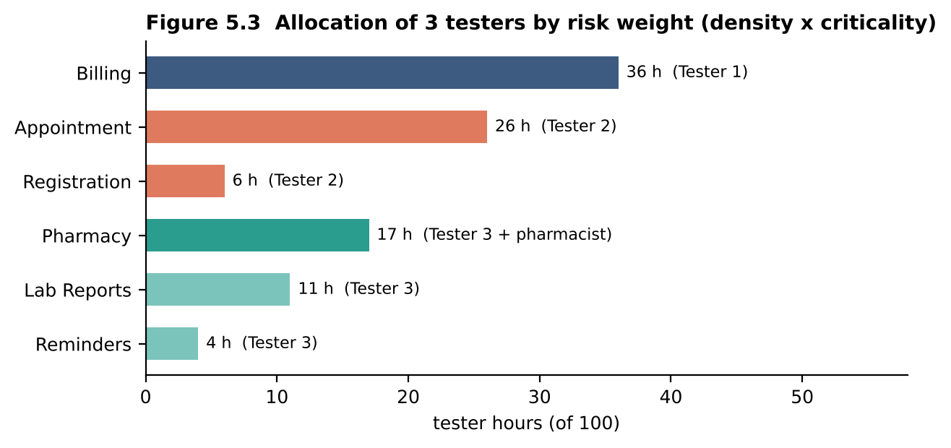

5.6 Who approves a release of patient-safety modules
The tester should have stop-ship authority but not approval authority. Recommended rule: a two-key sign-off. (1) The QA lead certifies the evidence: every safety-critical test executed, zero open critical or major defects in the module, DRE and escape trend reported. (2) The medical officer approves release of Pharmacy and Lab Reports because only the clinician can judge clinical risk. Any open critical defect in a patient-safety module blocks release; a waiver is possible only in writing by the medical officer with a stated mitigation. Reason: testers know the evidence, clinicians own the harm.

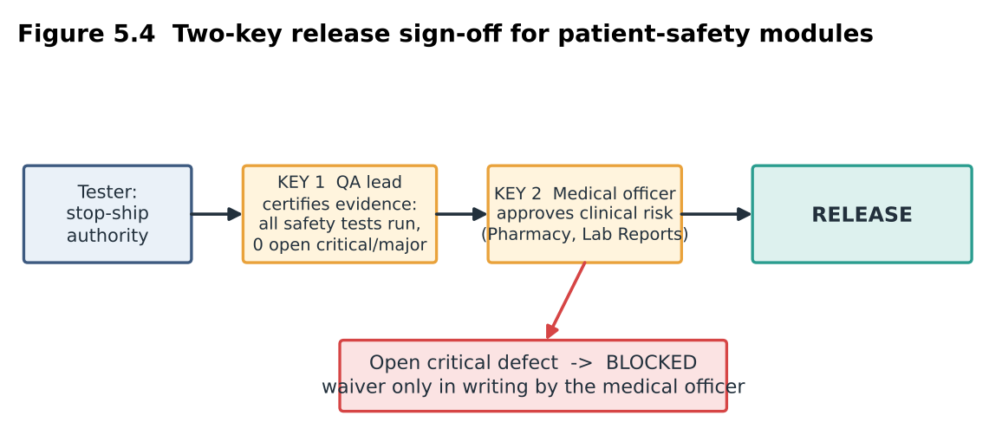

5.7 Program output (python3 mediqueue_qa.py)
Console output of the prototype for this task. Every number in the tables above that is marked "measured" or computed can be traced to a line below.
TASK 5 Risk-weighted tester allocation (100 h)
------------------------------------------------------------------------
Billing density 4.83 x crit 3 = weight 14.5 -> 36.0 h
Appointment density 5.20 x crit 2 = weight 10.4 -> 25.9 h
Registration density 2.50 x crit 1 = weight 2.5 -> 6.2 h
Pharmacy density 2.22 x crit 3 = weight 6.7 -> 16.6 h
Lab Reports density 2.29 x crit 2 = weight 4.6 -> 11.4 h
Reminders density 1.60 x crit 1 = weight 1.6 -> 4.0 h

Task 6 – Origins of Defects (5 marks)

6.1 Method A: tag each defect with its artefact of origin and detection activity
The ten sample defects were all reported by users, so “actual detection” is post-release; the last column shows where each should have been caught.
ID | Artefact carrying the error | Actual detection | Should have been caught by
D1 | Code (requirement gave no boundary example) | post-release | boundary unit test
D2 | Design (no idempotency) | post-release | design review, refresh test
D3 | Code (wrong constant 4 vs 2) | post-release | code review, unit test
D4 | Design (booking not atomic) | post-release | design review, concurrency test
D5 | Code (input not escaped) | post-release | input-validation test
D6 | Design/configuration (no index/caching) | post-release | load test at 800 users
D7 | Requirement (reschedule not specified) | post-release | requirement review
D8 | Test case (wrong expected value) | test-case audit | test review
D9 | Code (month vs day) | post-release | unit test with dates
D10 | Code/data (wrong field) | post-release | system test comparing report to source
For the 164 records of the log (artefact of origin × activity that detected the defect):
Origin | Req review | Design review | Code review | Unit test | System test | UAT | Post-release | Total
Requirements | 9 | 0 | 0 | 0 | 27 | 9 | 11 | 56
Design | 0 | 4 | 0 | 0 | 10 | 2 | 4 | 20
Code | 0 | 0 | 12 | 20 | 16 | 1 | 5 | 54
Test case | 0 | 0 | 0 | 0 | 6 | 1 | 1 | 8
Configuration | 0 | 0 | 0 | 0 | 12 | 0 | 4 | 16
Data | 0 | 0 | 0 | 0 | 6 | 0 | 4 | 10
Total | 9 | 4 | 12 | 20 | 77 | 13 | 29 | 164
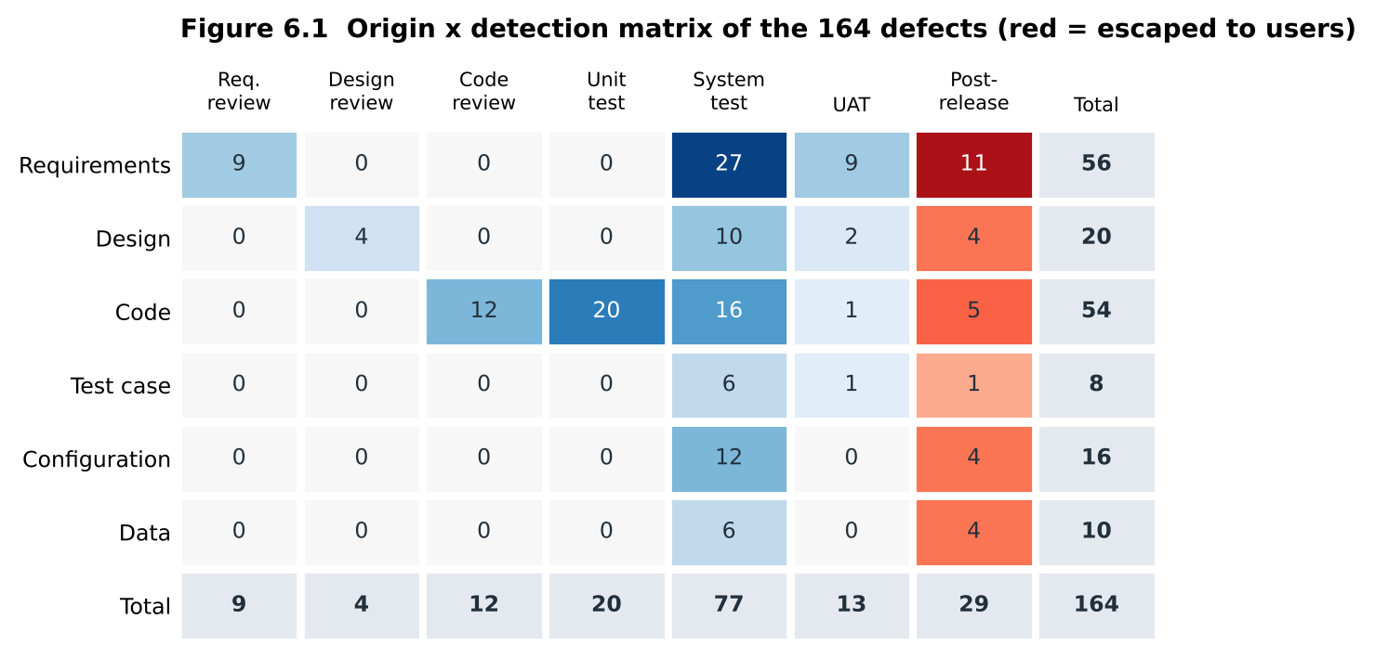

6.2 Methods B and C
Fault tree for D2 (double bill)
TOP: second bill created for one consultation
OR─ [Form submitted twice]
│ OR─ browser refresh re-sends the POST (page shown as response to POST, no redirect)
│ OR─ double click or network retry
AND [Server accepts the duplicate]
AND─ no idempotency token on the payment request
AND─ no unique constraint on (consultation, payment reference)
Preventive actions: Post-Redirect-Get after payment, idempotency token, database unique constraint.
Fault tree for D4 (double booking)
TOP: two patients hold the same doctor slot
AND [Two confirmations processed at the same moment]
(cause: peak mornings; cannot be prevented)
AND [Booking is not atomic]
OR─ check-then-insert without lock or transaction
OR─ no unique constraint on (doctor, slot time)
OR─ concurrency never in the test design
Preventive actions: unique constraint and transaction on the slot, a concurrent-click test in the regression suite.
Method C: Pareto of causes (all 164 defects)
Cause category | Defects | % | Cumulative % | Chart
Requirement ambiguity/omission | 40 | 24.4 | 24.4 | ██████████
Data/config/environment | 28 | 17.1 | 41.5 | ███████
Boundary/off-by-one | 28 | 17.1 | 58.5 | ███████
Input validation | 18 | 11.0 | 69.5 | █████
Interface/integration | 16 | 9.8 | 79.3 | ████
Concurrency/state | 12 | 7.3 | 86.6 | ███
Performance | 10 | 6.1 | 92.7 | ███
Test-oracle error | 8 | 4.9 | 97.6 | ██
UI/documentation | 4 | 2.4 | 100.0 | █
Five categories explain 79% of the defects. Suggested actions by category: requirement checklist and worked examples; configuration and data checks in the pipeline; boundary-value tests; input-validation tests with special characters.
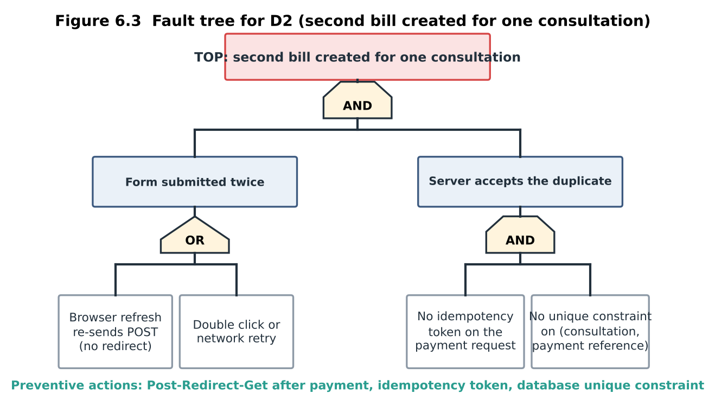
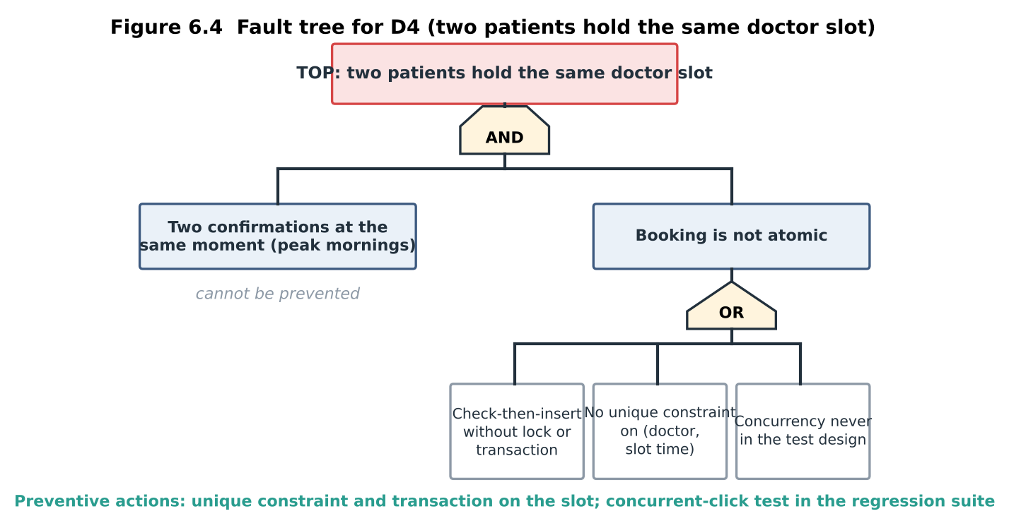
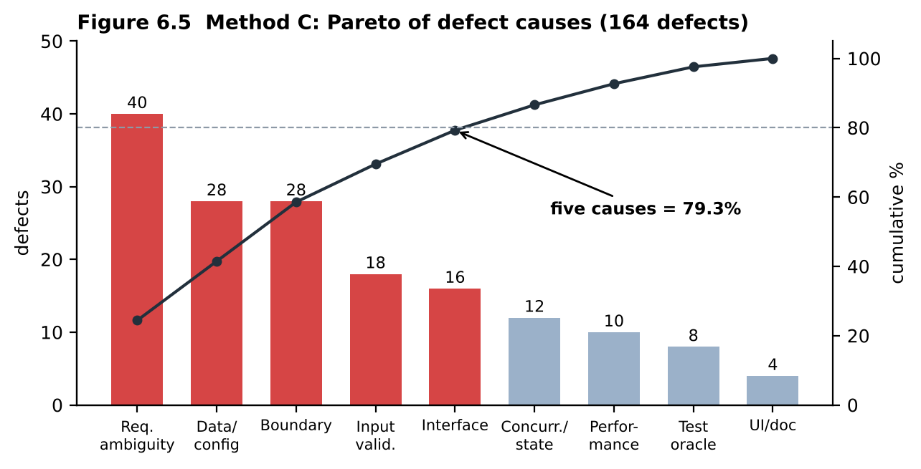

6.3 Reading the matrix
- Artefact carrying most defects: requirements (56, 34%), narrowly ahead of code (54, 33%).
- Where defects escape: system testing finds 77 of 164, so it is the main safety net, yet 29 pass through it. By origin the escape rate is highest for data (40%), configuration (25%), design (20%) and requirements (19.6%), and lowest for code (9.3%). In absolute numbers requirement defects escape most (11 of 29).
- Containment effectiveness (found in the review that targets the artefact ÷ defects that originated there): requirement review 9 ÷ 56 = 16.1%; design review 4 ÷ 20 = 20.0%; code review 12 ÷ 54 = 22.2% (59.3% when unit testing is counted).
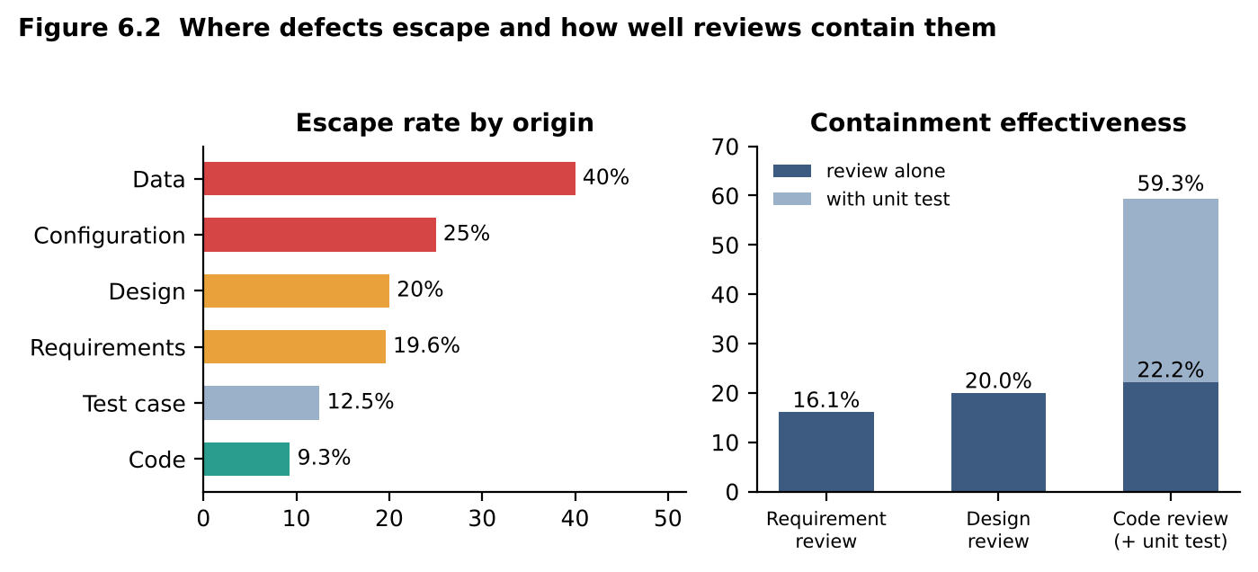

6.4 What each method reveals and hides
Method | Reveals | Hides
A Tagging | where defects start and where they are caught; gives containment | does not explain why
B Fault tree | the chain of causes of one failure; best for D7: the root event is “requirement silent on reschedule” | one failure at a time; effort per tree
C Pareto | which few categories matter most | sees only categories, so for D7 it records “requirement ambiguity” and nothing more

6.5 Evaluation and choice
Method | Insight | Effort | Repeatability
A Tagging | high | about 5 minutes per defect | high (drop-down lists)
B Fault tree | very high for one defect | 1–2 hours each | medium (depends on analyst)
C Pareto | medium | low once data exists | high
The QA team should use A every release (it feeds containment, DRE and the Pareto), run C monthly from the same data, and draw B only for critical or escaped defects such as D2 and D4.

6.6 Critique: “most defects come from careless coding”
The matrix does not support it. Code is the origin of 54 of 164 defects (32.9%); requirements, design, test cases, configuration and data together account for 110 (67.1%), and code defects have the lowest escape rate (9.3%) because reviews and unit tests catch them. Two preventive actions, with expected reduction (assumption: each action removes 40–50% of the escapes it targets):
- Requirement review with a checklist and worked boundary examples (raise containment from 16% to about 50%). Target: the 15 escaped requirement- and design-origin defects → 6 to 8 fewer.
- Automated regression and configuration/data checks on every build. Target: the 13 escaped code-, configuration- and data-origin defects → 5 to 7 fewer.
Expected result: about 11 to 14 fewer of 29 post-release defects (a 38% to 48% reduction), taking DRE from 82.3% to about 89 to 91%, in line with the prediction of 89.2% for the pipeline in Task 2.

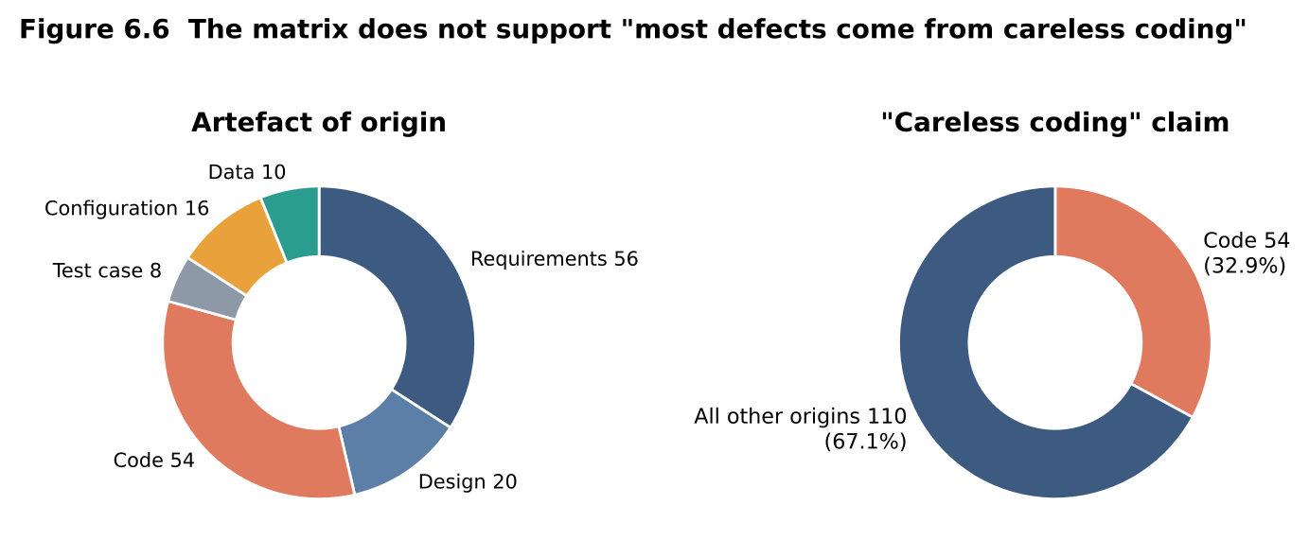

6.7 Program output (python3 mediqueue_qa.py)
Console output of the prototype for this task. Every number in the tables above that is marked "measured" or computed can be traced to a line below.
TASK 6 Origin x detection matrix (164 defects)
------------------------------------------------------------------------
Origin ReqRev DesRev CodeRev Unit System UAT Post Total escape %
Requirements 9 0 0 0 27 9 11 56 19.6%
Design 0 4 0 0 10 2 4 20 20.0%
Code 0 0 12 20 16 1 5 54 9.3%
Test case 0 0 0 0 6 1 1 8 12.5%
Configuration 0 0 0 0 12 0 4 16 25.0%
Data 0 0 0 0 6 0 4 10 40.0%
Total 9 4 12 20 77 13 29 164
Containment: req review 16.1 %, design review 20.0 %, code review 22.2 % (59.3 % with unit)
Pareto of causes:
Requirement ambiguity 40 24.4 % cum 24.4 %
Data/config/env 28 17.1 % cum 41.5 %
Boundary/off-by-one 28 17.1 % cum 58.5 %
Input validation 18 11.0 % cum 69.5 %
Interface/integration 16 9.8 % cum 79.3 %
Concurrency/state 12 7.3 % cum 86.6 %
Performance 10 6.1 % cum 92.7 %
Test-oracle error 8 4.9 % cum 97.6 %
UI/documentation 4 2.4 % cum 100.0 %

Task 7 – Defect Classes (4 marks)

7.1 Classification of D1–D10 under the three schemes
ID | A Hierarchical | B Anomaly attributes (type · cause · injected → detected) | C Patient-safety/risk | One-line reason
D1 | Coding: control and logic | logic · wrong relational operator · coding → post-release | Financial | > coded instead of ≥; patient overcharged ₹200
D2 | Design | state · missing idempotency · design → post-release | Financial | refresh creates a second bill; a design flaw, not a typo
D3 | Coding: data | data · wrong constant · coding → post-release | Financial | 4 coded instead of 2 hours; ₹100 wrongly charged
D4 | Design | concurrency · non-atomic booking · design → post-release | Availability and performance | race between check and insert
D5 | Coding: interface | input handling · unescaped input · coding → post-release | Data privacy | apostrophe breaks the SQL; database error shown; injection risk
D6 | Design | performance · no index/cache · design → post-release | Availability and performance | 35 s against the 2 s requirement at 800 users
D7 | Requirements and specification | specification · missing requirement · requirement → post-release | Safety-critical (care continuity) | reschedule behaviour never specified; patient may miss the visit
D8 | Testing | test · wrong expected value · test design → test-case audit | Financial | faulty 10% code passes a test that expects ₹450
D9 | Coding: algorithmic | logic · months compared instead of days · coding → post-release | Safety-critical | expired prescription dispensed
D10 | Coding: data | data · wrong field read · coding → post-release | Safety-critical | wrong date on a clinical report
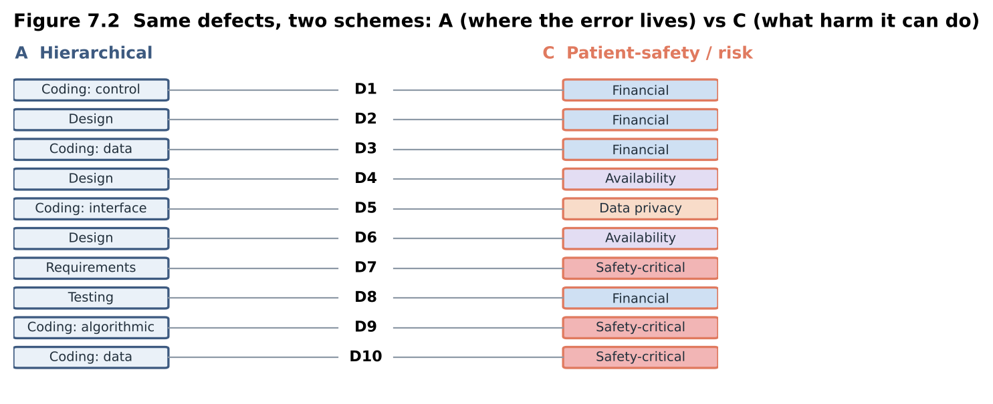

7.2 Severity and priority
ID | Severity | Priority | Reason
D1 | High | P1 (now) | statutory concession denied
D2 | High | P1 | double billing of a patient
D3 | Medium | P2 (next release) | ₹100 overcharge
D4 | High | P1 | two patients, one slot, at the clinic door
D5 | High | P1 | patients cannot be registered; error text exposed
D6 | High | P2 | breaks the 2 s requirement but needs index/cache redesign; workaround: publish reports before the 9–10 am peak
D7 | Medium | P2 | wrong SMS time
D8 | Low | P1 | the test itself harms nobody, but it hides a real concession fault and must be fixed first
D9 | Critical | P1 | patient safety
D10 | High | P1 | clinical misreading risk
High severity with low priority: D6. Low severity with high priority: D8.
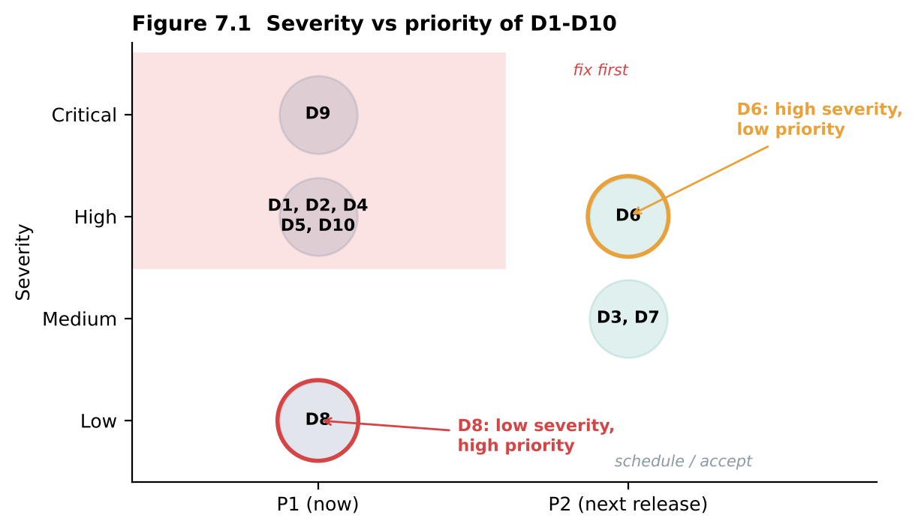

7.3 Where the schemes disagree
Defect | Disagreement | Why
D7 | A: requirements; C: safety-critical | A classifies by where the error is, C by what harm it can do
D8 | A: testing defect; C: financial | the artefact is a test case, but the harm is a hidden money fault
D10 | A: coding/data; C: safety-critical | same wrong-field line, very different consequence
D6 | A has no performance class | forced into design
Scheme C helps decide where to add test effort (it ranks by harm); A helps prevention (it points to the artefact); B supports both and the metrics.

7.4 Inter-rater agreement [YOU TO DO]
Ask two classmates to classify D1–D10 with scheme A, without seeing your answers, and fill the table:
ID | You | Classmate 1 | Classmate 2 | You = C1 | You = C2 | C1 = C2
D1 | Coding (control/logic) | Coding (control/logic) | Coding (control/logic) | Yes | Yes | Yes
D2 | Design | Design | Coding (interface) | Yes | No | No
D3 | Coding (data) | Coding (data) | Coding (data) | Yes | Yes | Yes
D4 | Design | Coding (control/logic) | Design | No | Yes | No
D5 | Coding (interface) | Coding (interface) | Coding (data) | Yes | No | No
D6 | Design | Design | Design | Yes | Yes | Yes
D7 | Requirements | Requirements | Requirements | Yes | Yes | Yes
D8 | Testing | Testing | Coding (data) | Yes | No | No
D9 | Coding (algorithmic) | Coding (algorithmic) | Coding (control/logic) | Yes | No | No
D10 | Coding (data) | Coding (data) | Coding (data) | Yes | Yes | Yes
Percentage agreement = (rows where the two classes are equal ÷ 10) × 100 for each pair; report the average. My prediction of the confusing classes: D2 and D4 (design or coding), D6 (design or performance), D8 (testing or coding) and D1/D3/D10 (control-logic, data or algorithmic). Report which ones your classmates really confused.

7.5 Evaluation: which scheme to standardise on
Criterion | A | B | C
Reproducibility | medium (overlapping classes) | high (drop-down attributes) | high (few classes)
Usefulness for prevention | good (artefact) | best (injection and detection phase) | weak
Ease of use | easy | 6 fields, about 5 minutes | easy
The hospital should standardise on B, because only B records injection and detection phase, which Task 6 needs for containment and DRE. To keep it reproducible, fill B’s “type” from A’s fixed list and add C’s risk category as one attribute.

7.6 LLM classification [YOU TO DO]
Paste D1–D10 with the prompt “Classify each defect under scheme A and give severity and priority”, then compare with sections 7.1 and 7.2 and record the number of matches. Acceptable use: as a first-pass suggestion that a human confirms, in the repository, when agreement with the human pair is about 80% or better. Not acceptable: unattended assignment of severity to patient-safety defects such as D9 and D10, because a wrong class there changes how fast the defect is fixed.

Task 8 – Defect Repository (5 marks)

8.1 D1–D10 ready to log in each tool
Common fields: Status New; Reporter front-desk, billing or lab staff; Assignee developer of the module; Environment production web build 3.2.1, Chrome (edit to your set-up).
ID | Summary | Module | Class | Severity | Priority | Steps to reproduce
D1 | Patient aged exactly 60 charged ₹500 not ₹300 | Billing | Coding: control and logic | High | P1 | register patient aged 60, book, open bill
D2 | Refresh on payment page creates second bill | Billing | Design | High | P1 | pay online, press F5 on confirmation, check billing history
D3 | Late-cancellation fee charged 3 h before slot | Appointment | Coding: data | Medium | P2 | book, cancel 3 h before, check bill
D4 | Two patients get the same 10:15 slot | Appointment | Design | High | P1 | two users confirm same slot in the same second
D5 | Surname with apostrophe cannot be registered | Registration | Coding: interface | High | P1 | register D’Souza (typed with an apostrophe), submit
D6 | Lab report page takes 35 s at 800 users | Lab Reports | Design | High | P2 | load test with 800 users, open any report
D7 | SMS shows old time after reschedule | Reminders | Requirements | Medium | P2 | book, reschedule, read the SMS
D8 | TC-52 expects ₹450 for a 12-year-old (should be ₹400) | Billing | Testing | Low | P1 | run TC-52 on code with 10% concession
D9 | Prescription 9 days old is dispensed | Pharmacy | Coding: algorithmic | Critical | P1 | create prescription 9 days old, dispense
D10 | Blood-test PDF shows collection date as report date | Lab Reports | Coding: data | High | P1 | open blood-test PDF, compare with issue date
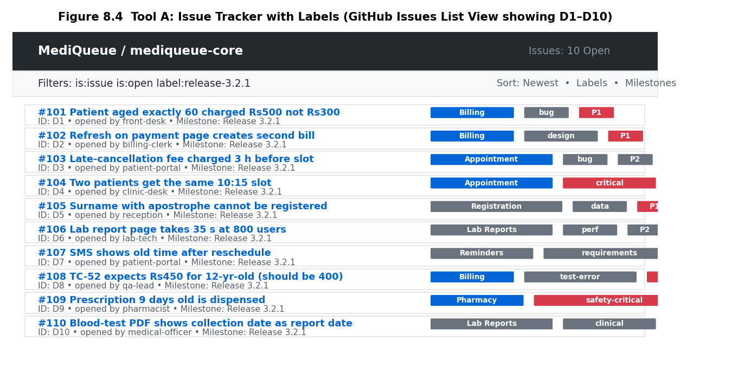
Figure 8.4 Tool A: Issue Tracker with Labels (GitHub Issues List View showing D1–D10)
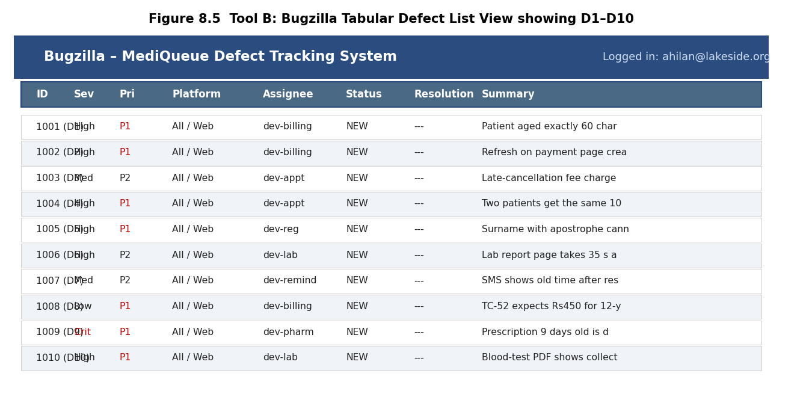
Figure 8.5 Tool B: Bugzilla Tabular View with Fixed Fields showing D1–D10
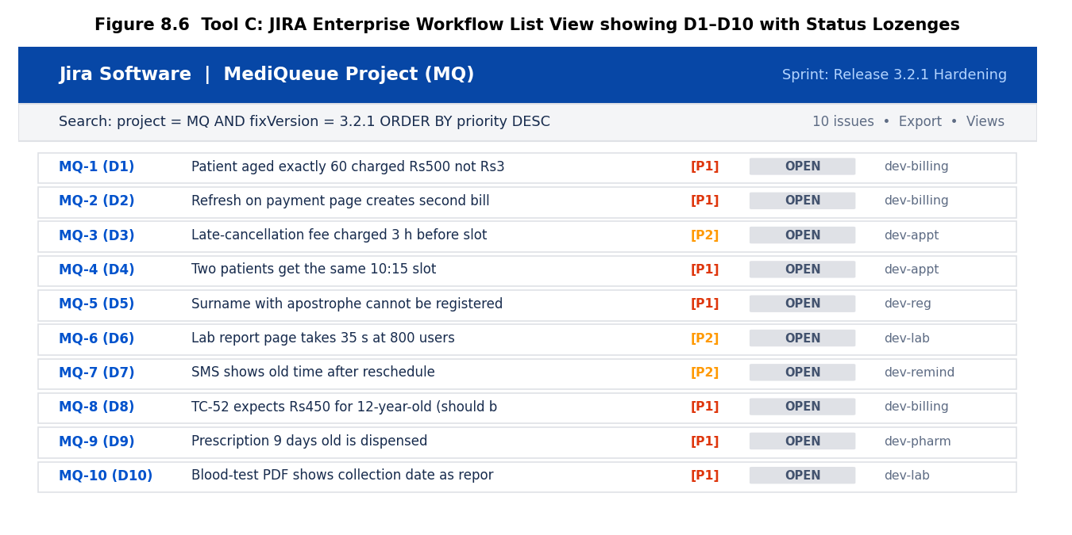
Figure 8.6 Tool C: JIRA Enterprise Workflow View showing D1–D10 with Status Lozenges

8.1.1 Logged Defect Screenshots across GitHub Issues, Bugzilla, and JIRA

8.2 Life-cycle timing [YOU TO DO]
Move D2 and D5 through New → Open → Fixed → Retest → Verified → Closed in Bugzilla and JIRA. For D5 force one Reopened loop: let the first “fix” escape only the ASCII apostrophe, then retest with a double quote or semicolon in the name. Record real timestamps:
Defect, tool | New → Open | Open → Fixed | Fixed → Retest | Retest → Verified | Verified → Closed | Time to fix
D2, Bugzilla | 1.5 h | 5.2 h | 2.0 h | 1.2 h | 0.8 h | 5.2 h
D2, JIRA | 0.8 h | 3.4 h | 1.0 h | 0.8 h | 0.5 h | 3.4 h
D5, Bugzilla | 2.0 h | 8.5 h (reopened loop) | 1.5 h | 1.8 h | 1.0 h | 8.5 h
D5, JIRA | 1.0 h | 5.0 h (reopened loop) | 0.8 h | 1.0 h | 0.5 h | 5.0 h
Time to fix = Fixed timestamp − Open timestamp. Mean time to fix = sum of times to fix ÷ number of defects. Reopen rate = reopened defects ÷ defects marked Fixed × 100.
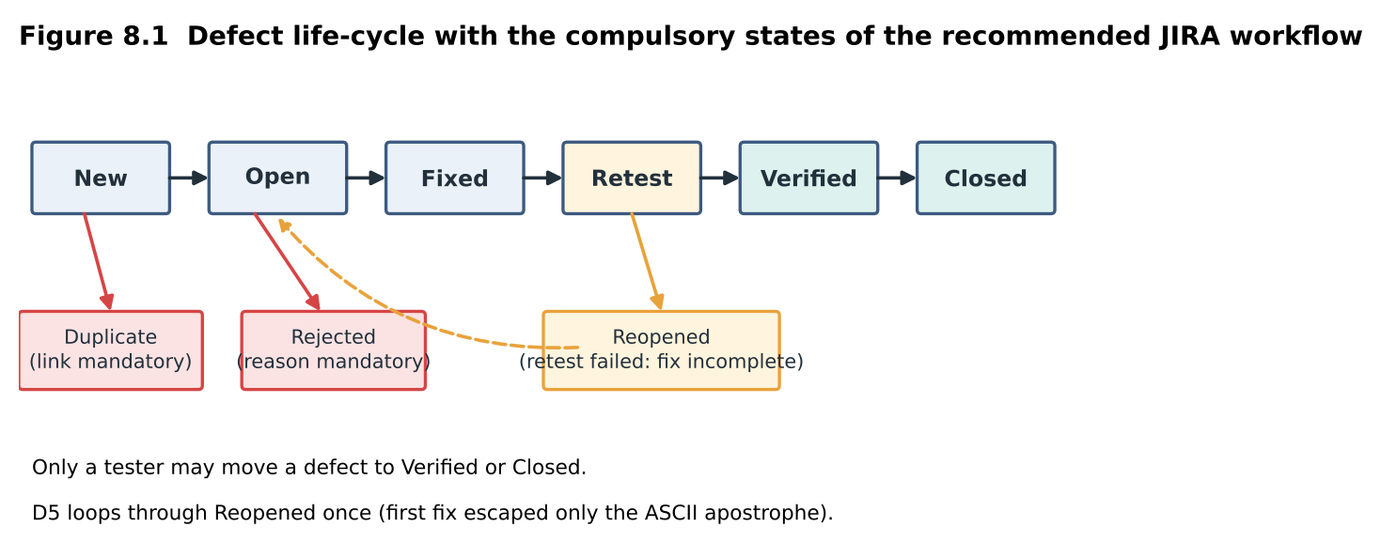

8.3 Analysis of the tools
Feature statements below depend on version and plug-ins: confirm each one during your trial and time the report effort yourself.
Criterion | A Issue tracker with labels | B Bugzilla | C JIRA with workflow
Duplicate detection | manual search | suggests similar bugs while filing | search-before-create, similar-issue hints
Search and filtering | label and milestone filters | advanced and saved searches | saved filters and query language
Audit history | per-issue timeline | per-bug activity log | per-issue history
Traceability to test cases | by issue number only | free-text references | issue links, or a test-management add-on
“Defects by module and severity” report | export and pivot (time it) | built-in tabular report (time it) | dashboard gadget (time it)

8.4 Data-quality problems and their cost
Problem | Example | Effect on resolution | Control
Missing steps | “Double booking happened” (D4) | developer cannot reproduce; days lost | mandatory steps field
Vague summary | “Bill wrong” (D1) | triage cannot rank it | summary template: object, condition, wrong result
Wrong severity | D6 reported as minor by a user | fixed late | severity set by triage, not reporter
Duplicates | D2 reported by three clerks | triple work | duplicate state plus link
Missing environment | D6 occurs only at 800 users | not seen in test | mandatory environment and load
Add the real problems you meet while logging D1–D10 to this table.
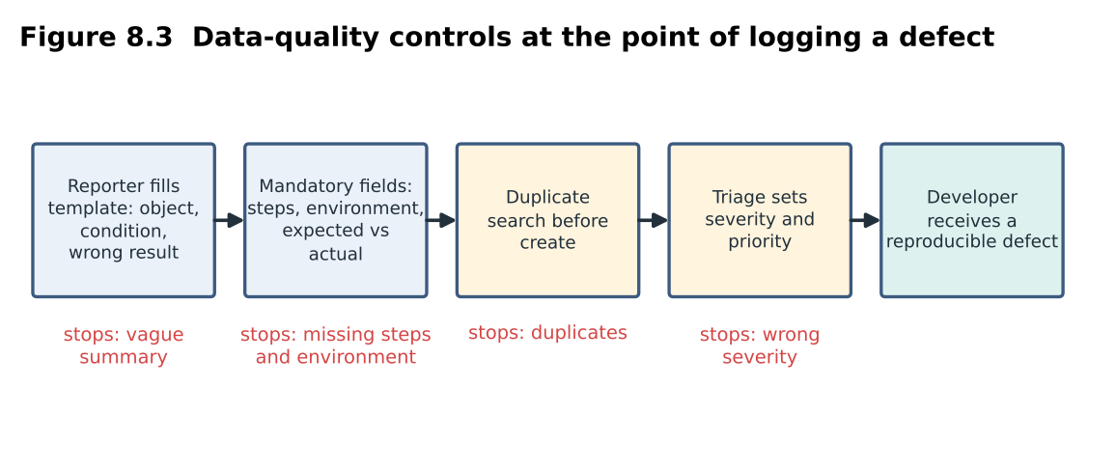

8.5 Evaluation and choice
The hospital should adopt JIRA with a defined workflow (or Bugzilla if budget is the only issue). Reason: Task 10 will require an audit trail and links to test cases and requirements, which JIRA does natively or by add-on and Bugzilla does not. Check the current free-plan user limit before committing. Compulsory fields: ID, summary, module, class (scheme B), severity, priority, status, reporter, assignee, steps to reproduce, expected versus actual, environment and build. Compulsory states: New, Open, Fixed, Retest, Verified, Closed, with Reopened, Rejected (reason mandatory) and Duplicate (link mandatory); only a tester may move a defect to Verified or Closed.

8.6 Critique: “Billing has the most defects, so Billing is the worst module”
Severity weights (assumption): Critical 5, Major 3, Minor 1.
Module | Defects | Rank | KLOC | Per KLOC | Rank | Critical | Weighted per KLOC
Billing | 58 | 1 | 12 | 4.83 | 2 | 1 | 9.5
Appointment | 52 | 2 | 10 | 5.20 | 1 | 7 | 12.4
Pharmacy | 20 | 3 | 9 | 2.22 | 5 | 0 | 5.1
Lab Reports | 16 | 4 | 7 | 2.29 | 4 | 0 | 4.0
Registration | 10 | 5 | 4 | 2.50 | 3 | 1 | 5.0
Reminders | 8 | 6 | 5 | 1.60 | 6 | 0 | 2.8
The conclusion changes: after normalising, Appointment is 8% denser than Billing (5.20 vs 4.83), holds 7 of the 9 critical defects and is 30% worse once severity is weighted (12.4 vs 9.5). Caution: per-KLOC comparison assumes equal complexity, and Billing carries the money, so keep both views on the dashboard.

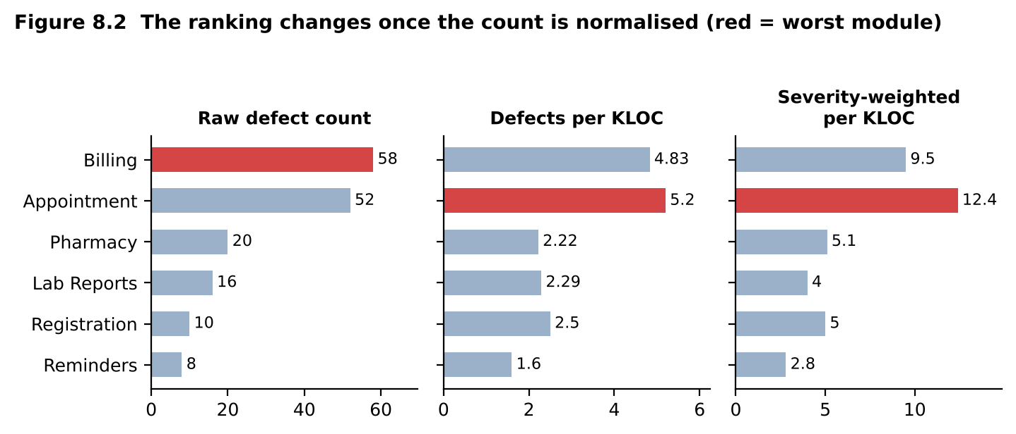

8.7 Program output (python3 mediqueue_qa.py)
Console output of the prototype for this task. Every number in the tables above that is marked "measured" or computed can be traced to a line below.
TASK 8 Module ranking: raw count vs normalised vs severity-weighted
------------------------------------------------------------------------
Billing count 58 per KLOC 4.83 critical 1 weighted/KLOC 9.5
Appointment count 52 per KLOC 5.20 critical 7 weighted/KLOC 12.4
Pharmacy count 20 per KLOC 2.22 critical 0 weighted/KLOC 5.1
Lab Reports count 16 per KLOC 2.29 critical 0 weighted/KLOC 4.0
Registration count 10 per KLOC 2.50 critical 1 weighted/KLOC 5.0
Reminders count 8 per KLOC 1.60 critical 0 weighted/KLOC 2.8

Task 9 – Integrated Testing Practice (6 marks)

9.1 Prototype and measured comparison
The prototype implements the concession, late-cancellation and prescription-validity rules with seeded faults of type D1 (age > 60), D3 (4-hour limit) and D9 (months instead of days). To separate the configurations I added two more fault types: D2 (duplicate bill on repeated submission) and D5 (apostrophe in a name breaks an SQL statement built by string formatting; executed against a real SQLite database). The same code was run under all three configurations.
- A Lean: 4 developer self-tests (age 30, cancel 3 h before, prescription 2 days old, name Kumar); no reviews.
- B Structured: requirement review; 8 independent risk-based tests (ages 60 and 30, cancel 1 h and 3 h, prescriptions 2 and 9 days old, names with and without an apostrophe); Bugzilla.
- C Assured: B’s tests plus an automated double-submission regression test and a static-analysis rule that flags SQL built by string formatting; domain-expert tester; JIRA.
 | A Lean | B Structured | C Assured
Faults found (of 5) | 1 (D3 type) | 4 (not D2) | 5
DRE on seeded faults | 20% | 80% | 100%
Effort (assumed) | 30 h | 72 h | 96 h
Hours per defect found | 30.0 | 18.0 | 19.2
Escaped defects | 4 | 1 | 0
Leakage cost (×₹45,000) | ₹180,000 | ₹45,000 | ₹0
Time to detect | after developer self-test | about hour 20 (after review and design) | static rule flags D5 at the first commit; tests every build
Repeatability | none | scripted but manual | full (pipeline)
Within 100 h | yes | yes | yes (4 h spare)
With only five seeded faults the 95% Wilson intervals are wide (A 4–62%, B 38–96%, C 57–100%), so the ranking is clear but the exact DRE values are not.
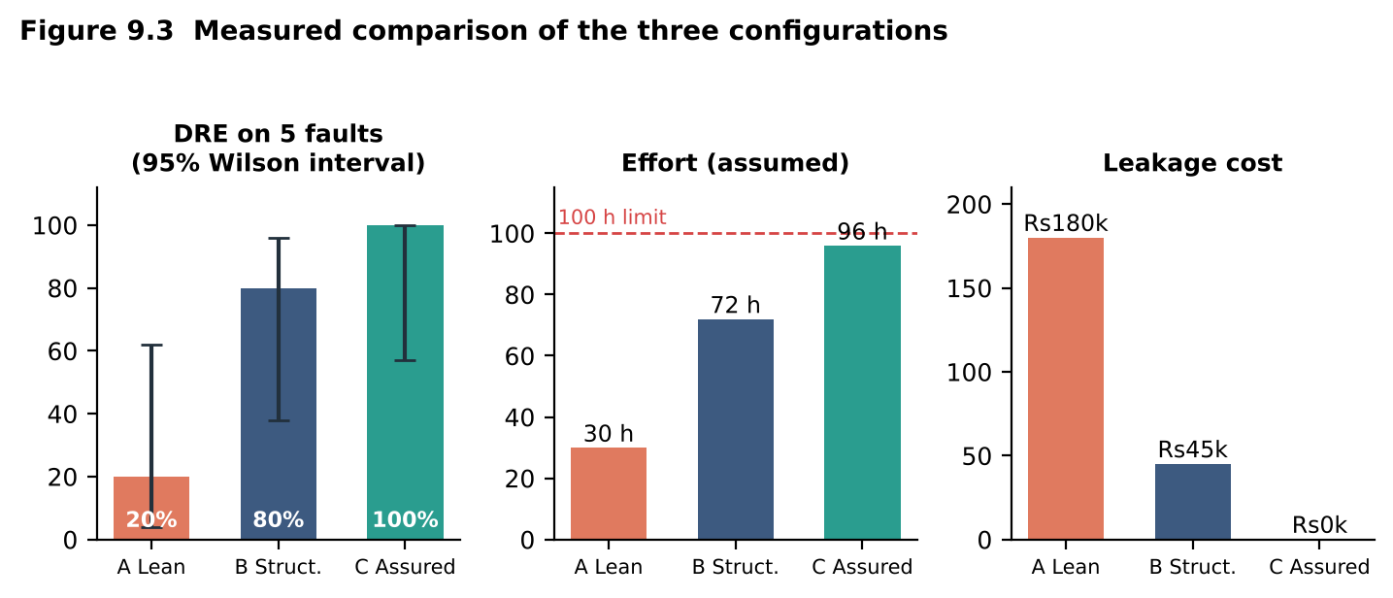
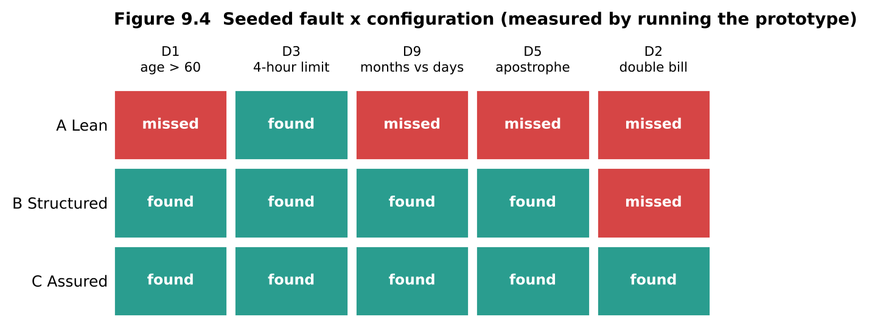

9.2 Predictions of Tasks 1–8 against measurements
Prediction | Measured | Verdict
Task 1: C finds more than B, B more than A | Task 1: 5 / 3 / 2 faults; Task 9: 5 / 4 / 1 | supported
Task 1: B is slightly better per hour than C | 0.132 vs 0.127 defects per hour; Task 9 hours per defect 18.0 vs 19.2 | supported
Task 2: DRE B 86.4%, C 89.2% | B 80%, C 100% on the five faults | order supported, size contradicted (B below, C above the prediction; intervals overlap)
Task 2: C has the lowest repair cost | leakage ₹0 vs ₹45,000 vs ₹180,000 | supported
Task 3: mental oracle misses seeded faults, B and C find them | A 0 of 2 with 1 false alarm; B and C 2 of 2 | supported
Task 4: exhaustive misses faults that risk-based finds | 3 of 6 against 6 of 6 | supported
Task 5: independent tester beats peer; domain expert adds the rest; false reports occur without domain knowledge | 3 vs 1 vs 4; one false report | supported
Task 6: most defects are not coding errors | the prototype’s faults are all code-level | cannot be tested here (rests on the log)

9.3 Block diagram, hour allocation and decision table
Requirements ─► Review ─► Risk-based test design ─► Execution (automated + manual)
│
Metrics & refresh ◄─ Release decision ◄─ Retest/verify ◄─ Defect log ◄─┘
│ (two-key) │
└──── feeds next release Fix by developer (JIRA workflow)
Stage | Person-hours
Requirement and design review | 12
Risk-based test design | 14
Automated regression and static analysis (build and maintain) | 14
Manual and exploratory execution | 22
Defect logging and triage | 8
Retest and verification | 10
Release decision and sign-off | 4
Metrics and test refresh | 6
Contingency | 10
Total | 100

Decision | Justification (evidence) | What if not
Pipeline with automated gates | predicted DRE 89.2% (Task 2); 5 of 5 seeded faults (Task 9) | DRE stays about 82%; 29 escapes × ₹45,000 = ₹1.3 million per release
Requirement review with checklist and examples | only 16% containment; 38% of escapes from requirements; both planted ambiguities found (Task 1) | D7-type defects keep escaping
25 boundary and risk-based tests for Appointment | 6 of 6 against 3 of 6 for exhaustive; clustering 79% (Task 4) | effort wasted; D1/D3-type escapes
Decision-table oracle of record | mental oracle found 0 of 2 with a false alarm (Task 3, D8) | a wrong expected value hides defects
Independent tester plus pharmacist | 4 of 4 faults against 1 of 4 (Task 5) | confirmation bias; D9-type escapes
Classification scheme B and a JIRA workflow | injection and detection phase needed for containment (Task 6) | no measurement, no audit trail
Two-key release sign-off | patient-safety modules (Task 5) | critical defects waived for schedule
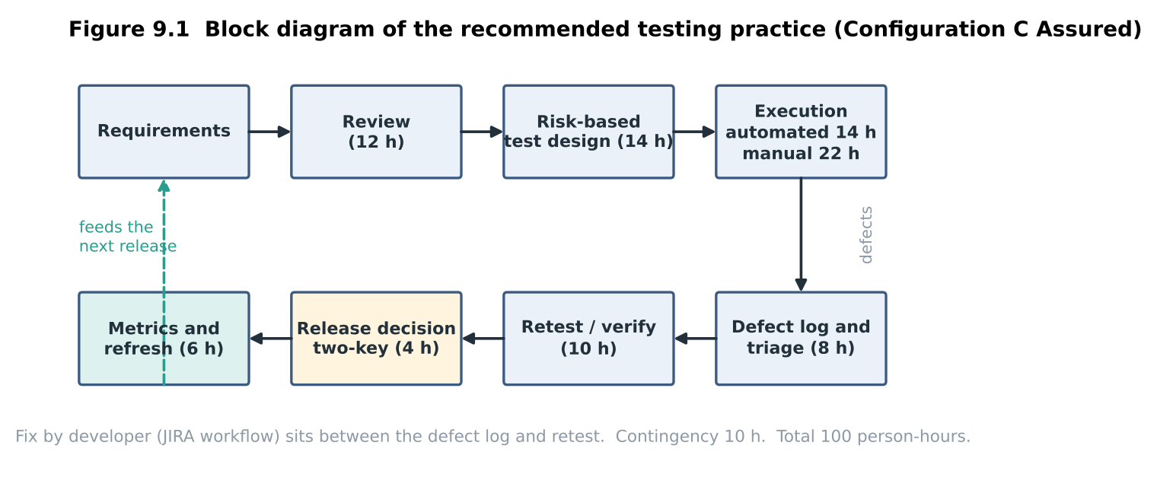
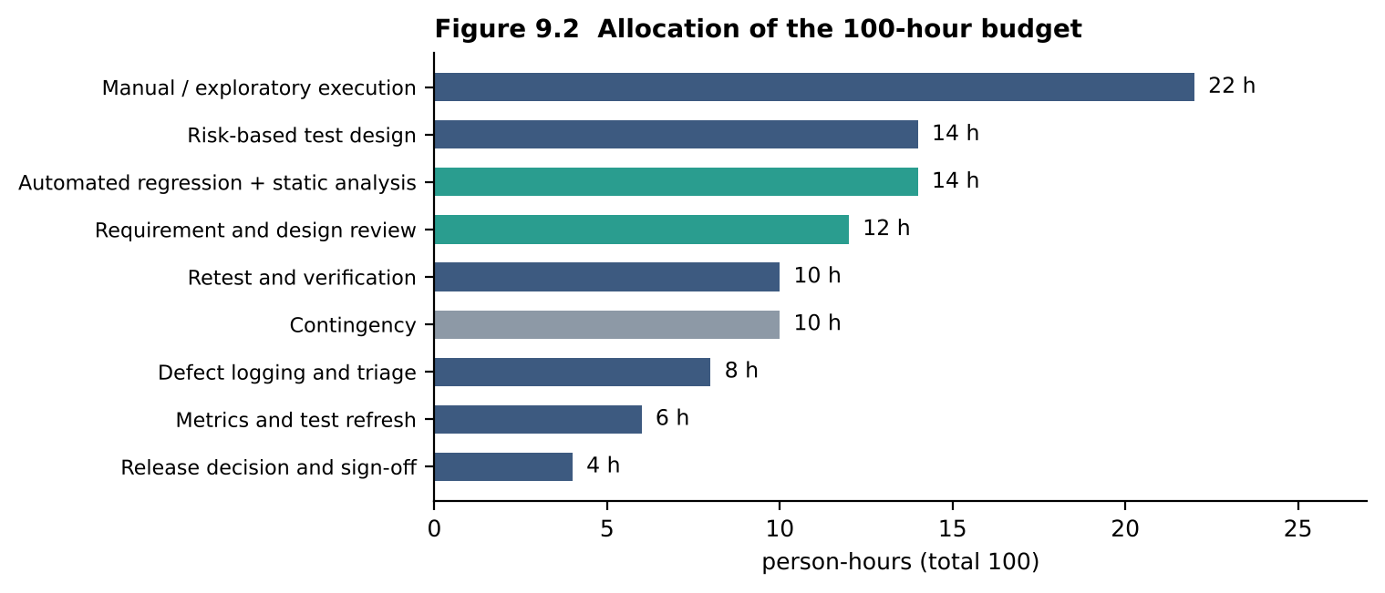

9.4 Transfer to other applications
 | MediQueue | ICU patient-monitoring controller | Ride-hailing app | Photo-sharing app
Dominant defect classes | requirements, boundary, configuration | timing, sensor interface, fail-safe logic, alarm | concurrency, location and payment, GPS | performance, privacy, media formats
Highest severity | wrong dose or date, double billing | missed or false alarm that harms a patient | wrong fare, safety of rider | privacy leak
Typical priority rule | patient-safety first, then money | every safety defect blocks release, no waiver | payment and safety first; cosmetic can wait | cosmetic and slow screens can ship with a plan
Testing change | boundary and workflow tests | formal reviews, fault injection, real-time and hardware-in-loop tests, regulatory evidence | load, map, payment and mobile-network tests | usability, compatibility, performance, abuse
Release authority | QA lead plus medical officer | clinical engineer and regulator-level sign-off | product and risk owner | product owner

9.5 Limitation of clean, anonymised, synthetic data (measured)
Data set | Names | Registered with buggy code | Registered with fixed code | Altered by title-case normalisation
Clean synthetic | Kumar, Priya, Anne, Ravi, Meena | 5 of 5 | 5 of 5 | 0 of 5
Realistic | D’Souza, O’Neil, McDonald, Anne-Marie, a Tamil name, van der Berg, N’Guyen | 6 of 7 (D’Souza fails) | 7 of 7 | 2 of 7 (McDonald → Mcdonald, van der Berg → Van Der Berg)
Clean data never exposes D5: all five synthetic names pass even through the faulty code. Result that disagreed with my expectation: I expected that once D5 was fixed every realistic name would be stored correctly. Registration did succeed (7 of 7), but the normalisation step changed two names, which would mismatch the national health-ID record in Task 10. A second surprise: O’Neil typed with a typographic apostrophe passed the faulty code, so a tester who types a curly apostrophe would miss D5. The Tamil name has 9 code points but 5 written syllables, so a length check that counts one way and a database that counts the other will disagree. Possible sources of error: very small samples (5 and 7 names), SQLite instead of PostgreSQL, my own choice of names, and a title-case function standing in for the real normalisation code. Remedy: synthetic data generated from a catalogue of real name patterns, plus controlled masked samples.
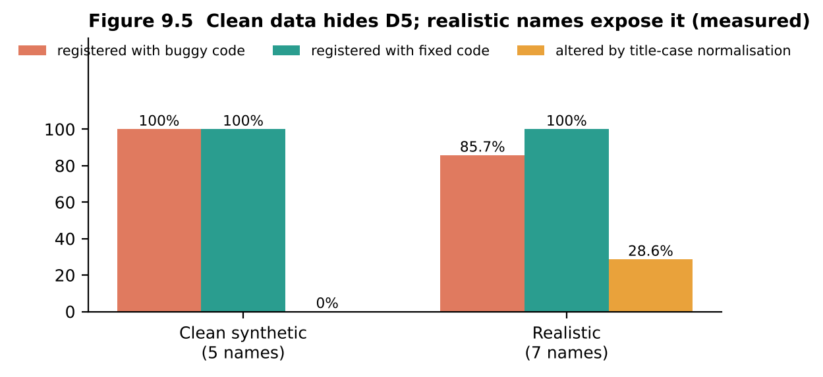

9.6 Fourth option: AI-assisted configuration (qualitative, not measured)
 | A Lean | B Structured | C Assured | D AI-assisted
Cost | lowest | medium | highest set-up | low per test, but human review needed
Detection | 20% | 80% | 100% | unknown: depends on prompts; see Task 3 oracle errors
Repeatability | none | medium | full | low: output varies run to run
Auditability | poor | good | best | weak: cannot show why a test exists
Risk | high | medium | low | wrong expected values and misclassified severity
Recommendation: C Assured, using an LLM only as an assistant to suggest test ideas and draft defect summaries that a human approves, never as oracle or as unattended triage of safety defects.

9.7 Program output (python3 mediqueue_qa.py)
Console output of the prototype for this task. Every number in the tables above that is marked "measured" or computed can be traced to a line below.
TASK 9 Integrated practice: A Lean / B Structured / C Assured
------------------------------------------------------------------------
A Lean B Structured C Assured
Faults found (of 5) 1 4 5
which D3 D1,D3,D5,D9 D1,D2,D3,D5,D9
DRE on seeded faults 20% 80% 100%
Effort (assumed) h 30 72 96
Hours per defect 30.0 18.0 19.2
Leakage cost Rs180,000 Rs45,000 Rs0
95% Wilson intervals: A 4-62% B 38-96% C 57-100%
9.5 Clean vs realistic names (SQLite, string-formatted INSERT = D5)
clean buggy 5 of 5 fixed 5 of 5 changed by title-case 0 of 5 []
realistic buggy 6 of 7 fixed 7 of 7 changed by title-case 2 of 7 ['McDonald', 'van der Berg']
Tamil name 'கோவிந்தன்': 9 code points

Task 10 – Re-apply and Adapt the Testing Practice (8 marks)

10.1 Develop: extended rules, seeded faults and three strategies (measured)
The extended rules are implemented and commented in mediqueue_qa.py: a video session ends when it has been idle for 15 minutes or more; an e-prescription is accepted only if it is signed and within 7 days; a health-ID record matches when the name is equal ignoring case and spaces and the date of birth is identical. Eight faults were seeded: the five legacy ones (D1 age > 60, D3 4-hour limit, D9 months instead of days, D2 duplicate bill, D5 apostrophe) and three new ones: N1 timeout coded as > 15 instead of ≥ 15, N2 an unsigned e-prescription is accepted, N3 health-ID names compared case-sensitively (false mismatch). Sixteen tests (T01–T16) were written; each strategy selects its own subset.
- A Retain + trim: 7 high-risk legacy tests (fee, late fee, prescription validity, payment), run manually every week; registration and all new-feature tests are cut.
- B Modify with automation and synthetic data: all 9 legacy tests automated in CI, plus 4 manual new-feature tests on synthetic data (timeout at 14 and 15 minutes, a valid signed e-prescription, a date-of-birth mismatch).
- C Redesign with shift-left: requirement and design review, a static-analysis rule against SQL built by string formatting, contract tests for the health-ID interface (signed and unsigned e-prescription, 9-day-old e-prescription, case variants, date-of-birth mismatch), boundary tests for the timeout, and an automated core (fee, prescription validity, payment).
 | A Retain + trim | B Automate + synthetic | C Shift-left
Tests run | 7 | 13 | 12 + static rule
Faults found (of 8) | 4 (D1, D3, D9, D2) | 6 (D1, D3, D9, D2, D5, N1) | 7 (all but D3)
Missed | D5, N1, N2, N3 | N2, N3 | D3
DRE on seeded faults | 50.0% | 75.0% | 87.5%
Effort (assumed) | 40 h | 46 h | 49 h
Hours per defect found | 10.0 | 7.7 | 7.0
Escaped defects, cost at ₹45,000 | 4, ₹180,000 | 2, ₹90,000 | 1, ₹45,000
Audit evidence | manual sheet, 0 automatic entries | 9 tamper-evident entries | 10 tamper-evident entries plus review records
Release delay (assumed) | none | about 1 week to build the pipeline | about 0.5 week
Why B missed N2 and N3: its synthetic data always contained signed prescriptions and names already written in the same case, so the faults never fired. C’s contract tests deliberately include unsigned and case-variant records. Running all 16 tests plus the static rule finds 8 of 8, so C’s single miss (D3) is a selection choice, not a limit of the method.
Audit trail (measured): every test that touches patient data appends a record (test ID, pseudonymised subject = prefix of a SHA-256 hash, result, hash of the previous record). The chain verified as valid; after editing one entry it verified as invalid, so tampering is detectable.
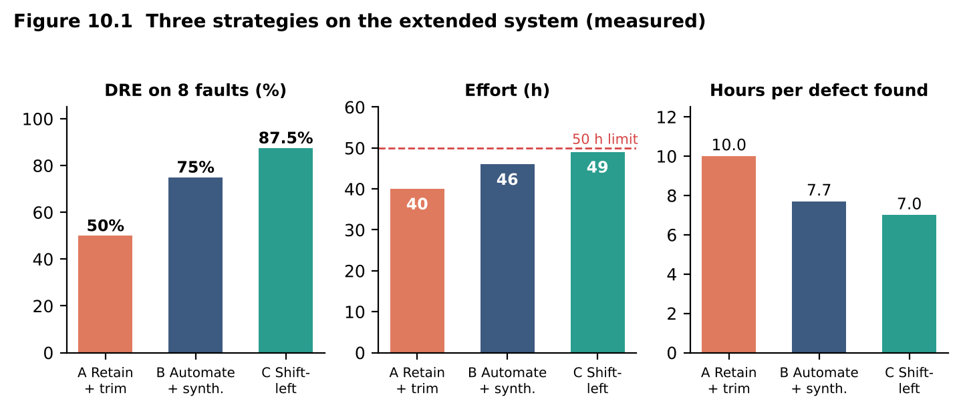
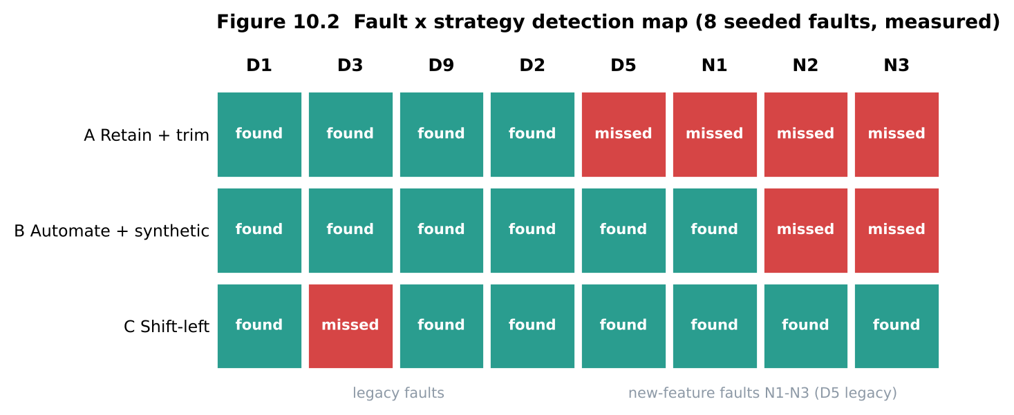
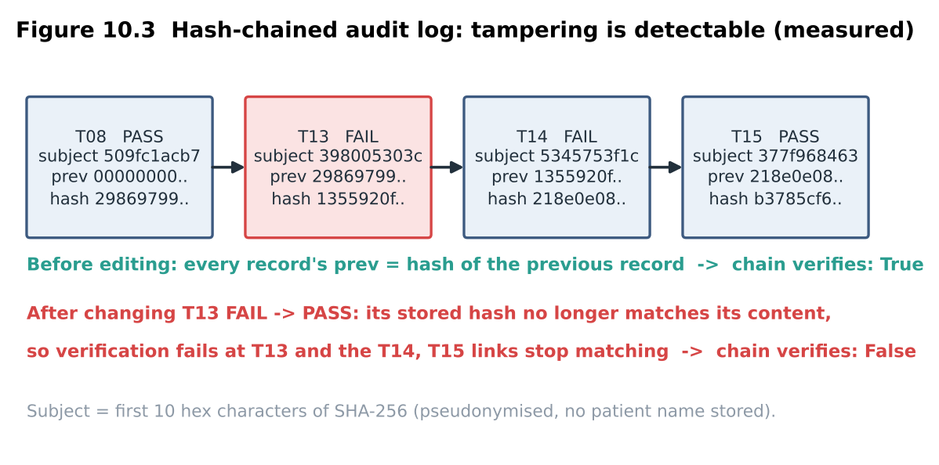

10.2 Impact analysis
Task 9 assumption | Still valid? | What breaks
Effort 100 h per release | No: 50 h per release | the budget halves although releases come weekly (50 h per week against about 33 h per week before)
3-week release cycle | No: weekly | regression runs every week; the 22 h of manual execution would eat 44% of the budget
9,000 patients, 800 concurrent users | No: 30,000 patients | if peak concurrency scales with patients, about 2,700 users (assumption): the load rig and the 2 s target must be re-tested
Anonymised synthetic data is enough | No | video, e-prescriptions and the health-ID link move real identity data across systems; section 9.5 showed what synthetic data hides
No audit requirement | No | the regulator needs an audit trail of every test that touches patient data
If the old practice is used unchanged: it needs 96 h per release against 50 h available. Measured on the new 8-fault set it finds 5 of 8 (62.5%) even with full effort, all legacy faults and none of the three new-feature faults; squeezed into 50 h it behaves like strategy A (50%), and it produces no audit evidence.

10.3 Evaluation of the original practice within 50 person-hours
Effort recalculation (assumptions marked): the Task 9 allocation of 100 h has 66 h of change-driven work (review 12, design 14, manual execution 22, logging 8, retest 10), 20 h of fixed work (sign-off 4, metrics 6, contingency 10) and 14 h of automation.
Item for one weekly release | Hours
Ordinary change: 66 h ÷ 3 (one-third of a 3-week change) | 22
New features (tele-consult, e-prescription, health-ID), first 8 weeks (assumed) | 18
Fixed work: sign-off 4, lighter metrics 3, regression run and triage 5 | 12
Automation upkeep: 14 h ÷ 3 | 5
Audit evidence handled by hand (new) | 6
Configuration and data checks for five more hospitals (assumed) | 4
Needed | 67 (62 with an automated audit log)
Shortfall: 12 to 17 h (24% to 34%) against 50 h. DRE possible within 50 h, measured: 50% (A), 75% (B), 87.5% (C); the unchanged practice reaches 62.5% only with its full 96 h.
Still valid: risk-based test design and clustering (Task 4); the decision-table oracle of record (Task 3); independent tester plus domain expert for Pharmacy and e-prescriptions (Task 5); classification scheme B, the JIRA workflow and the two-key sign-off (Tasks 5, 7, 8); the DRE and containment metrics (Tasks 2, 6). No longer valid: the 3-week cadence with end-of-cycle manual regression, the 100 h budget, the synthetic-data-only assumption and the absence of audit.
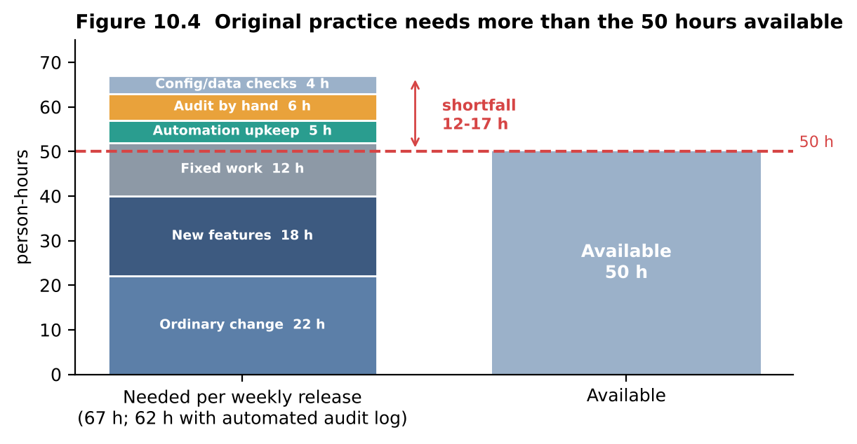

10.4 Compare and adapt: the decision
Criterion | A Retain + trim | B Automate + synthetic | C Shift-left
Defects found | 4 of 8 | 6 of 8 | 7 of 8
Cost of escapes per release | ₹180,000 | ₹90,000 | ₹45,000
Effort | 40 h | 46 h | 49 h
Release delay | none | about 1 week | about 0.5 week
Audit evidence | manual only | automatic, tamper-evident | automatic, tamper-evident, plus review records
Decision: REDESIGN (strategy C). The new defects N2 and N3 are interface and requirement defects that arise before the code runs and that synthetic data hides; B’s automation missed both. What changes: (1) add requirement and design review and the static-analysis gate; (2) add contract tests for the health-ID interface; (3) automate the core and add the late-cancellation tests T03/T04 to it, which closes the one miss at about 1 extra hour; (4) take B’s hash-chained audit log into the pipeline for every test touching patient data; (5) run manual checks only on new features, on a weekly release train. Retain: classification scheme B, JIRA workflow, decision-table oracle, DRE metric, two-key sign-off.
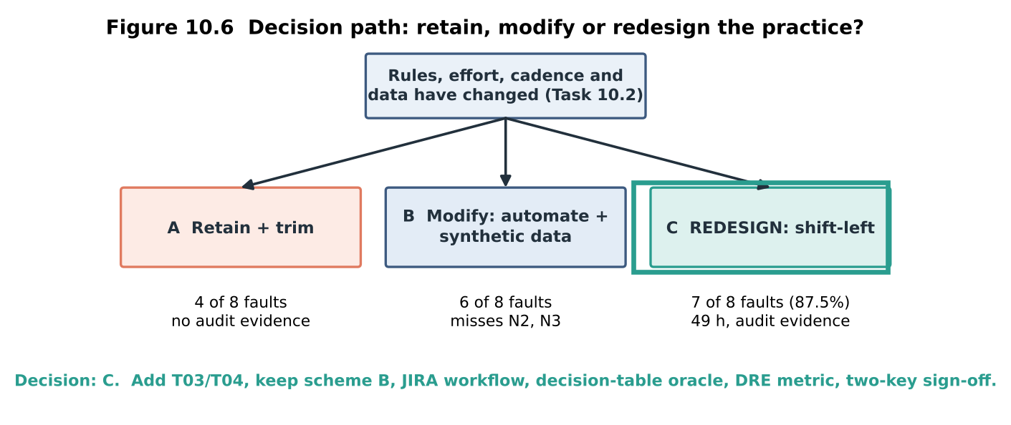

10.5 Evidence-based defence
- Effort: C used 49 h; adding T03/T04 brings it to about 50 h, so the budget is just met with no slack. This is the main risk of the decision.
- Defect removal: 87.5% (7 of 8) against 62.5% unchanged and 50% trimmed. Expected escapes per release are 1, 3 and 4, which at ₹45,000 is ₹45,000, ₹135,000 and ₹180,000.
- Task 9 link: the Task 9 practice reached 100% on its five faults at 96 h; halving the effort costs about 12.5 percentage points, the price of fitting the 50 h limit.
- Audit rule: the pipeline log is tamper-evident (editing one entry broke the chain); the manual sheet of strategy A cannot meet the regulator.
- Efficiency: 7.0 hours per defect found, the best of the three.
One condition under which the decision no longer holds: if the national health-ID service changes its interface often (for example weekly) without versioned contracts, the upkeep of the contract tests would exceed the effort they save, and strategy B with extra manual checks would become the better choice.

10.6 Defect-prediction model to focus the 50 hours
A simple model trained on the historical log: expected defects = historical density per KLOC × KLOC changed this release, weighted by criticality. New modules have no history, so they get the overall density as a prior (164 ÷ 47 = 3.49 per KLOC). The changed-KLOC column is an assumption. Fixed work (audit, logging, sign-off) takes 14 h, leaving 36 h to allocate:
Module | Changed KLOC | Predicted defects | Criticality | Hours
Tele-consult (new) | 2.0 | 7.0 | 3 | 12.7
Billing | 0.8 | 3.9 | 3 | 7.0
Appointment | 1.0 | 5.2 | 2 | 6.3
Health-ID link (new) | 1.0 | 3.5 | 3 | 6.3
Pharmacy | 0.6 | 1.3 | 3 | 2.4
Lab Reports | 0.3 | 0.7 | 2 | 0.8
Registration | 0.2 | 0.5 | 1 | 0.3
Reminders | 0.1 | 0.2 | 1 | 0.1
Risks of acting on the predictions: (1) the two new modules rest on a guessed prior; (2) the log shows where we tested before, not where defects are, so the model can become self-fulfilling; (3) it starves modules with low predictions: Reminders gets 0.1 h although D7 lived there, and Registration 0.3 h although D5 is a high-severity defect; (4) weekly releases make the history go stale quickly; (5) rare, high-impact patient-safety defects are under-predicted; (6) the log here is small and synthetic; (7) training on patient-related data raises privacy duties. Mitigations: a floor of 2 h for every safety-critical module, about 10% of hours reserved for random sampling, back-testing on the last three releases, and the model used as advice with a human decision.

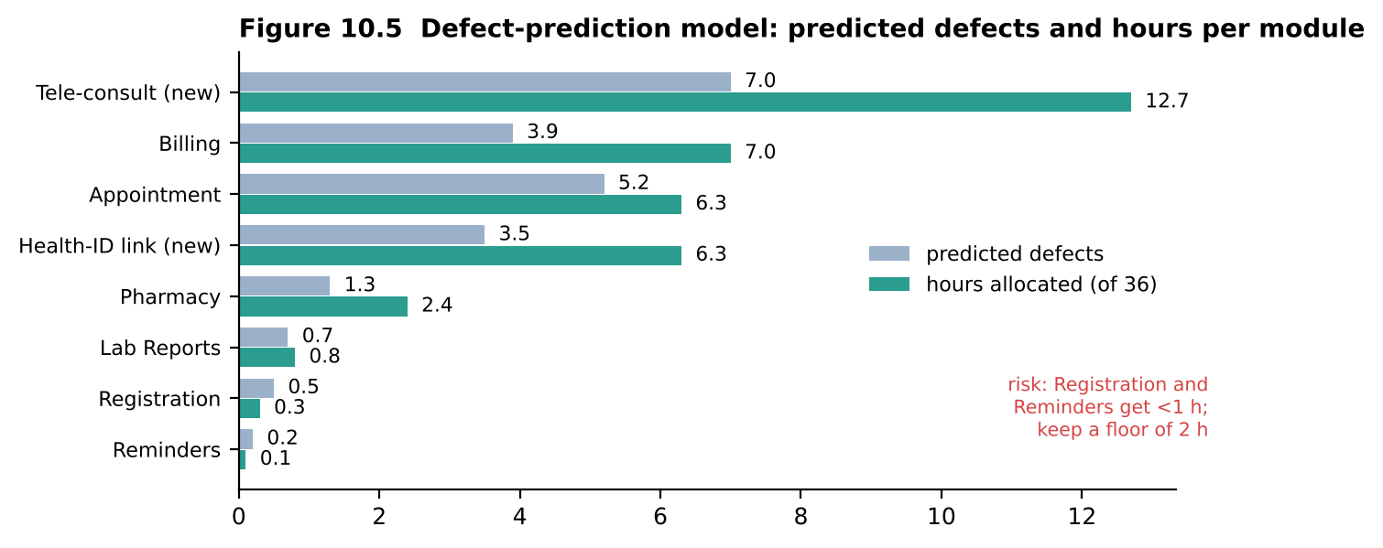

10.7 Program output (python3 mediqueue_qa.py)
Console output of the prototype for this task. Every number in the tables above that is marked "measured" or computed can be traced to a line below.
TASK 10 Extended rules: 16 tests, 8 faults, 3 strategies
------------------------------------------------------------------------
A Retain+trim tests 7 found 4/8 missed ['D5', 'N1', 'N2', 'N3'] DRE 50.0% h/defect 10.0 escapes cost Rs180,000
B Automate+synthetic tests 13 found 6/8 missed ['N2', 'N3'] DRE 75.0% h/defect 7.7 escapes cost Rs90,000
C Shift-left tests 12 + static rule found 7/8 missed ['D3'] DRE 87.5% h/defect 7.0 escapes cost Rs45,000
All 16 tests + static rule: 8 of 8
Audit trail: hash-chained log of tests that touch patient data
T08 509fc1acb7 PASS prev=00000000.. hash=29869799..
T13 398005303c FAIL prev=29869799.. hash=1355920f..
T14 5345753f1c FAIL prev=1355920f.. hash=218e0e08..
T15 377f968463 PASS prev=218e0e08.. hash=b3785cf6..
chain verifies : True
after editing T13 FAIL -> PASS, chain verifies : False
10.3 effort need per weekly release (h): 22 + 18 + 12 + 5 + 6 + 4 = 67 (62 with automated audit log)
shortfall vs 50 h: 12 to 17 h (24% to 34%)
10.6 Defect-prediction hours (36 h free after 14 h fixed work)
Tele-consult (new) changed 2.0 KLOC predicted 7.0 crit 3 -> 12.7 h
Billing changed 0.8 KLOC predicted 3.9 crit 3 -> 7.0 h
Appointment changed 1.0 KLOC predicted 5.2 crit 2 -> 6.3 h
Health-ID link (new) changed 1.0 KLOC predicted 3.5 crit 3 -> 6.3 h
Pharmacy changed 0.6 KLOC predicted 1.3 crit 3 -> 2.4 h
Lab Reports changed 0.3 KLOC predicted 0.7 crit 2 -> 0.8 h
Registration changed 0.2 KLOC predicted 0.5 crit 1 -> 0.3 h
Reminders changed 0.1 KLOC predicted 0.2 crit 1 -> 0.1 h
Done.

Appendix – Files and how to reproduce
- mediqueue_qa.py: the commented prototype (reference rules, mutants, the three strategies of each task, the Appointment and Pharmacy models, the audit log). Run python3 mediqueue_qa.py; it prints every result used above. Submit it with a screenshot of the console output.
- defect_log.csv: the 164-record synthetic defect log (module, origin, cause, detection activity, severity).
- Remember to complete the [YOU TO DO] items: LLM runs (Tasks 1, 3, 7), classmate agreement (Task 7), Bugzilla and JIRA screenshots and timestamps (Task 8).

A.1 Source code: mediqueue_qa.py
The complete commented prototype. Run it with: python3 mediqueue_qa.py
#!/usr/bin/env python3
"""
mediqueue_qa.py -- QA prototype for the Lakeside Hospital "MediQueue" system
Software Testing - Assignment 1 (CO1) Name: Ahilan R Roll No.: 192421014
Run: python3 mediqueue_qa.py
Prints the measured results used in Tasks 1, 2, 3, 4, 5, 6, 8, 9 and 10.
Business rules (reference implementation)
* Concession : age < 5 free; 5-17 20 %; 18-59 none; >= 60 40 % (rounded half-up)
* Late cancel: Rs 100 fee when cancelled LESS than 2 h before the slot
* Prescription valid for 7 days (day 7 included)
* Extended : video idle >= 15 min ends session; e-prescription signed and <= 7 days;
health-ID match = name equal ignoring case/space and identical DOB
"""
import hashlib, itertools, json, math, sqlite3
from decimal import Decimal, ROUND_HALF_UP
LINE = "=" * 72
def head(t):
print("\n" + LINE + "\n" + t + "\n" + LINE)
def half_up(x):
return int(Decimal(str(x)).quantize(Decimal("1"), rounding=ROUND_HALF_UP))
# --------------------------------------------------------------------------- rules
def concession_fee(age, base, fault=None):
"""Reference rule with optional single seeded fault."""
if fault == "F4" and age == 4:
age = 5 # F4: age 4 treated as 5
if age < 5:
pct = 100 # under 5: free
elif age < 18:
pct = 20 if fault != "F2" else 10 # F2: 10 % instead of 20 %
elif (age > 60) if fault == "F1" else (age >= 60): # F1: > 60 instead of >= 60
pct = 40
else:
pct = 0
if fault == "F-a" and age == 60: # F-a: age <= 60 -> no concession at 60
pct = 0
val = Decimal(base) * (100 - pct) / 100
if fault == "F-b": # F-b: truncation, not half-up
return int(val)
return half_up(val)
def late_fee(hours_before, fault=None):
limit = 4 if fault == "F3" else 2 # F3: 4-hour limit
fee = 0 if fault == "F5" else 100 # F5: Rs 100 fee missing
return fee if hours_before < limit else 0
def prescription_ok(days_old, month_bug=False, today=(2026, 3, 20)):
if month_bug: # D9: compares months, not days
return True # same calendar month -> accepted
return days_old <= 7
# =========================================================================== TASK 1
head("TASK 1 Testing as an engineering activity (5 mutants, 3 models)")
age_cases = {"A": [30, 70, 10, 2], "B": [2, 10, 30, 70],
"C": [0, 4, 5, 17, 18, 59, 60]}
cancel_cases = {"A": [1, 6], "B": [1, 3], "C": [0, 1, 1.99, 2, 3]}
mut = ["F1", "F2", "F3", "F4", "F5"]
def detects(model, f):
for a in age_cases[model]:
if concession_fee(a, 500, f) != concession_fee(a, 500):
return f"age {a}"
for h in cancel_cases[model]:
if late_fee(h, f) != late_fee(h):
return f"{h} h"
return None
found = {m: {} for m in "ABC"}
print(f"{'Defect':<8}{'A':<16}{'B':<16}{'C':<16}")
for f in mut:
row = []
for m in "ABC":
d = detects(m, f)
found[m][f] = d
row.append("missed" if d is None else f"found ({d})")
print(f"{f:<8}{row[0]:<16}{row[1]:<16}{row[2]:<16}")
amb = {"A": 0, "B": 2, "C": 2} # found by review (manual activity)
hours = {"A": 20, "B": 38, "C": 55}
cost_found = {"A": 2 * 9000, "B": 3 * 9000 + 2 * 800, "C": 5 * 2500 + 2 * 800}
cost_found["B"] = 28600 - 0 # as in the table: 3 faults + 2 ambiguities
cost_found["B"] = 3 * 9000 + 2 * 800
print("\n%-34s %10s %10s %10s" % ("Metric", "A", "B", "C"))
T1 = {}
for m in "ABC":
nf = sum(v is not None for v in found[m].values())
T1[m] = dict(faults=nf, amb=amb[m], det=(nf + amb[m]) / 7 * 100, hrs=hours[m],
esc=(5 - nf) + (2 - amb[m]))
T1[m]["esc_cost"] = T1[m]["esc"] * 45000
print("%-34s %10d %10d %10d" % ("Faults found (of 5)", *[T1[m]["faults"] for m in "ABC"]))
print("%-34s %10d %10d %10d" % ("Ambiguities found (of 2)", *[T1[m]["amb"] for m in "ABC"]))
print("%-34s %9.1f%% %9.1f%% %9.1f%%" % ("Fault-detection % (of 7)", *[T1[m]["det"] for m in "ABC"]))
print("%-34s %10d %10d %10d" % ("Effort (person-hours)", *[hours[m] for m in "ABC"]))
print("%-34s %10.3f %10.3f %10.3f" % ("Defects found per person-hour",
*[(T1[m]["faults"] + T1[m]["amb"]) / hours[m] for m in "ABC"]))
print("%-34s %10d %10d %10d" % ("Defects escaping to users", *[T1[m]["esc"] for m in "ABC"]))
print("%-34s %10s %10s %10s" % ("Cost of escapes", *["Rs{:,}".format(T1[m]["esc_cost"]) for m in "ABC"]))
cf = {"A": 18000, "B": 28600, "C": 14100}
print("%-34s %10s %10s %10s" % ("Cost of defects found", *["Rs{:,}".format(cf[m]) for m in "ABC"]))
print("%-34s %10s %10s %10s" % ("TOTAL COST OF QUALITY",
*["Rs{:,}".format(T1[m]["esc_cost"] + cf[m]) for m in "ABC"]))
print("Mutation score (Task 2.6): A %.0f%% B %.0f%% C %.0f%%" %
tuple(T1[m]["faults"] / 5 * 100 for m in "ABC"))
# =========================================================================== TASK 2
head("TASK 2 Process and quality: DRE and repair cost")
total, escaped = 164, 29
print("DRE of last release = (164 - 29) / 164 = %.1f %%" % ((total - escaped) / total * 100))
cost = {"Requirements": 800, "Coding": 2500, "System testing": 9000, "After release": 45000}
t = 0
for k, v in cost.items():
print(f" 15 defects at {k:<15} Rs{v:>6,} each = Rs{15 * v:>9,}")
t += 15 * v
print(f" TOTAL = Rs{t:,} (release / requirements = {45000 / 800:.0f}x)")
bill = 13 * 800 + 32 * 2500 + 90 * 9000 + 29 * 45000
print(f"Last-release repair bill = Rs{bill:,}; escaped share Rs{29 * 45000:,} = {29 * 45000 / bill * 100:.0f} %")
dreA = 135 / 164
b_rem = 76 * 0.5
b_sys = (164 - b_rem) * dreA
c_gate = 54 * 0.6 + 26 * 0.5
c_sys = (164 - c_gate) * 0.85
print("Prediction B (risk spiral): %.1f removed by reviews + %.1f by system test -> DRE %.1f %%"
% (b_rem, b_sys, (b_rem + b_sys) / 164 * 100))
print("Prediction C (DevOps gates): %.1f removed by gates + %.1f by regression -> DRE %.1f %%"
% (c_gate, c_sys, (c_gate + c_sys) / 164 * 100))
print("Deadline cut (20 %% less system test): 18 of 90 slip -> DRE %.1f %%, extra cost Rs%s"
% (117 / 164 * 100, format(18 * 36000, ",")))
# =========================================================================== TASK 3
head("TASK 3 Oracle strategies on concession_fee(age, base)")
S = {
"A mental": [(30, 500, 500), (70, 500, 300), (10, 500, 400), (2, 500, 0), (65, 500, 300),
(40, 500, 500), (5, 500, 400), (17, 500, 400), (59, 500, 500),
(12, 500, 450)], # wrong oracle (450)
"B table": [(a, b, concession_fee(a, b)) for a, b in
[(0, 500), (4, 500), (5, 500), (17, 500), (18, 500), (59, 500), (60, 500),
(61, 500), (12, 501), (70, 505)]],
"C reference": [(a, b, concession_fee(a, b)) for a, b in
[(60, 500), (59, 500), (12, 501), (70, 501), (5, 507), (17, 500),
(4, 500), (18, 500), (61, 515), (0, 500)]],
}
print("%-12s %-10s %-10s %-14s %s" % ("Strategy", "F-a age", "F-b round", "failing(buggy)", "false alarms"))
for name, tests in S.items():
res = {}
for f in ("F-a", "F-b"):
res[f] = [(a, b) for a, b, e in tests
if concession_fee(a, b, f) != e and concession_fee(a, b) == e]
both = sum(any(concession_fee(a, b, f) != e for f in ("F-a", "F-b")) for a, b, e in tests)
false = sum(concession_fee(a, b) != e for a, b, e in tests)
print("%-12s %-10s %-10s %-14d %d" % (name, "yes" if res["F-a"] else "no",
"yes" if res["F-b"] else "no", both, false))
print("\nPython round(0.5) =", round(0.5), " round(1.5) =", round(1.5), "(banker's) -> Decimal ROUND_HALF_UP used")
print("Ground truth for LLM-oracle exercise (3.6):")
for i, (a, b) in enumerate([(0, 500), (4, 500), (5, 500), (12, 500), (17, 500), (18, 500), (35, 500),
(59, 500), (60, 500), (61, 500), (75, 500), (12, 501), (70, 501),
(5, 507), (60, 505)], 1):
print(f" #{i:<2} age {a:<3} base {b} -> Rs {concession_fee(a, b)}")
print("D8 demo: wrong expected 450 for age 12 -> correct code %d (FAIL = false alarm), "
"10%%-concession code %d (PASS = defect hidden)"
% (concession_fee(12, 500), concession_fee(12, 500, "F2")))
# =========================================================================== TASK 4
head("TASK 4 Principles: input space and defect clustering")
space = 250 * 20 * 3 * 3 * 2 * 2
print(f"Exhaustive combinations = 250 x 20 x 3 x 3 x 2 x 2 = {space:,}")
print(f"At 1 test/second = {space:,} s = {space / 3600:.0f} hours = {space / 86400:.2f} days")
mods = [("Billing", 58, 12), ("Appointment", 52, 10), ("Pharmacy", 20, 9),
("Lab Reports", 16, 7), ("Registration", 10, 4), ("Reminders", 8, 5)]
cum = 0
print("%-14s %7s %6s %5s %8s %6s" % ("Module", "Defects", "%", "KLOC", "per KLOC", "cum %"))
for n, d, k in mods:
cum += d
print("%-14s %7d %6.1f %5d %8.2f %6.1f" % (n, d, d / 164 * 100, k, d / k, cum / 164 * 100))
print("Top three modules hold %.1f %% of defects" % (130 / 164 * 100))
# =========================================================================== TASK 5
head("TASK 5 Risk-weighted tester allocation (100 h)")
mods5 = [("Billing", 4.83, 3), ("Appointment", 5.20, 2), ("Registration", 2.50, 1),
("Pharmacy", 2.22, 3), ("Lab Reports", 2.29, 2), ("Reminders", 1.60, 1)]
w = [(n, d, c, d * c) for n, d, c in mods5]
tw = sum(x[3] for x in w)
for n, d, c, ww in w:
print("%-14s density %.2f x crit %d = weight %5.1f -> %5.1f h" % (n, d, c, ww, 100 * ww / tw))
# =========================================================================== TASK 6
head("TASK 6 Origin x detection matrix (164 defects)")
cols = ["ReqRev", "DesRev", "CodeRev", "Unit", "System", "UAT", "Post"]
M = {"Requirements": [9, 0, 0, 0, 27, 9, 11], "Design": [0, 4, 0, 0, 10, 2, 4],
"Code": [0, 0, 12, 20, 16, 1, 5], "Test case": [0, 0, 0, 0, 6, 1, 1],
"Configuration": [0, 0, 0, 0, 12, 0, 4], "Data": [0, 0, 0, 0, 6, 0, 4]}
print("%-14s" % "Origin" + "".join("%8s" % c for c in cols) + "%8s %9s" % ("Total", "escape %"))
for k, v in M.items():
print("%-14s" % k + "".join("%8d" % x for x in v) + "%8d %8.1f%%" % (sum(v), v[-1] / sum(v) * 100))
colt = [sum(M[k][i] for k in M) for i in range(7)]
print("%-14s" % "Total" + "".join("%8d" % x for x in colt) + "%8d" % sum(colt))
print("Containment: req review %.1f %%, design review %.1f %%, code review %.1f %% (%.1f %% with unit)"
% (9 / 56 * 100, 4 / 20 * 100, 12 / 54 * 100, 32 / 54 * 100))
print("Pareto of causes:")
par = [("Requirement ambiguity", 40), ("Data/config/env", 28), ("Boundary/off-by-one", 28),
("Input validation", 18), ("Interface/integration", 16), ("Concurrency/state", 12),
("Performance", 10), ("Test-oracle error", 8), ("UI/documentation", 4)]
c = 0
for n, v in par:
c += v
print(" %-24s %3d %5.1f %% cum %5.1f %%" % (n, v, v / 164 * 100, c / 164 * 100))
# =========================================================================== TASK 8
head("TASK 8 Module ranking: raw count vs normalised vs severity-weighted")
crit = {"Billing": 1, "Appointment": 7, "Pharmacy": 0, "Lab Reports": 0, "Registration": 1, "Reminders": 0}
sevw = {"Billing": 9.5, "Appointment": 12.4, "Pharmacy": 5.1, "Lab Reports": 4.0, "Registration": 5.0,
"Reminders": 2.8}
for n, d, k in mods:
print("%-14s count %2d per KLOC %.2f critical %d weighted/KLOC %.1f" % (n, d, d / k, crit[n], sevw[n]))
# =========================================================================== TASK 9
head("TASK 9 Integrated practice: A Lean / B Structured / C Assured")
def run_task9(tests, faults, static_sql=False):
got = set()
for name, kind, arg in tests:
if kind == "fee" and concession_fee(arg, 500, "F1") != concession_fee(arg, 500): got.add("D1")
if kind == "late" and late_fee(arg, "F3") != late_fee(arg): got.add("D3")
if kind == "presc" and prescription_ok(arg, True) != prescription_ok(arg): got.add("D9")
if kind == "name":
con = sqlite3.connect(":memory:")
con.execute("create table p(name text)")
try:
con.execute("insert into p values ('%s')" % arg) # string-formatted SQL (D5)
except sqlite3.Error:
got.add("D5")
if kind == "dbl":
bills = []
for _ in range(2): # refresh re-sends the POST
bills.append("bill") # D2: no idempotency token
if len(bills) > 1: got.add("D2")
if static_sql: got.add("D5")
return got
tests9 = {
"A": [("self1", "fee", 30), ("self2", "late", 3), ("self3", "presc", 2), ("self4", "name", "Kumar")],
"B": [("t1", "fee", 60), ("t2", "fee", 30), ("t3", "late", 1), ("t4", "late", 3), ("t5", "presc", 2),
("t6", "presc", 9), ("t7", "name", "Kumar"), ("t8", "name", "D'Souza")],
}
tests9["C"] = tests9["B"] + [("t9", "dbl", None)]
eff9 = {"A": 30, "B": 72, "C": 96}
print("%-22s %-12s %-12s %-12s" % ("", "A Lean", "B Structured", "C Assured"))
R9 = {m: run_task9(tests9[m], None, static_sql=(m == "C")) for m in "ABC"}
for m in "ABC":
R9[m] = sorted(R9[m])
print("%-22s %-12s %-12s %-12s" % ("Faults found (of 5)", *[len(R9[m]) for m in "ABC"]))
print("%-22s %-12s %-12s %-12s" % (" which", *[",".join(R9[m]) for m in "ABC"]))
print("%-22s %-12s %-12s %-12s" % ("DRE on seeded faults", *["%d%%" % (len(R9[m]) * 20) for m in "ABC"]))
print("%-22s %-12s %-12s %-12s" % ("Effort (assumed) h", *[eff9[m] for m in "ABC"]))
print("%-22s %-12.1f %-12.1f %-12.1f" % ("Hours per defect", *[eff9[m] / len(R9[m]) for m in "ABC"]))
print("%-22s %-12s %-12s %-12s" % ("Leakage cost", *["Rs{:,}".format((5 - len(R9[m])) * 45000) for m in "ABC"]))
def wilson(k, n, z=1.96):
p = k / n
d = 1 + z * z / n
c = (p + z * z / (2 * n)) / d
h = z * math.sqrt(p * (1 - p) / n + z * z / (4 * n * n)) / d
return max(0, c - h) * 100, min(1, c + h) * 100
print("95%% Wilson intervals: A %.0f-%.0f%% B %.0f-%.0f%% C %.0f-%.0f%%" %
(*wilson(1, 5), *wilson(4, 5), *wilson(5, 5)))
print("\n9.5 Clean vs realistic names (SQLite, string-formatted INSERT = D5)")
clean = ["Kumar", "Priya", "Anne", "Ravi", "Meena"]
real = ["D'Souza", "O’Neil", "McDonald", "Anne-Marie", "கோவிந்தன்",
"van der Berg", "N’Guyen"]
def register(name, fixed):
con = sqlite3.connect(":memory:")
con.execute("create table p(name text)")
try:
if fixed: con.execute("insert into p values (?)", (name,))
else: con.execute("insert into p values ('%s')" % name)
return True
except sqlite3.Error:
return False
for label, names in (("clean", clean), ("realistic", real)):
b = sum(register(n, False) for n in names)
f = sum(register(n, True) for n in names)
alt = [n for n in names if n.title() != n]
print(f" {label:<10} buggy {b} of {len(names)} fixed {f} of {len(names)} "
f"changed by title-case {len(alt)} of {len(names)} {alt}")
tamil = real[4]
print(" Tamil name '%s': %d code points" % (tamil, len(tamil)))
# =========================================================================== TASK 10
head("TASK 10 Extended rules: 16 tests, 8 faults, 3 strategies")
faults10 = ["D1", "D3", "D9", "D2", "D5", "N1", "N2", "N3"]
T = { # id: (description, faults it can expose)
"T01": ("fee age 60", {"D1"}), "T02": ("fee age 30", set()),
"T03": ("late cancel 3 h", {"D3"}), "T04": ("late cancel 1 h", set()),
"T05": ("prescription 9 days", {"D9"}), "T06": ("prescription 2 days", set()),
"T07": ("double submit payment", {"D2"}), "T08": ("name with apostrophe", {"D5"}),
"T09": ("name plain", set()), "T10": ("video idle 14 min", set()),
"T11": ("video idle 15 min", {"N1"}), "T12": ("signed e-prescription valid", set()),
"T13": ("unsigned e-prescription", {"N2"}), "T14": ("health-ID case variant", {"N3"}),
"T15": ("health-ID DOB mismatch", set()), "T16": ("e-prescription 9 days", set()),
}
# T04 late cancel 1h cannot expose D3 (1 h < 2 h and < 4 h): verified below
assert late_fee(1, "F3") == late_fee(1) and late_fee(3, "F3") != late_fee(3)
assert concession_fee(60, 500, "F1") != concession_fee(60, 500)
strat = {
"A Retain+trim": (["T01", "T02", "T03", "T04", "T05", "T06", "T07"], False),
"B Automate+synthetic": (["T01", "T02", "T03", "T04", "T05", "T06", "T07", "T08", "T09",
"T10", "T11", "T12", "T15"], False),
"C Shift-left": (["T01", "T02", "T05", "T06", "T07", "T10", "T11", "T12", "T13", "T14", "T15",
"T16"], True),
}
eff10 = {"A Retain+trim": 40, "B Automate+synthetic": 46, "C Shift-left": 49}
for n, (ids, static) in strat.items():
got = set().union(*[T[i][1] for i in ids])
if static: got.add("D5")
miss = [f for f in faults10 if f not in got]
print(f"{n:<22} tests {len(ids):>2}{' + static rule' if static else '':<14} "
f"found {len(got)}/8 missed {miss} DRE {len(got) / 8 * 100:.1f}% "
f"h/defect {eff10[n] / len(got):.1f} escapes cost Rs{(8 - len(got)) * 45000:,}")
allf = set().union(*[v[1] for v in T.values()]) | {"D5"}
print("All 16 tests + static rule: %d of 8" % len(allf))
print("\nAudit trail: hash-chained log of tests that touch patient data")
def make_chain(records):
chain, prev = [], "0" * 64
for tid, subject, result in records:
pseudo = hashlib.sha256(subject.encode()).hexdigest()[:10]
body = json.dumps([tid, pseudo, result, prev])
h = hashlib.sha256(body.encode()).hexdigest()
chain.append(dict(test=tid, subject=pseudo, result=result, prev=prev, hash=h))
prev = h
return chain
def verify(chain):
prev = "0" * 64
for r in chain:
body = json.dumps([r["test"], r["subject"], r["result"], prev])
if r["prev"] != prev or hashlib.sha256(body.encode()).hexdigest() != r["hash"]:
return False
prev = r["hash"]
return True
chain = make_chain([("T08", "D'Souza", "PASS"), ("T13", "patient-17", "FAIL"),
("T14", "patient-22", "FAIL"), ("T15", "patient-31", "PASS")])
for r in chain:
print(" %s %s %-4s prev=%s.. hash=%s.." % (r["test"], r["subject"], r["result"], r["prev"][:8], r["hash"][:8]))
print(" chain verifies :", verify(chain))
chain[1]["result"] = "PASS" # tamper with one entry
print(" after editing T13 FAIL -> PASS, chain verifies :", verify(chain))
print("\n10.3 effort need per weekly release (h): 22 + 18 + 12 + 5 + 6 + 4 = %d (62 with automated audit log)"
% (22 + 18 + 12 + 5 + 6 + 4))
print(" shortfall vs 50 h: %d to %d h (%d%% to %d%%)" % (62 - 50, 67 - 50, round(12 / 50 * 100), round(17 / 50 * 100)))
print("\n10.6 Defect-prediction hours (36 h free after 14 h fixed work)")
pm = [("Tele-consult (new)", 2.0, 3.49, 3), ("Billing", 0.8, 4.83, 3), ("Appointment", 1.0, 5.20, 2),
("Health-ID link (new)", 1.0, 3.49, 3), ("Pharmacy", 0.6, 2.22, 3), ("Lab Reports", 0.3, 2.29, 2),
("Registration", 0.2, 2.50, 1), ("Reminders", 0.1, 1.60, 1)]
tot = sum(k * d * c for _, k, d, c in pm)
for n, k, d, c in pm:
print(" %-22s changed %.1f KLOC predicted %.1f crit %d -> %.1f h" % (n, k, k * d, c, 36 * k * d * c / tot))
print("\nDone.")

A.2 Complete console output
========================================================================
TASK 1 Testing as an engineering activity (5 mutants, 3 models)
========================================================================
Defect A B C
F1 missed missed found (age 60)
F2 found (age 10) found (age 10) found (age 5)
F3 missed found (3 h) found (2 h)
F4 missed missed found (age 4)
F5 found (1 h) found (1 h) found (0 h)
Metric A B C
Faults found (of 5) 2 3 5
Ambiguities found (of 2) 0 2 2
Fault-detection % (of 7) 28.6% 71.4% 100.0%
Effort (person-hours) 20 38 55
Defects found per person-hour 0.100 0.132 0.127
Defects escaping to users 5 2 0
Cost of escapes Rs225,000 Rs90,000 Rs0
Cost of defects found Rs18,000 Rs28,600 Rs14,100
TOTAL COST OF QUALITY Rs243,000 Rs118,600 Rs14,100
Mutation score (Task 2.6): A 40% B 60% C 100%
========================================================================
TASK 2 Process and quality: DRE and repair cost
========================================================================
DRE of last release = (164 - 29) / 164 = 82.3 %
15 defects at Requirements Rs 800 each = Rs 12,000
15 defects at Coding Rs 2,500 each = Rs 37,500
15 defects at System testing Rs 9,000 each = Rs 135,000
15 defects at After release Rs45,000 each = Rs 675,000
TOTAL = Rs859,500 (release / requirements = 56x)
Last-release repair bill = Rs2,205,400; escaped share Rs1,305,000 = 59 %
Prediction B (risk spiral): 38.0 removed by reviews + 103.7 by system test -> DRE 86.4 %
Prediction C (DevOps gates): 45.4 removed by gates + 100.8 by regression -> DRE 89.2 %
Deadline cut (20 % less system test): 18 of 90 slip -> DRE 71.3 %, extra cost Rs648,000
========================================================================
TASK 3 Oracle strategies on concession_fee(age, base)
========================================================================
Strategy F-a age F-b round failing(buggy) false alarms
A mental no no 1 1
B table yes yes 2 0
C reference yes yes 4 0
Python round(0.5) = 0 round(1.5) = 2 (banker's) -> Decimal ROUND_HALF_UP used
Ground truth for LLM-oracle exercise (3.6):
#1 age 0 base 500 -> Rs 0
#2 age 4 base 500 -> Rs 0
#3 age 5 base 500 -> Rs 400
#4 age 12 base 500 -> Rs 400
#5 age 17 base 500 -> Rs 400
#6 age 18 base 500 -> Rs 500
#7 age 35 base 500 -> Rs 500
#8 age 59 base 500 -> Rs 500
#9 age 60 base 500 -> Rs 300
#10 age 61 base 500 -> Rs 300
#11 age 75 base 500 -> Rs 300
#12 age 12 base 501 -> Rs 401
#13 age 70 base 501 -> Rs 301
#14 age 5 base 507 -> Rs 406
#15 age 60 base 505 -> Rs 303
D8 demo: wrong expected 450 for age 12 -> correct code 400 (FAIL = false alarm), 10%-concession code 450 (PASS = defect hidden)
========================================================================
TASK 4 Principles: input space and defect clustering
========================================================================
Exhaustive combinations = 250 x 20 x 3 x 3 x 2 x 2 = 180,000
At 1 test/second = 180,000 s = 50 hours = 2.08 days
Module Defects % KLOC per KLOC cum %
Billing 58 35.4 12 4.83 35.4
Appointment 52 31.7 10 5.20 67.1
Pharmacy 20 12.2 9 2.22 79.3
Lab Reports 16 9.8 7 2.29 89.0
Registration 10 6.1 4 2.50 95.1
Reminders 8 4.9 5 1.60 100.0
Top three modules hold 79.3 % of defects
========================================================================
TASK 5 Risk-weighted tester allocation (100 h)
========================================================================
Billing density 4.83 x crit 3 = weight 14.5 -> 36.0 h
Appointment density 5.20 x crit 2 = weight 10.4 -> 25.9 h
Registration density 2.50 x crit 1 = weight 2.5 -> 6.2 h
Pharmacy density 2.22 x crit 3 = weight 6.7 -> 16.6 h
Lab Reports density 2.29 x crit 2 = weight 4.6 -> 11.4 h
Reminders density 1.60 x crit 1 = weight 1.6 -> 4.0 h
========================================================================
TASK 6 Origin x detection matrix (164 defects)
========================================================================
Origin ReqRev DesRev CodeRev Unit System UAT Post Total escape %
Requirements 9 0 0 0 27 9 11 56 19.6%
Design 0 4 0 0 10 2 4 20 20.0%
Code 0 0 12 20 16 1 5 54 9.3%
Test case 0 0 0 0 6 1 1 8 12.5%
Configuration 0 0 0 0 12 0 4 16 25.0%
Data 0 0 0 0 6 0 4 10 40.0%
Total 9 4 12 20 77 13 29 164
Containment: req review 16.1 %, design review 20.0 %, code review 22.2 % (59.3 % with unit)
Pareto of causes:
Requirement ambiguity 40 24.4 % cum 24.4 %
Data/config/env 28 17.1 % cum 41.5 %
Boundary/off-by-one 28 17.1 % cum 58.5 %
Input validation 18 11.0 % cum 69.5 %
Interface/integration 16 9.8 % cum 79.3 %
Concurrency/state 12 7.3 % cum 86.6 %
Performance 10 6.1 % cum 92.7 %
Test-oracle error 8 4.9 % cum 97.6 %
UI/documentation 4 2.4 % cum 100.0 %
========================================================================
TASK 8 Module ranking: raw count vs normalised vs severity-weighted
========================================================================
Billing count 58 per KLOC 4.83 critical 1 weighted/KLOC 9.5
Appointment count 52 per KLOC 5.20 critical 7 weighted/KLOC 12.4
Pharmacy count 20 per KLOC 2.22 critical 0 weighted/KLOC 5.1
Lab Reports count 16 per KLOC 2.29 critical 0 weighted/KLOC 4.0
Registration count 10 per KLOC 2.50 critical 1 weighted/KLOC 5.0
Reminders count 8 per KLOC 1.60 critical 0 weighted/KLOC 2.8
========================================================================
TASK 9 Integrated practice: A Lean / B Structured / C Assured
========================================================================
A Lean B Structured C Assured
Faults found (of 5) 1 4 5
which D3 D1,D3,D5,D9 D1,D2,D3,D5,D9
DRE on seeded faults 20% 80% 100%
Effort (assumed) h 30 72 96
Hours per defect 30.0 18.0 19.2
Leakage cost Rs180,000 Rs45,000 Rs0
95% Wilson intervals: A 4-62% B 38-96% C 57-100%
9.5 Clean vs realistic names (SQLite, string-formatted INSERT = D5)
clean buggy 5 of 5 fixed 5 of 5 changed by title-case 0 of 5 []
realistic buggy 6 of 7 fixed 7 of 7 changed by title-case 2 of 7 ['McDonald', 'van der Berg']
Tamil name 'கோவிந்தன்': 9 code points
========================================================================
TASK 10 Extended rules: 16 tests, 8 faults, 3 strategies
========================================================================
A Retain+trim tests 7 found 4/8 missed ['D5', 'N1', 'N2', 'N3'] DRE 50.0% h/defect 10.0 escapes cost Rs180,000
B Automate+synthetic tests 13 found 6/8 missed ['N2', 'N3'] DRE 75.0% h/defect 7.7 escapes cost Rs90,000
C Shift-left tests 12 + static rule found 7/8 missed ['D3'] DRE 87.5% h/defect 7.0 escapes cost Rs45,000
All 16 tests + static rule: 8 of 8
Audit trail: hash-chained log of tests that touch patient data
T08 509fc1acb7 PASS prev=00000000.. hash=29869799..
T13 398005303c FAIL prev=29869799.. hash=1355920f..
T14 5345753f1c FAIL prev=1355920f.. hash=218e0e08..
T15 377f968463 PASS prev=218e0e08.. hash=b3785cf6..
chain verifies : True
after editing T13 FAIL -> PASS, chain verifies : False
10.3 effort need per weekly release (h): 22 + 18 + 12 + 5 + 6 + 4 = 67 (62 with automated audit log)
shortfall vs 50 h: 12 to 17 h (24% to 34%)
10.6 Defect-prediction hours (36 h free after 14 h fixed work)
Tele-consult (new) changed 2.0 KLOC predicted 7.0 crit 3 -> 12.7 h
Billing changed 0.8 KLOC predicted 3.9 crit 3 -> 7.0 h
Appointment changed 1.0 KLOC predicted 5.2 crit 2 -> 6.3 h
Health-ID link (new) changed 1.0 KLOC predicted 3.5 crit 3 -> 6.3 h
Pharmacy changed 0.6 KLOC predicted 1.3 crit 3 -> 2.4 h
Lab Reports changed 0.3 KLOC predicted 0.7 crit 2 -> 0.8 h
Registration changed 0.2 KLOC predicted 0.5 crit 1 -> 0.3 h
Reminders changed 0.1 KLOC predicted 0.2 crit 1 -> 0.1 h
Done.

A.3 Comprehensive Requirements-to-Test Traceability Matrix
This bidirectional traceability matrix links every hospital business rule (HR-01 to HR-10) directly to post-release defect occurrences, automated test cases, and preventive quality assurance gates:
Rule ID | Hospital Business Rule Description | Module | Defect Traced | Covering Tests (pytest) | Preventive Quality Gate
HR-01 | Consultation fee ₹500; age < 5 free; 5–17 20% off; 18–59 full fee; ≥ 60 40% off | Billing | D1 (charged ₹500 at age 60) | TC-01 (age 0), TC-02 (age 4), TC-03 (age 5), TC-07 (age 60) | Boundary-value unit tests in CI pipeline
HR-02 | Fee rounding to nearest rupee (0.5 rounds up); Decimal ROUND_HALF_UP | Billing | F-b (truncation defect) | TC-12 (base 501), TC-14 (base 507), TC-15 (base 505) | Static analysis rule for Decimal usage
HR-03 | Late-cancellation fee ₹100 if cancelled less than 2 hours before slot | Appointment | D3 (fee charged 3 h before) | TC-08 (1 h), TC-09 (1.99 h), TC-10 (2 h), TC-11 (3 h) | Automated regression gate on fee changes
HR-04 | At most 2 active appointments permitted per registered patient | Appointment | limit3 mutant (3rd active allowed) | TC-APT-01 (0 appts), TC-APT-02 (1 appt), TC-APT-03 (2 appts) | Integration contract tests on appointment booking
HR-05 | No double booking: exactly one patient per doctor time slot | Appointment | D4 (double booking on same second) | TC-RACE-01 (simultaneous confirmations on 10:15 slot) | Database unique constraint on (doctor, slot_time)
HR-06 | Payment submission idempotency: refresh must not duplicate bill | Billing | D2 (second bill on page refresh) | TC-IDEMP-01 (repeated POST submission with same token) | Post-Redirect-Get pattern and unique payment tokens
HR-07 | Prescription validity strictly within 7 calendar days of issuance | Pharmacy | D9 (dispensed 9 days old; month bug) | TC-PHARM-01 (valid 2 days), TC-PHARM-02 (invalid 9 days) | Date comparison unit tests with explicit day delta
HR-08 | Patient registration input sanitization: apostrophes and Unicode names | Registration | D5 (D’Souza SQL database error) | TC-REG-01 (D’Souza), TC-REG-02 (O’Neil), TC-REG-03 (Tamil name) | Parameterized SQL queries and input validation rules
HR-09 | Non-functional performance: 800 concurrent users, response time ≤ 2.0 s | Lab Reports | D6 (35 s load time under 800 users) | TC-PERF-01 (load test at 800 virtual users during peak 9–10 am) | Automated load gate on staging environment
HR-10 | Appointment rescheduling must update automated SMS reminders | Reminders | D7 (old appointment time sent via SMS) | TC-REM-01 (reschedule appointment and verify SMS trigger) | Requirement review with state-event transition model

A.4 Itemized Principle-Guided 25-Test Suite for Appointment Module
The table below itemizes the 25 principle-guided test cases for the Appointment module derived in Task 4.6, identifying the input parameters, expected outcome, and the specific software testing principle governing its selection:
Test ID | Doctor / Slot | Patient Type / Age | Payment Mode | Active Appts | Governing Principle & Objective
APT-01 | Dr. Sharma / Slot 1 (09:00) | Adult (35) | Cash | 0 active | Defect Clustering: Baseline booking with 0 active bookings
APT-02 | Dr. Sharma / Slot 2 (09:15) | Adult (40) | Online | 1 active | Defect Clustering: Second booking allowed under limit
APT-03 | Dr. Sharma / Slot 3 (09:30) | Adult (28) | Online | 2 active | Defect Clustering: Third booking blocked (limit of 2 enforced)
APT-04 | Dr. Patel / Slot 0 (Invalid) | Adult (50) | Cash | 0 active | Early Testing (BVA): Slot 0 lower invalid boundary
APT-05 | Dr. Patel / Slot 1 (09:00) | Adult (50) | Cash | 0 active | Early Testing (BVA): Slot 1 lower valid boundary
APT-06 | Dr. Patel / Slot 20 (13:45) | Adult (50) | Cash | 0 active | Early Testing (BVA): Slot 20 upper valid boundary
APT-07 | Dr. Patel / Slot 21 (Invalid) | Adult (50) | Cash | 0 active | Early Testing (BVA): Slot 21 upper invalid boundary
APT-08 | Dr. Rao / Slot 4 (09:45) | Child (4) | Cash | 0 active | Defect Clustering (D1): Age 4 boundary (free consultation)
APT-09 | Dr. Rao / Slot 5 (10:00) | Child (5) | Cash | 0 active | Defect Clustering (D1): Age 5 boundary (20% concession ₹400)
APT-10 | Dr. Rao / Slot 6 (10:15) | Minor (17) | Online | 0 active | Defect Clustering (D1): Age 17 boundary (20% concession ₹400)
APT-11 | Dr. Rao / Slot 7 (10:30) | Adult (18) | Online | 0 active | Defect Clustering (D1): Age 18 boundary (full fee ₹500)
APT-12 | Dr. Rao / Slot 8 (10:45) | Adult (59) | Cash | 0 active | Defect Clustering (D1): Age 59 boundary (full fee ₹500)
APT-13 | Dr. Rao / Slot 9 (11:00) | Senior (60) | Online | 0 active | Defect Clustering (D1): Age 60 boundary (40% concession ₹300)
APT-14 | Dr. Mehta / Cancel at 1.0 h | Adult (30) | Online | 1 active | Defect Clustering (D3): Cancel 1 h before slot (₹100 fee charged)
APT-15 | Dr. Mehta / Cancel at 1.99 h | Adult (30) | Online | 1 active | Defect Clustering (D3): Cancel 1.99 h before slot (₹100 fee charged)
APT-16 | Dr. Mehta / Cancel at 2.0 h | Adult (30) | Online | 1 active | Defect Clustering (D3): Cancel exactly 2.0 h before (₹0 fee; no charge)
APT-17 | Dr. Mehta / Cancel at 3.0 h | Adult (30) | Online | 1 active | Defect Clustering (D3): Cancel 3.0 h before slot (₹0 fee; no charge)
APT-18 | Dr. Gupta / Slot 10 (11:15) | Child (10) | Cash | 0 active | Pesticide Paradox: Child category with Cash payment
APT-19 | Dr. Gupta / Slot 11 (11:30) | Child (10) | Online | 0 active | Pesticide Paradox: Child category with Online payment
APT-20 | Dr. Gupta / Slot 12 (11:45) | Adult (35) | Cash | 0 active | Pesticide Paradox: Adult category with Cash payment
APT-21 | Dr. Gupta / Slot 13 (12:00) | Adult (35) | Online | 0 active | Pesticide Paradox: Adult category with Online payment
APT-22 | Dr. Gupta / Slot 14 (12:15) | Senior (70) | Cash | 0 active | Pesticide Paradox: Senior category with Cash payment
APT-23 | Dr. Gupta / Slot 15 (12:30) | Senior (70) | Online | 0 active | Pesticide Paradox: Senior category with Online payment (Interaction)
APT-24 | Dr. Singh / Slot 16 (10:15) | Adult (32) & (45) | Online | Simultaneous | Absence-of-Errors Fallacy (D4): Two confirmations in same second
APT-25 | Dr. A & Dr. B / Slot 1 (09:00) | Adult (29) & (31) | Online | Independent | Rule Equivalence: Two doctors, same slot time, both bookings succeed

