Agile lab fat

NAME:K S VISHNU VARDHAN
REG NO:23MIS0585

FILE STRUCTURE:
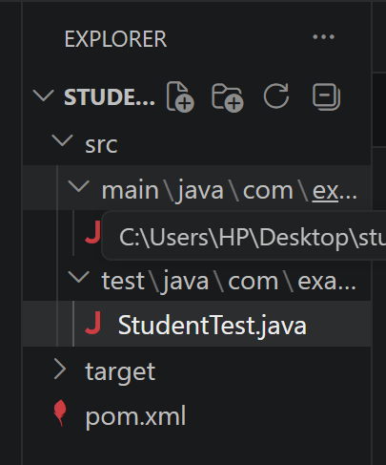

STUDENTAPP.JAVA
package com.example;

import java.util.*;

class Student {
String name;
int cat, assignment, fat;
int total;
double gpa;
String grade;

Student(String name, int cat, int assignment, int fat) {
this.name = name;
this.cat = cat;
this.assignment = assignment;
this.fat = fat;
calculate();
}

void calculate() {
total = cat + assignment + fat;
gpa = total / 10.0;

if (total >= 90) grade = "A";
else if (total >= 75) grade = "B";
else if (total >= 60) grade = "C";
else grade = "D";
}
}

public class StudentApp {

public static Student findTopper(List<Student> students) {
return Collections.max(students, Comparator.comparingInt(s -> s.total));
}

public static void main(String[] args) {
Scanner sc = new Scanner(System.in);
List<Student> students = new ArrayList<>();

for (int i = 0; i < 5; i++) {
System.out.println("\nEnter details for Student " + (i + 1));

System.out.print("Name: ");
String name = sc.next();

System.out.print("CAT (30): ");
int cat = sc.nextInt();

System.out.print("Assignment (20): ");
int assignment = sc.nextInt();

System.out.print("FAT (50): ");
int fat = sc.nextInt();

students.add(new Student(name, cat, assignment, fat));
}

Student topper = findTopper(students);

System.out.println("\n===== STUDENT RESULTS =====");
for (Student s : students) {
System.out.println(
s.name + " | Total: " + s.total +
" | GPA: " + s.gpa +
" | Grade: " + s.grade
);
}

System.out.println("\n Topper: " + topper.name + " (" + topper.total + ")");
}
}

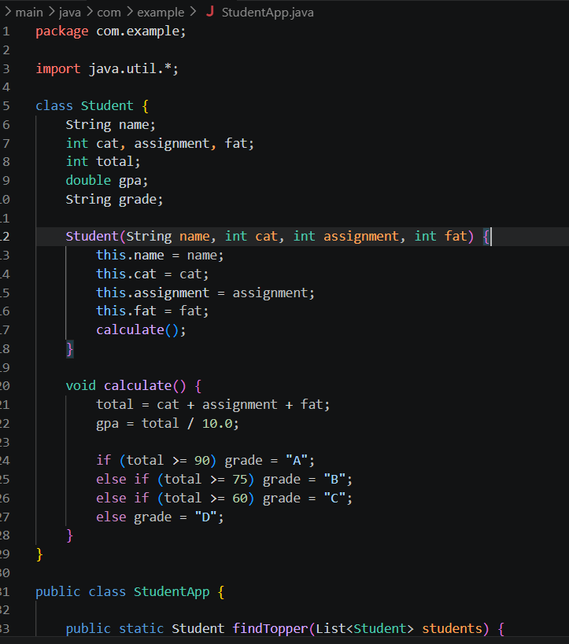
STUDENTTEST.JAVA
package com.example;

import org.junit.Test;
import static org.junit.Assert.*;
import java.util.*;

public class StudentTest {

@Test
public void testTopperCalculation() {
List<Student> students = new ArrayList<>();

students.add(new Student("A", 25, 15, 40)); // 80
students.add(new Student("B", 30, 20, 50)); // 100
students.add(new Student("C", 20, 10, 30)); // 60

Student topper = StudentApp.findTopper(students);

assertEquals("B", topper.name);
}
}

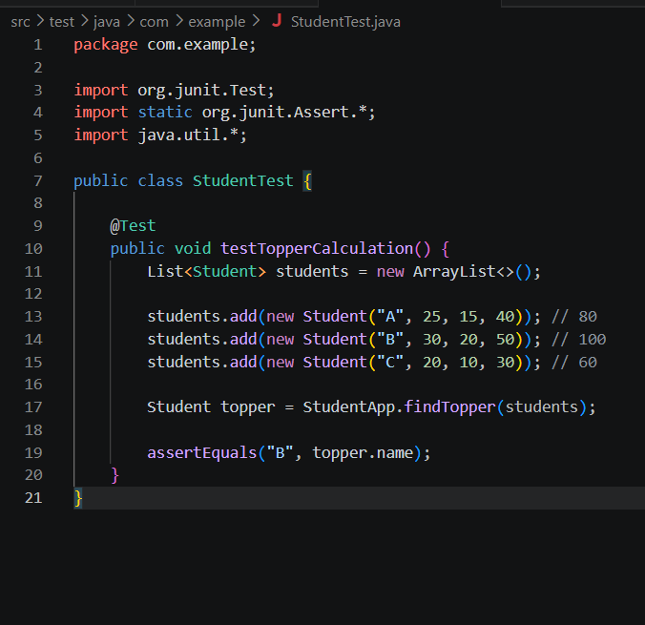

POM.XML
<project xmlns="http://maven.apache.org/POM/4.0.0"
xmlns:xsi="http://www.w3.org/2001/XMLSchema-instance"
xsi:schemaLocation="http://maven.apache.org/POM/4.0.0
http://maven.apache.org/xsd/maven-4.0.0.xsd">

<modelVersion>4.0.0</modelVersion>

<groupId>com.example</groupId>
<artifactId>student-performance-system</artifactId>
<version>1.0-SNAPSHOT</version>

<dependencies>
<!-- JUnit for testing -->
<dependency>
<groupId>junit</groupId>
<artifactId>junit</artifactId>
<version>4.13.2</version>
<scope>test</scope>
</dependency>
</dependencies>

<build>
<plugins>
<!-- Compiler Plugin -->
<plugin>
<groupId>org.apache.maven.plugins</groupId>
<artifactId>maven-compiler-plugin</artifactId>
<version>3.8.1</version>
<configuration>
<source>1.8</source>
<target>1.8</target>
</configuration>
</plugin>
</plugins>
</build>

</project>

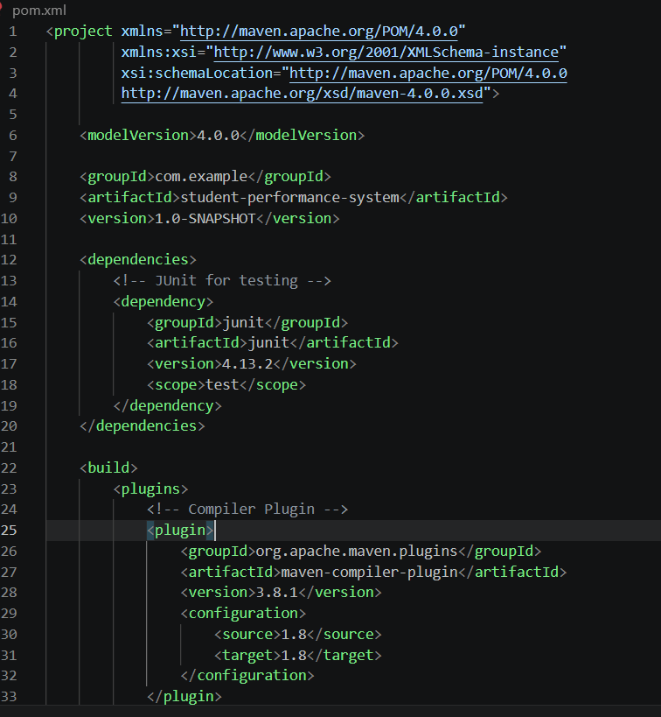

MVN CLEAN PACKAGE

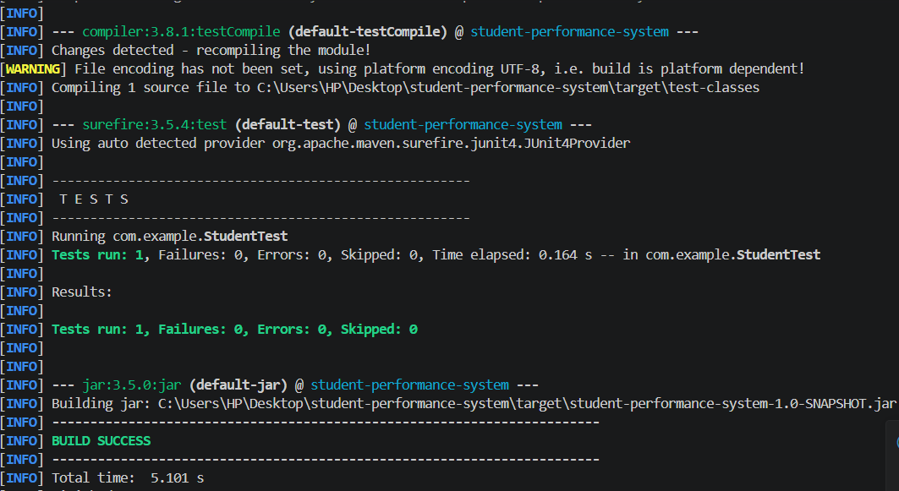

Git comments:
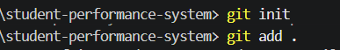

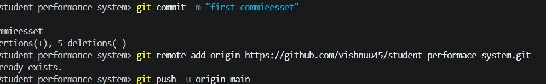

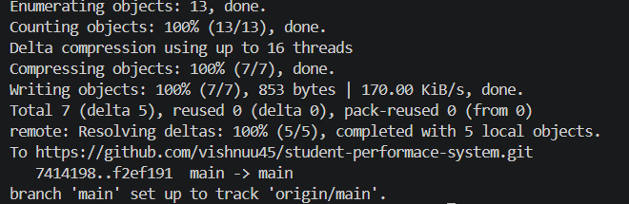

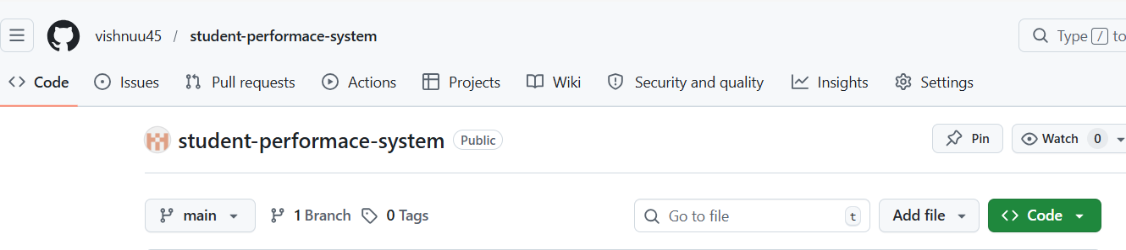

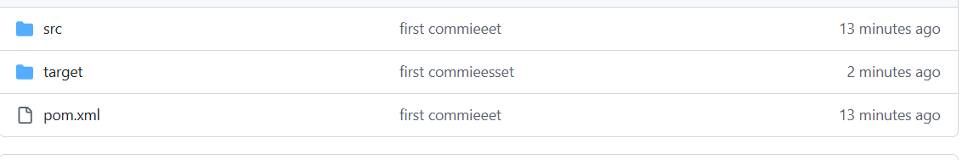

Piple script:

pipeline {
agent any

tools {
maven 'Maven3'
}

stages {

stage('Clean Workspace') {
steps {
deleteDir()
}
}

stage('Clone Repository') {
steps {
git branch: 'main',
url: 'https://github.com/vishnuu45/student-performace-system.git',
credentialsId: 'github-cred'
}
}

stage('Build Project') {
steps {
bat 'mvn clean package'
}
}

stage('Run Tests') {
steps {
bat 'mvn test'
}
}

stage('Archive JAR') {
steps {
archiveArtifacts artifacts: 'target/*.jar', fingerprint: true
}
}

stage('Success Message') {
steps {
echo 'CI/CD Pipeline Executed Successfully!'
}
}
}

post {
success {
echo 'Build SUCCESS'
}
failure {
echo 'Build FAILED'
}
}
}

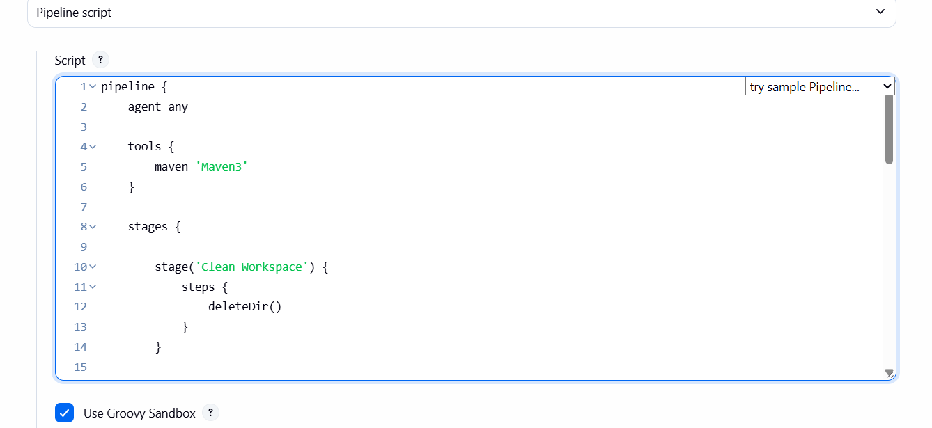

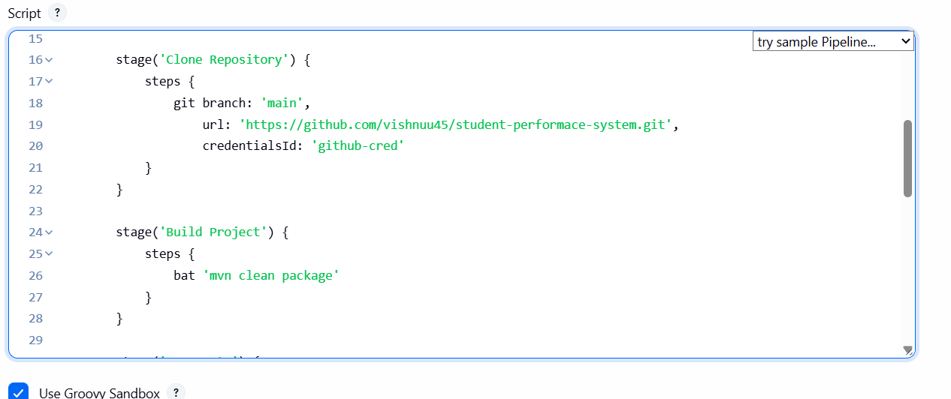

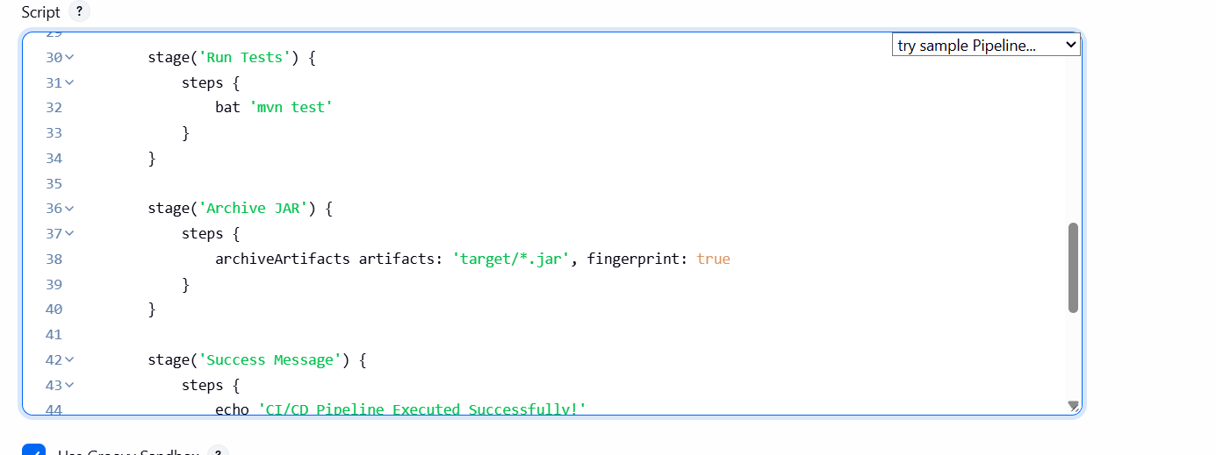

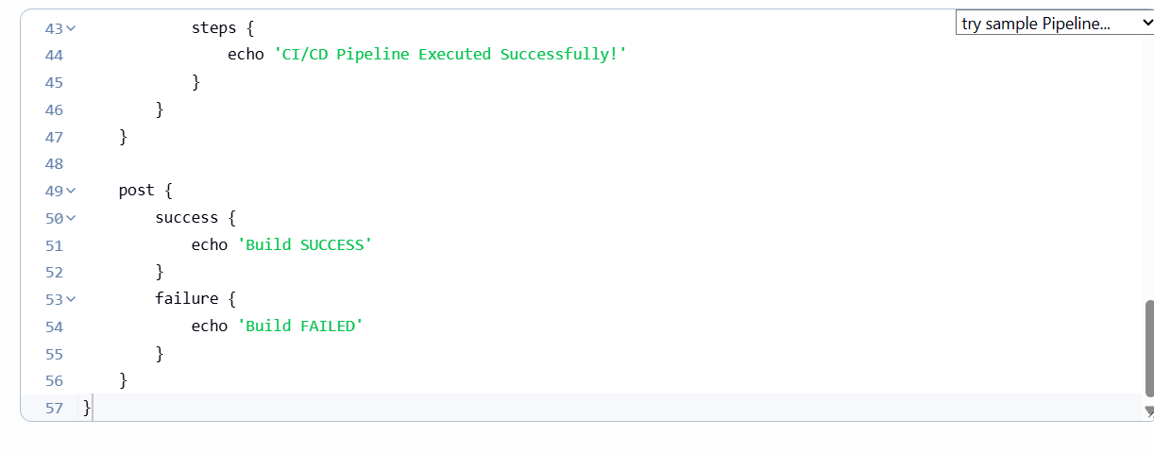

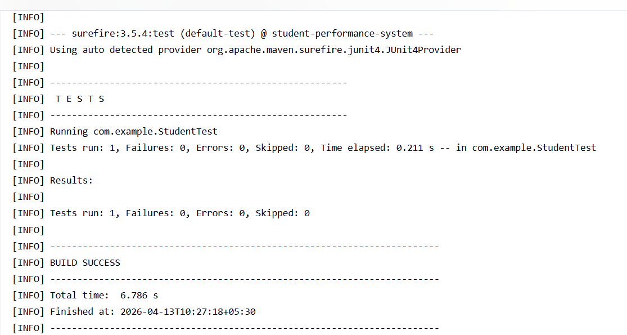

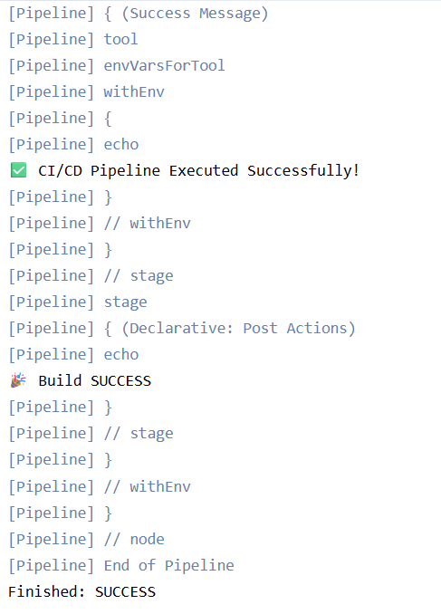

Pipeline overview:
