**MENTAL HEALTH SUPPORT**

**ABSTRACT**

Providing effective mental health support is essential for promoting overall well-being and addressing the complex challenges individuals face in today's society. This abstract explores the significance of mental health support systems, emphasizing the need for accessible and comprehensive interventions. Acknowledging the interconnectedness of mental health with various aspects of life, the abstract highlights the importance of destigmatizing mental health issues and fostering a supportive environment. Additionally, the abstract discusses the role of diverse therapeutic approaches, including counseling, psychotherapy, and community-based initiatives, in addressing the spectrum of mental health concerns.

Furthermore, it emphasizes the integration of technology and digital platforms to increase the reach and efficiency of mental health support services. Ultimately, the abstract underscores the urgency of prioritizing mental health on a global scale to enhance the overall quality of life and contribute to a healthier, more resilient society.

**Software Requirement Specification**

**Required Hardware**

* AMD Ryzen Processor.
* 512 MB RAM.
* 20 GB Hard Disk space.

**Required Software**

* Chrome.
* HTML.
* CSS.

**Data Flow Diagrams**

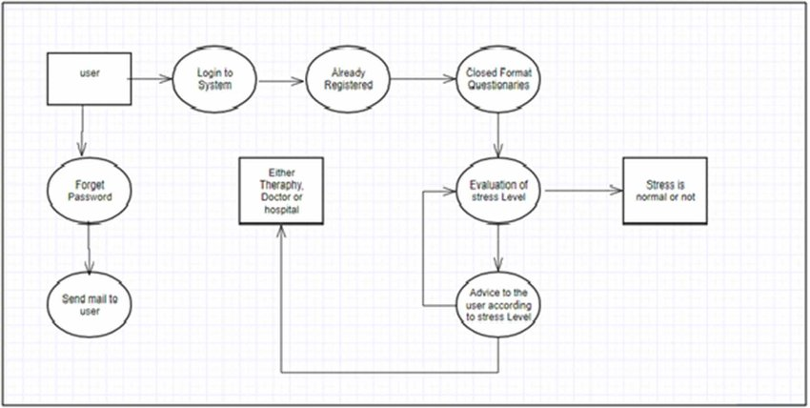

**ER-Diagrams**

The entity Relationship Diagram (ERD) depicts the relationship between the data objects. The ERD is the notation that is used to conduct the date modeling activity the attributes of each data object noted is the ERD can be described resign a data object descriptions.

The set of primary components that are identified by the ERD are

* Data object
* Relationships
* Attributes
* Various types of indicators.

The primary purpose of the ERD is to represent data objects and their relationships.

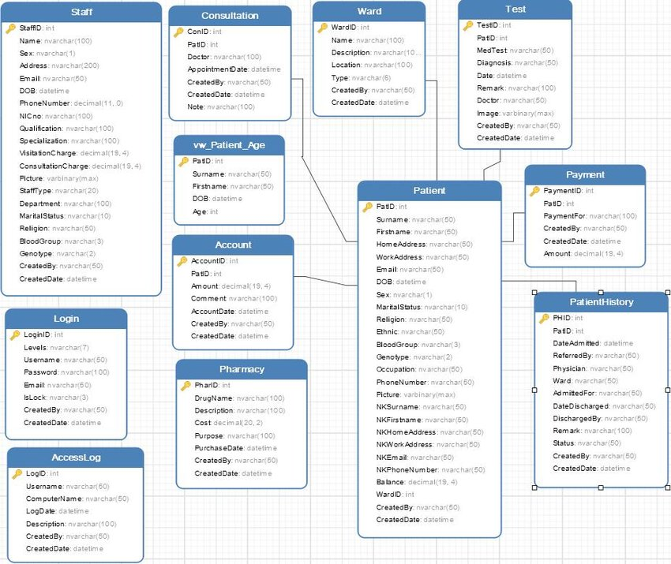

**ADVANTAGES AND DISADVANTAGES**

**Advantages:**

Mental health apps provide immediate and accessible support, allowing users to access resources and tools from the convenience of their smartphone or other devices. This is especially valuable for individuals who may face barriers to seeking traditional in-person support.

**Disadvantages:**

The process usually requires a patient identity which the system can detect. It requires a reliable internet connection. The quality of content in mental health application can vary. Users should approach these application with a critical mindset, seeking those that align with their needs and preferences while remaining aware of their limitations.

**TEMPLATE**

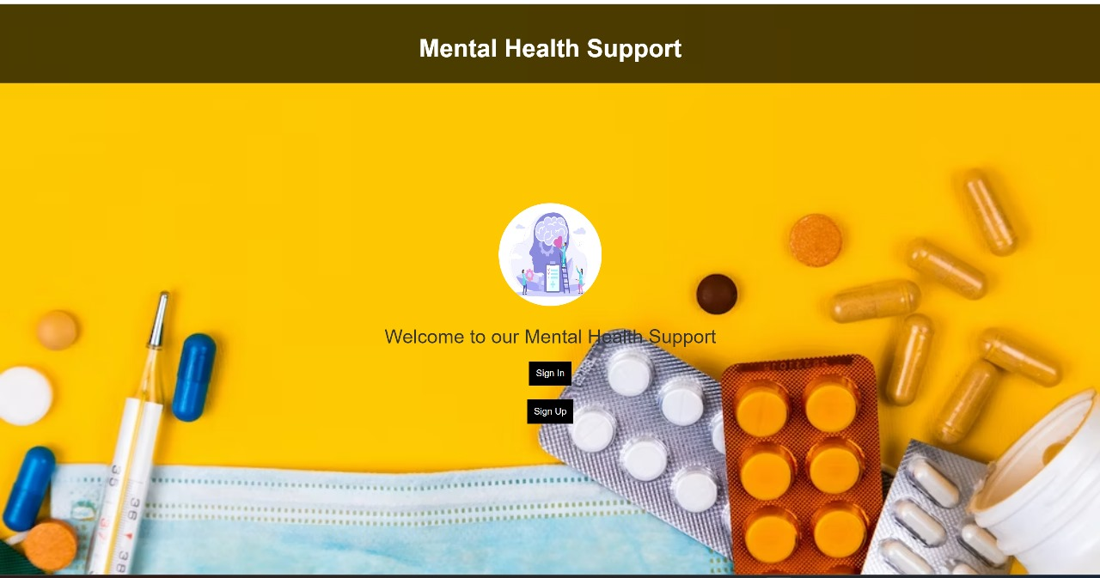

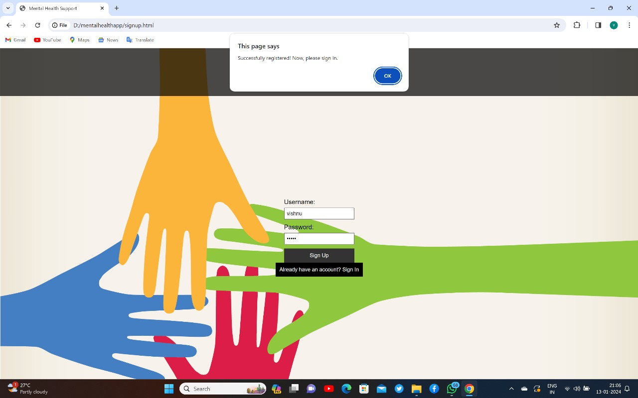

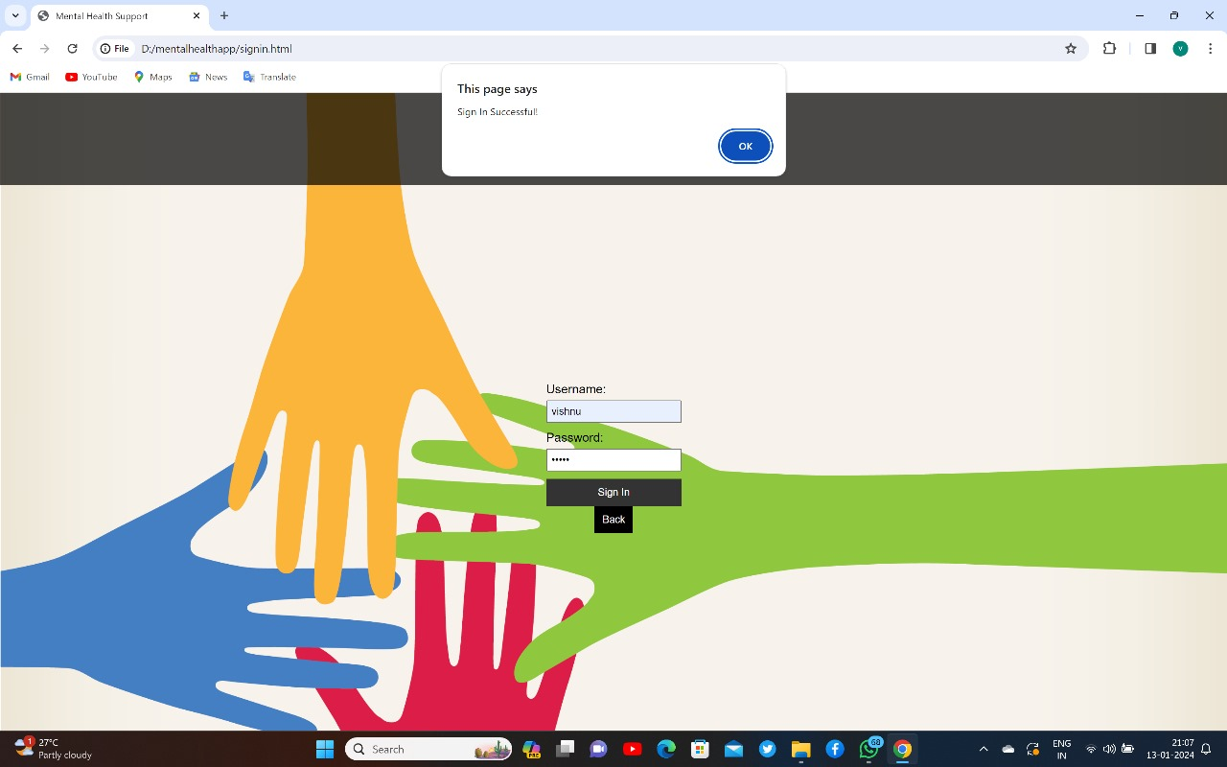

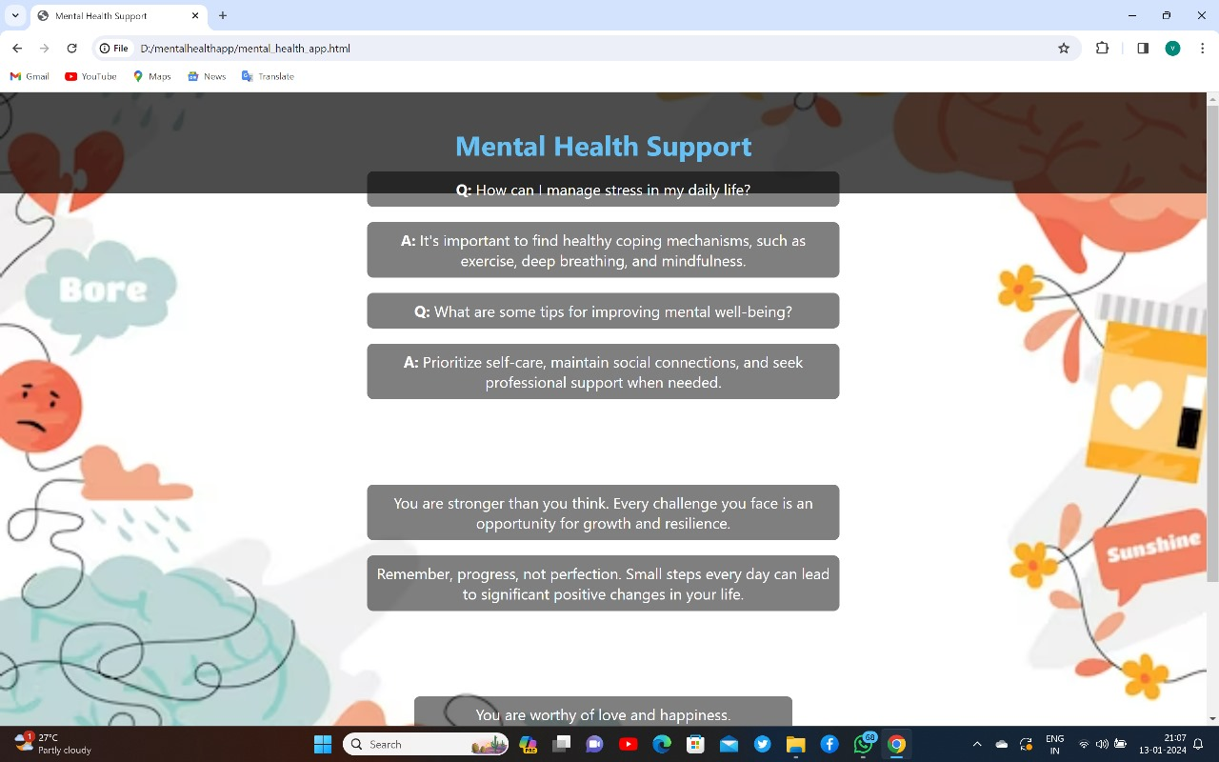

**CONCLUSION**

**MENTAL HEALTH SUPPORT**  Our mental health support application is designed to be user-friendly with sign-in, sign-up, and login pages to ensure a personalized experience. Through these features, users can access a variety of helpful resources and suggestions tailored to their needs. By creating a secure and easy-to-navigate platform, we aim to provide individuals with a supportive environment where they can find valuable tools to enhance their mental well-being. Together, let’s make mental health support accessible and approachable for everyone.

**REFERENCES**

* <https://www.google.com/>
* <https://www.w3schools.com/html/>
* <https://www.w3schools.com/css/>
* <https://www.wikipedia.org/>