UI Demo

<https://storeforecasterstoreforecaster-iiai0e.streamlit.app/>

I have a link to an API that is hosted on the Stream lit framework. This API can provide you with sales forecasts for individual stores or multiple stores for a specified time period. You can adjust the forecast period using a scroll bar, and you can select either a single store or multiple stores using a drop-down menu.

The user interface displays an option called "Export Forecast", which allows the user to download the results of the forecast for individual sales

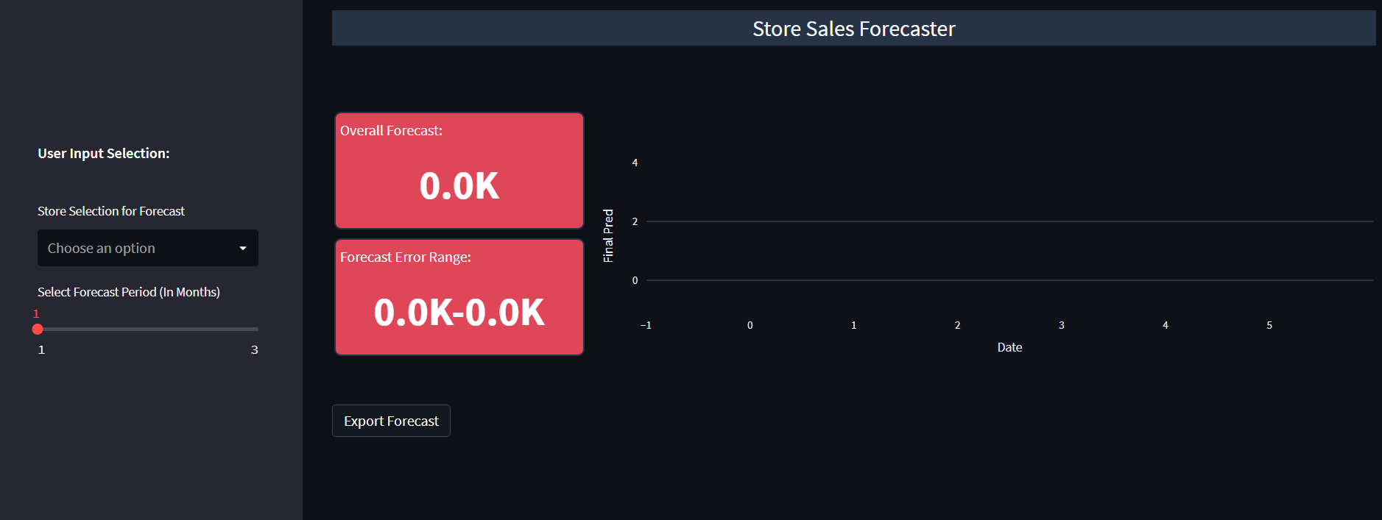

Here is the downloaded forecast files snipper which contains store wise forecast sales.

