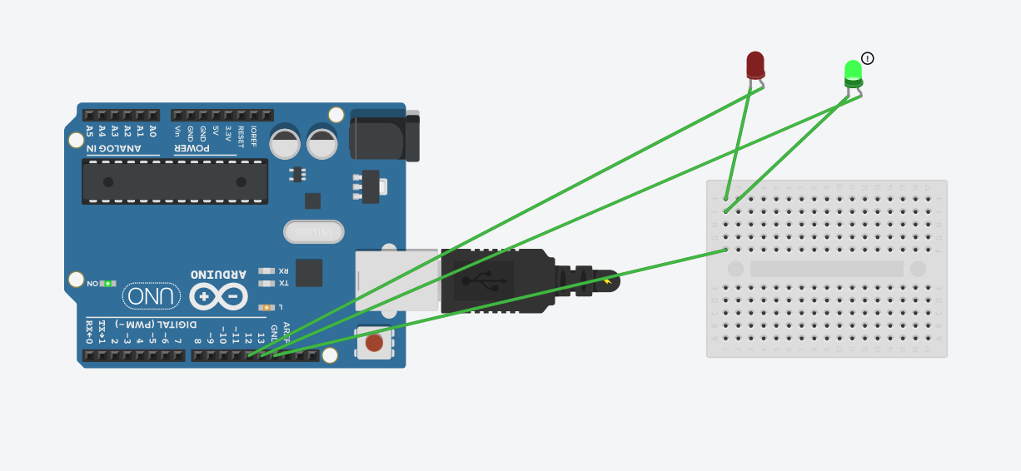

The red light will flash for the 60 times in one minute =60/60=1 sec

That means it will flash at an interval of 1 sec each time=1 sec, 2 sec, 3 sec, 4 sec ,5 sec, 6 sec and so on (multiples of 1)

Similarly the green light will flash for the first time in two minutes=120/240= 1/2 sec

That means it will flash at an interval of 1/2 sec each time = 1/2 sec, 1 sec and so on (multiples of 1/2)