**Data Flow Diagram Level 0**

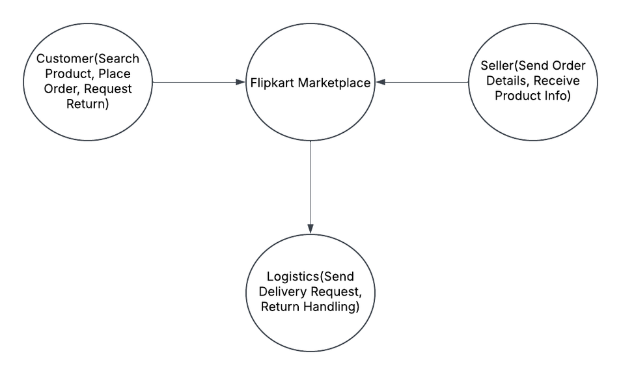

**Data Flow Diagram Level 1**

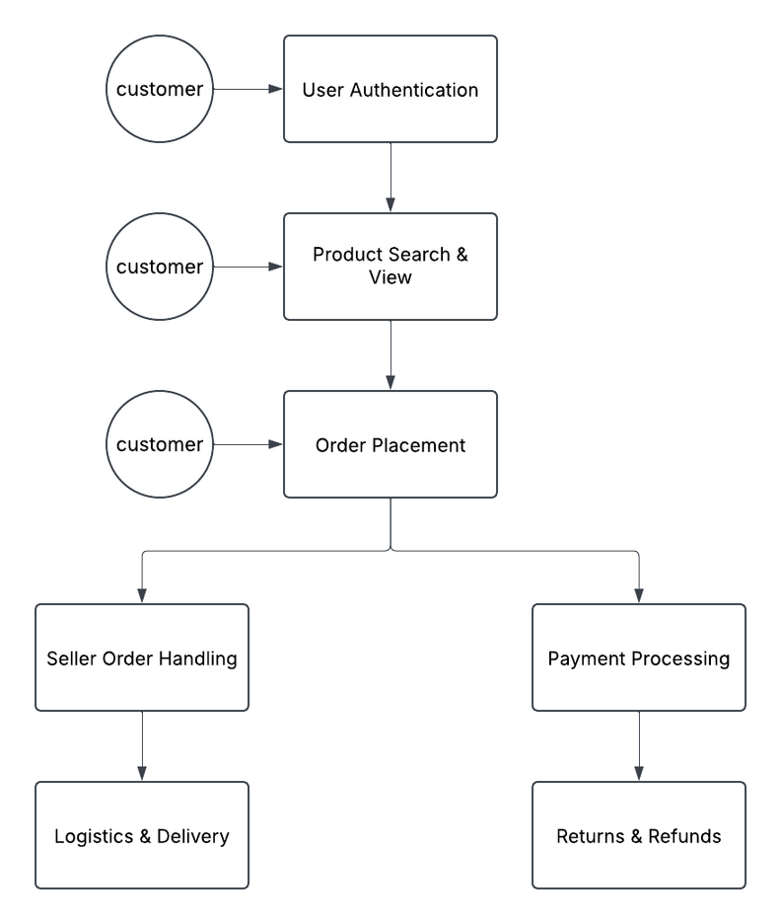

**Data Flow Diagram Level 2**

