**DISTRIBUTED COMPONENTS LAB**

**CA 2 – SET 3**

**Aim:**

To calculate EB Bill for the given number of units using Beans in Java.

**Algorithm:**

**Step 1:** Start

**Step 2:** Create a JAVA Class Library

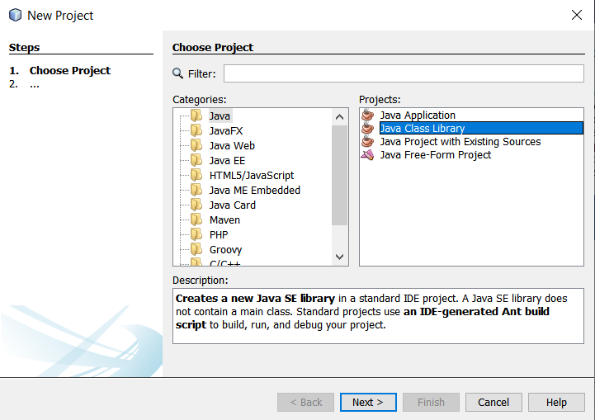

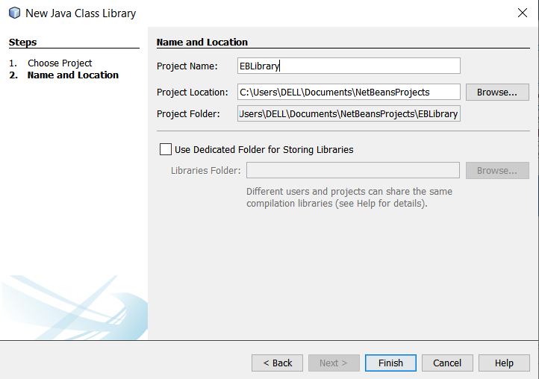

**Step 3:** Create a JAVA EE Enterprise Application.

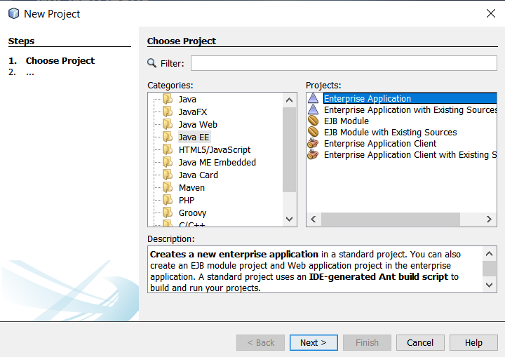

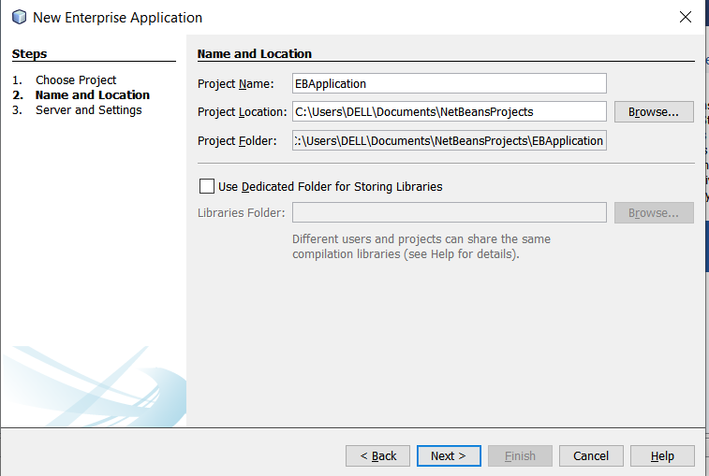

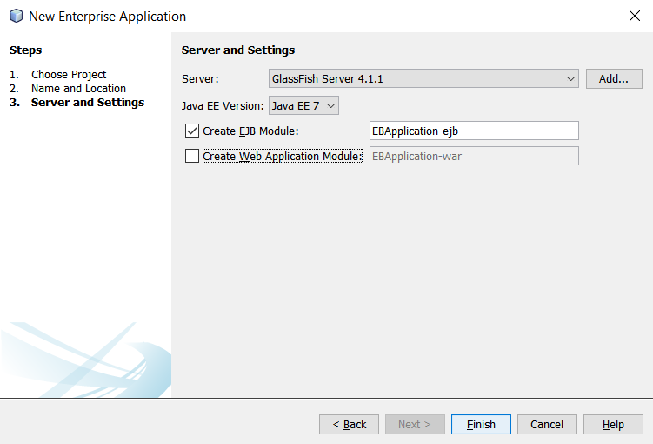

**Step 4:** Create a new Session Bean for the Application created.

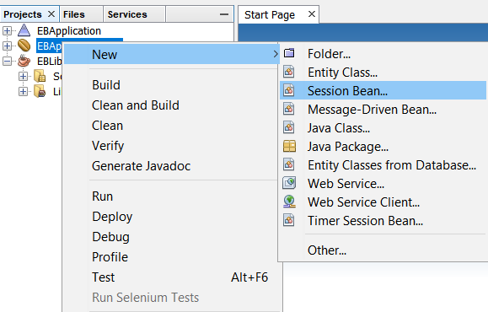

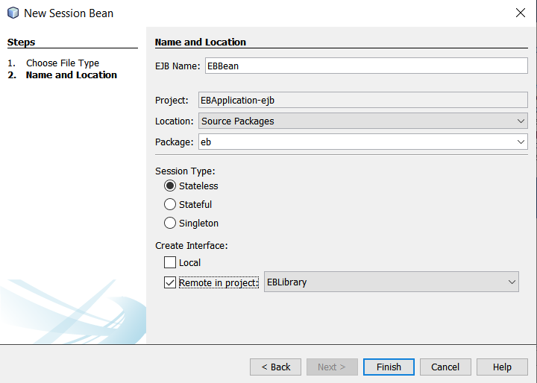

**Step 5:** Add the required Business Methods and deploy.

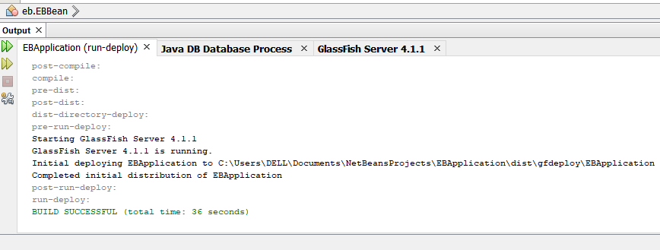

**Step 6:** Create a JAVA EE Enterprise Application Client and add the bean.

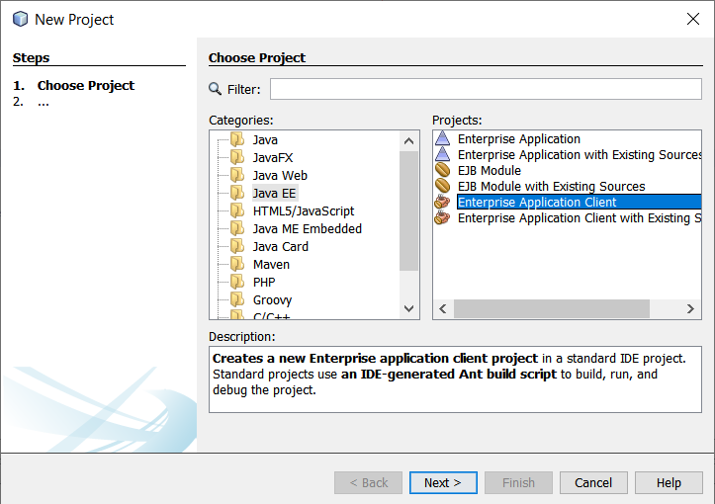

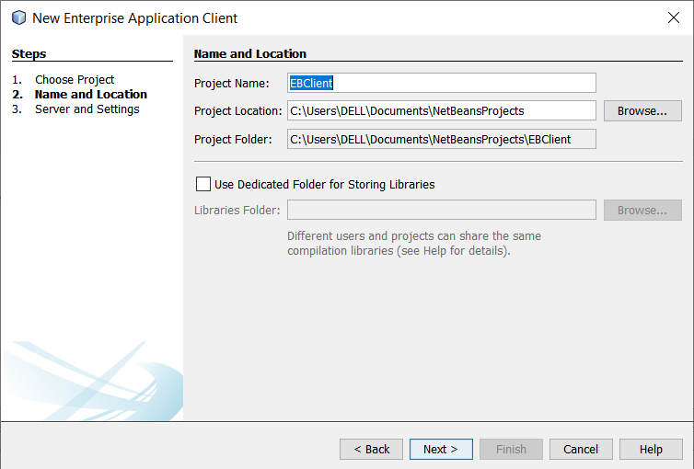

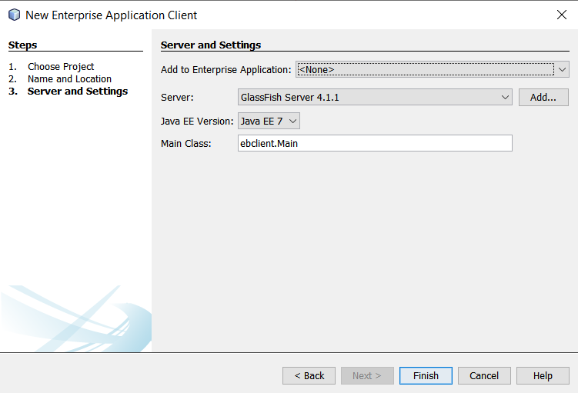

**Step 7:** Use the functions of the bean to complete the application.

**Step 8:** Stop

**Program:**

**EBBean.java:**

/*

 * To change this license header, choose License Headers in Project Properties.

 * To change this template file, choose Tools | Templates

 * and open the template in the editor.

 */

package eb;

import javax.ejb.Stateless;

/**

 *

 * @author DELL

 */

@Stateless

public class EBBean implements EBBeanRemote {

    @Override

    public int calculate(int units) {

        if (units<=100) {

            return units*50;

        }

        else if (units<=200) {

            return (100*50)+(units-100)*100;

        }

        else if (units<=300) {

            return (100*50)+(100*100)+(units - 200)*200;

        }

        else if (units>300) {

            return (100*50)+(100*100)+(100*200)+(units-300)*300;

        }

        return 0;

    }

    // Add business logic below. (Right-click in editor and choose

    // "Insert Code > Add Business Method")

}

**EBClient.java:**

/*

 * To change this license header, choose License Headers in Project Properties.

 * To change this template file, choose Tools | Templates

 * and open the template in the editor.

 */

package ebclient;

import eb.EBBeanRemote;

import javax.ejb.EJB;

import java.util.*;

/**

 *

 * @author DELL

 */

public class Main {

    @EJB

    private static EBBeanRemote eBBean;

    /**

     * @param args the command line arguments

     */

    public static void main(String[] args) {

        // TODO code application logic here

        Scanner sc = new Scanner(System.in);

        while(true) {

            System.out.println("Enter the number of units: ");

            int units = sc.nextInt();

            int amount = eBBean.calculate(units);

            System.out.println("The amount is: " + amount);

        }

    }

}

**Output:**

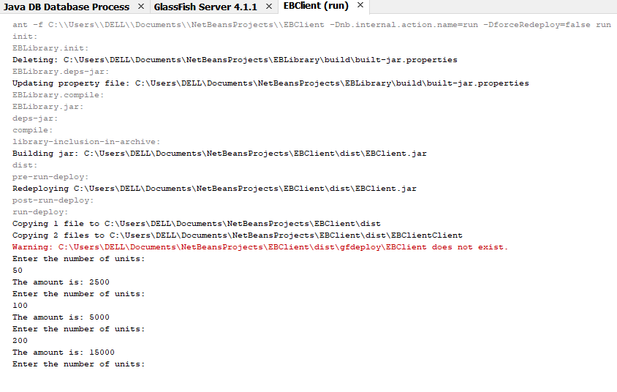

**Result:**

The Electricity calculation application is successfully implemented using Java Beans.