**DISTRIBUTED COMPONENTS LAB**

**EXERCISE 4**

**JAVA BEAN**

**Aim:**

To create Java Session Beans and implement the logic using the same for the given application.

**Algorithm:**

**Step 1:** Start

**Step 2:** Create Java Class Library

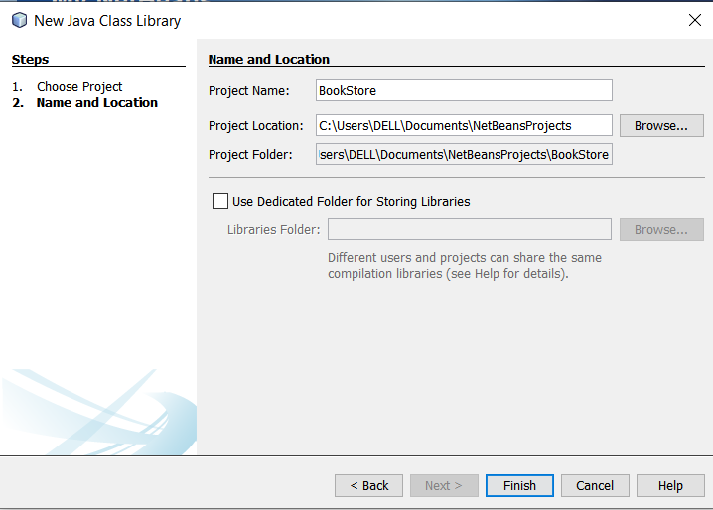

**Step 3:** Create Enterprise Application

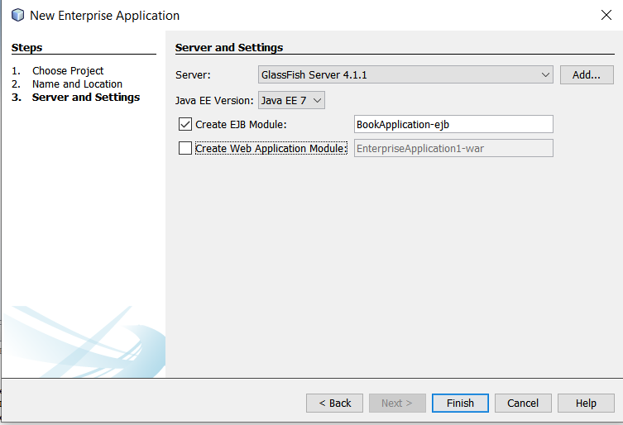

**Step 4:** Add the necessary beans

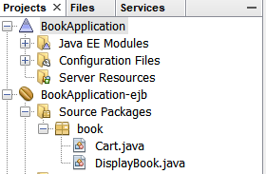

**Step 5:** Deploy the beans

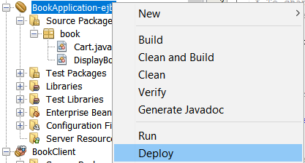

**Step 6:** Create the Client

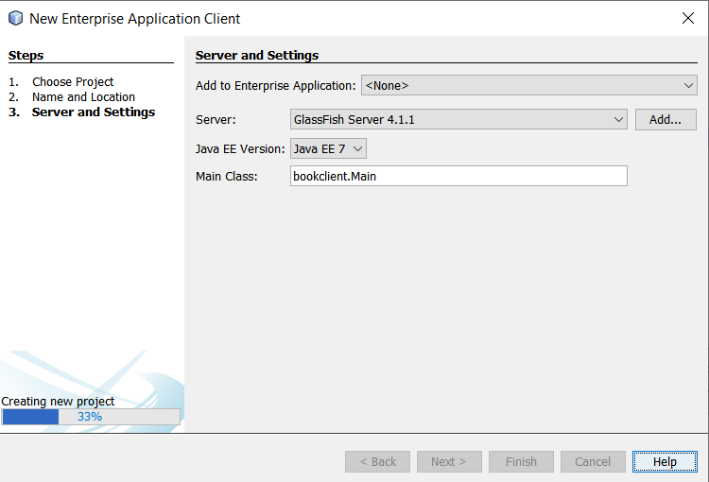

**Step 7**: Use the beans to implement the application

**Step 8:** Stop

**CODE:**

**DISPLAYBOOK.JAVA:**

/*

 * To change this license header, choose License Headers in Project Properties.

 * To change this template file, choose Tools | Templates

 * and open the template in the editor.

 */

package book;

import javax.ejb.Stateless;

import java.util.*;

/**

 *

 * @author DELL

 */

@Stateless

public class DisplayBook implements DisplayBookRemote {

    HashMap<String,Integer> books = new HashMap<>();

    public DisplayBook() {

        books.put("Java",100);

        books.put("Cpp",1000);

        books.put("Blockchain", 1999);

        books.put("DCL",1022);

        books.put("Interview",1243);

        books.put("Python",1320);

    }

    @Override

    public String bookDetails(String book) {

        if(books.containsKey(book)) {

            return Integer.toString(books.get(book));

        }

        else {

            return "No book found!";

        }

    }

    // Add business logic below. (Right-click in editor and choose

    // "Insert Code > Add Business Method")

}

**CART.JAVA:**

/*

 * To change this license header, choose License Headers in Project Properties.

 * To change this template file, choose Tools | Templates

 * and open the template in the editor.

 */

package book;

import javax.ejb.Stateless;

import java.util.*;

/**

 *

 * @author DELL

 */

class CreditCard {

    String sixteen;

    String cvv;

    String expiry;

    String name;

    CreditCard(String sixteen,String cvv,String expiry,String name) {

        this.sixteen = sixteen;

        this.cvv = cvv;

        this.expiry = expiry;

        this.name = name;

    }

}

@Stateless

public class Cart implements CartRemote {

    HashMap<String,Integer> books = new HashMap<>();

    ArrayList<CreditCard> cards = new ArrayList<>();

    ArrayList<String> cart = new ArrayList<>();

    public Cart() {

        books.put("Java",100);

        books.put("Cpp",1000);

        books.put("Blockchain", 1999);

        books.put("DCL",1022);

        books.put("Interview",1243);

        books.put("Python",1320);

        cards.add(new CreditCard("12345","123","1/2/2020","vishnu"));

        cards.add(new CreditCard("12347","124","1/3/2020","sishnu"));

        cards.add(new CreditCard("12349","126","1/4/2020","gishnu"));

        cards.add(new CreditCard("12348","127","1/5/2020","hishnu"));

        cards.add(new CreditCard("12346","128","1/6/2020","wishnu"));

    }

    @Override

    public String addToCard(String book) {

        cart.add(book);

        return "Added";

    }

    // Add business logic below. (Right-click in editor and choose

    // "Insert Code > Add Business Method")

    @Override

    public String removeFromCart(String book) {

        cart.remove(book);

        return "Removed!";

    }

    @Override

    public int bill() {

        int amount = 0;

        for(int i=0;i<cart.size();i++) {

            amount += books.get(cart.get(i));

        }

        return amount;

    }

    @Override

    public String payment() {

        return null;

    }

    @Override

    public String pay(String number, String cvv, String date, String name) {

        int flag = 0;

        for(int i=0;i<cards.size();i++) {

            if(cards.get(i).sixteen.equals(number) &&

               cards.get(i).cvv.equals(cvv) &&

               cards.get(i).expiry.equals(date) &&

               cards.get(i).name.equals(name)) {

                flag = 1;

                break;

            }

        }

        if(flag==1) {

            cart.clear();

            return "Successfully Completed!";

        }

        return "Payment details not found!";

    }

}

**CLIENT SIDE MAIN.JAVA:**

package bookclient;

import book.CartRemote;

import book.DisplayBookRemote;

import java.util.*;

import javax.ejb.EJB;

/**

 *

 * @author DELL

 */

public class Main {

    @EJB

    private static DisplayBookRemote displayBook;

    @EJB

    private static CartRemote cart;

    /**

     * @param args the command line arguments

     */

    public static void main(String[] args) {

        // TODO code application logic here

        Scanner sc = new Scanner(System.in);

        String book,output;

        while(true) {

            System.out.println("Enter your choice: \n1. Search book\n2. Add to cart\n3. Remove from cart\n4. Bill\n5. Pay");

            int choice = sc.nextInt();

            switch(choice) {

                    case 1:

                        System.out.println("Enter book name: ");

                        book = sc.next();

                        output = displayBook.bookDetails(book);

                        System.out.println("Book found: " + book + ": " + output);

                        break;

                    case 2:

                        System.out.println("Enter book name: ");

                        book = sc.next();

                        output = cart.addToCard(book);

                        System.out.println(output);

                        break;

                    case 3:

                        System.out.println("Enter book name: ");

                        book = sc.next();

                        output = cart.removeFromCart(book);

                        System.out.println(output);

                        break;

                    case 4:

                        System.out.println("The biil is: " + cart.bill());

                        break;

                    case 5:

                        String number = sc.next();

                        String cvv = sc.next();

                        String expiry = sc.next();

                        String name = sc.next();

                        output = cart.pay(number, cvv, expiry, name);

                        System.out.println(output);

                        break;

                    default:

                        break; }}}}

**OUTPUT:**

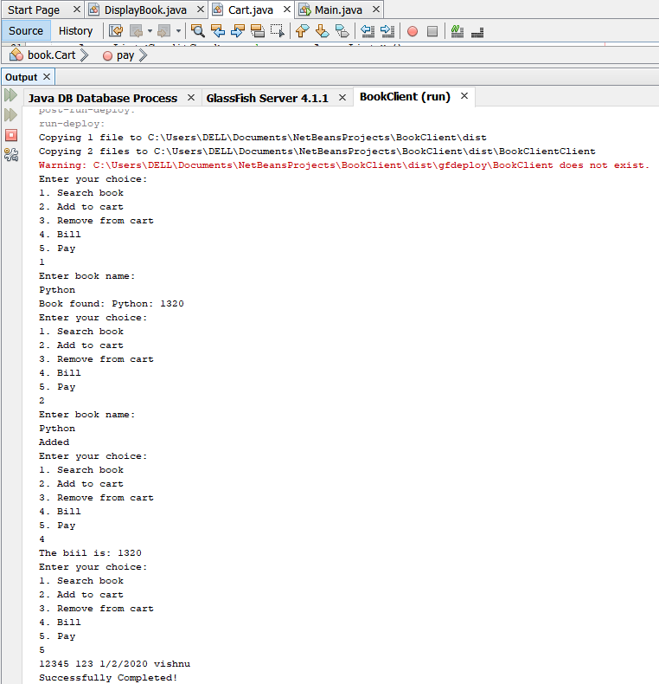

**RESULT:**

The above given application is successfully implemented using Java Beans.