SIMATS ENGINEERING
ASSESSMENT TOOL 1
COURSE NAME: INTERNET PROGRAMMING
COURSE CODE: CSA4305
COURSE OUTCOME COVERED
CO-1: Develop well-structured, standards-compliant web pages using HTML/XHTML and XML, and apply Internet protocols and HTTP communication mechanisms for web content delivery. (L2)
Assessment Tool: Application-Based Questions
Weightage: 40%
QUESTIONS: Total Marks: 30
1: Online Symposium Portal
A college is developing an online symposium registration portal. The following HTML structure and HTTP interaction is observed:
<form action="/register" method="POST">
<input type="text" name="name">
<input type="email" name="email">
<button>Submit</button>
</form>
When a student submits the form, the browser sends an HTTP request to the server, and the server responds accordingly.
Questions:
1. Identify appropriate HTML5 semantic elements missing in the structure. 2. Modify the structure to make it standards-compliant.
3. Interpret the HTTP request generated during form submission.
4. Analyze the HTTP response cycle from server to browser.
5. Suggest improvements for usability and accessibility.
2: Cross-Browser Compatibility Issue
A company website shows inconsistent layout across browsers. The following HTML snippet is used:
<html>
<head>
<title>Company</title>
</head>
<body>
<div>
<h1>Welcome
<p>About us
</div>
</body>
</html>
Questions:
1. Identify improper nesting and missing closing tags.
2. Analyze how different browsers may interpret this structure.
3. Identify missing semantic elements (e.g., header, section).
4. Provide a corrected W3C-compliant HTML structure.
5. Suggest techniques to ensure cross-browser compatibility.
3: Form Submission Failure
A web application fails to send form data to the server. The following configuration is observed:
<form action="/submit" method="GET">
<input type="text" name="username">
<input type="password" name="password">
<button type="button">Login</button>
</form>
Questions:
1. Identify issues in the form configuration.
2. Analyze why the HTTP request is not triggered.
3. Interpret the role of GET method in this scenario.
4. Propose a corrected implementation.
5. Suggest improvements for secure data transmission.

Code of Conduct:
- I _____B VishnuVardhan (192311267)__________ (Name / Reg No) certify that this submission is my original work and that I have adhered to the guidelines specified for this assessment. I understand that any violation of academic integrity rules will result in disciplinary action.
Signature of the student: vishnuvardhan

RUBRICS FOR CALCULATION:
Criteria | Weig  htage | Level 4 –  Exemplary | Level 3 –  Proficient | Level 2 –  Developing | Level 1 –  Beginning
Understanding of Concepts | 25% | Demonstrates  thorough, accurate understanding of  concepts | Good  understanding with minor gaps | Basic  understanding with some  misconception s | Poor  understandin g; major  misconceptio ns
Explanation | 25% | Detailed, well  explained answers with relevant  examples | Clear  explanation with adequate  details | Limited  explanation;  lacks depth | Poor or  unclear  explanation
Application | 20% | Effectively applies concepts with strong analytical ability | Applies  concepts with minor errors | Limited  application  with weak  analysis | No  application or incorrect  analysis
Organization | 15% | Well-structured  answers with logical flow and coherence | Organized with minor issues in flow | Basic  structure,  lacks clarity | Poor  organization, incoherent  answers
Accuracy | 10% | Completely accurate and covers all  required points | Mostly accurate with minor  omissions | Partially  correct with  missing points | Incorrect  answers with major gaps
Clarity | 5% | Clear, neat,  professional  presentation | Understandable with minor  issues | Limited clarity, readability  issues | Poorly  written,  difficult to  understand

1. Online Symposium Portal

1. Identify appropriate HTML5 semantic elements missing
The form should be placed inside semantic HTML5 elements such as:
- <header>
- <main>
- <section>
- <form>
- <label>
- <footer> (optional)

2. Standards-compliant HTML structure

<!DOCTYPE html>
<html lang="en">
<head>
<meta charset="UTF-8">
<meta name="viewport" content="width=device-width, initial-scale=1.0">
<title>Symposium Registration</title>
</head>
<body>
<header>
<h1>Online Symposium Registration</h1>
</header>
<main>
<section>
<form action="/register" method="POST">
<label for="name">Name:</label>
<input type="text" id="name" name="name" required>
<label for="email">Email:</label>
<input type="email" id="email" name="email" required>
<button type="submit">Submit</button>
</form>
</section>
</main>
<footer>
<p>&copy; 2026 College Symposium</p>
</footer>
</body>
</html>
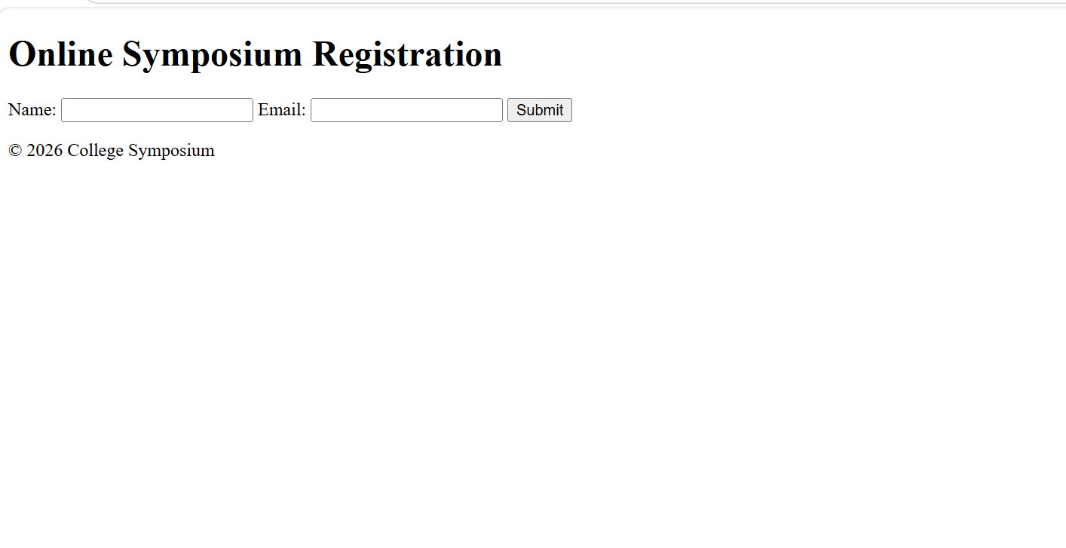

3. HTTP request generated during form submission
When the user clicks Submit, the browser sends an HTTP POST request.
Example:
POST /register HTTP/1.1
Host: www.college.edu
Content-Type: application/x-www-form-urlencoded
name=John&email=john@example.com
POST → Sends data to the server.
/register → Server endpoint.
Body → Contains form data.

4. HTTP response cycle
User fills the form.
Browser sends POST request.
Server receives and validates data.
Server stores registration information.
Server returns an HTTP response.
Example:
HTTP/1.1 200 OK
Content-Type: text/html
Browser displays:
Registration Successful
If validation fails:
HTTP/1.1 400 Bad Request

5. Improvements for usability and accessibility
Use <label> for every input.
Add required attribute.
Use meaningful placeholder text.
Add client-side validation.
Use HTTPS.
Display success/error messages.
Ensure keyboard navigation.
Provide ARIA attributes where necessary.

2. Cross-Browser Compatibility Issue

1. Improper nesting and missing closing tags
Problems:
- Missing </h1>
- Missing </p>
- Missing </div>
- Improper nesting
- No <!DOCTYPE html>
- Missing <meta charset> and viewport.

2. Browser interpretation
Different browsers automatically try to fix invalid HTML.
Possible effects:
- Different spacing
- Different font sizes
- Broken layout
- Unexpected rendering
- Inconsistent DOM structure

3. Missing semantic elements
Should include:
- <header>
- <main>
- <section>
4. Correct W3C-compliant HTML
<!DOCTYPE html>
<html lang="en">
<head>
<meta charset="UTF-8">
<meta name="viewport" content="width=device-width, initial-scale=1.0">
<title>Company</title>
</head>
<body>
<header>
<h1>Welcome</h1>
</header>
<main>
<section>
<p>About us</p>
</section>
</main>
</body>
</html>
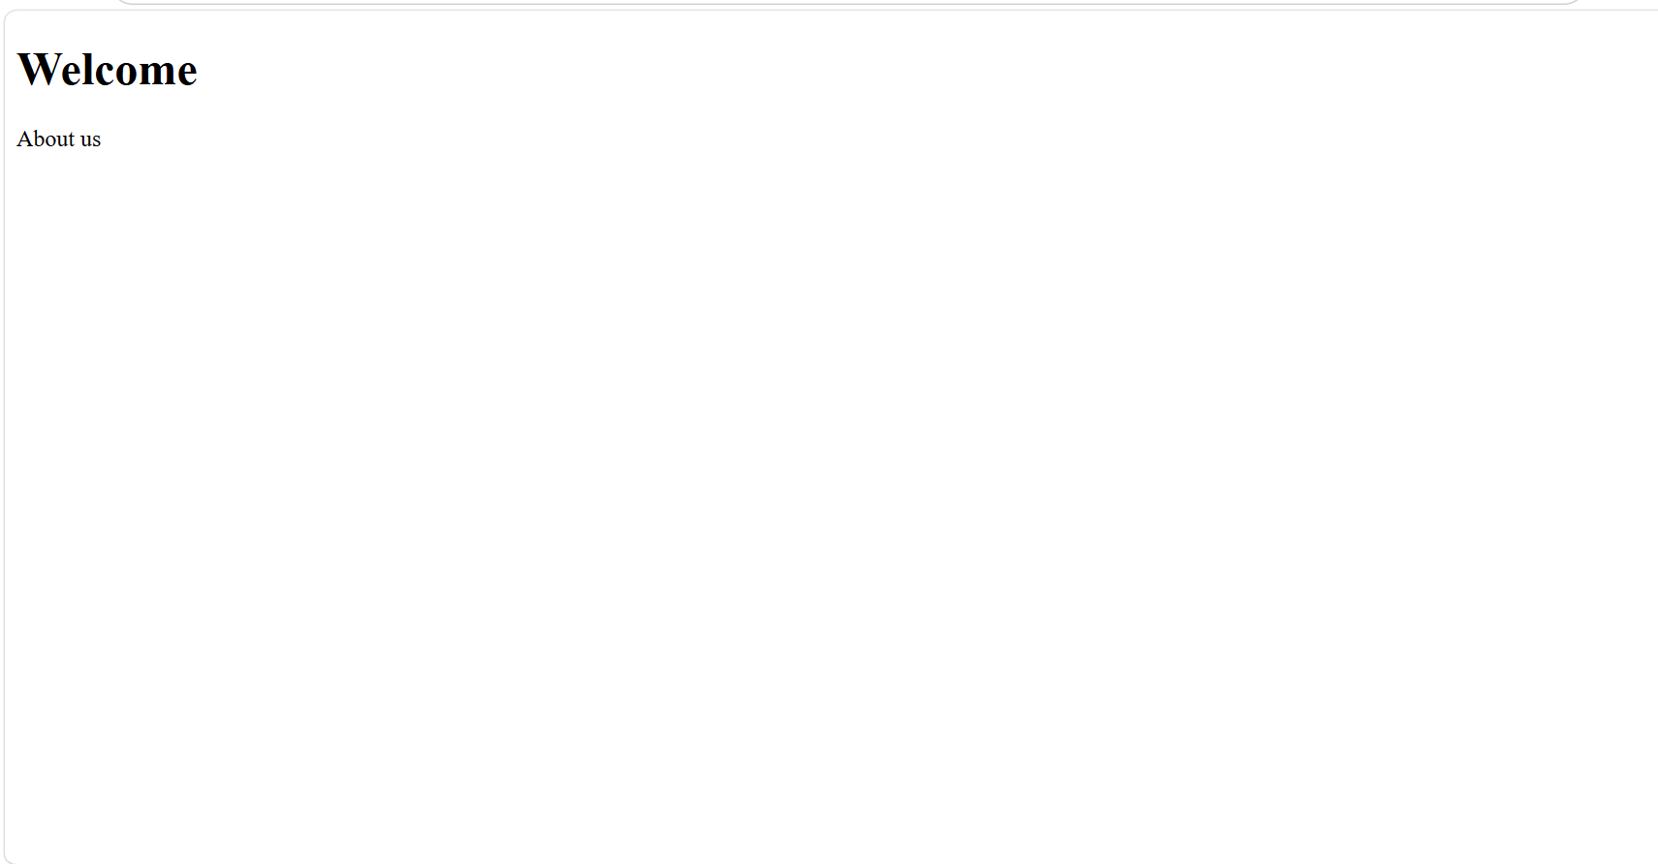
5. Techniques for cross-browser compatibility
Validate HTML using W3C Validator.
Use HTML5 semantic elements.
Include <!DOCTYPE html>.
Test in Chrome, Firefox, Edge, and Safari.
Use CSS Reset or Normalize.css.
Use feature detection instead of browser detection.
Write standards-compliant HTML and CSS.
Use responsive design.

3. Form Submission Failure

1. Issues in the form configuration
Problems:
- Button type is "button" instead of "submit".
- GET method sends sensitive data in URL.
- Password should not be transmitted using GET.

2. Why the HTTP request is not triggered
The button is:
<button type="button">
This only performs a normal button action.
It does not submit the form.
The correct type is:
<button type="submit">

3. Role of GET method
GET:
- Sends data in the URL.
- Used for retrieving information.
- Data is visible in browser history.
- Not suitable for passwords or confidential information.
Example:
/submit?username=John&password=12345
4. Correct implementation

<!DOCTYPE html>
<html lang="en">
<head>
<meta charset="UTF-8">
<title>Login</title>
</head>
<body>
<form action="/submit" method="POST">
<label for="username">Username</label>
<input type="text" id="username" name="username" required>
<label for="password">Password</label>
<input type="password" id="password" name="password" required>
<button type="submit">Login</button>
</form>
</body>
</html>
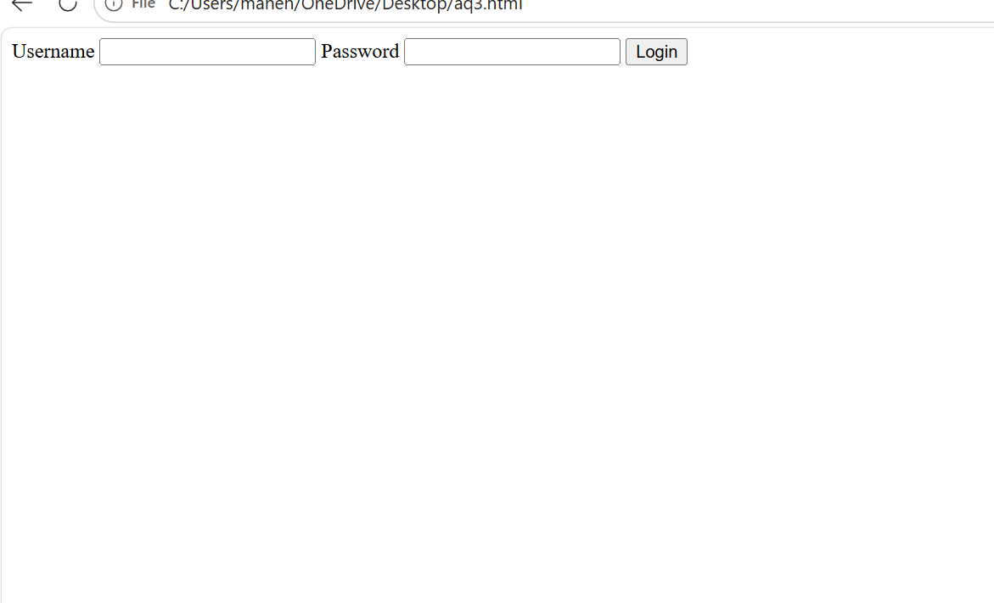

5. Improvements for secure data transmission
- Use POST instead of GET.
- Use HTTPS to encrypt communication.
- Validate input on both client and server.
- Hash passwords before storing them.
- Implement CSRF protection.
- Use secure session management.
- Display meaningful error messages without exposing sensitive information.
- Enable server-side authentication and input sanitization.

