AI-Powered College
Multi-Agent Assistant System

1. Abstract
The College Multi-Agent Assistant is a web-based academic support system that allows students and faculty to interact with college data using natural language. It combines a React frontend, Flask backend, SQLite database, JWT authentication, LangGraph orchestration, RAG, and Groq LLM calls to provide secure role-aware answers.

2. Introduction
Educational institutions manage attendance, courses, results, leave requests, classrooms, and policy information. This project provides a conversational interface that helps users access that information quickly while preserving access control.
The scope includes authenticated student and faculty access, natural-language chat, database-backed responses, RAG-based policy answers, leave management, and visible agent tracing.

3. Objectives
- Build a secure college assistant for students and faculty.
- Use a multi-agent workflow to route, validate, and answer queries.
- Provide database-backed academic and administrative responses.
- Use RAG for handbook, leave policy, bus route, and infrastructure queries.
- Maintain chat memory and show agent traces.

4. System Overview
The frontend provides login, chat, leave submission, and faculty leave review screens. The Flask backend exposes authentication, chat, and leave APIs. SQLite stores seeded college data. LangGraph coordinates the agents, and Groq-backed prompts support routing, SQL generation, validation, and response writing.

5. Technology Stack
- Programming Languages: Python and JavaScript.
- Frontend: React, Vite, Axios, and lucide-react.
- Backend: Flask, Flask-CORS, Flask-JWT-Extended, and Werkzeug.
- Agent Framework: LangGraph and LangChain.
- LLM Provider: Groq through langchain_groq.ChatGroq.
- Database: SQLite.
- RAG: ChromaDB, sentence-transformers, local markdown files, and lexical fallback.

6. System Workflow

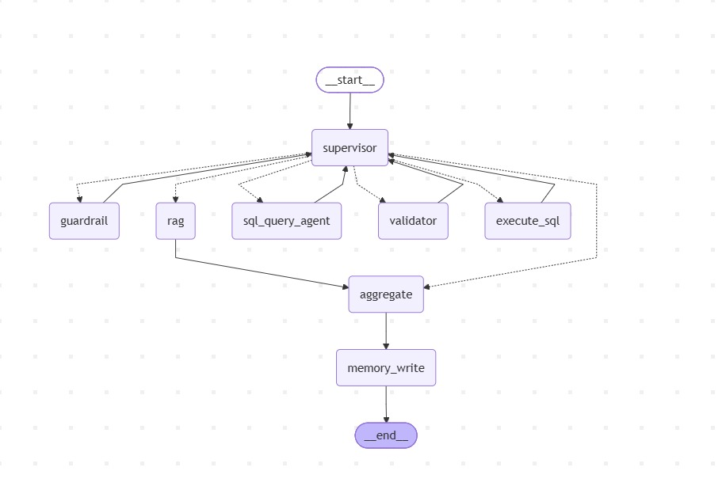

7. Module Description

7.1 Supervisor Agent
Role: central coordinator.
Input: user query, role, schema, policy, and chat history.
Processing: invokes guardrail, decides route, coordinates agents, manages retries, and aggregates responses.
Output: final response or next route.

7.2 Guardrail Agent
Role: safety and access screening.
Input: user role, user ID, query, and policy.
Processing: accepts safe college-related requests and rejects unsafe or unrelated requests.
Output: allow or deny verdict.

7.3 SQL Query Agent
Role: SQL generation and execution support.
Input: scoped request, user details, schema, and validator feedback.
Processing: generates or revises SQLite queries.
Output: SQL query or explanation; execution returns database result.

7.4 Validator Agent
Role: SQL correctness and safety validation.
Input: SQL, scoped request, schema, user role, and policy.
Processing: checks syntax, schema usage, row-level security, and allowed operations.
Output: valid or invalid verdict with feedback.

7.5 RAG Tool
Role: knowledge retrieval.
Input: user question.
Processing: searches markdown knowledge files or Chroma store.
Output: relevant context for policy and campus answers.

7.6 Aggregate Node
Role: final response generation.
Input: direct answer, RAG context, or SQL result.
Processing: writes a natural response using prompts.
Output: final chatbot message.

7.7 Memory Write Node
Role: conversation storage.
Input: user and assistant turns.
Processing: appends them to per-user JSON memory.
Output: updated session history.

8. Database Design

SQLite stores users, students, faculty, courses, prerequisites, course registrations, attendance, results, leave requests, classrooms, and classroom bookings. The live schema is read from backend/agents/schema.py.
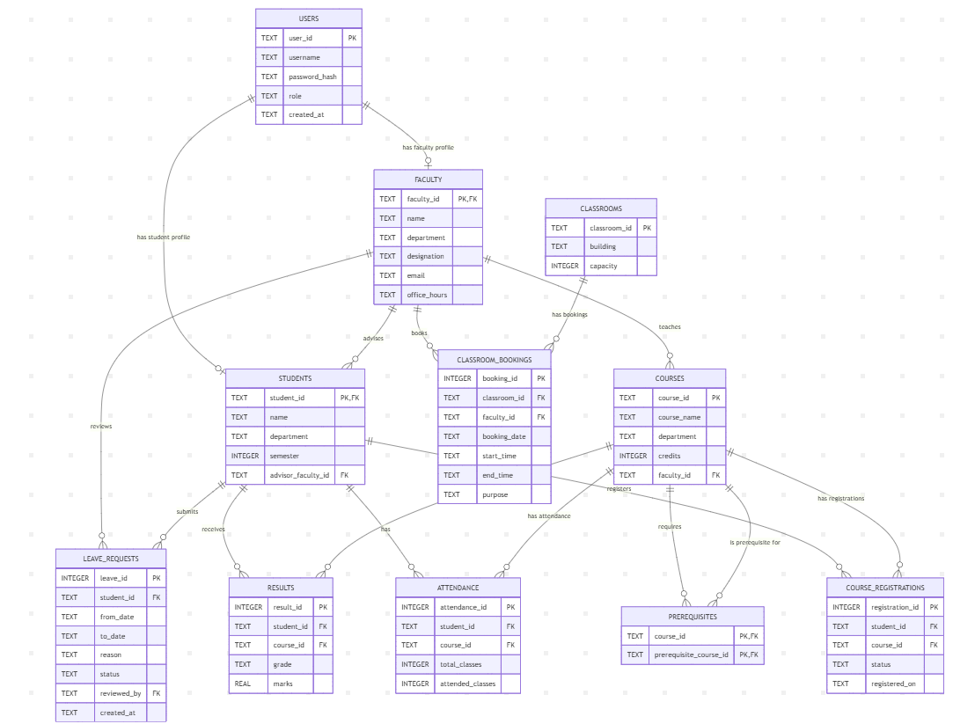

9. Implementation Summary
The frontend sends authenticated requests to Flask APIs. The backend creates LangGraph state and passes it through the Supervisor Agent. The system retrieves RAG context, generates and validates SQL, executes safe queries, aggregates natural answers, and stores conversation memory.

10. Features
- Student and faculty login using seeded accounts.
- Natural-language chat for college queries.
- Role-aware attendance, course, result, leave, classroom, and policy answers.
- Student leave submission and faculty leave review.
- Agent trace display and Mermaid graph visualization.

11. Security and Validation
- JWT authentication identifies users.
- Role policy limits student and faculty access.
- Guardrails block unsafe, unrelated, and prompt-injection requests.
- Validator checks SQL before execution.
- Database tool blocks multi-statement SQL, administrative SQL, unsafe writes, and unscoped queries.

12. Testing
Test Case | Input / Action | Expected Result
Student Login | 192125022 / password123 | Student dashboard opens.
Faculty Login | FAC001 / password123 | Faculty tools open.
Attendance Query | Ask attendance for a course | Scoped attendance answer returns.
Policy Query | Ask minimum attendance policy | RAG answer returns.
Leave Submit | Student submits leave form | Pending leave is created.
Unsafe Request | Ask for another student's data | Request is denied or blocked.

13. Results and Output
The final system provides a working authenticated chatbot for college-management queries with natural responses, agent traces, leave workflows, and secure database retrieval.

Login Page:

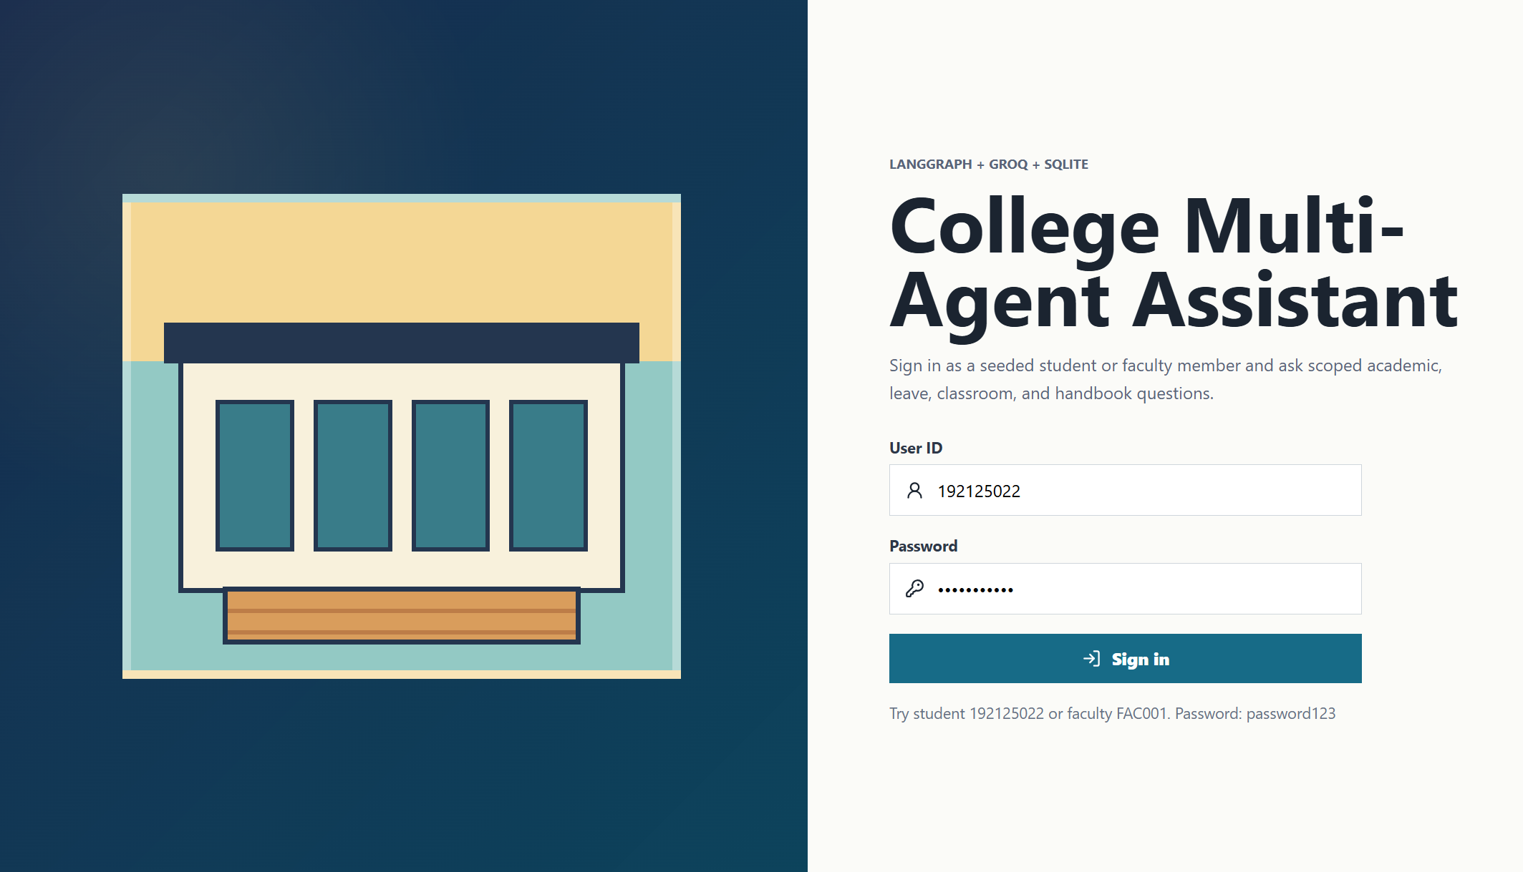

Student chat interface:

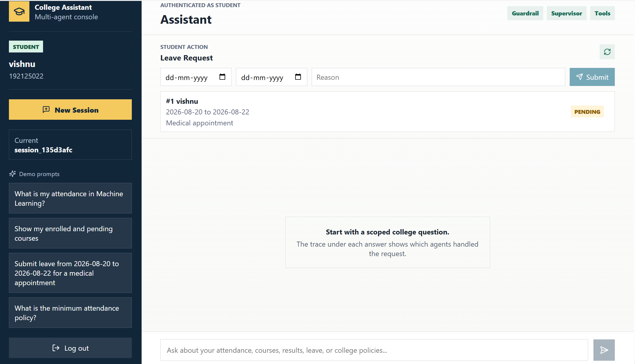

Faculty login:

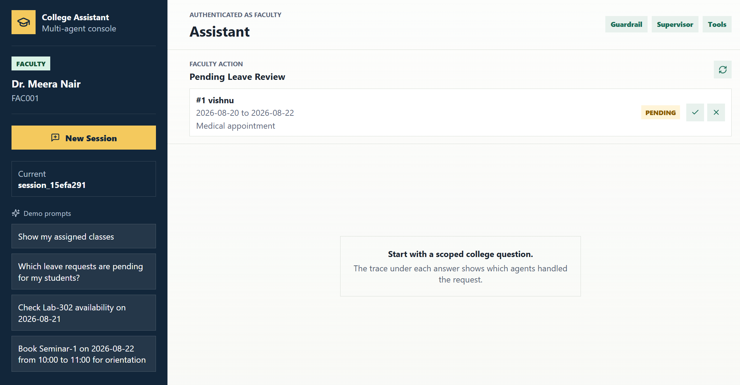

Sample input outputs:

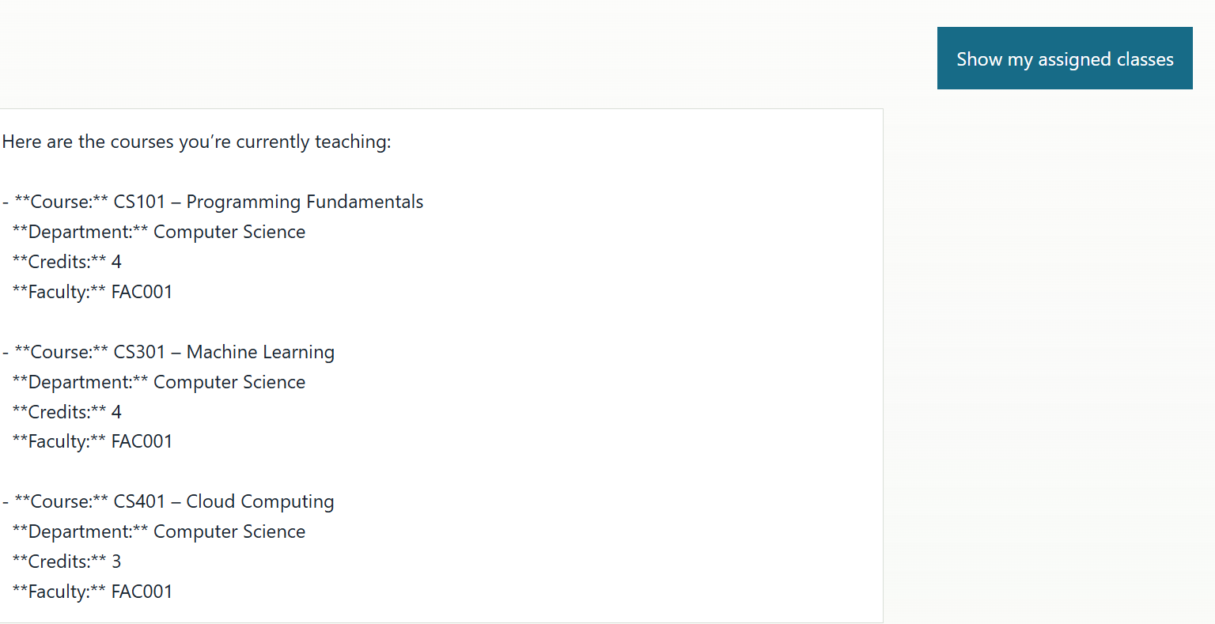

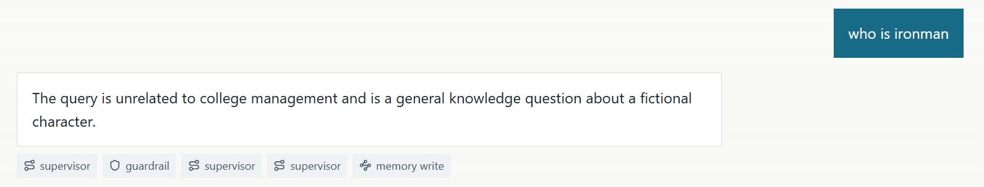

14. Limitations
- The database uses seeded demo data.
- LLM routing depends on Groq API availability.
- The RAG knowledge base is limited to local markdown files.
- The frontend is demonstration-focused.

15. Future Enhancements
- Add admin dashboards and audit logs.
- Expand database and knowledge-base coverage.
- Add automated tests for APIs and agent routes.
- Deploy with production database and secure secret management.

16. Conclusion
The project demonstrates how a supervised multi-agent workflow can safely provide natural-language access to academic and administrative information. It combines web development, authentication, database design, LLM orchestration, validation, and RAG in a practical college assistant.

