A CASE-STUDY BASED REPORT
ON
Crop Recommendation System Using Random Forest and Naive Bayes
submitted in partial fulfilment of the requirements for the Course
MACHINE LEARNING
BACHELOR OF TECHNOLOGY
in
A.Y.: 2026-27
by
B.Vishnu vardhan roll 2520030392
CH.Nripendra roll 2520030280
Under the Esteemed guidance of
Jyothsna Datti
Asst.Professor, Dept. of CSE




INDEX
Abstract
Introduction
Background
Motivation for the Project
Overview of the Work Carried Out
Scope and Responsible-Use Statement
Problem Statement
Case-Study Scenario
Central Case-Study Question
Formal Problem Definition
Objectives that Guide the Study
Assumptions and Limitations
Dataset and Exploratory Data Analysis
About the Dataset
Purpose of EDA
Preparation Steps Actually Performed
EDA Exploration - Implementation
Summary of EDA Findings
Algorithm Selection and Implementation

Conclusion

Signature of the Team members

Abstract
Choosing the right crop for a piece of land is an important decision in agriculture. Farmers need to know which crop is best suited to their soil and climate so that they can improve yield and avoid losses. This case study, "Crop Recommendation System Using Random Forest and Naive Bayes", recommends the most suitable crop from soil nutrients and climate conditions, namely nitrogen (N), phosphorus (P), potassium (K), temperature, humidity, soil pH, and rainfall.
The supplied dataset of 2,200 records covering 22 crops is checked for missing values, duplicate records, and outliers, and is explored using descriptive statistics, histograms, and correlation analysis. It is then divided into 80% training data and 20% testing data using a stratified split. Two classification models, Random Forest and Naive Bayes, are trained and evaluated using Accuracy, Precision, Recall, F1-Score, and confusion matrices. On the test data, both models achieved an accuracy of 99.55%, with an F1-score of 0.9955 for Random Forest and 0.9954 for Naive Bayes. Five-fold cross-validation gave mean accuracies of 99.55% for Random Forest and 99.45% for Naive Bayes. Rainfall, humidity, potassium, and phosphorus were found to be the most influential factors. The study shows how machine learning can support data-based crop recommendation.
Introduction
Agriculture depends strongly on soil and weather conditions, and the success of a crop is decided by factors such as the nutrient content of the soil, temperature, humidity, soil pH, and rainfall. Every farm produces a large amount of such information, and studying it can help farmers and agricultural advisers understand which crop suits a particular field.
Machine learning provides useful methods for analysing this data. In this project, Random Forest and Naive Bayes classifiers are used to recommend one of 22 crops from seven soil and climate attributes. Random Forest combines many decision trees to learn complex relationships, while Naive Bayes provides a simple and fast probabilistic baseline. Both models are trained on historical data and tested on unseen data, and their results are compared using standard classification metrics.
Background
Precision agriculture uses data and machine learning methods to convert soil and weather measurements into useful knowledge for farmers, agronomists, and planners. Classification is a natural approach when the quantity to be predicted is a category, such as the name of a crop. A classifier learns from past records in which the soil and climate conditions are known together with the crop that suits them.
Random Forest is an ensemble technique in which many decision trees are trained on random samples of the data and random subsets of the features, and the final crop is chosen by the majority vote of the trees. This reduces overfitting and allows the model to capture non-linear relationships between the attributes. Naive Bayes is a probabilistic classifier based on Bayes' theorem that assumes the attributes are independent of one another for a given crop. Its Gaussian variant models each attribute with a normal distribution for every crop. Comparing an ensemble model with a simple probabilistic model is a common way to find out whether additional complexity gives better predictions on a given dataset.
Motivation for the Project
Selecting a crop by experience alone can be inconsistent and risky, because many factors must be considered together. A wrong choice can lead to poor yield, wasted fertiliser, and financial loss. A machine learning model can combine all the soil and climate measurements and produce a consistent recommendation for every field.
Another motivation is to find out which factors contribute most to the recommendation, and to compare an ensemble model with a probabilistic model on the same data. The answers can help farmers, agricultural advisers, and planners make data-based decisions about crop selection and resource use.
Overview of the Work Carried Out
The work began with loading the crop recommendation dataset and examining its shape, column types, and descriptive statistics. The data was checked for missing values and duplicate records, and the spread of each attribute was studied using the IQR method for outliers. Distributions and relationships between the attributes were analysed using histograms and a correlation matrix.
The seven soil and climate attributes were used as input features and the crop label was used as the target class. The data was divided into training and testing sets in an 80:20 ratio, keeping the same proportion of every crop in both sets. Random Forest and Naive Bayes classifiers were trained on the training set and evaluated on the testing set using Accuracy, Precision, Recall, F1-Score, and confusion matrices. Five-fold cross-validation was also performed, and the importance of each feature was then examined.
Scope and Responsible-Use Statement
The scope of this case study is limited to the supplied dataset of 2,200 records covering 22 crops and to the two selected models, Random Forest and Naive Bayes. The purpose is to demonstrate how machine learning can recommend a suitable crop from soil and climate conditions.
The recommendations should be treated as decision-support information and not as the only basis for important farming decisions. Factors such as soil type, market price, water availability, pests, seed variety, and local farming practice are not included in the data. The results are valid only for the supplied dataset and may change when the models are applied to other regions or seasons.
Problem Statement
Selecting a suitable crop is difficult when many soil and climate factors are involved, and these factors interact with one another, so no single measurement is enough. The problem addressed in this case study is to recommend the most suitable crop from soil nutrient levels and climate conditions, and to compare a Random Forest classifier with a Naive Bayes classifier using standard classification measures.
Case-Study Scenario
Consider an agricultural advisory service that has soil test results and climate data for a large number of fields, including nitrogen, phosphorus, and potassium levels, temperature, humidity, soil pH, and rainfall. Farmers want a quick and consistent way to find out which crop is best suited to their land so that they can plan cultivation and improve yield.
In this case study, the supplied dataset is analysed using exploratory data analysis, and two classification models are trained to recommend the crop. Their predictions on unseen records are compared to understand which model is better suited to this task.
Central Case-Study Question
How accurately can Random Forest and Naive Bayes recommend the most suitable crop from soil and climate attributes, and which of the two models gives the better predictions on unseen data?
The study also asks which soil and climate factors have the strongest influence on the recommendation.
Formal Problem Definition
The dataset contains 2,200 records. Each record has seven numerical input attributes (N, P, K, temperature, humidity, ph, and rainfall) and one categorical target variable, label, which takes one of 22 crop names. The task is to learn a function that maps the soil and climate attributes of a field to the most suitable crop.
The models are trained on a training portion of the data and evaluated on a held-out testing portion using Accuracy, Precision, Recall, and F1-Score. Precision, Recall, and F1-Score are calculated as weighted averages over the 22 crops. Higher values of these measures indicate better predictions.
Objectives that Guide the Study
The first objective is to analyse the crop recommendation dataset and understand how the soil and climate attributes are distributed and related to one another. The second objective is to clean and prepare the data and divide it into training and testing sets.
The third objective is to implement Random Forest and Naive Bayes classifiers and evaluate them using Accuracy, Precision, Recall, and F1-Score. The final objective is to compare the two models and identify the factors that contribute most to the recommendations.
Assumptions and Limitations
The study assumes that the supplied dataset is accurate and that the seven soil and climate attributes contain enough information to recommend a crop. It also assumes that the records are independent of one another and that the testing data represents fields the models have not seen.
The main limitations are the size of the dataset, which has only 2,200 records with exactly 100 records per crop, and the absence of contextual information such as soil type, market price, and local practice. Only default settings of the models were used, and no extensive hyperparameter tuning was performed. The reported results come from a single 80:20 split, supported by five-fold cross-validation, so they may vary slightly with a different split. The very high accuracy also suggests that the crops are well separated in this dataset, and performance on real-world data may be lower. The study is therefore a demonstration within the scope of the available data and not a complete crop advisory system.
Dataset and Exploratory Data Analysis
The project uses a crop recommendation dataset in CSV format containing 2,200 records and eight columns. Exploratory Data Analysis was carried out to understand the structure of the data, its quality, and the relationships between the soil and climate attributes before any model was trained.
About the Dataset
Each row of the dataset represents one field condition. Seven columns are numerical soil and climate attributes, and label is the categorical target variable containing the name of the recommended crop. The dataset covers 22 crops (rice, maize, chickpea, kidney beans, pigeon peas, moth beans, mung bean, black gram, lentil, pomegranate, banana, mango, grapes, watermelon, muskmelon, apple, orange, papaya, coconut, cotton, jute, and coffee), with exactly 100 records for each crop. Table 1 describes the columns.
Column | Description
N | Ratio of nitrogen content in the soil
P | Ratio of phosphorus content in the soil
K | Ratio of potassium content in the soil
temperature | Temperature in degrees Celsius
humidity | Relative humidity (%)
ph | pH value of the soil
rainfall | Rainfall in millimetres (mm)
label | Recommended crop (target class, 22 crops)

Table 1: Description of dataset columns.
Purpose of EDA
The purpose of EDA is to understand the shape and data types of the dataset, verify its quality by checking for missing values and duplicates, study the distribution and spread of each attribute, detect outliers, and measure how the attributes are related to one another. These findings guide the preparation steps and help to interpret the model results later.
Preparation Steps Actually Performed
The dataset was loaded using Pandas and its shape, column names, data types, and descriptive statistics were inspected. A check of the data found no missing values and no duplicate records, so no cleaning or imputation was needed. All seven input attributes were already numerical, and the crop names in the label column were used directly as class labels, which Scikit-learn handles internally. Every crop has exactly 100 records, so the classes are perfectly balanced. Feature scaling was not applied, because Random Forest is not affected by the scale of the features and Gaussian Naive Bayes estimates the mean and variance of each feature separately.
Outliers were identified using the IQR method. Potassium (K) had 200 outliers, phosphorus (P) had 138, rainfall had 100, temperature had 86, soil pH had 57, and humidity had 30, while nitrogen (N) had none. These values correspond to crops that naturally grow under extreme conditions, such as the very high potassium and phosphorus levels for apple and grapes and the heavy rainfall for rice, so they are genuine and were retained. The seven attributes were used as features and label as the target. The data was split randomly into 1,760 training records and 440 testing records using a stratified split and a fixed random state of 42, so that every crop has 80 training and 20 testing records and the results can be reproduced.
EDA Exploration - Implementation
Descriptive statistics were calculated for every numerical attribute, and the results are given in Table 2. Potassium has the widest spread (standard deviation 50.65, range 5 to 205), and rainfall varies from 20.21 mm to 298.56 mm with a mean of 103.46 mm. Soil pH ranges from 3.50 to 9.94 with a mean of 6.47, which is slightly acidic to neutral.
Attribute | Mean | Std Dev | Min | Max
N | 50.55 | 36.92 | 0.00 | 140.00
P | 53.36 | 32.99 | 5.00 | 145.00
K | 48.15 | 50.65 | 5.00 | 205.00
temperature | 25.62 | 5.06 | 8.83 | 43.68
humidity | 71.48 | 22.26 | 14.26 | 99.98
ph | 6.47 | 0.77 | 3.50 | 9.94
rainfall | 103.46 | 54.96 | 20.21 | 298.56

Table 2: Descriptive statistics of the dataset.
The distribution of each attribute was plotted as a histogram, shown in Figure 1. Temperature and soil pH are roughly bell-shaped around their means, humidity is concentrated at high values, and potassium is strongly right-skewed because a few crops require very high potassium. Several attributes are spread over wide ranges, which shows that different crops grow under very different conditions.
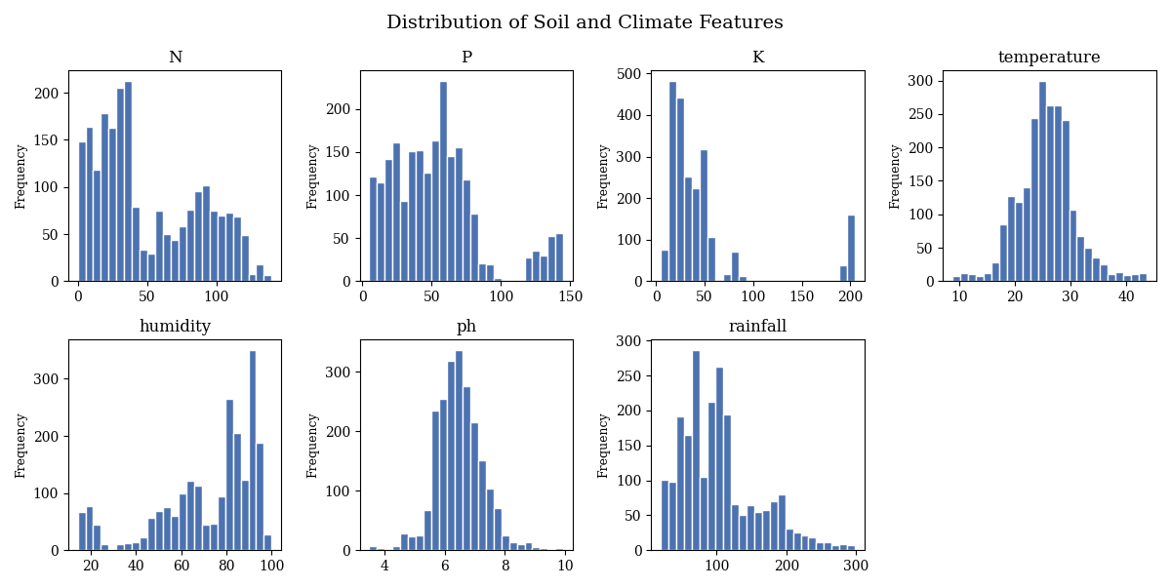
Figure 1: Distribution of the soil and climate features.
A correlation matrix, shown in Figure 2, was used to study the relationships between the attributes. Phosphorus and potassium have the strongest correlation (0.74), which reflects the crops that need high amounts of both nutrients. All other pairs have weak correlations, with absolute values of 0.23 or less, so the remaining attributes carry mostly independent information.
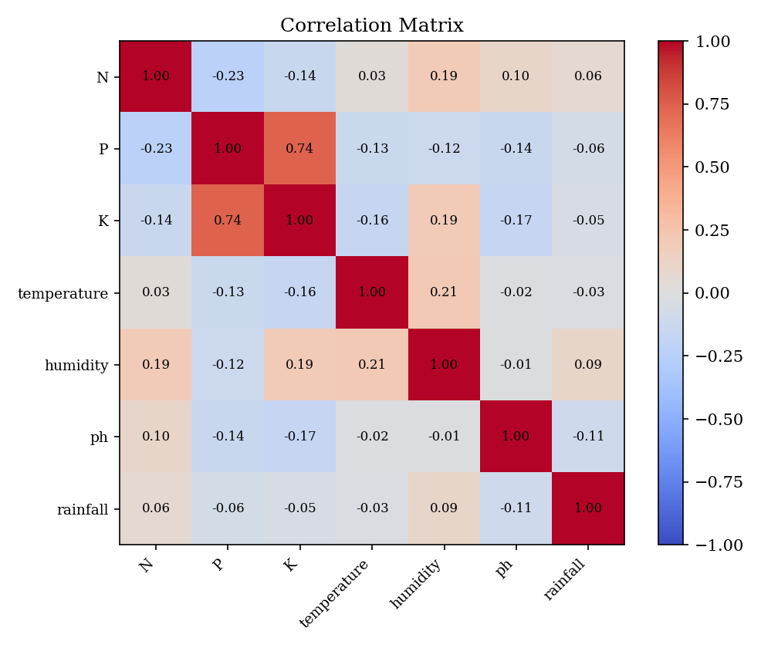
Figure 2: Correlation matrix of the soil and climate features.
Summary of EDA Findings
The dataset is clean, with 2,200 records, no missing values, no duplicates, and exactly 100 records for each of the 22 crops. Outliers are present in six of the seven attributes, but they belong to crops with naturally extreme requirements and were retained.
Only phosphorus and potassium are strongly correlated with each other, and the other attributes are largely independent. The crops differ clearly in their typical conditions, for example rice needs very high rainfall, while chickpea and kidney beans grow at low humidity, which suggests that a classifier can separate the crops well. The weak correlations among most attributes are also favourable for Naive Bayes, which assumes that the attributes are independent.
Algorithm Selection and Implementation
The models were implemented in Python using Pandas and NumPy for data handling, Matplotlib for plots, and Scikit-learn for modelling and evaluation. The work can be run in Jupyter Notebook, Google Colab, or Visual Studio Code. Because the target is a category (the crop name), classification algorithms were selected.
Random Forest was selected as a powerful ensemble model that builds many decision trees on random samples of the data and random subsets of the features and combines them by majority voting. It was trained with the default Scikit-learn settings (100 trees, Gini criterion, and a random state of 42). Its feature importance values were highest for rainfall (0.230), humidity (0.224), potassium (0.175), and phosphorus (0.151), and lower for nitrogen (0.096), temperature (0.072), and soil pH (0.051).
Naive Bayes (Gaussian Naive Bayes) was selected as a simple and fast probabilistic baseline. It applies Bayes' theorem and assumes that the attributes are independent of one another for a given crop. For every crop, it learns the mean and variance of each attribute from the training data, and a new record is assigned to the crop with the highest posterior probability. The default Scikit-learn settings were used, so no parameters had to be tuned.
Both models were trained on the 1,760 training records and evaluated on the 440 unseen testing records. The results are given in Table 3, where Precision, Recall, and F1-Score are weighted averages over the 22 crops.
Metric | Random Forest | Naive Bayes
Accuracy | 0.9955 | 0.9955
Precision | 0.9957 | 0.9959
Recall | 0.9955 | 0.9955
F1-Score | 0.9955 | 0.9954

Table 3: Performance of the two models on the testing data.
Both models achieved the same accuracy of 99.55%, correctly classifying 438 of the 440 test records. Random Forest misclassified one black gram record as maize and one rice record as jute, while Naive Bayes misclassified two rice records as jute, as shown in the confusion matrices in Figure 3. Precision and F1-Score differ only in the fourth decimal place, so the two models are practically equal on this test set. Five-fold stratified cross-validation gave mean accuracies of 99.55% (standard deviation 0.32%) for Random Forest and 99.45% (standard deviation 0.18%) for Naive Bayes, which confirms that the result does not depend on a single split. The very high score of the simple Naive Bayes model shows that the crops are well separated by their soil and climate conditions. Random Forest additionally provides feature importance values, shown in Figure 4, which identify rainfall and humidity as the most influential factors, followed by potassium and phosphorus. Naive Bayes is simpler and faster to train, while Random Forest offers feature importance values and a marginally higher mean cross-validation accuracy. Tuning the parameters or using more diverse data might change this outcome.
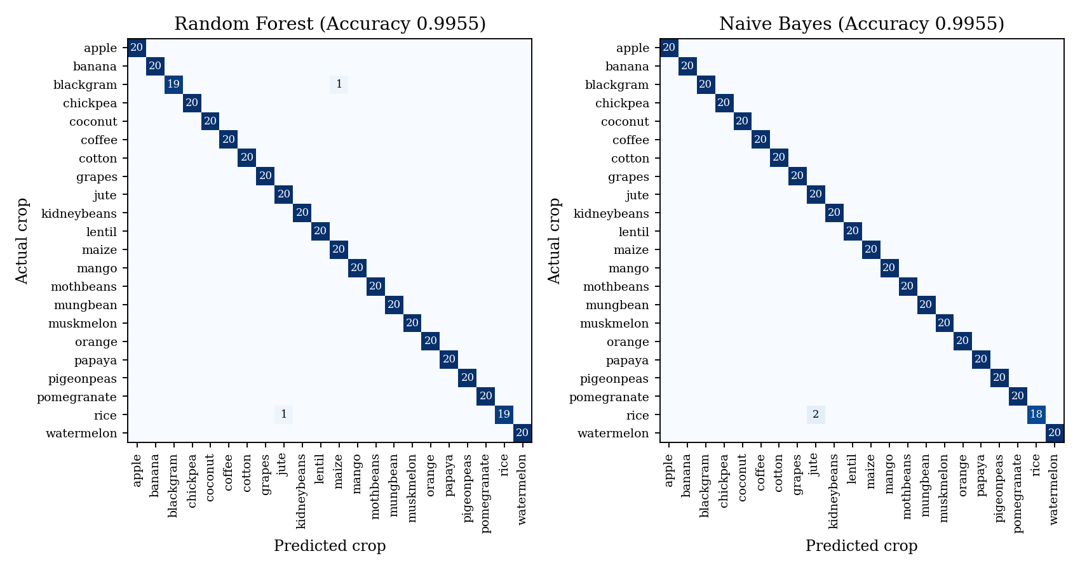
Figure 3: Confusion matrices of Random Forest and Naive Bayes.
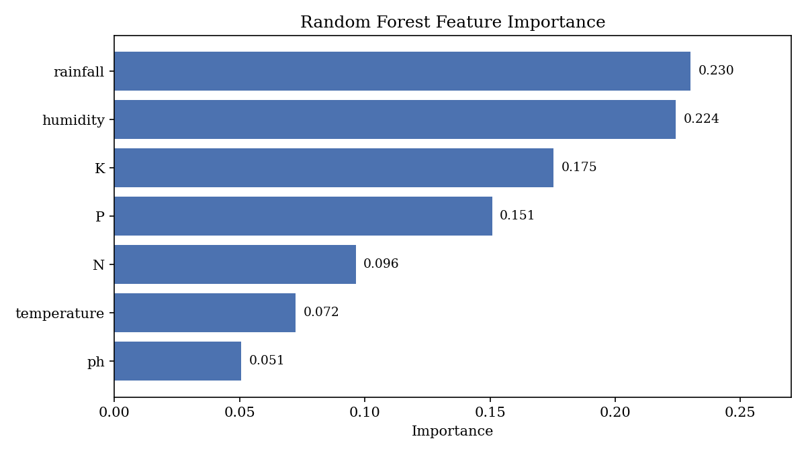
Figure 4: Feature importance from Random Forest.
Conclusion
This case study demonstrated the use of machine learning to recommend a suitable crop from soil and climate conditions. Exploratory data analysis showed that the dataset is clean and perfectly balanced across 22 crops, and that only phosphorus and potassium are strongly correlated. Random Forest and Naive Bayes were trained on 1,760 records and tested on 440 unseen records.
Both models gave excellent results, each reaching an accuracy of 99.55% on the test data, with F1-scores of 0.9955 for Random Forest and 0.9954 for Naive Bayes. Five-fold cross-validation gave 99.55% for Random Forest and 99.45% for Naive Bayes, so the two models are practically equal in accuracy. Random Forest showed that rainfall, humidity, potassium, and phosphorus contribute most to the recommendation. The study shows that machine learning can give accurate, data-based crop recommendations, and that a simple model such as Naive Bayes can perform as well as an ensemble when the classes are well separated. Future work can test tuned models, other algorithms such as XGBoost and Support Vector Machines, and larger real-world datasets that include soil type, season, and market information, and can deploy the best model as a web application for farmers.

